grafik, daire, renklilik, simge, sembol içeren bir resim

Açıklama otomatik olarak oluşturuldukırpıntı çizim, simge, sembol, grafik, tasarım içeren bir resim

Açıklama otomatik olarak oluşturuldu

MIDDLE EAST TECHNICAL UNIVERSITY

ELECTRICAL & ELECTRONICS ENGINEERING DEPARTMENT

**EE464 HOMEWORK 1 – Magnetic Design of the Hardware Project**

Members: Onat Şimşek - 2375772

Selen Özge Özgür –

Onur Emirhan Çon -

Date: 24.03.2024

## Introduction

Question 1)

As Team “The Isolated Ones”, we plan to design a Flyback converter as an isolated DC/DC converter, or in other words as an SMPS.

1. While checking the analog controllers of the Flyback converter, we found out that UC3845 will be more than enough for this project. UC3845 can supply a duty cycle of 0.5 maximum, which gives us an upper boundary to choose our duty cycle. Hence, we have chosen a duty cycle range of 0.2 to 0.4. In order to ensure that the controller gives a duty cycle in this range, our turns ratio should be 1:1. This can be calculated as follows:

Due to the diode between the secondary side and the load, assume secondary voltage as 12.75V (Vsecondary = 12.75V) so that our output voltage is around 12V. Moreover, it is known that the voltage equation of a Flyback converter is as follows:

where V2 = 12.75 V, V1 = 20-40 V. When V1 = 20 and ratio is taken as 1, Dmax is found as around 0.39. Furthermore, when V1 = 40 and ratio is taken as 1, Dmin is found as around 0.24. The found duty cycles determine the boundaries of the operating region of the Flyback converter.

1. For the transformer of the Flyback converter, we have selected an E-core with a gap of 1mm. The datasheet of the core can be found in the appendix section. An E-core is selected since the leakage flux in E cores is smaller than toroid cores due to their shape. Moreover, due to the existence of coil formers for each and every E-core, it is much easier to wind the coils to the core. Also, since we are to design a Flyback converter, the energy should be stored in the core first to transfer the energy to the secondary side. Hence, an E-core with a gap is required for us to implement a better solution to store the energy in the core when the switch is ON.

Another reason for us to select this core is that it has a high permeability, even with the air gap, and it does not have a high volume, with a volume of 11.5 cm3, so that the core will not take up so much space in our final design.

In order to find the required number of turns for both the primary and the secondary, which are the same for our design, we need to determine the magnetizing inductance value first. By using the magnetizing inductance formula in the Application Note, AN4137, Design Guidelines for Off-line Flyback Converters Using FPS [1], the magnetizing inductance Lm can be calculated as follows:

where Pin is the input power, which is selected as 72W to ensure an efficiency more that 80%, KRF is the ripple factor, which is defined as in the Figure 1 and selected as 0.35, fs is the switching frequency, which is selected as 100kHz.

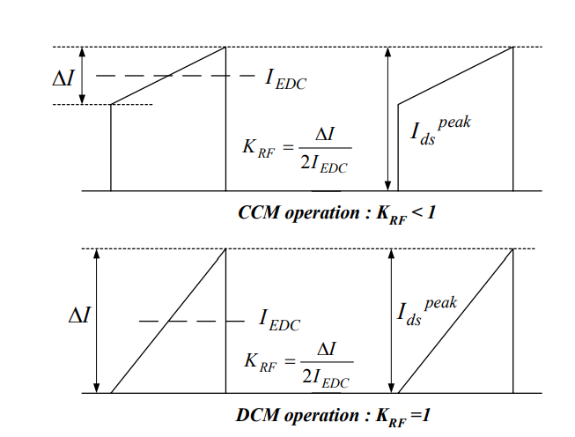

Figure 1. MOSFET drain current and ripple factor KRF

After putting the values into the equation, Lm is found to be 18.55µH. Then, to find the required number of turns of the primary, the AL value of the core is used and the required number of turns is found by using the following formula:

where AL value of the core we have selected having a 1mm of air gap is 196 nH/T2. Hence, after making the calculation, the required number of turns are found as 10, approximately. Moreover, by limiting the Bmax value, the minimum required number of turns can also be calculated to check whether the previously calculated number of turns is valid or not by using the formula present in [2] as follows:

where Bsat is selected as 0.2T, and effective area of the core we have selected is 125 mm2. When putting all the numbers to the equation above, it is found that minimum required number of turns should be larger than 6.22 turns (Nmin > 6.22 turns). This concludes that 10 turns in the primary and the secondary meet the requirement of minimum turns and can be used further in this design.

## References

[1]: AN-4137 Design Guidelines for Off-line Flyback Converters using FPS. Available at:

<https://u.dianyuan.com/bbs/u/0/1071889497.pdf>

[2]: Single Transistor Forward Converter Design. Available at:

<https://ocw.metu.edu.tr/pluginfile.php/152997/mod_resource/content/0/forward_magnetic_design_recitation.pdf>

## Appendix

Link to core datasheet:

<https://www.tdk-electronics.tdk.com/inf/80/db/fer/etd_39_20_13.pdf>