PRAHARI
Proactive AI-Powered Road Watch System

National Road Safety Hackathon 2026 - IIT Madras
Team Name: Outliers
Presenter: Palash Singh Tomar
Theme: Road Watch

Executive Summary
Our prototype, Prahari, is an AI-powered solution for the National Road Safety Hackathon 2026. By addressing the 'Road Watch' theme, we bridge the gap between infrastructure hazards and driver awareness. Our approach balances high-impact safety results with low-effort deployment by utilizing edge-AI on common mobile devices. Targeted at both daily commuters and road authorities, Prahari provides a scalable, tech-forward vision for safer Indian roads.

1. Rationale: Why This Domain?

1.1 The "Why"
India witnesses one of the highest numbers of road accidents globally. While reactive safety measures (like post-crash emergency response) are essential and exist in various forms, real-time proactive monitoring is the missing link in Indian infrastructure. The motivation behind Prahari stems from the urgent need to shift the paradigm from reactive to preventive. By leveraging Artificial Intelligence to detect road anomalies and monitor driver behavior in real-time, we can prevent accidents before they occur. Our technical motivation is driven by the recent advancements in Edge AI, allowing complex computer vision models like YOLOv8 to run directly on smartphones without requiring expensive specialized hardware.
Personal Motivation: As regular commuters on Indian highways, the team has witnessed the devastating consequences of sudden infrastructure failures (like unmarked potholes) and distracted driving. The sheer volume of preventable tragedies demands an accessible, scalable, and intelligent intervention.

1.2 Domain Selection & Hackathon Alignment
We chose the 'Road Watch' domain because it directly aligns with the 2026 hackathon's focus on AI-driven preventive measures. Rather than waiting for a collision to trigger a distress signal, Prahari acts as an ever-vigilant sentinel. It continuously scans the road environment, creating a digital safety net.
"I chose this domain because while reactive safety exists, real-time proactive monitoring—Road Watch—is the missing link in Indian infrastructure."

2. Effort vs. Impact Analysis
To ensure our solution is both highly effective and practically deployable at scale, we conducted an Effort vs. Impact analysis.
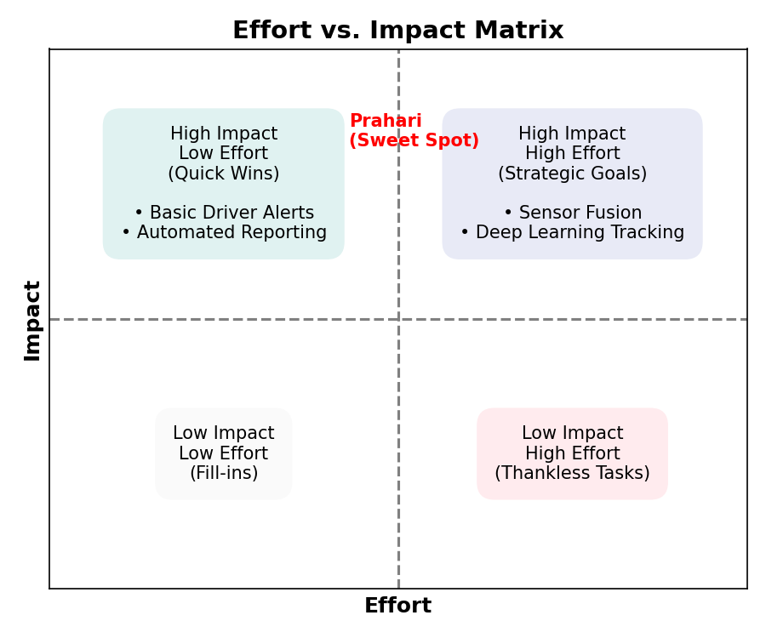
Figure 1: Effort vs. Impact Matrix highlighting Prahari's strategic positioning.
• Low Effort / High Impact (Quick Wins): Features like automated pothole reporting using standard smartphone cameras, or simple proximity-based driver alerts. These require minimal hardware investment but yield immediate safety benefits.
• High Effort / High Impact (Strategic Goals): Complex features involving full sensor fusion (integrating LIDAR, radar, and cameras) or deep learning models for advanced behavior tracking. While highly effective, they pose significant deployment barriers due to cost.

Justification of the 'Sweet Spot'
Prahari is deliberately engineered to sit in the optimal 'Sweet Spot' of the matrix. By leveraging existing smartphone cameras and on-device Edge AI, we eliminate the need for expensive proprietary hardware. This drastically reduces the 'Effort' (cost, deployment friction, hardware installation) while maximizing 'Impact' (widespread adoption, real-time hazard detection, community-driven data aggregation).

3. Target Audience
Prahari is designed as a multi-sided platform, serving both the individuals on the road and the institutions responsible for road safety.

3.1 Primary Users
• Commuters: Daily office-goers and inter-city travelers who need real-time alerts about road conditions, potholes, and accident-prone zones ahead.
• Commercial Truck Drivers: Long-haul drivers who face fatigue. The system monitors driver alertness and warns against dangerous infrastructure anomalies on unfamiliar routes.
• Delivery Partners: Gig economy workers on two-wheelers who are highly vulnerable to sudden road defects like potholes or oil spills.

3.2 Secondary Stakeholders
• Traffic Police & Highway Authorities: Gain access to a predictive dashboard offering data insights on congestion, recurring hazard locations, and high-risk driving zones.
• Municipal Corporations: Receive auto-generated, geo-tagged reports of infrastructure decay (e.g., potholes, broken signs) prioritized by severity, enabling targeted and efficient repair workflows.
• Insurance Companies: Can leverage anonymized telematics and risk assessment data to dynamically adjust premiums and accurately reconstruct accident contexts.

4. Technology Stack
Our technology choices prioritize cross-platform accessibility, low-latency processing, and secure, scalable data management.

Frontend (Mobile Application)
• Framework: React Native / Expo
Enables a unified codebase for both Android and iOS devices, crucial for rapid deployment to a diverse user base. Features an intuitive UI optimized for minimal driver distraction.

Backend (Server & API)
• API Layer: Python FastAPI
Chosen for its high performance and asynchronous capabilities, essential for handling high-frequency telemetry data streams.
• Database: PostgreSQL with PostGIS
Utilized for robust relational data management and advanced geospatial querying (finding hazards within a specific radius of moving vehicles).
• Cloud Platform: AWS / Firebase
For real-time pub/sub messaging (Firebase Cloud Messaging) and scalable container orchestration.

AI/ML Models (The Core Intelligence)
• Vision Processing: YOLOv8 (You Only Look Once)
A state-of-the-art real-time object detection model, fine-tuned specifically to recognize Indian road hazards (potholes, stray animals, unmarked speed breakers).
• Edge Computing: TensorFlow Lite
Model quantization enables the YOLOv8 model to run directly on the smartphone's NPU/GPU. This ensures zero-latency detection and operational capability even in areas with no cellular network.

Hardware Interactions
• Standard Smartphones: Utilizing built-in cameras, GPS, and IMU sensors (accelerometers/gyroscopes) to detect sudden braking or swerving.
• Dashcam Integration: APIs available for external IoT GPS modules and Wi-Fi-enabled dashcams for commercial fleet deployment.

5. Simplified Workflow

5.1 Sequence Flow
The core system operates on a continuous, low-latency loop:
1. Data Capture: The smartphone camera captures a live video feed at 30 FPS while mounted on the dashboard.
2. Edge Processing: TensorFlow Lite executes the YOLOv8 model locally on the device frame-by-frame, detecting a 'Severe Pothole'.
3. Alert Generation: The app immediately renders a visual/audio alert to the driver. Simultaneously, the app bundles the hazard classification, GPS coordinates, and a timestamp.
4. Cloud Synchronization: The bundled data is sent via async API to the FastAPI backend. If offline, data is cached locally via SQLite/IndexedDB and synced when connection resumes.
5. Community Broadcast: The backend geospatial engine updates the live threat map and pushes alerts to other drivers approaching the same GPS coordinates.

5.2 Use Case Dynamics
• The Driver: Interacts with a heads-up 'Drive Mode' interface. Requires zero manual input. The system passively monitors and proactively alerts via voice (e.g., 'Caution: Deep pothole 100 meters ahead').
• The Admin/Authority: Logs into a web-based React dashboard. Views heatmaps of reported hazards, reviews auto-captured images of infrastructure defects, and updates the status of repairs (e.g., Pending -> In Progress -> Resolved).

6. Core Features & Prototype Walkthrough

Feature 1: Real-Time Edge Hazard Detection
• Mechanism: Live camera feed runs through quantized YOLOv8.
• Action: Instantly identifies potholes, stray cattle, and jaywalkers.
• Benefit: Prevents accidents before they happen without relying on cloud latency.

Feature 2: Community Threat Mapping
• Mechanism: Auto-tagging detected hazards with precise GPS coordinates.
• Action: Updates a central database to warn other approaching commuters.
• Benefit: Creates a crowdsourced, self-updating map of road infrastructure health.

Feature 3: Sensor-Fusion Crash Detection
• Mechanism: Continuously monitors smartphone accelerometer and gyroscope.
• Action: Detects G-force spikes indicative of an impact or extreme hard braking.
• Benefit: Can trigger an automated SOS to emergency services if the driver is unresponsive.

Feature 4: Authority Dashboard (MogPot Integration)
• Mechanism: Geospatial clustering of reported potholes.
• Action: Generates work orders for municipal authorities based on hazard severity and traffic volume.
• Benefit: Bridges the gap between citizen reporting and government action with undeniable visual proof.

Prototype Walkthrough
1. Initialization: User mounts the phone and taps 'Start Trip'.
2. Active Scan: UI switches to a dark, distraction-free mode. A green border indicates the AI is actively scanning.
3. Detection: As a hazard approaches, a bounding box briefly appears, and a distinct audio chime warns the driver.
4. Post-Trip Summary: The app displays a summary of anomalies encountered, gamifying safe driving by rewarding users for 'mapping' new hazards.

7. Technical Methodology & Implementation

7.1 Model Training Pipeline
To achieve high accuracy on Indian roads, we employed a specialized data pipeline:
• Data Collection: Sourced diverse datasets including RDD2020 (Road Damage Dataset) and locally captured dashcam footage representing unique Indian road scenarios (e.g., varying lighting, unpaved shoulders).
• Annotation & Augmentation: Used Roboflow for strict bounding-box annotation. Applied aggressive augmentation (motion blur, glare, night-time simulation) to ensure model robustness under varying weather and lighting conditions.
• Training: Trained YOLOv8-nano over 100 epochs using GPU-accelerated cloud instances, optimizing for a balance between mean Average Precision (mAP) and inference speed.

7.2 Ensuring Low-Latency Alerts
Latency is a matter of life and death in road safety. By exporting our PyTorch model to TensorFlow Lite (FP16 or INT8 quantization), we reduced the model size by 70%. This allows standard mobile processors (like Snapdragon 7-series or Apple A-series) to achieve 25-30 FPS inference locally, meaning detection-to-alert time is under 150 milliseconds.

7.3 Data Privacy & Security (2026 Standards)
Given the strict data protection regulations (DPDP Act):
• Anonymization at the Edge: No video feeds are streamed to the cloud. The AI runs locally, and only metadata (hazard type, GPS, time) and heavily blurred snapshot images are uploaded.
• Ephemeral Processing: Frames are processed in memory and immediately discarded. Prahari does not record or store continuous video.
• Encryption: All API payloads are encrypted in transit using TLS 1.3, and user identity is decoupled from telemetry data to prevent tracking.

8. Scalability & Sustainability

Integration with Government Ecosystems
Prahari is designed not as a siloed application, but as an integrative layer. The backend APIs can be seamlessly integrated into existing government applications like mParivahan or the NHAI 'Rajmargyatra' app. By offering an SDK, third-party logistics apps (Swiggy, Zomato, Uber) can embed our Edge AI scanning module directly into their driver apps, instantly scaling the sensor network to millions of vehicles.

Financial Sustainability
• B2B Fleet Licensing: Charging logistics and transport companies a subscription for advanced fleet monitoring and route-risk analysis.
• Insurance Partnerships: Providing anonymized risk maps to insurance firms to refine underwriting models.
• Government Contracts: SaaS model for municipal corporations to access the prioritized pothole/infrastructure repair dashboard.

Technical Scalability
The FastAPI backend paired with PostgreSQL/PostGIS is horizontally scalable via Kubernetes. As the number of concurrent users grows, the cloud infrastructure dynamically scales to handle the influx of geospatial data points without degrading the performance of the core database.

9. Conclusion & Road Map

Conclusion
Prahari redefines road safety in India by transforming millions of ordinary smartphones into an intelligent, proactive 'Road Watch' network. By bringing advanced AI to the edge, we bypass infrastructure constraints, respect user privacy, and deliver real-time, life-saving interventions. Prahari represents a scalable, cost-effective leap forward in achieving Vision Zero for road fatalities.

6-Month Road Map
• Month 1-2 (Prototype Refinement): Optimize YOLOv8-nano model for lower-end Android devices. Finalize the offline sync architecture.
• Month 3 (Closed Alpha): Deploy the app to a closed group of 50 delivery drivers in a localized urban sector (e.g., Chennai or Bangalore) to gather real-world telemetry and false-positive rates.
• Month 4 (Dashboard Iteration): Work with a pilot municipal ward to refine the Authority Dashboard based on their workflow requirements.
• Month 5 (Public Beta Integration): Launch public beta. Develop SDK for integration with a partner logistics firm.
• Month 6 (Pilot Evaluation & Pitch): Comprehensive data review of anomalies detected vs. accidents prevented. Pitch to state transport departments for wider adoption and official backing.

