Пищовче по R

Entering data with c
The most useful R command for quickly entering in small data sets is the c function. This function combines, or concatenates terms together. As an example, suppose we have the following count of the number of typos per page of these notes: 2 3 0 3 1 0 0 1 To enter this into an R session we do so with
typos = c(2,3,0,3,1,0,0,1)
typos
[1] 2 3 0 3 1 0 0 1

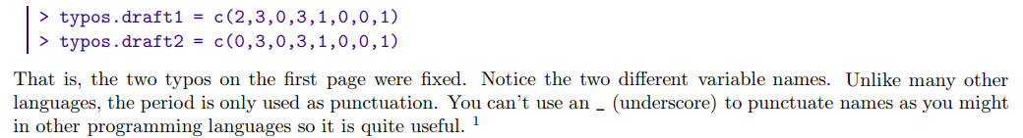
sum(vector)
mean(vector)
median(vector)
max(vector)
length(vector)

x[day : (day+4)]

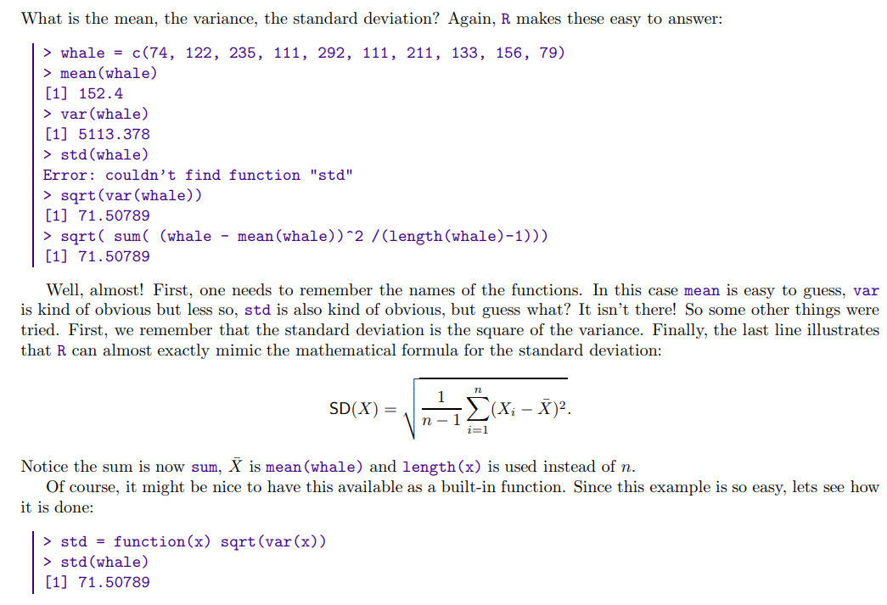
(above is same as sd(whale) )

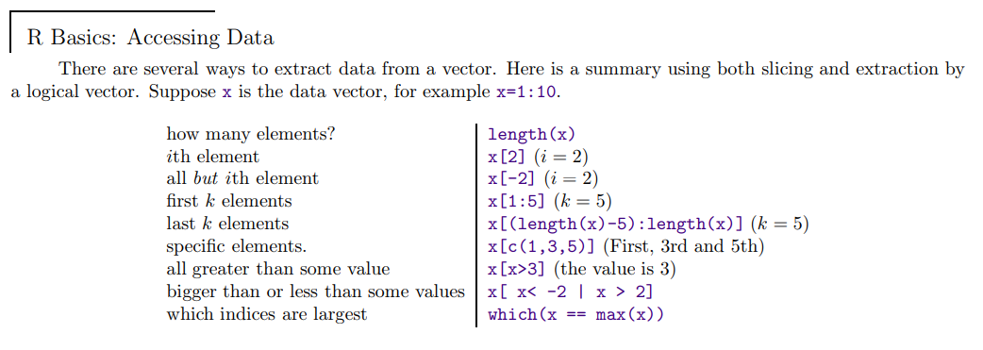
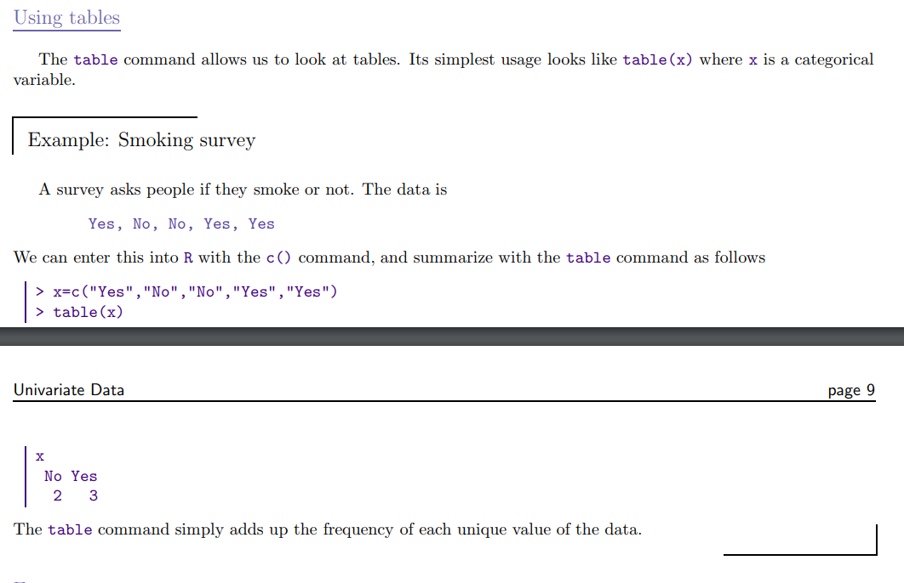
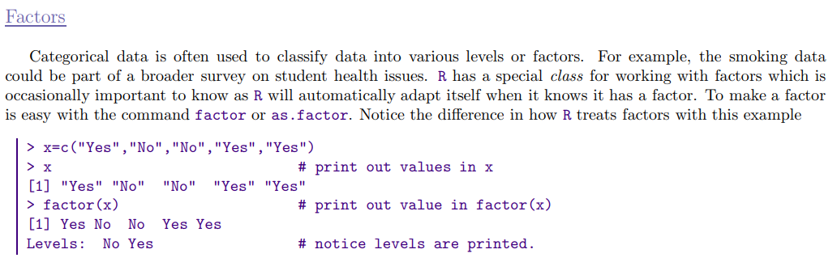
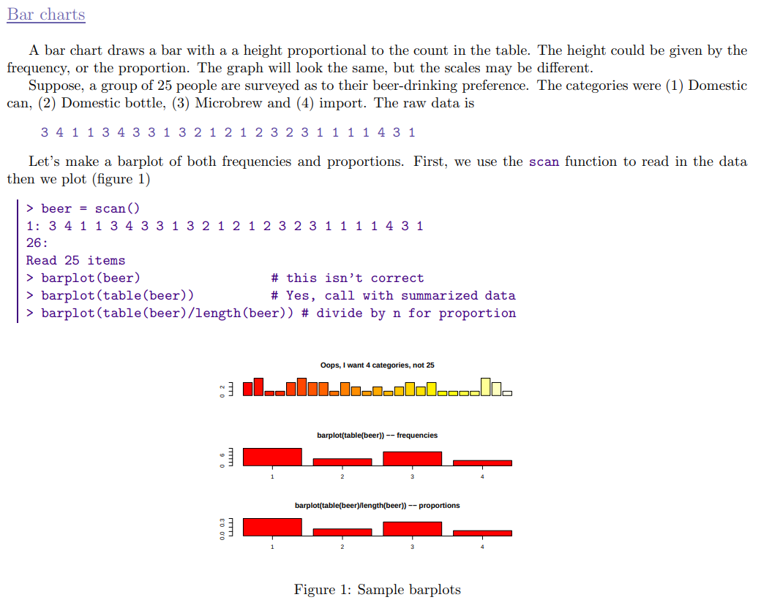
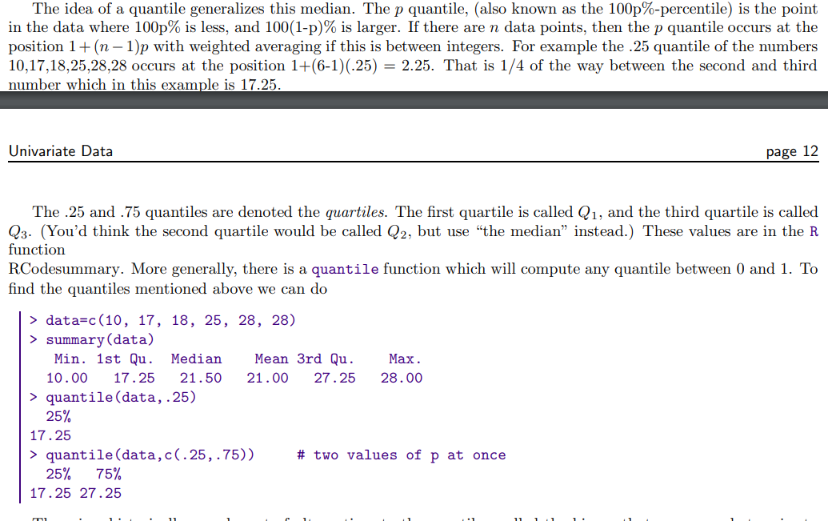

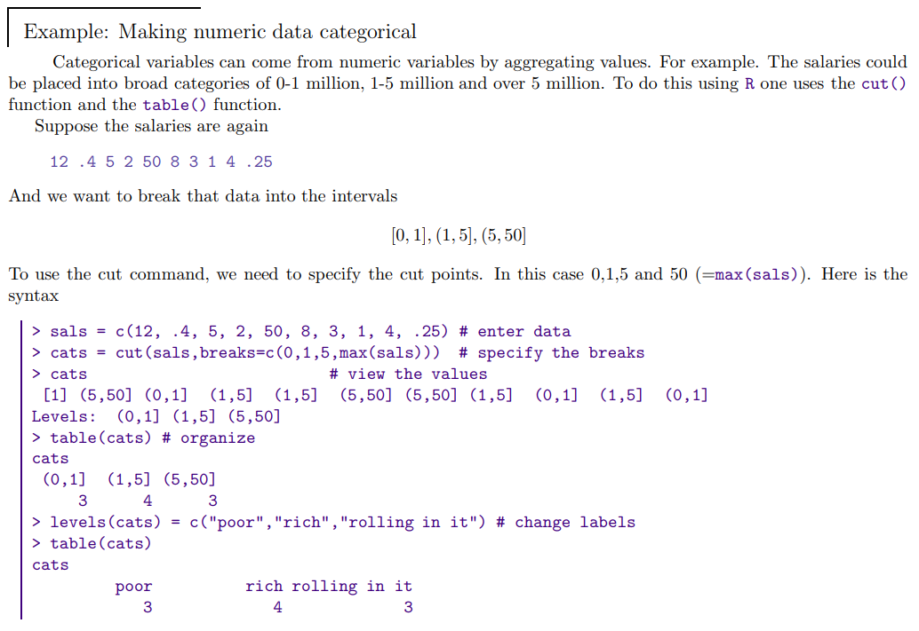

Bivariate data
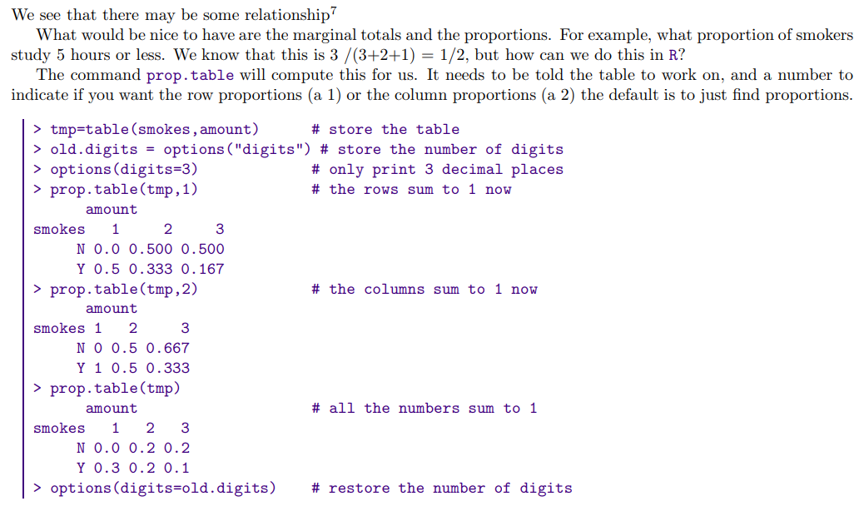

Linear Regression
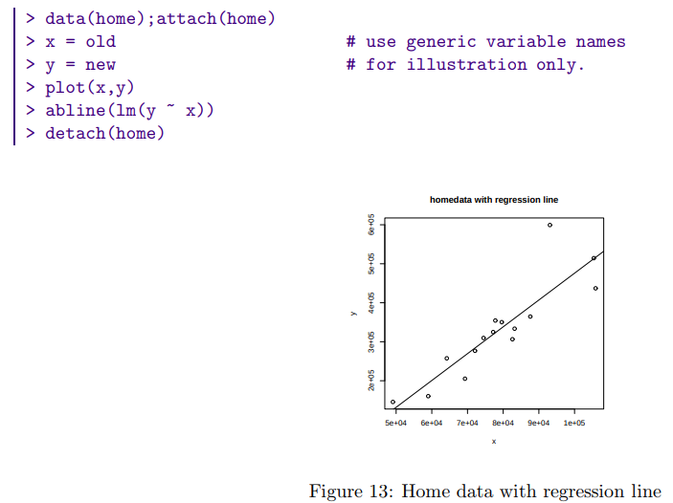
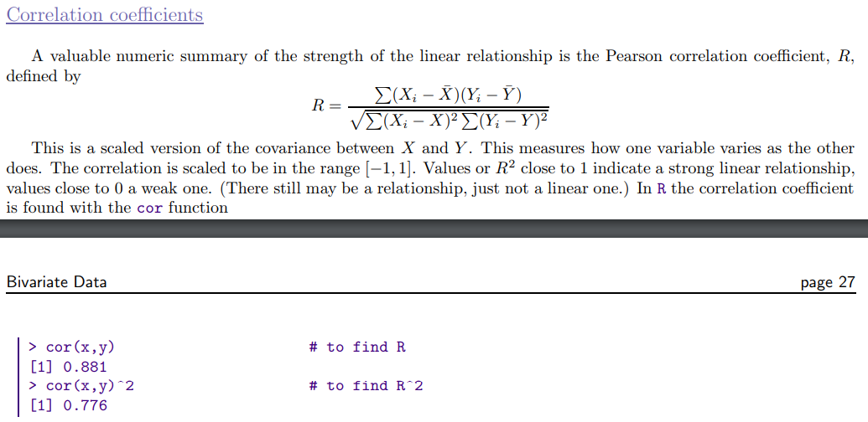

Data frames
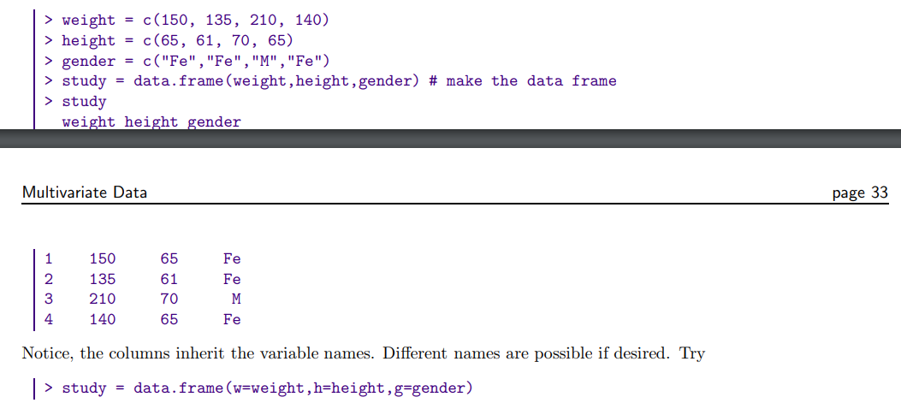

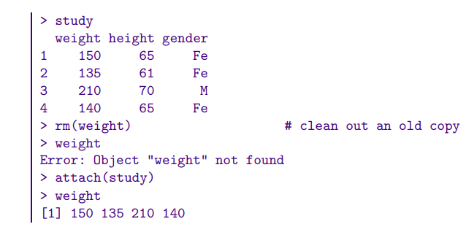
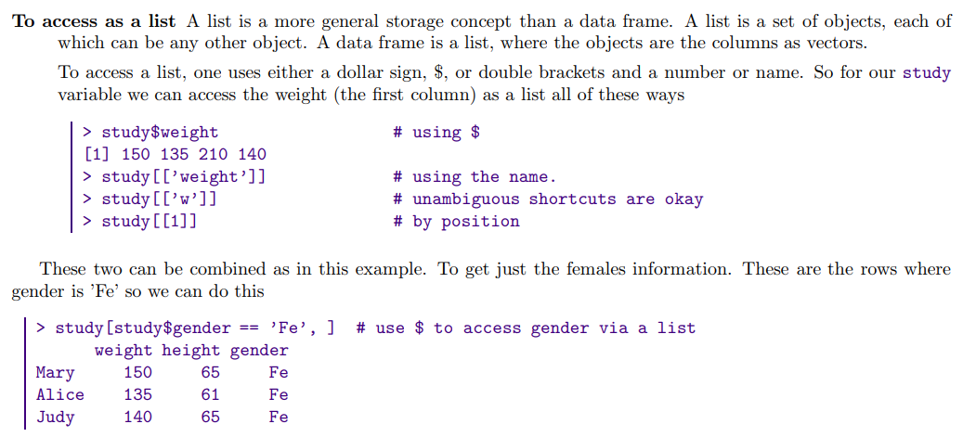

In probability theory and statistics, the chi-squared distribution (also chi-square or χ2-distribution) with k degrees of freedom is the distribution of a sum of the squares of k independent standard normal random variables.

