**Evaluating effect size distribution of different regenerative agriculture practices across soil, climatic and topographical factors**

**Environmental factors**

* Climatic / bio climatic variables
* Topographical variables
* Soil properties

Climatic / bioclimatic variables

Topographical variables

Soil

properties

Farmer

management

**Figure:** Factors affecting effect size of the different regenerative agriculture practices

**Introduction**

More than 70% of the Earth’s land area which was initially covered by forests and wildlands have been transformed to various use by human being1. A large fraction of such use is devoted to agriculture occupying about 40% of the world land area. However, food production results in a huge environmental footprint with one-third of soils in the world being degraded and fertile soil being lost at the rate of 24 billion tons of topsoil every year2 along with about 34% of global greenhouse gas emissions3. Meanwhile, it is projected that food production would have to increase in the future to satisfy both the need of the global growing population and the increase in per capita demand4. In this context, sustainable pathways that would contribute to land restoration, biodiversity protection and GHG mitigation are more and more emphasized.

Regenerative agriculture (RA) has emerged as an alternative farming strategy seeking to achieve global food security by reducing the use of external inputs, improving soil health and minimize environmental damage5-7. The RA involves different practices (RAP) such as reduced or not tillage (NT), cover crop (CC), perennials and agroforestry (AF), organic farming (OF), intercropping (IN) as well as crop-livestock integration6,8. Previous reviews reported potential beneﬁts of different RAP for increasing soil organic carbon (SOC) and soil water uptake as well as GHG mitigation climate mitigation 6,8,9. However, yield outcomes through the implementation of RAP are subject to many controverses.

Some previous studies showed that RAP could potentially result in increasing yields while others reported a neutral or declining trends10,11 after implementation. While evaluating the outcome of different crops and environmental variables on NT as compared to CT yields, Pittelkow, et al. 12 showed that NT impact on yield is dependent upon the region with increasing trend in moisture-limited arid regions while declining patterns are observed in tropical regions with maize-based systems. A global meta-analysis based on740 paired measurements from 90 peer-reviewed articles showed that NT increased barley yield by 49% especially in dry climate13. In a drought period, about 60% higher maize yield was observed under NT management compared to conventional tillage14. However, contrary trends are also reported with the application of crop rotation, residue management, and no-tillage having no effect on yield stability relative to CT15. The same study showed that organic farming had 15% lower yield compared to CT.

Under AF management, findings showed that yield either increased by 7 – 16 % in crop yield especially in subtropical and tropical zones16, or reduced by 2.6 % every year in European areas depending on the density and age of the trees17. While about 14% yield increase is reported under CC especially in coarse soil texture and dryland areas along with the use of leguminous cover crops18, about 3% yield reductions were observed especially for cash crops in temperate soils19,20. Findings related to the analysis of the benefits and management of IN practices revealed that average grain yields were 22.3% higher in intercropped systems compared to monocultures of the same crops21 while other reported 39% reduction in primary maize yield compared to pure maize yield22. In context whereby by is no any significant increase or decrease, some studies reported that yields could be sustained for longtime under RAP especially for degraded soils23.

The discrepancy of yield outcomes under different RAP showed that various factors interplay to determine the magnitude and direction of crop yields for farmers. These factors involved climatic variables such as temperature and precipitation, soils properties such as texture, pH, soil, organic carbon level as well as topographic features such as

**INCREASE**

* **Rehberger**

During the 2012 drought, farmers in western Iowa who practiced no-till farming experienced higher corn yields than conventional tillage farmers (6.2 Mg/ha in compared with 2.5 Mg/ha), suggesting that soil management practices can improve yield stability (Al-Kaisi et al 2013). **Khangura**

The literature suggests that agricultural practices such as minimum tillage, residue retention, and cover cropping can improve soil carbon, crop yield, and **soil health in certain climatic zones and soil types.**

Increasing SOC up to 2% has been shown to increase yield in maize and wheat, and may reduce reliance on N fertiliser [28,29]

When compared to conventional tillage, NT reduced the global warming potential at acidic soil sites, increased barley yield by 49%, and showed potential to reduce greenhouse gas emissions (GHG) in dry climates, according to a meta-analysis of 740 paired measurements from 90 peer-reviewed articles [49].

Using data from 678 peer-reviewed publications, a global meta-analysis assessed the impact of various crop and environmental variables on NT relative to CT yields. The study found that the impact of NT on yield varied depending on the region, with yield declining in tropical regions with maize-based systems and increasing in moisture-limited arid regions [53].

A long-term tillage experiment demonstrated that, in a semi-arid subtropical environment, it would take at least 20 years to achieve the full soil beneﬁts (physical, chemical, and biological) of an NT system [54]. When NT was used instead of traditional tillage, yield increased by 47 and 28%, respectively, with and without the use of N and Zn fertilisers.

* However, yield improvement in corn and soybean has been reported after cover crops in a dry year [95].
* Similarly, increased yields of main crops after summer cover crops were attributed to reduced compaction and soil temperature, and increased soil aggregate stability, carbon, and nitrogen concentration and soil water content [96].
* A few studies have found that when no tillage was combined with stubble retention, crop yield and SOC stocks increased signiﬁcantly [117,118]

**DECREASE**

**in Rehberger**

However, in contrast, a meta-analysis on the yield stability of conventional, organic, and conservation agriculture revealed that the application of crop rotation, residue management, and no-tillage had no effect on yield stability (absolute or relative) compared to conventional till, and indicated that organically managed ﬁelds had a 15% lower relative yield stability (yield stability per unit yield produced) compared to conventional ﬁelds (Knapp and van der Heijden 2018).

* **Khangura**

Using data from 678 peer-reviewed publications, a global meta-analysis assessed the impact of various crop and environmental variables on NT relative to CT yields. The study found that the impact of NT on yield varied depending on the region, with yield declining in tropical regions with maize-based systems and increasing in moisture-limited arid regions [53].

* Conversely, a 10% reduction in wheat yield has been reported following cover cropping [93].

**STABLE**

**in Rehberger**

It might not increase or decrease but we can sustain => some focus on yields that can be sustained long-term, particularly for lands that have seen productivity decline (Lal 2020, Rhodes 2017 in Rehberger)

**NEUTRAL**

**in Rehberger**

Neutral impact => while having a net neutral effect on crop yield (although crop yield response was highly variable and context dependent) (Tamburini et al 2020 in Rehberger).

However, in contrast, a meta-analysis on the yield stability of conventional, organic, and conservation agriculture revealed that the application of crop rotation, residue management, and no-tillage had no effect on yield stability (absolute or relative) compared to conventional till, and indicated that organically managed ﬁelds had a 15% lower relative yield stability (yield stability per unit yield produced) compared to conventional ﬁelds (Knapp and van der Heijden 2018).

**Khangura**

In contrast, from a study of historical wheat yield patterns under NT and CT, [50] concluded that the tillage system had no effect on wheat yield and that Australian wheat varieties were not adapted to the NT system.

**CONTEXT Yield increase or decrease?**

* The prevailing environmental conditions of a region have the greatest inﬂuence on carbon sequestration and, as a result, crop yields
* Recent global analysis of NT-induced changes in soil C and crop yield based on 260 and 1970 paired studies, respectively, revealed that compared to CT, conservation agriculture beneﬁts arid regions the most by achieving a win–win outcome of increased C sequestration and crop yield. In more humid areas, only SOC gains are likely to occur, with no effect on crop yield, whereas in some colder areas there will be a negative impact on both SOC and yield [55].
* Increased SOC can lead to a higher crop yield, which can be attributed to increased plant available water holding capacity and N availability, particularly in N-deﬁcient soils. While a critical SOC threshold of 2% is established for sustainable crop production in temperate regions and about 1% in tropical regions [60], it would be worthwhile to investigate the minimum critical SOC threshold for cereals and other rotational crops in Western Australia’s Mediterranean climate.

**RAP and yield outcomes? What are the controverses?**

* Give specific context based examples

NT-Tillage: increase SOC esp. with residue retention in a double-cropping system is

the most promising management strategy for increasing SOC stocks in croplands

SOC, Texture, water uptake………

**Here some advantages across litteratures**

* Identify potential optimal pathways for productions across different factors----------
* What is the optimal application conditions for a specific management ?

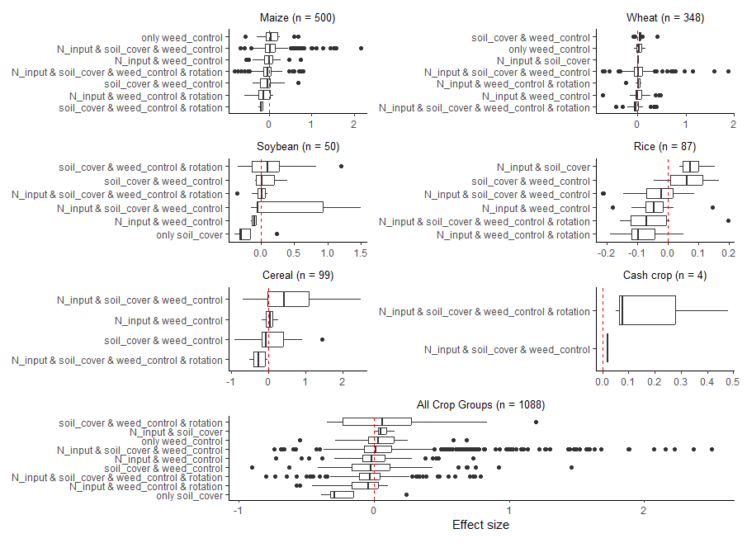

Plan

address crises of soil health, biodiversity, and food security to sustain food production

* Introduce
* regenerative agriculture
* Give key example
* Show that effect size globally var across those and suggest why …. Here report key factors affecting such change in ES pattern
* Show limitation that they reported just for too numbers of environmental variables
* Here we will consider a broader range of EV and see how they vary to able to present a synthesis for decision making

Why my study is necessary:

* Given the paucity of studies where the alleles and mutations involved in adaptation in natural populations have been identified, we suggest that it is not yet possible to reach a general consensus on the subject of the distribution of effect sizes.

Objective

* Our goal is to give a broad overview of how the major mechanisms of evolution, i.e. natural selection, genetic drift, mutation and migration might influence the distribution of effect sizes of adaptive substitutions. We hope to motivate further theoretical and empirical study into the many ways in which the genetics and ecology of natural populations and species can influence the effect sizes of adaptive substitutions, and to encourage a consideration of these factors in future work.
* Our review extends the idea expressed by Remington [[**18**](https://royalsocietypublishing.org/doi/10.1098/rspb.2015.3065#RSPB20153065C18)] that there is no ‘one size fits all’ expectation for the distribution of effect sizes, and examines a range of factors that are expected to influence the distribution of effect sizes for adaptive substitutions.
* This paper describes in more detail the different hereditary and **environmental** **factors** that….
* The effectiveness of AMF at aggregating soil can therefore depend on a range of factors, whose individual effects cannot always be disentangled. To date there are several narrative reviews addressing AMF and soil aggregation (e.g. Oades [1993](https://link.springer.com/article/10.1007/s11104-013-1899-2#ref-CR62); Rillig and Mummey [2006](https://link.springer.com/article/10.1007/s11104-013-1899-2#ref-CR69); Six et al. [2004](https://link.springer.com/article/10.1007/s11104-013-1899-2#ref-CR75); Tisdall [1994](https://link.springer.com/article/10.1007/s11104-013-1899-2#ref-CR77)). Here we aim to quantitatively synthesize the importance of experimental settings and multiple biotic and abiotic factors for the effect of inoculation with AMF on soil macroaggregates.
* In general, adverse effects of accelerated soil acidification have been confirmed on soil compaction, the impedance of root growth, inhibition of micronutrients’ uptake, loss of N, and reduction of crop yield. Although NT has been widely reported to decrease the soil pH, divergent results have also been reported at different site-specific conditions. Thus, quantifying the effects, principal factors, and possible consequences of NT on soil acidification are crucial to understanding the pathway or/and mechanisms to sustaining agro-ecosystem services. Therefore, a global meta-analysis was conducted to understand: (i) The response of the soil pH and its variations among different conditions, (ii) the relative importance of factors affecting changes in soil pH, and (iii) relationships between soil pH and soil properties under NT.

**Results**

* **Final output: Dashboard of the ES distribution across the factors for each Regenerative Agriculture practice**

Shackelford, G.E., Kelsey, R. and Dicks, L.V., 2019. Effects of cover crops on multiple ecosystem services: Ten meta-analyses of data from arable farmland in California and the Mediterranean. *Land use policy*, *88*, p.104204.

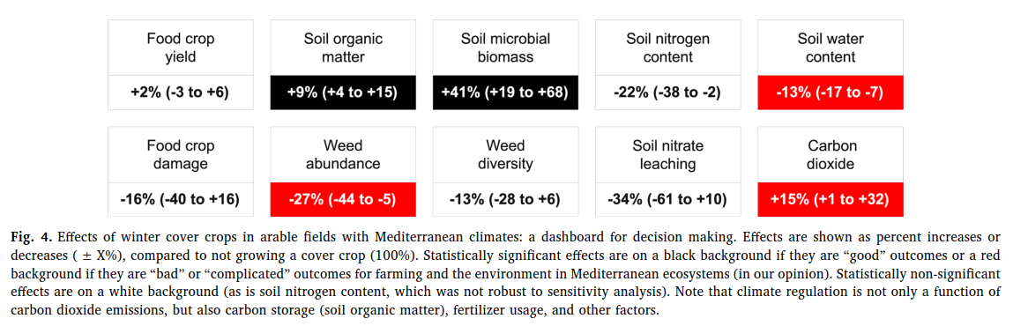

**References**

1 UNCCD. Summary for Decision Makers (Global Land Outlook) 2nd edn. (2022).

2 Bakker, H. *The world food crisis: Food security in comparative perspective*. (Canadian Scholars Press, 1990).

3 Crippa, M. *et al.* Food systems are responsible for a third of global anthropogenic GHG emissions. *Nature Food* **2**, 198-209 (2021).

4 Bodirsky, B. L. *et al.* Global food demand scenarios for the 21 st century. *PloS one* **10**, e0139201 (2015).

5 Newton, P., Civita, N., Frankel-Goldwater, L., Bartel, K. & Johns, C. What is regenerative agriculture? A review of scholar and practitioner definitions based on processes and outcomes. *Frontiers in Sustainable Food Systems* **4**, 577723 (2020).

6 Rehberger, E., West, P. C., Spillane, C. & McKeown, P. C. What climate and environmental benefits of regenerative agriculture practices? an evidence review. *Environmental Research Communications* **5**, 052001 (2023).

7 O’Donoghue, T., Minasny, B. & McBratney, A. Digital Regenerative Agriculture. *npj Sustainable Agriculture* **2**, 5 (2024).

8 Khangura, R., Ferris, D., Wagg, C. & Bowyer, J. Regenerative agriculture—A literature review on the practices and mechanisms used to improve soil health. *Sustainability* **15**, 2338 (2023).

9 Haddaway, N. R. *et al.* How does tillage intensity affect soil organic carbon? A systematic review. *Environmental Evidence* **6**, 1-48 (2017).

10 Giller, K. E., Hijbeek, R., Andersson, J. A. & Sumberg, J. Regenerative agriculture: an agronomic perspective. *Outlook on agriculture* **50**, 13-25 (2021).

11 Ranganathan, J., Waite, R., Searchinger, T. & Zionts, J. Regenerative agriculture: Good for soil health, but limited potential to mitigate climate change. *World Resources Institute: Washington, DC, USA* (2020).

12 Pittelkow, C. M. *et al.* Productivity limits and potentials of the principles of conservation agriculture. *Nature* **517**, 365-368 (2015).

13 Huang, Y. *et al.* Greenhouse gas emissions and crop yield in no-tillage systems: A meta-analysis. *Agriculture, Ecosystems & Environment* **268**, 144-153 (2018).

14 Al‐Kaisi, M. M. & Lal, R. Aligning science and policy of regenerative agriculture. *Soil Science Society of America Journal* **84**, 1808-1820 (2020).

15 Knapp, S. & van der Heijden, M. G. A global meta-analysis of yield stability in organic and conservation agriculture. *Nature communications* **9**, 3632 (2018).

16 Baier, C., Gross, A., Thevs, N. & Glaser, B. Effects of agroforestry on grain yield of maize (Zea mays L.)—A global meta-analysis. *Frontiers in Sustainable Food Systems* **7**, 1167686 (2023).

17 Ivezić, V., Yu, Y. & Werf, W. v. d. Crop yields in European agroforestry systems: a meta-analysis. *Frontiers in sustainable food systems* **5**, 606631 (2021).

18 Peng, Y., Wang, L., Jacinthe, P.-A. & Ren, W. Global synthesis of cover crop impacts on main crop yield. *Field Crops Research* **310**, 109343 (2024).

19 Clark, A. J., Decker, A. M., Meisinger, J. J. & McIntosh, M. S. Kill date of vetch, rye, and a vetch—rye mixture: II. Soil moisture and corn yield. *Agronomy Journal* **89**, 434-441 (1997).

20 Thorup-Kristensen, K., Magid, J. & Jensen, L. S. Catch crops and green manures as biological tools in nitrogen management in temperate zones. (2003).

21 Li, X.-F. *et al.* Long-term increased grain yield and soil fertility from intercropping. *Nature Sustainability* **4**, 943-950 (2021).

22 Li, C. *et al.* Limited environmental and yield benefits of intercropping practices in smallholder fields: Evidence from multi-source data. *Field Crops Research* **299**, 108974 (2023).

23 Lal, R. Regenerative agriculture for food and climate. *Journal of soil and water conservation* **75**, 123A-124A (2020).