**Evaluating effect size distribution of different regenerative agriculture practices across soil, climatic and topographical factors**

**Ozias Hounkpatin, Johannes Piipponen, Matti Kummu**

# Introduction

More than 70% of the Earth’s land area which was initially covered by forests and wildlands have been transformed to various use by human being1. A large fraction of such use is devoted to agriculture occupying about 40% of the world land area. However, food production results in a huge environmental footprint with one-third of soils in the world being degraded and fertile soil being lost at the rate of 24 billion tons of topsoil every year2 along with about 34% of global greenhouse gas emissions3. Meanwhile, it is projected that food production would have to increase in the future to satisfy both the need of the global growing population and the increase in per capita demand4. In this context, sustainable pathways that would contribute to land restoration, biodiversity protection and GHG mitigation are more and more emphasized.

Regenerative agriculture (RA) has emerged as an alternative farming strategy seeking to achieve global food security by reducing the use of external inputs, improving soil health and minimize environmental damage5-7. The RA involves different practices (RAP) such as reduced or not tillage (NT), cover crop (CC), perennials and agroforestry (AF), organic farming (OF), intercropping (IN) as well as crop-livestock integration6,8. Previous reviews reported potential beneﬁts of different RAP for increasing soil organic carbon (SOC) and soil water uptake as well as GHG mitigation climate mitigation 6,8,9. However, yield outcomes through the implementation of RAP are subject to many controverses.

Some previous studies showed that RAP could potentially result in increasing yields while others reported a neutral or declining trends10,11 after implementation. While evaluating the outcome of different crops and environmental variables on NT as compared to conventional tillage (CT) yields, Pittelkow, et al. 12 showed that NT impact on yield is dependent upon the region with increasing trend in moisture-limited arid regions while declining patterns are observed in tropical regions with maize-based systems. A global meta-analysis based on740 paired measurements from 90 peer-reviewed articles showed that NT increased barley yield by 49% especially in dry climate13. In a drought period, about 60% higher maize yield was observed under NT management compared to CT14. However, contrary trends are also reported with the application of crop rotation, residue management, and no-tillage having no effect on yield stability relative to CT15. The same study showed that OF had 15% lower yield compared to CT.

Under AF management, findings showed that yield either increased by 7 – 16 % in crop yield especially in subtropical and tropical zones16, or reduced by 2.6 % every year in European areas depending on the density and age of the trees17. While about 14% yield increase is reported under CC especially in coarse soil texture and dryland areas along with the use of leguminous cover crops18, about 3% yield reductions observed especially for cash crops in temperate soils19,20. About 10% decrease in wheat yield was observed following cover cropping21. Findings related to the analysis of the benefits and management of IN practices revealed that average grain yields were 22.3% higher in intercropped systems compared to monocultures of the same crops22 while other reported 39% reduction in primary maize yield compared to pure maize yield23. In context whereby there is no significant increase or decrease, some studies reported that yields could be sustained for longtime under RAP especially for degraded soils24.

The discrepancy of yield outcomes under different RAP showed that various factors interplay to determine the magnitude and direction of crop yields for farmers. However, farmers, decision makers and other stakeholders might be interested in having a better understanding on how environmental factors affect crop yield changes under different RAP. Though previous meta-analytic studies have analyzed the variation in productivity between regenerative and CT managements, they mostly focus on a single type of RAP 23,25-28 without investigating their comparative potential across various factors and crop types at a global scale. To our knowledge, these studies do not include or have incomplete records of key soil variables such as bulk density, soil organic carbon, phosphorus, pH, texture, cation exchange capacity, or topographic variables such as elevation and slope or climate variable such as temperature, precipitation, crop growing degree days etc.

Consequently, these studies do not involve a large range of environmental factors except for some NT studies which considered alongside management variables such as soil texture 26,29 or aridity25 as well as climate zones or climatic variables such as temperature and precipitation. However, advances in remote sensing technology in recent decades have resulted in the existence of global earth data with the affordability and accessibility of satellite imagery which provide valuable information on environmental conditions and variables related to soil properties (e.g. soilGrids), climate, topography etc. which in turn are potential factors affecting crop yields30-32. Our current study is unique in that it focuses on different RAP and their influence on relative crop yields across climatic, topographic variables and additional soil properties beyond texture. Therefore, the objective of this paper was to take advantage of global earth and field experiment data to assess the distribution of RAP related relative yields among different conditions defined by environmental factors at a global scale.

# Materials and methods

# Data collection

Different global meta-analysis data from Xu et al.26, Jian et al.33, Pittelkow et al.25, Xia et al.34, Verret et al.35, Ding et al.36 and Felix et al.27 were considered in the present study. A preliminary quality check was carried out to remove duplicates studies as well as outliers based on the relative yield (relative yield > 2. 5 t/ha). A total of 10 232 comparisons between RAP and CT were derived from 758 publications covering 773 sites worldwide (Figure 1). After compiling the data, the crop types were classified into seven groups with the most cultivated crops in the world such as maize, wheat, soybean and rice considered separately. The remaining crops were categorized cereal, cash-crop and vegetable & fruits and others (see Table 1 in supplementary material). The compiled data cover the following RAP practices : NT, AF, CC and OF.

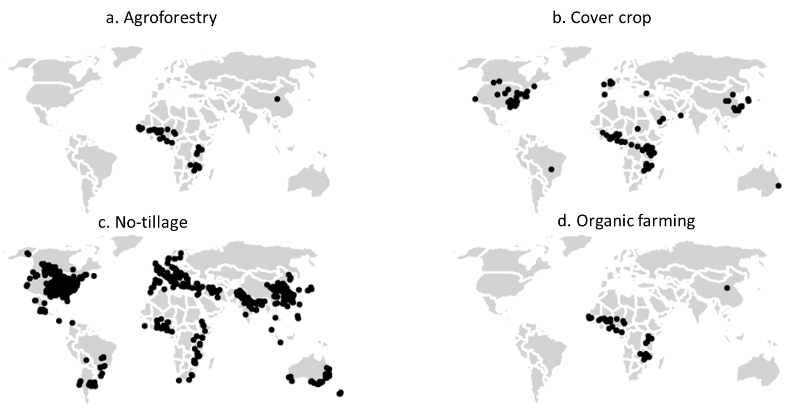



Figure 1: Global distribution of the study sites

# Environmental and management effect size moderators

The impact of the RAP on ES was assessed based on 3 environmental components: climate, soil properties and terrain. For each of the three components, a number of indicators was identiﬁed (Table 1).

Climate, soil properties and terrain variables has been documented to have a major impact on crop growth and food production37-40. As climate variables, precipitation and temperature are closely associated with crop growth and crop yield and affect soil moisture status which in turn determines whether water might be a limiting factor the crop phenological development. The aridity considered in this study as climate indicator is defined as the ratio of precipitation to potential evapotranspiration and

is a measure of moisture availability for crop growth. The global aridity index for the 1970–2000 period was obtained from the Consortium for Spatial Information (1 km)41. The Growing Degree (GDD) measures the heat accumulation over the growing season and is a measure of the relationship between temperature and plant development. The Growing degree days (GDD) used in this based was sourced from Ahvo, et al. 42.

Terrain attributes interact with weather to affect soil temperature and moisture43,44. Water stress occurs most likely in upslope positions with lower and higher variability in yields compared to lower slope positions45-47. Terrain indicators such as terrain and slope (1 km) were obtained via the platform provided by the global study of Amatulli, et al. 48. Additionally, the geomorphological landform grid (250 m) data produced by Iwahashi, et al. 49 was considered.

Soil properties determine the local environment for crop growth by affecting soil aeration, nutrient cycling and root growth50,51. For instance, soil texture affects the available water capacity in the root space while soil pH influences the availability of nutrients to plants and microbial activity52,53. Global soil properties such as soil texture (sand, silt, clay), bulk density (BD), soil organic carbon (SOC), pH were downloaded from the SoilGrids (250 m) platform 54. The global stock of soil Olsen phosphorus came from the global study carried out by McDowell et al.55

In addition, additional management variables such as cover crop (yes/no), N fertilizer (yes/no), weeding (yes/no) and rotation (yes/no) were considered for NT. Consequently, under each component, the distribution of the ES under NT was further analyzed for each of these management variables.

# Data analysis

The data analysis focused on the effect size (ES), i.e. the response ratios (RR) of crop yield to these management systems and was assessed by taking the natural logarithm calculated of RR following Luo, et al. 56 : RR = ln(XT/XC) where XT and XC are the yield value under treatment (NT, AG, CC, or OF) and control, respectively. Moderator analysis was conducted to determine the RAP effects ES. This analysis was carried out by grouping the metadata into the following categories:

* Crop groups. The previously defined crop groups were considered: maize, wheat, soybean and rice, cereal, cash-crop and vegetable & fruits and others.
* Bulk densities. Low values of BD describe permeable soils allowing plant to reach the nutrient and water easily while high values denote a compacted soil with high mechanical impedance resulting in limited roots growth. It was categorized into three different categories: low (< 1.2 kg/dm3) , moderate (1.2 kg/dm3 < BD < 1.47 kg/dm3), high (BD > 1.47 kg/dm3)57. cite
* pH. Three categories were considered: acidic soils (pH < 6.3,) neutral soils (6.3 < pH < 7.4) and alkaline soils (pH > 7.4). cite
* Phosphorus. The P distribution classes were low: P < 10.9 mg/kg, moderate: 10.9 mg/kg < P < 21.4 mg/kg and High : P > 21.4 mg/kg. cite
* Soil organic carbon. Three categories were considered: SOC < 5 g/kg, 5 g/kg < SOC < 10 g/kg and SOC > 10 g/kg. cite
* Soil texture: These textures were grouped into fine (clay, silty clay loam, clay loam, and sandy clay), medium (silt loam and loam), and coarse (sandy loam and sandy). Cite
* # 1: fine (clay, silty clay loam, clay loam, and sandy clay) : cl SiClLo ClLo SiCl SaCl SaClLo
* # 2: medium (silt loam and loam) Si SiLo Lo
* # 3: coarse (sandy loam and sandy) SaLo Sa LoSa
* Aridity. It was divided into five categories: Hyper-Arid (AI < 0.05), arid (0.05 < AI < 0.2), semi-arid (0.2 < AI < 0.5), sub-humid (0.5 < AI < 0.65) and humid (AI > 0.65). cite
* Growing degree days. Four classes were considered: unsuitable (GDD < 800°C/y), suitable (800°C/y < GDD < 2700°C/y), heat Stress (2700°C/y < GDD < 6000°C/y), high heat Stress (4000°C/y < GDD < 6000°C/y). cite

Using bootstrapping, which involves resampling the response ratio mean 1000 times, 95% confidence intervals were determined for each category. The effect size was deemed non-significant if the confidence interval was zero.

Table 1: Environmental variables (in bracket are abbreviations)

|  |  |  |  |
| --- | --- | --- | --- |
| Component | Indicators | Unit | Resolution |
| Soil properties | Soil texture | % | 250 m |
| pH |  | 250 m |
| soil organic carbon (SOC) | g/kg | 250 m |
| Soil Olsen phosphorus concentrations (phosphorus) | mg/kg | 1000 m |
| Bulk density (bd) | kg/dm³ | 250 m |
| Terrain | Slope | % | 0.0083° |
| Digital elevation model (dem) | m | 0.0083° |
| Geormorphological landform |  | 0.0083° |
| Climate | Growing degree days for maize (GDD_maize) | ° C | 0.0083° |
| Growing degree days for wheat (GDD_maize) | ° C | 0.0083° |
| Growing degree days for rice (GDD_maize) | ° C | 0.0083° |
| Growing degree days for soybean (GDD_maize) | ° C | 0.0083° |
| Aridity index (aridity) | °C/y | 0.0083° |

# Publication bias and sensitivity analysis

# The consideration of the variance for each study is usually required in meta-analysis for conducting using a funnel plot analysis. However, the majority of the studies did not provide the variance for such purpose. Therefore, the density plots of the different RAP were created to check the distribution of all individual effect sizes in the dataset to check potential publication bias 58,59. Moreover, a sensitivity analysis was carried out using the Jacknife approach to determine the robustness of the analysis60. Every study was given a distinct study ID during the Jacknife analysis process, and data from one study was removed from the database for every computation.

# Results

# Overview of the data base

Table 1: Summary statistics of the data used in the meta-analysis. AG: agroforestry, CC: cover crop, NT: no-tillage, OF: organic farming. Aridity index are presented as mean (± standard deviation)

|  |  |  |  |  |  |  |  |  |  |  |  |
| --- | --- | --- | --- | --- | --- | --- | --- | --- | --- | --- | --- |
| Crop Group | n | Studies | AF | CC | NT | OF | Arid | Continental | Temperate | Tropical | Aridity index |
| Overall | 10 002 | 732 | 783 | 1 029 | 7 622 | 568 | 1 716 | 3 396 | 3 774 | 1 111 | 0.65 (± 0.30) |
| Maize | 3 620 | 314 | 496 | 486 | 2 467 | 171 | 271 | 1 437 | 1 237 | 674 | 0.69 (± 0.25) |
| Wheat | 2 416 | 271 |  | 87 | 2 111 | 218 | 727 | 664 | 987 | 38 | 0.54 (± 0.29) |
| Rice | 486 | 48 |  | 53 | 428 | 5 | 27 | 14 | 338 | 103 | 0.96 (± 0.35) |
| Soybean | 937 | 121 |  | 20 | 899 | 18 | 38 | 561 | 325 | 13 | 0.79 (± 0.21) |
| Cereal | 1 203 | 136 | 169 | 7 | 942 | 85 | 354 | 507 | 313 | 29 | 0.54 (± 0.30) |
| Cash crop | 320 | 37 | 22 | 96 | 198 | 4 | 49 |  | 263 | 8 | 0.78 (± 0.30) |
| Vegetables, fruits and others | 1 020 | 120 | 96 | 280 | 577 | 67 | 250 | 213 | 311 | 246 | 0.58 (± 0.31) |
|  |  |  |  |  |  |  |  |  |  |  |  |

# Overall effect size by regenerative agriculture practices, crop groups, soil properties,

# terrain and climatic variables

# 

Figure 2: Distribution of effect size between regenerative agriculture practices, crop groups, soil properties, terrain, and climatic variables (RAP: Regenerative agriculture practices, P: Phosphorus, BD: bulk density, DEM: digital elevation model, GDD: growing degree days)**.** The symbols used in the figure include dots with error bars, representing the overall mean effect size values ±95% confidence intervals. Categories whose 95% confidence intervals do not include 0 (represented by the vertical red lines) have significant differences between regenerative agriculture practices and controls

# Effect size distribution across climate variables for different regenerative agriculture

# practices

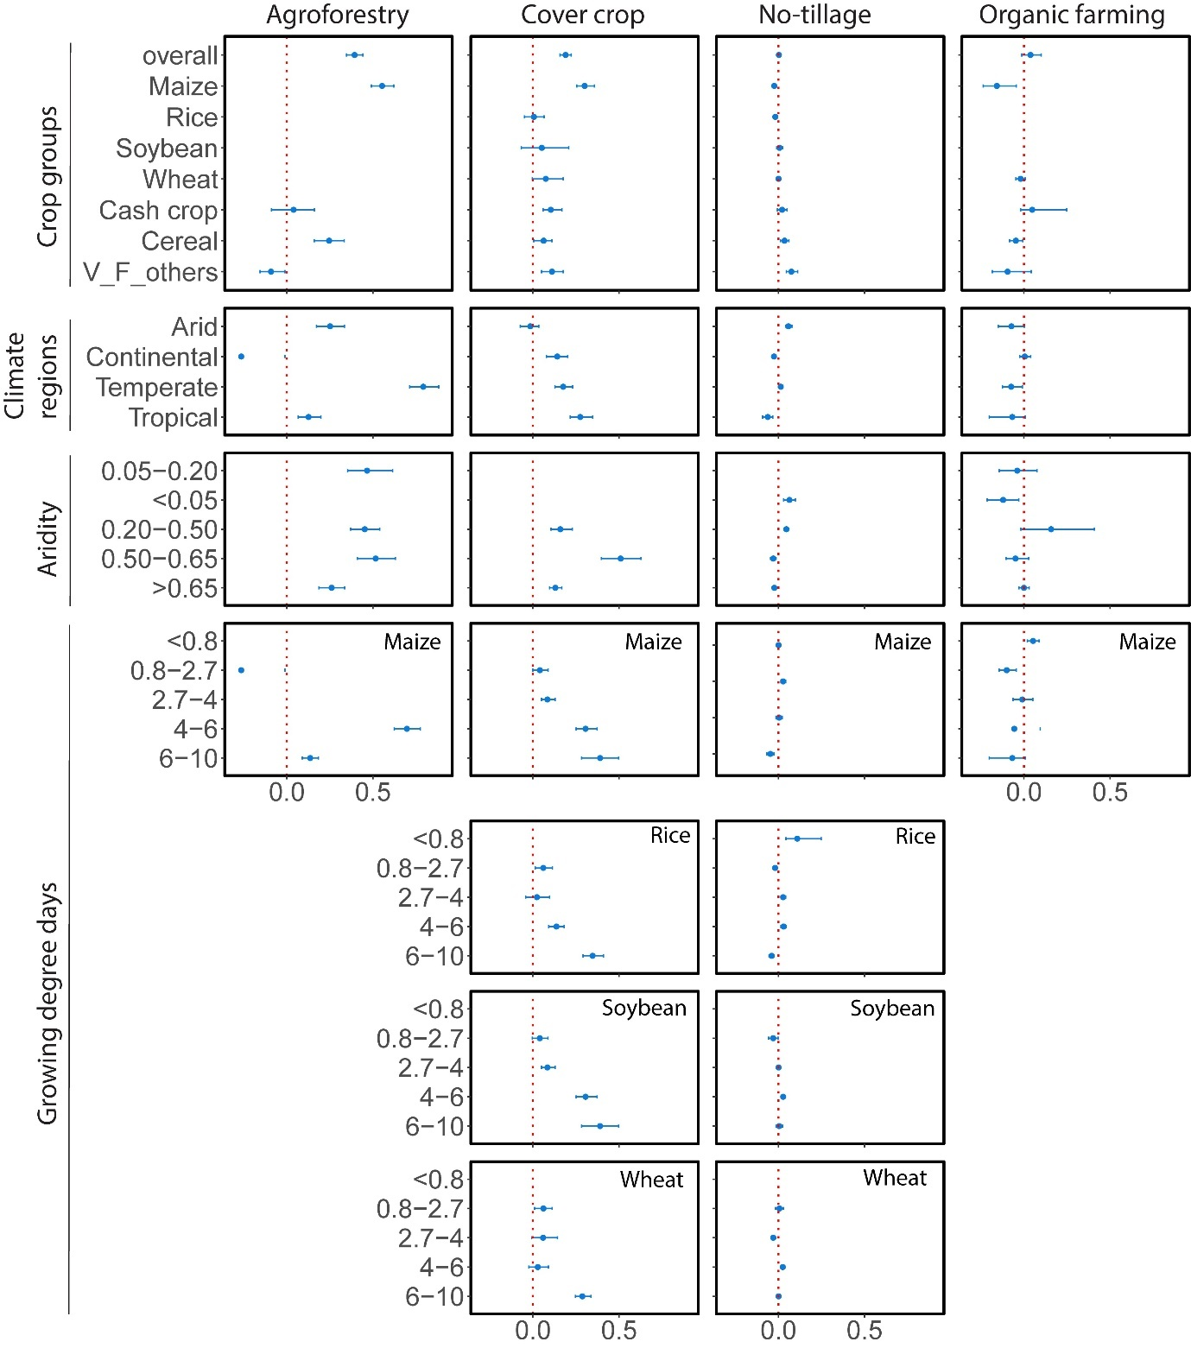

Figure 3: Distribution of effect size across crop groups and climatic variables for different between regenerative agriculture practices. The symbols used in the figure include dots with error bars, representing the overall mean effect size values ±95% confidence intervals. Categories whose 95% confidence intervals do not include 0 (represented by the vertical red lines) have significant differences between regenerative agriculture practices and controls.

Figure 4: Distribution of effect size across soil properties and terrain for different between regenerative agriculture practices. P: Phosphorus, BD: bulk density, DEM: digital elevation model, GDD: growing degree days)**.** The symbols used in the figure include dots with error bars, representing the overall mean effect size values ±95% confidence intervals. Categories whose 95% confidence intervals do not include 0 (represented by the vertical red lines) have significant differences between regenerative agriculture practices and controls.

# Effect size distribution across different no-tillage management practices

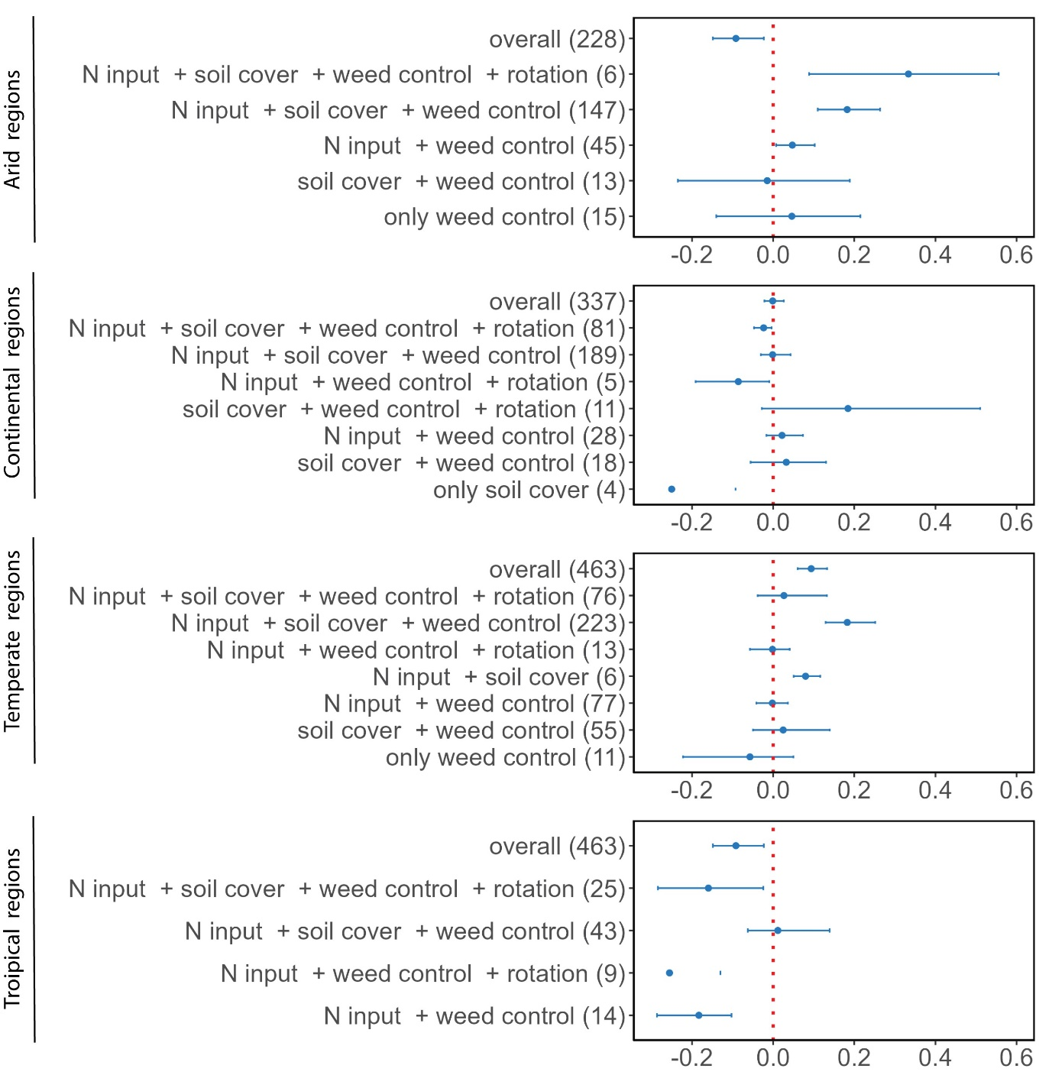

# Figure 5: Distribution of effect size across different no-tillage management practices. N: nitrogen.

# Publication bias and sensitivity analysis

B

A

**Figure 5:** The (A) density plot (B) the sensitivity analysis for each regenerative agriculture practice. The lower and higher 95% confidence intervals are provided as dashed red lines. AF: Agroforestry, CC: cover crop, NT: no-tillage, AF: organic farming (Figure axis labels have to be improved).

Supplementary material 1: Crop groups

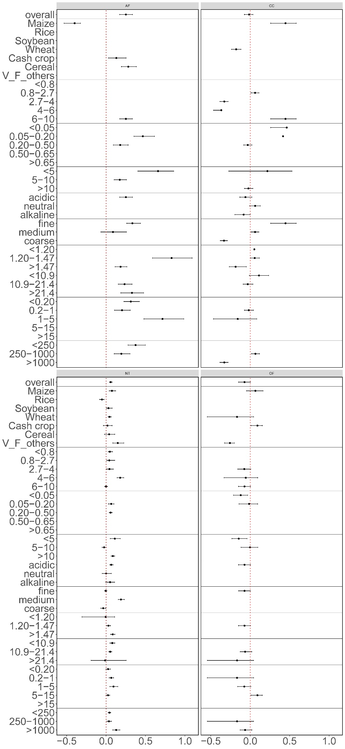

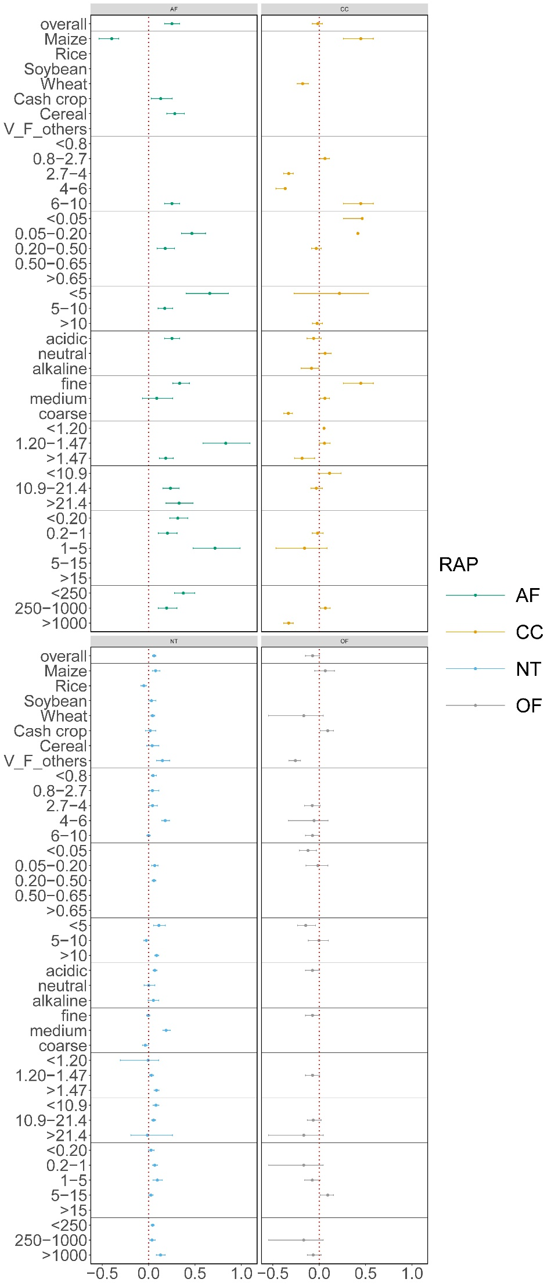

Supplementary material 2: Distribution of effect size for different management practices in the arid zone across different environmental moderators

Supplementary material 3: Distribution of effect size for different management practices in the continental zone across different environmental moderators

Supplementary material 4: Distribution of effect size for different management practices in the temperate zone across different environmental moderators

Supplementary material 5: Distribution of effect size for different management practices in the tropical zone across different environmental moderators

**References**

1 UNCCD. Summary for Decision Makers (Global Land Outlook) 2nd edn. (2022).

2 Bakker, H. *The world food crisis: Food security in comparative perspective*. (Canadian Scholars Press, 1990).

3 Crippa, M. *et al.* Food systems are responsible for a third of global anthropogenic GHG emissions. *Nature Food* **2**, 198-209 (2021).

4 Bodirsky, B. L. *et al.* Global food demand scenarios for the 21 st century. *PloS one* **10**, e0139201 (2015).

5 Newton, P., Civita, N., Frankel-Goldwater, L., Bartel, K. & Johns, C. What is regenerative agriculture? A review of scholar and practitioner definitions based on processes and outcomes. *Frontiers in Sustainable Food Systems* **4**, 577723 (2020).

6 Rehberger, E., West, P. C., Spillane, C. & McKeown, P. C. What climate and environmental benefits of regenerative agriculture practices? an evidence review. *Environmental Research Communications* **5**, 052001 (2023).

7 O’Donoghue, T., Minasny, B. & McBratney, A. Digital Regenerative Agriculture. *npj Sustainable Agriculture* **2**, 5 (2024).

8 Khangura, R., Ferris, D., Wagg, C. & Bowyer, J. Regenerative agriculture—A literature review on the practices and mechanisms used to improve soil health. *Sustainability* **15**, 2338 (2023).

9 Haddaway, N. R. *et al.* How does tillage intensity affect soil organic carbon? A systematic review. *Environmental Evidence* **6**, 1-48 (2017).

10 Giller, K. E., Hijbeek, R., Andersson, J. A. & Sumberg, J. Regenerative agriculture: an agronomic perspective. *Outlook on agriculture* **50**, 13-25 (2021).

11 Ranganathan, J., Waite, R., Searchinger, T. & Zionts, J. Regenerative agriculture: Good for soil health, but limited potential to mitigate climate change. *World Resources Institute: Washington, DC, USA* (2020).

12 Pittelkow, C. M. *et al.* Productivity limits and potentials of the principles of conservation agriculture. *Nature* **517**, 365-368 (2015).

13 Huang, Y. *et al.* Greenhouse gas emissions and crop yield in no-tillage systems: A meta-analysis. *Agriculture, Ecosystems & Environment* **268**, 144-153 (2018).

14 Al‐Kaisi, M. M. & Lal, R. Aligning science and policy of regenerative agriculture. *Soil Science Society of America Journal* **84**, 1808-1820 (2020).

15 Knapp, S. & van der Heijden, M. G. A global meta-analysis of yield stability in organic and conservation agriculture. *Nature communications* **9**, 3632 (2018).

16 Baier, C., Gross, A., Thevs, N. & Glaser, B. Effects of agroforestry on grain yield of maize (Zea mays L.)—A global meta-analysis. *Frontiers in Sustainable Food Systems* **7**, 1167686 (2023).

17 Ivezić, V., Yu, Y. & Werf, W. v. d. Crop yields in European agroforestry systems: a meta-analysis. *Frontiers in sustainable food systems* **5**, 606631 (2021).

18 Peng, Y., Wang, L., Jacinthe, P.-A. & Ren, W. Global synthesis of cover crop impacts on main crop yield. *Field Crops Research* **310**, 109343 (2024).

19 Clark, A. J., Decker, A. M., Meisinger, J. J. & McIntosh, M. S. Kill date of vetch, rye, and a vetch—rye mixture: II. Soil moisture and corn yield. *Agronomy Journal* **89**, 434-441 (1997).

20 Thorup-Kristensen, K., Magid, J. & Jensen, L. S. Catch crops and green manures as biological tools in nitrogen management in temperate zones. (2003).

21 Nielsen, D. C. *et al.* Cover crop effect on subsequent wheat yield in the central Great Plains. *Agronomy Journal* **108**, 243-256 (2016).

22 Li, X.-F. *et al.* Long-term increased grain yield and soil fertility from intercropping. *Nature Sustainability* **4**, 943-950 (2021).

23 Li, C. *et al.* Limited environmental and yield benefits of intercropping practices in smallholder fields: Evidence from multi-source data. *Field Crops Research* **299**, 108974 (2023).

24 Lal, R. Regenerative agriculture for food and climate. *Journal of soil and water conservation* **75**, 123A-124A (2020).

25 Pittelkow, C. M. *et al.* When does no-till yield more? A global meta-analysis. *Field crops research* **183**, 156-168 (2015).

26 Su, Y., Gabrielle, B. & Makowski, D. The impact of climate change on the productivity of conservation agriculture. *Nature Climate Change* **11**, 628-633 (2021).

27 Félix, G. F., Scholberg, J. M., Clermont-Dauphin, C., Cournac, L. & Tittonell, P. Enhancing agroecosystem productivity with woody perennials in semi-arid West Africa. A meta-analysis. *Agronomy for Sustainable Development* **38**, 57 (2018).

28 de la Cruz, V. Y. V., Cheng, W. & Tawaraya, K. Yield gap between organic and conventional farming systems across climate types and sub-types: A meta-analysis. *Agricultural Systems* **211**, 103732 (2023).

29 Su, Y., Gabrielle, B., Beillouin, D. & Makowski, D. (2021).

30 Dash, P. K. in *Remote Sensing of Soils* 357-370 (Elsevier, 2024).

31 Vance, T. C., Huang, T. & Butler, K. A. Big data in Earth science: Emerging practice and promise. *Science* **383**, eadh9607 (2024).

32 Kganyago, M., Adjorlolo, C., Mhangara, P. & Tsoeleng, L. Optical remote sensing of crop biophysical and biochemical parameters: An overview of advances in sensor technologies and machine learning algorithms for precision agriculture. *Computers and Electronics in Agriculture* **218**, 108730 (2024).

33 Jian, J., Du, X. & Stewart, R. D. A database for global soil health assessment. *Scientific Data* **7**, 16 (2020).

34 Xia, L., Lam, S. K., Yan, X. & Chen, D. How does recycling of livestock manure in agroecosystems affect crop productivity, reactive nitrogen losses, and soil carbon balance? *Environmental Science & Technology* **51**, 7450-7457 (2017).

35 Verret, V. *et al.* Can legume companion plants control weeds without decreasing crop yield? A meta-analysis. *Field Crops Research* **204**, 158-168 (2017).

36 Ding, W. *et al.* Improving yield and nitrogen use efficiency through alternative fertilization options for rice in China: A meta-analysis. *Field Crops Research* **227**, 11-18 (2018).

37 Kuradusenge, M. *et al.* Crop yield prediction using machine learning models: Case of Irish potato and maize. *Agriculture* **13**, 225 (2023).

38 Wang, Q., Huang, K., Liu, H. & Yu, Y. Factors affecting crop production water footprint: A review and meta-analysis. *Sustainable Production and Consumption* **36**, 207-216 (2023).

39 Grigorieva, E., Livenets, A. & Stelmakh, E. Adaptation of agriculture to climate change: A scoping review. *Climate* **11**, 202 (2023).

40 Baker, N. T. & Capel, P. D. Environmental factors that influence the location of crop agriculture in the conterminous United States. Report No. 2328-0328, (US Geological Survey, 2011).

41 Zomer, R. J., Xu, J. & Trabucco, A. Version 3 of the global aridity index and potential evapotranspiration database. *Scientific Data* **9**, 409 (2022).

42 Ahvo, A. *et al.* Agricultural input shocks affect crop yields more in the high-yielding areas of the world. *Nature food* **4**, 1037-1046 (2023).

43 Leuthold, S. J., Wendroth, O., Salmerón, M. & Poffenbarger, H. Weather-dependent relationships between topographic variables and yield of maize and soybean. *Field Crops Research* **276**, 108368 (2022).

44 Kumhálová, J., Kumhála, F., Matějková, Š. & Kroulík, M. The relationship between topography and yield in different weather conditions. *Precision Agriculture*, 606-616 (2011).

45 Leuthold, S. J., Salmeron, M., Wendroth, O. & Poffenbarger, H. Cover crops decrease maize yield variability in sloping landscapes through increased water during reproductive stages. *Field Crops Research* **265**, 108111 (2021).

46 Martinez-Feria, R. A. & Basso, B. Unstable crop yields reveal opportunities for site-specific adaptations to climate variability. *Scientific Reports* **10**, 2885 (2020).

47 Basso, B., Shuai, G., Zhang, J. & Robertson, G. P. Yield stability analysis reveals sources of large-scale nitrogen loss from the US Midwest. *Scientific Reports* **9**, 5774 (2019).

48 Amatulli, G. *et al.* A suite of global, cross-scale topographic variables for environmental and biodiversity modeling. *Scientific data* **5**, 1-15 (2018).

49 Iwahashi, J., Kamiya, I., Matsuoka, M. & Yamazaki, D. Global terrain classification using 280 m DEMs: segmentation, clustering, and reclassification. *Progress in Earth and Planetary Science* **5**, 1-31 (2018).

50 Sainju, U. M. & Alasinrin, S. Y. Changes in soil chemical properties and crop yields with long‐term cropping system and nitrogen fertilization. *Agrosystems, Geosciences & Environment* **3**, e20019 (2020).

51 Sainju, U. M., Liptzin, D. & Jabro, J. D. Relating soil physical properties to other soil properties and crop yields. *Scientific Reports* **12**, 22025 (2022).

52 Dewangan, S., Kumari, L., Minj, P., Kumari, J. & Sahu, R. The effects of soil ph on soil health and environmental sustainability: A review. *JETIR, Jun* (2023).

53 Zhang, S. *et al.* Effects of soil amendments on soil acidity and crop yields in acidic soils: A world-wide meta-analysis. *Journal of Environmental Management* **345**, 118531 (2023).

54 Poggio, L. *et al.* SoilGrids 2.0: producing soil information for the globe with quantified spatial uncertainty. *Soil* **7**, 217-240 (2021).

55 McDowell, R., Noble, A., Pletnyakov, P. & Haygarth, P. A Global Database of Soil Plant Available Phosphorus. *Scientific Data* **10**, 125 (2023).

56 Luo, Y., Hui, D. & Zhang, D. Elevated CO2 stimulates net accumulations of carbon and nitrogen in land ecosystems: A meta‐analysis. *Ecology* **87**, 53-63 (2006).

57 Chen, G. & Weil, R. R. Root growth and yield of maize as affected by soil compaction and cover crops. *Soil and Tillage Research* **117**, 17-27 (2011).

58 Joshi, D. R. *et al.* A global meta‐analysis of cover crop response on soil carbon storage within a corn production system. *Agronomy journal* **115**, 1543-1556 (2023).

59 Basche, A. & DeLonge, M. The impact of continuous living cover on soil hydrologic properties: A meta‐analysis. *Soil Science Society of America Journal* **81**, 1179-1190 (2017).

60 Philibert, A., Loyce, C. & Makowski, D. Assessment of the quality of meta-analysis in agronomy. *Agriculture, Ecosystems & Environment* **148**, 72-82 (2012).