Code Checkin/Check out procedure

# Procedure to Setup repository in local

1. Following git (bit bucket) repository is being used as code repository

<https://bitbucket.sdlc.toyota.com/projects/SPAD>

1. Open the same on a browser,
   1. click “Repositories” in the top menu and
   2. click on “SPAD – Accessory Management System (AMS) / AMSWeb as illustrated in the following screen shot

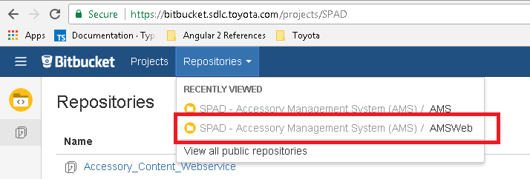

1. This will open the repository on screen.
2. Open the branch containing the latest code as illustrated in the following screen shot

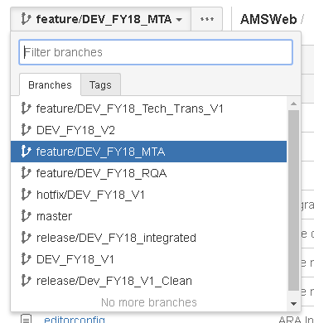

1. You will be able to find “Clone” option on the left margin. Click on it and copy the url provided buy the menu as illustrated in the following screen shot

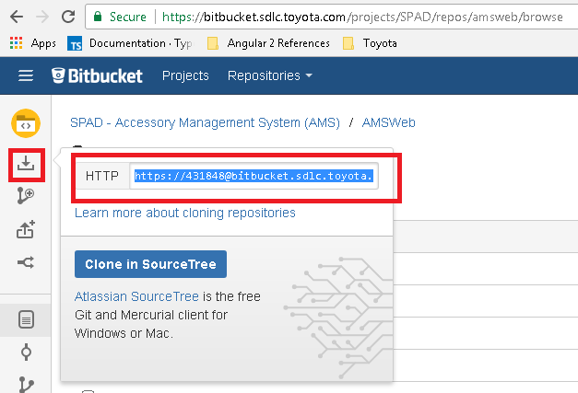

1. Open the local repository folder where you want to clone the git branch
   1. Right click
   2. Choose “Git Clone” from the branch to produce the following popup screen

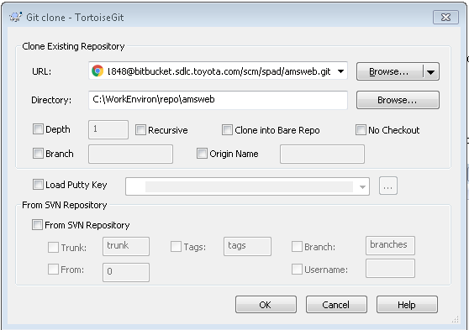

1. Copy branch name from Bit Bucket as illustrated in the following screen shot

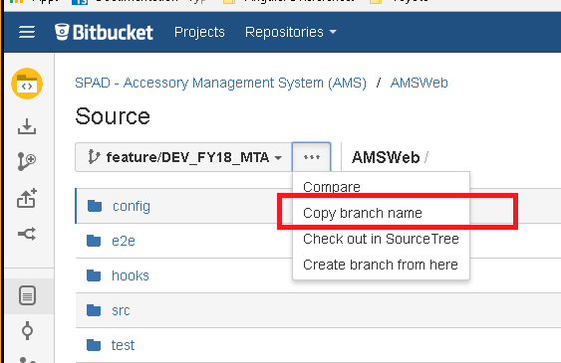

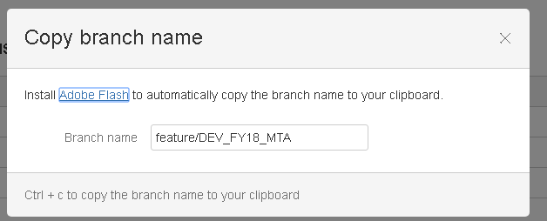

1. Copy and paste the branch name into the following location illustrated in the screen shot

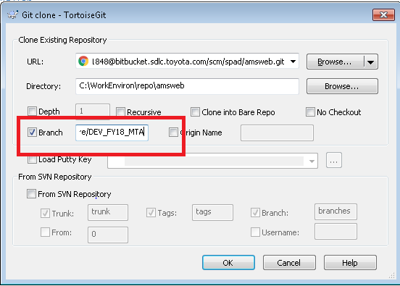

1. Click on ok and the check out will happen with screens similar to the following screen shots

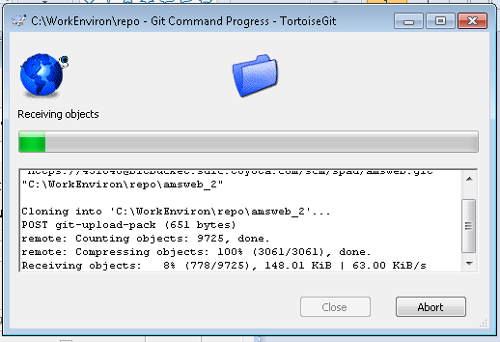

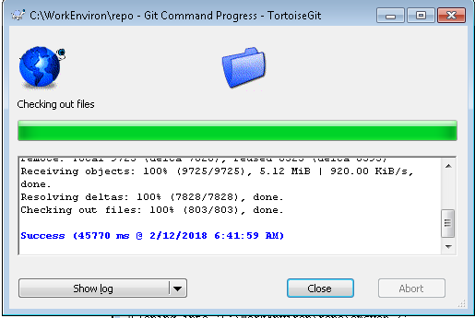

And you can find that the code repository has been created in your local. In my case it has been created as “**C:\WorkEnviron\repo\amsWeb**” as illustrated in the following screen shot

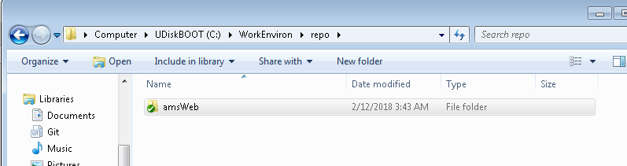

# Check Out Procedure

1. Right click the repository folder -> click Tortoise Git -> click Pull

In my case I am right clicking on the “amsWeb” folder in “C:\WorkEnviron\repo”

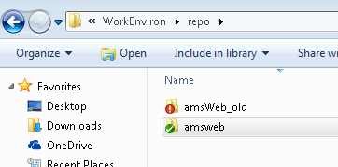

1. Click ok on the following screen

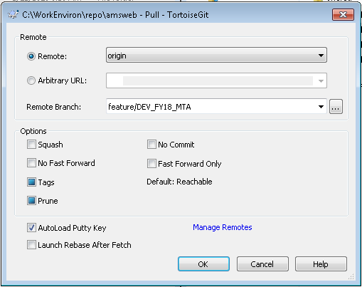

1. Provide user credentials if you are asked for. Once the checkout is complete you should be seeing a screen similar to the following.

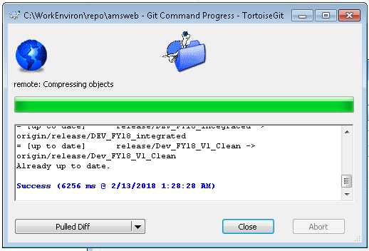

# Code Check in Procedure

1. Get the latest code from repo by doing the following

Right click your repo folder -> click on “TortoiseGit”-> and click on ”Pull”

1. Merge your dev code with the repo code. I use beyondCompare to merge dev code and local repo code as illustrated in the following screen shot

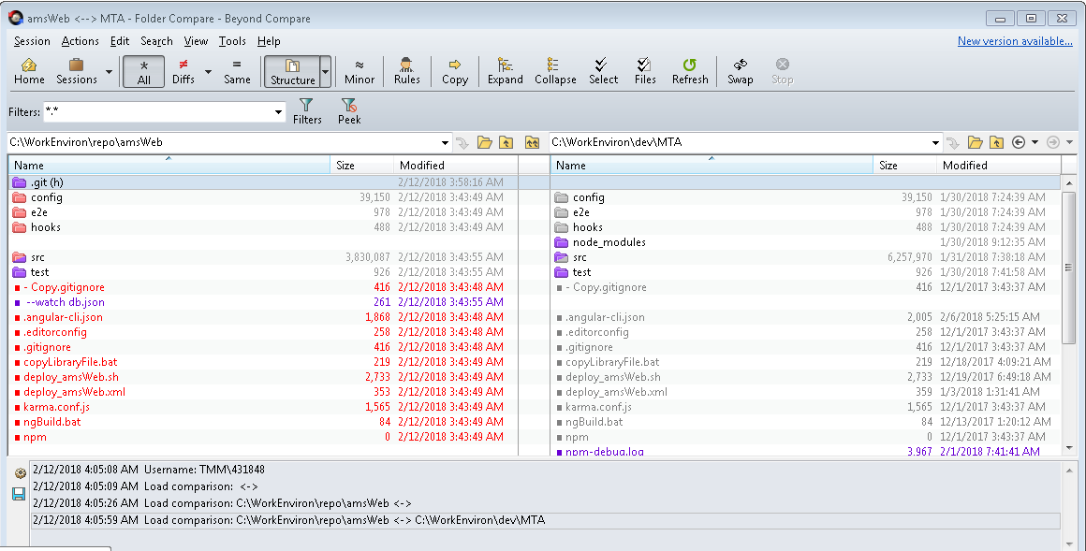

1. Once you are done merging, right click your repo folder again, “Git Commit -> branch name” . Check if the branch name is the name of the branch you pulled out the code from.

