**T.C. Maltepe University**

**Faculty of Engineering and Natural Sciences**

**Software Engineering Department**

**Dietician Mobil App**

**SE 373 01 Mobile Programming**

**170706002 – Özkan Parlakkılıç**

**Project Advisor: Prof. Dr. Oruç Raif ÖNVURAL**

**1. Detailed Problem Definition**

Let me start by talking about how I approach the problems in the project and how I create solutions.

* Validation Rules :

Validation problems are a classic problem that happens to every programmer. In my project, I encountered this problem while checking the inputs. I solved the problem by checking whether the inputs are empty or not with my function called checkForFields (a little different in the email).

* User Actions :

The user must be able to successfully register in the system, log in and ask questions.

**2. Detailed System Arthitecture**

**2.1 Input Output Diagram**

|  |  |  |
| --- | --- | --- |
| **Modül** | **Input** | **Output** |
| Login | Email , Password | Dashboard |
| Register | Fullname,Email , Password | Save Database |
| User Dashboard | Send Question, Get Program | List of Program |
| Dietician Dashboard | Answer Question | List of Questions |

**3. Database Design**

Four Collection :

* Dieticians

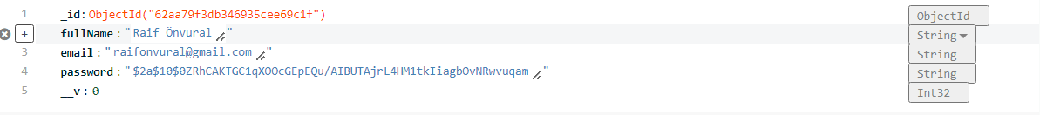

* Users

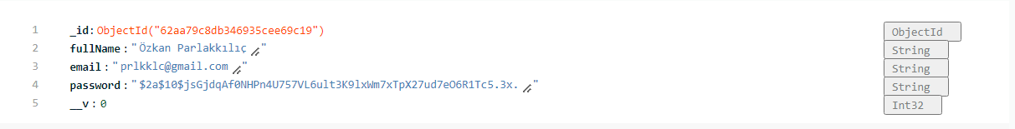

* Programs

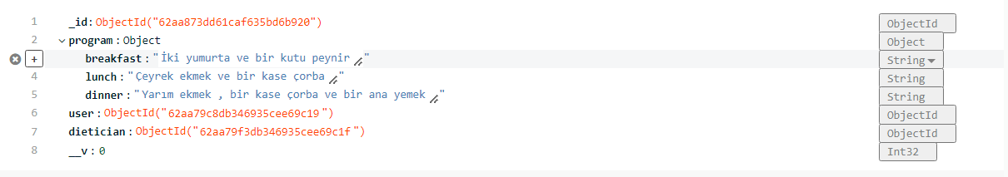

* Questions



**4. Output Screens**

Start Page

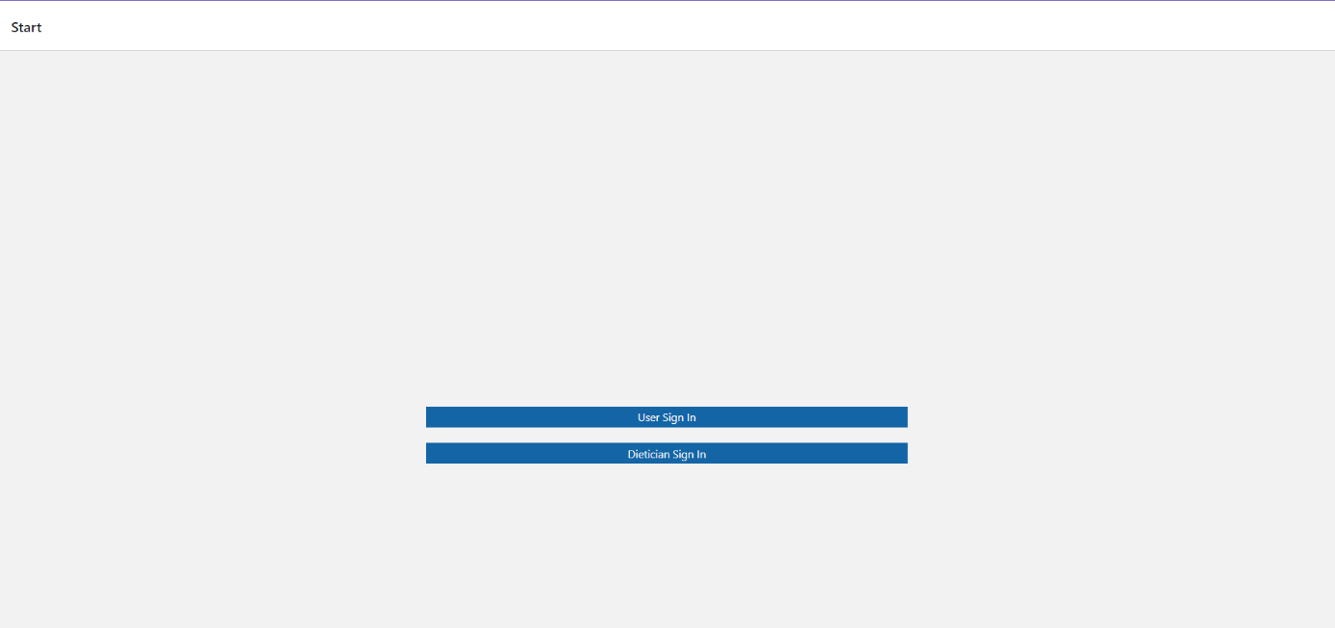

User Sign In

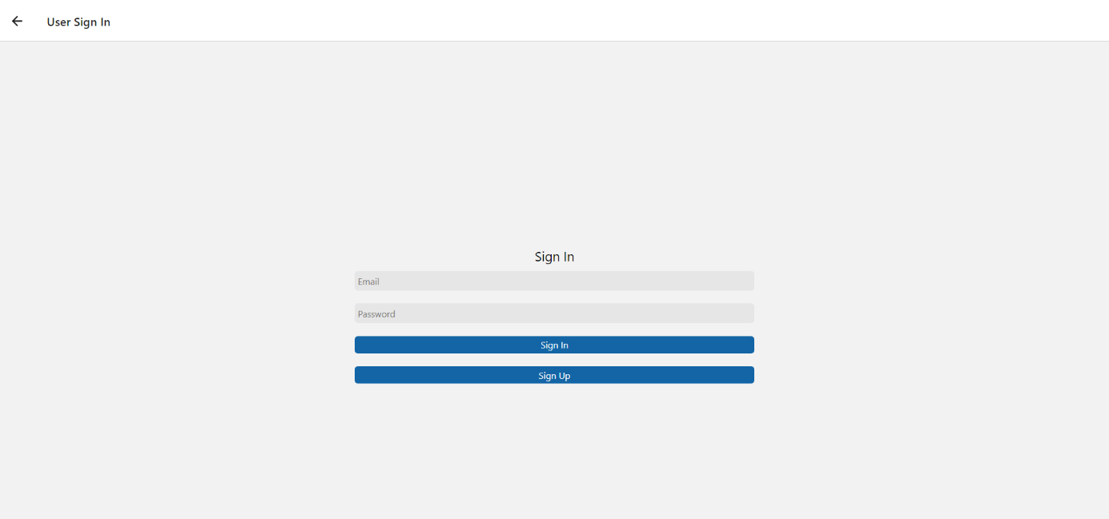

User Sign Up

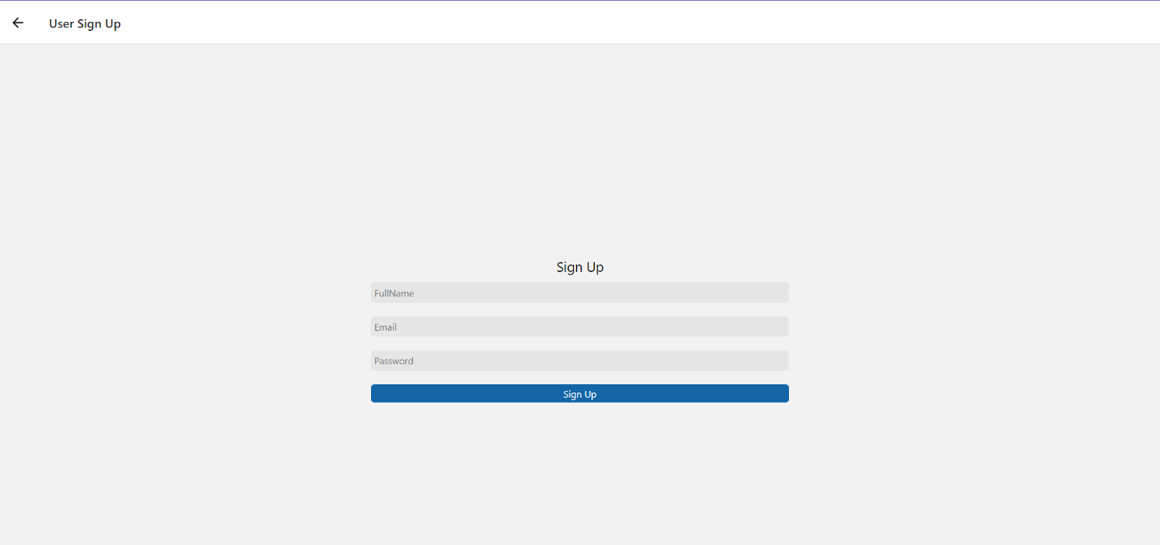

User Dashboard

metin içeren bir resim

Açıklama otomatik olarak oluşturuldu

User Program

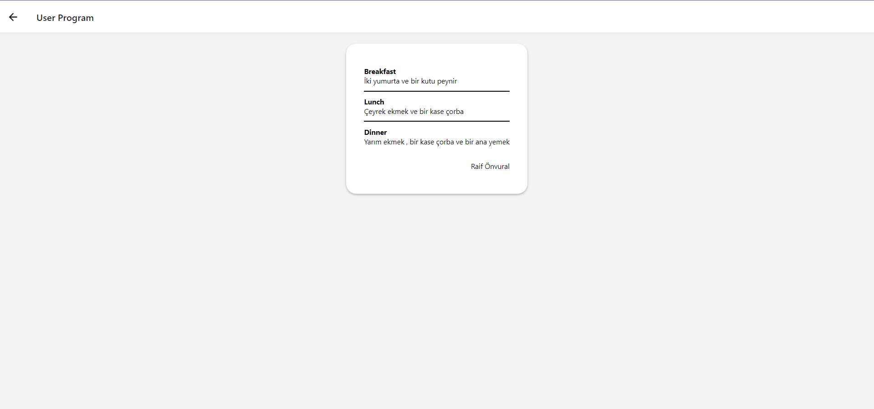

Dietician Sign In

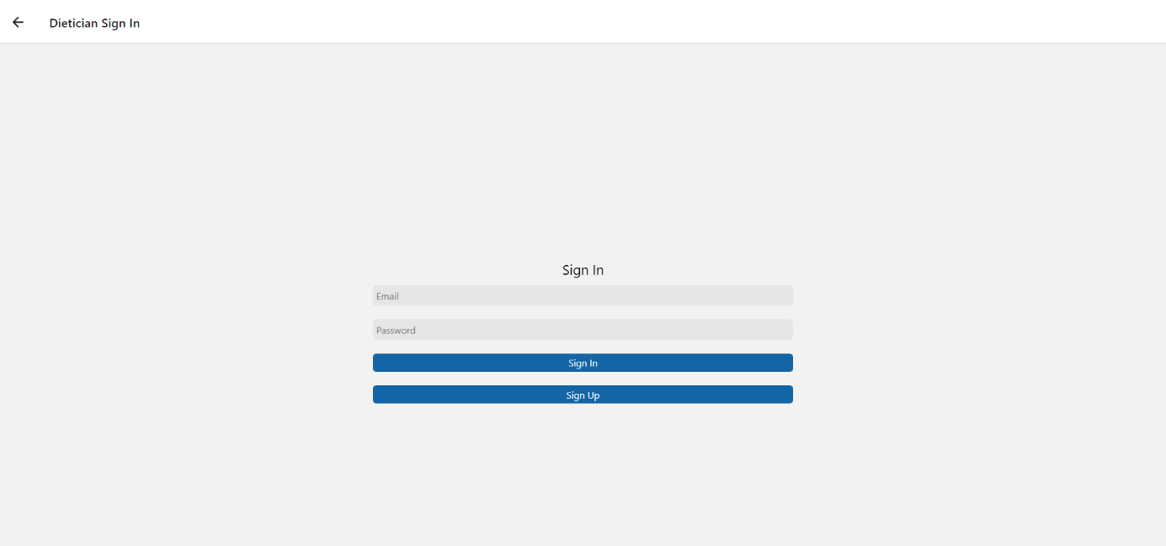

Dietician Sign Up

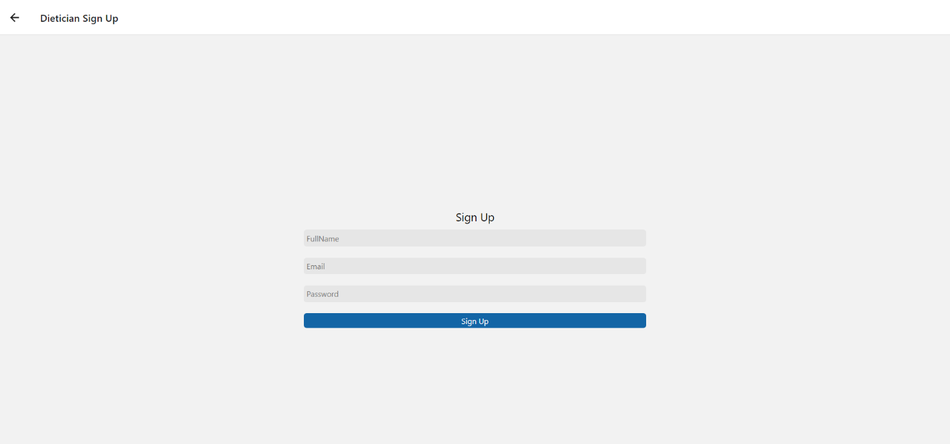

Modal

metin içeren bir resim

Açıklama otomatik olarak oluşturuldu

Dietician Dashboard

metin içeren bir resim

Açıklama otomatik olarak oluşturuldu

Dietician Create Program

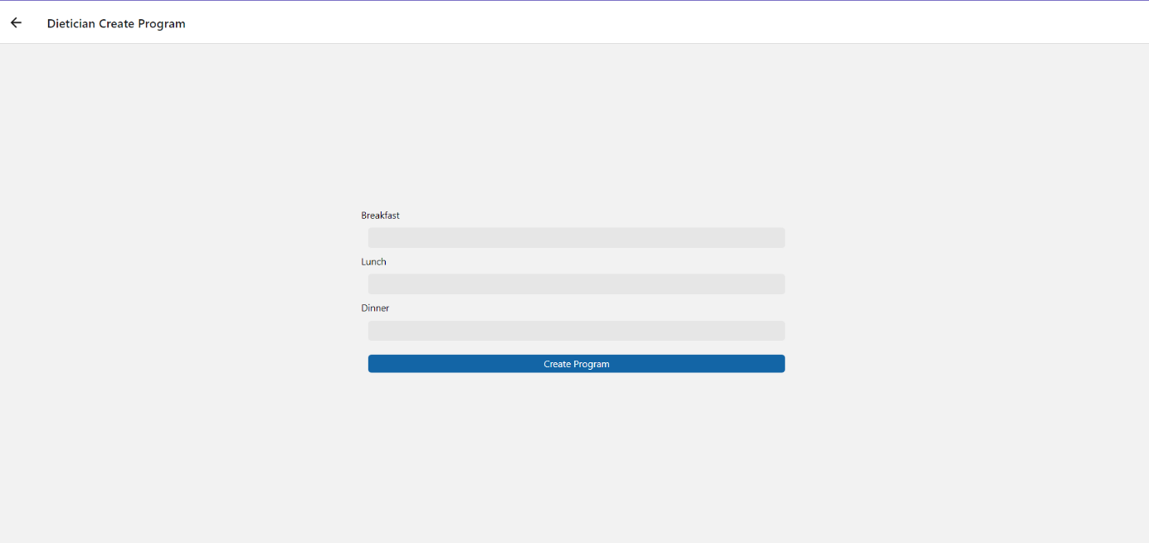

My Github Links:

Front end : <https://github.com/ozkanparlakkilic/DieticianMobilApp.git>

Back end : <https://github.com/ozkanparlakkilic/DieticianBackend.git>