**SİMLPE LORA GATEWAY AND NODE**

# 1. Introduction

This page describes our low-cost simple LoRa gateway based on a Raspberry PI and Lora node based on a Ardunio nano. The gateway can receive messages from any LoRa device. This project is simple communication with lora. Ardunio Nodes send to temparature and humidity values to gateway. I used RadioHead library on ardunio and added to SHT21 communication codes.

# 2. Hardware

* Raspberry pi 2/3

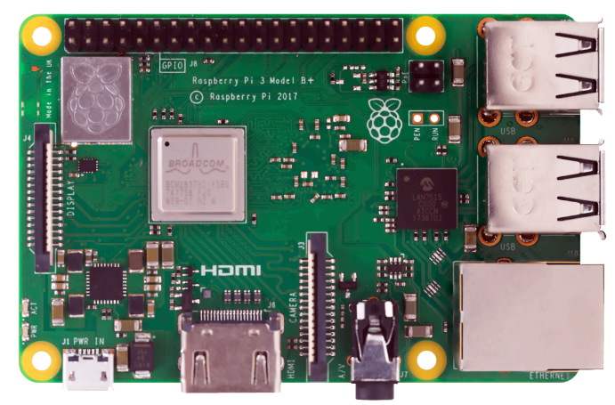

* HopeRF RFM95W buy-Link <https://bit.ly/2QnZxY8>

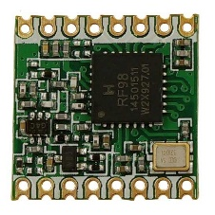

* SHT21 Temperature and Humidity Sensor buy-Link <https://bit.ly/2JDVvKZ>

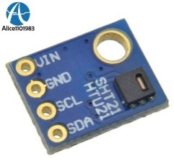

* Arduino Nano v2 breakout, 2 layer board of 30x81mm <https://bit.ly/2X7UY72>

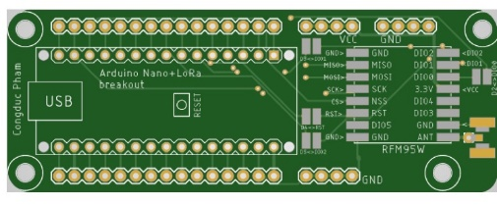

* RFM95 breakout, 2 layer board of 29x37mm <https://bit.ly/2JHp2TL>

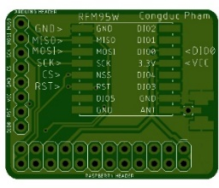

**Gateway Electrical Connection**

RFM95 and raspberry pi communicate with SPI.

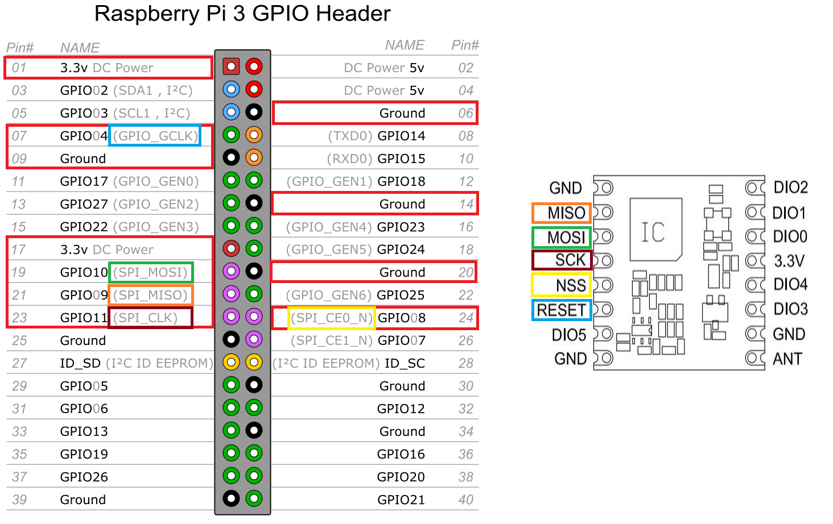

RPI 2/3 RFM95W

GND pin 6----------GND (ground in)

3V3 pin 1----------3.3V (3.3V in)

GPIO4 pin 7----------RST (Reset)

CS/CE0 pin 24----------NSS (CS chip select in)

SCK pin 23----------SCK (SPI clock in)

MOSI pin 19----------MOSI (SPI Data in)

MISO pin 21----------MISO (SPI Data out)

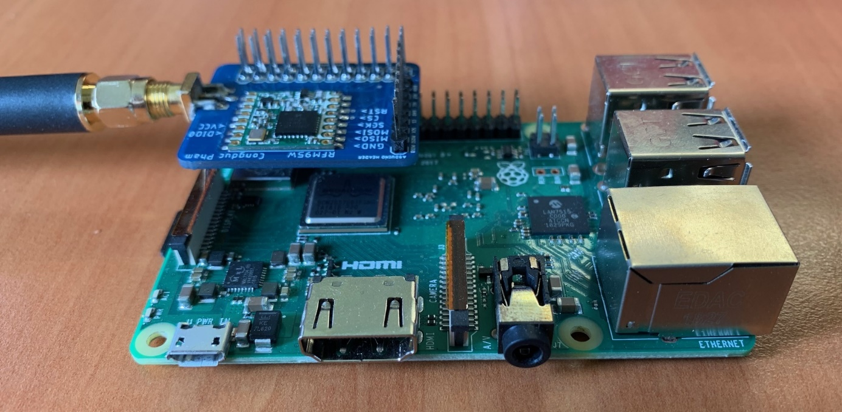

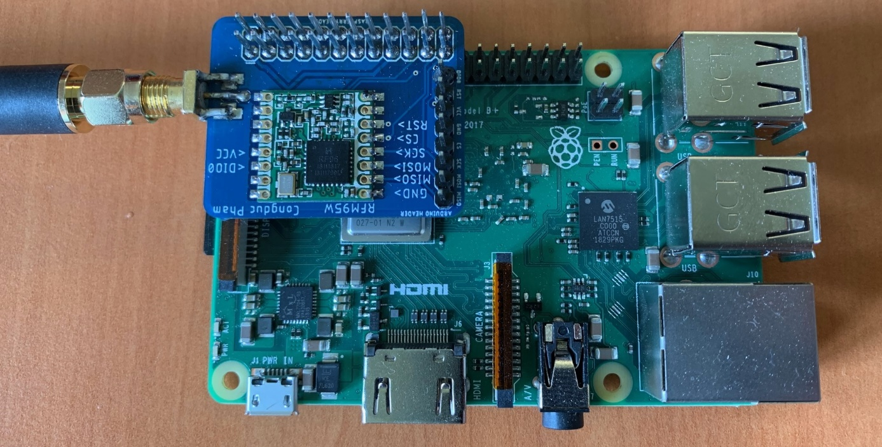

**Node Electrical Connection**

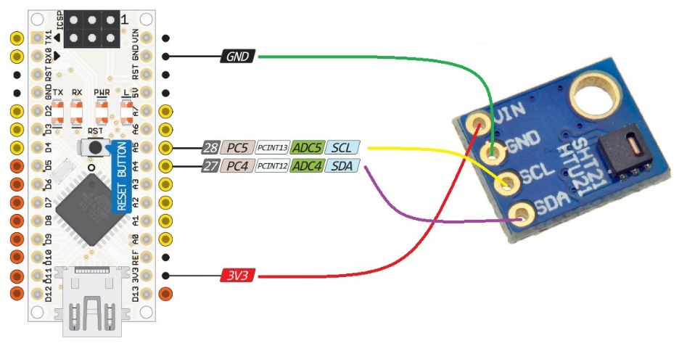

Arduino SHT21

GND----------GND (ground in)

3V3----------VIN (3.3V in)

SCL pin A5----------SDA (I2C Data pin)

SDA pin A4----------SCL (I2C Data clock)

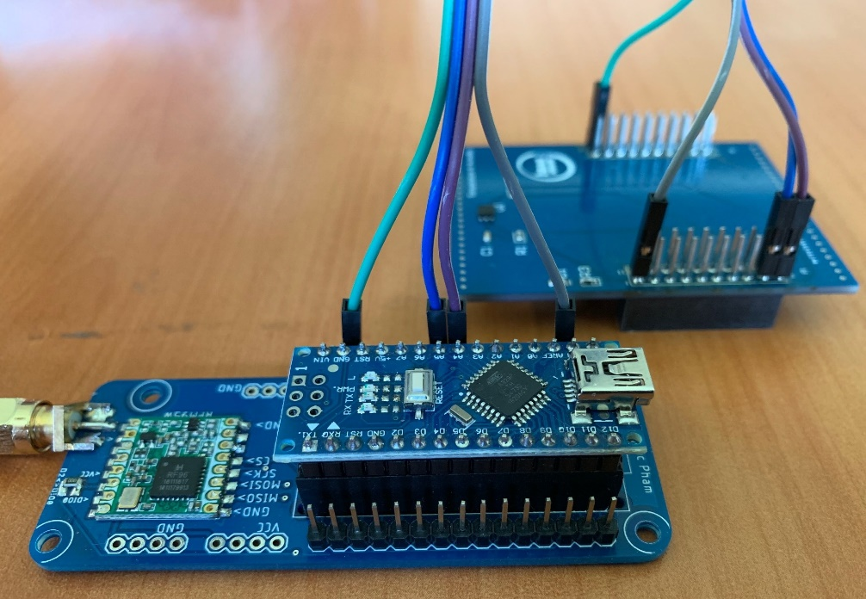

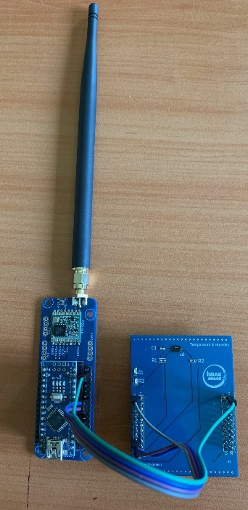

# 3. Software

**Ardunio Software**

Ardunio program uses RadioHead library for lora and communicate I2C with SHT21 temperature and humidity sensor.

This code uses some defines.

#define RF95_FREQ 865.2

If you want to change freq, you must change gateway too.

// So called LoRa mode 1 (BW125, CR45, SF12) with CRC on

RH_RF95::ModemConfig my_Bw125Cr45Sf4096 = {0x72, 0xc4, 0x0C};

Lora mode 1 settings

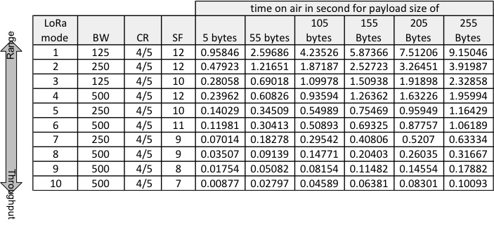

// CHANGE HERE THE NODE ADDRESS

#define node_addr 1

Node address

And in code delay time is 10sn. If you want to change time delay, edit delay time in loop code.

You must install RadioHead and SHT21 library to Ardunio IDE. (Radiohead.zip-sht21.zip)

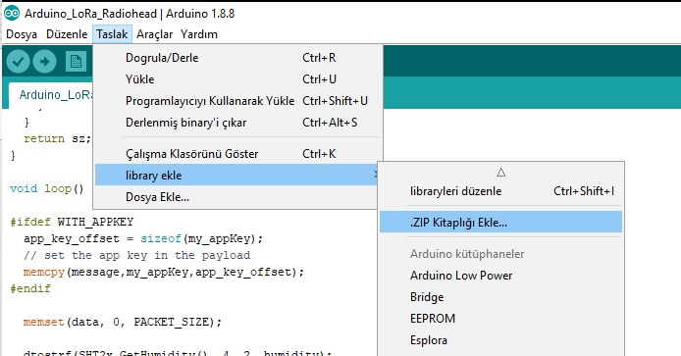

Download Ardunio lora node code:

----------------aa

**Gateway Software**

SSSss