Özlem Ataş

05.04.2018

*Transfer Service Problem Solution*

In this submission, Transfer request from one account to an other account problem was solved in Java language with using SOAP.

This document describes the details of design, project configuration, implementation and guides for

how to run Java implementations.

*Design*

TransferRequest is a class that holds the senderAccount, receiverAccount informantions and amount belongs to that transaction. Account is an other model class which holds account number, account name and balance. TransferResponse is a class that s used for return response by transfer service. This response class store the information about result of the process. If the process has errors response returns the error details.

TestTransferService is a service class responsible for creating initial account and transfer money. All business logic is implemented in TestTransferService class.

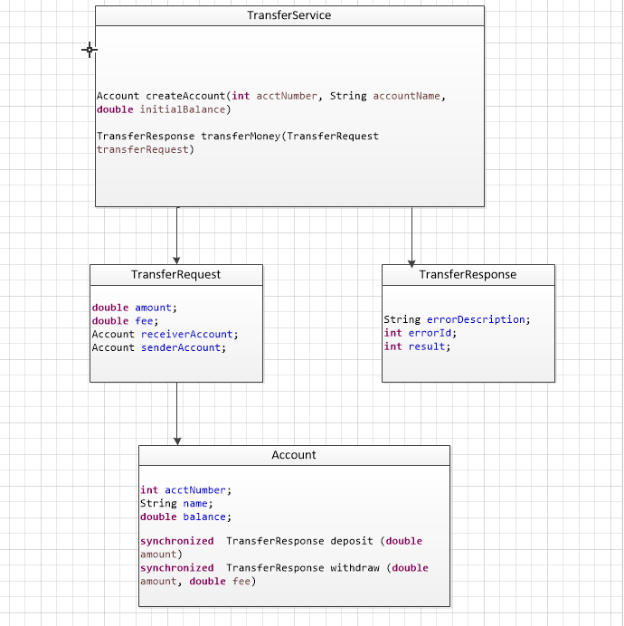

The wsdl file for TransferService is TransferService.wsdl. This wsdl can be used to generate client.jar for the clients which will call TransferService SOAP WS.

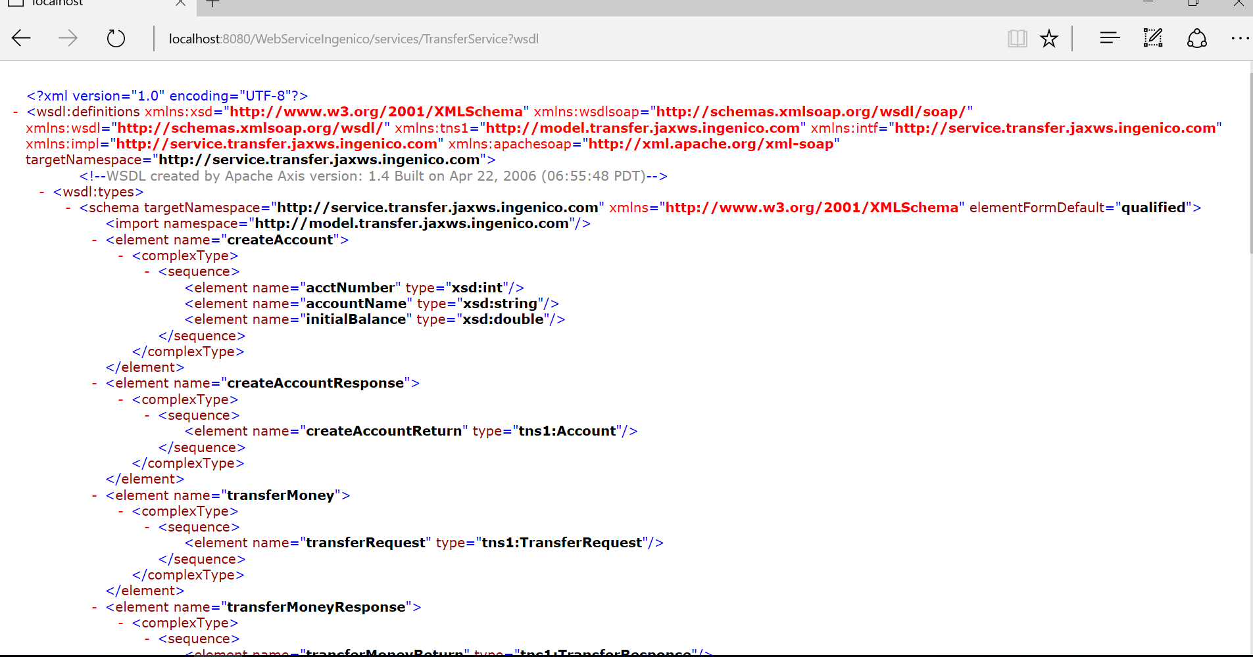

TestTransferService and SimultaneousTransferTest classes are used to test TransferService.

SimultaneousTransferTest class uses multi-threading for update an account management system. To Support simultaneous transfer, deposit and withdraw methods of Account class are defined as **synchronized**

*Version Controlling with Git*

In this project git is selected as the version control system and Github cloud service is selected as

the git repository.

Source codes are committed to following links: