*Özlem Ataş*

*12.04.2018*

**Technical Design Document**

* **Design**

Byteland, City, State are model classes for Bytelan processing systems. Byteland holds the city and state lists belongs to that country. City object holds the information of that city and state belongs to that city. And also holds neigbours cities connected to the city. State is an other model class which define state object. State class holds city list of the state and the neigbour states connected to the state.

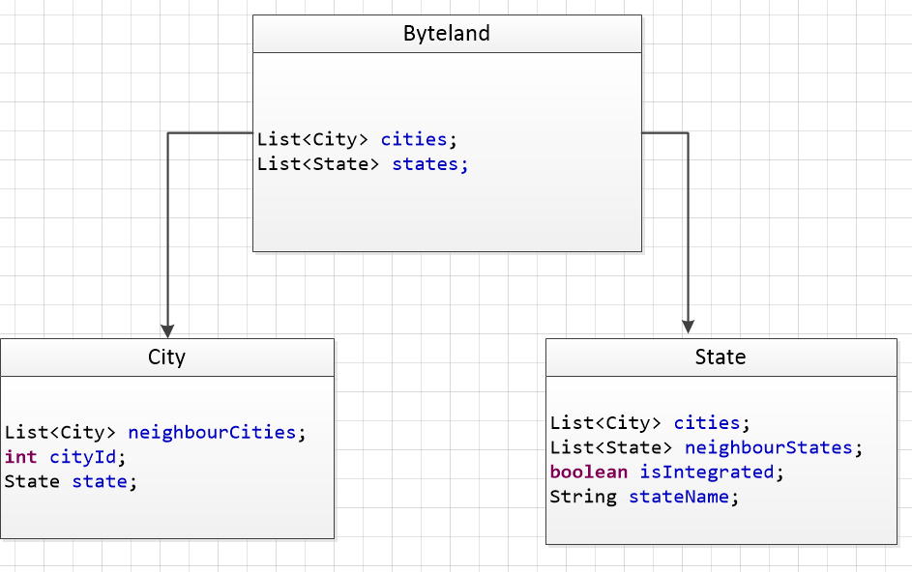

BytelandService is an interface that responsible for creating Byteland county from inputs,. All business logic is implemented in BytelandServiceImpl class.

IntegrationService is an interface that responsible for integration process of cities to a global state All business logic is implemented in IntegrationServiceImpl class.

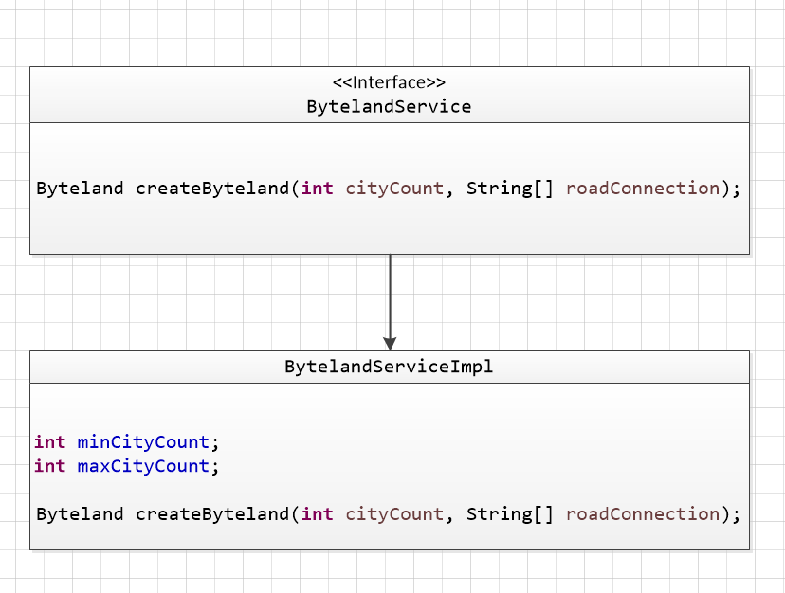

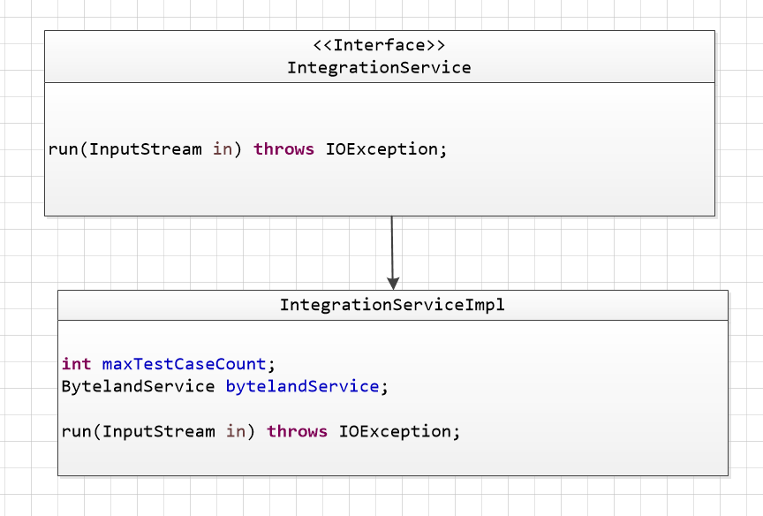

Max city count, min city count and max test case count are kept as parametric in *application.properties* file.

min.city.count=2

max.city.count=600

max.test.case.count=1000

* **Build Project with Maven**

Maven is used as a build management tool.

In order to compile source code and build the project, following command should be

executed from command line in the project directories:

mvn clean package

This command will clean previous build directory, re-compile the source code and

package compiled classes.

* **Applcation Run**

Java project is implemented using Spring Boot for application start-up.

In order to run the project, just type the following command and enter input as defined in the problem definition.

$ mvn spring-boot:run -Drun.arguments=""

The application will print the results on conlose.