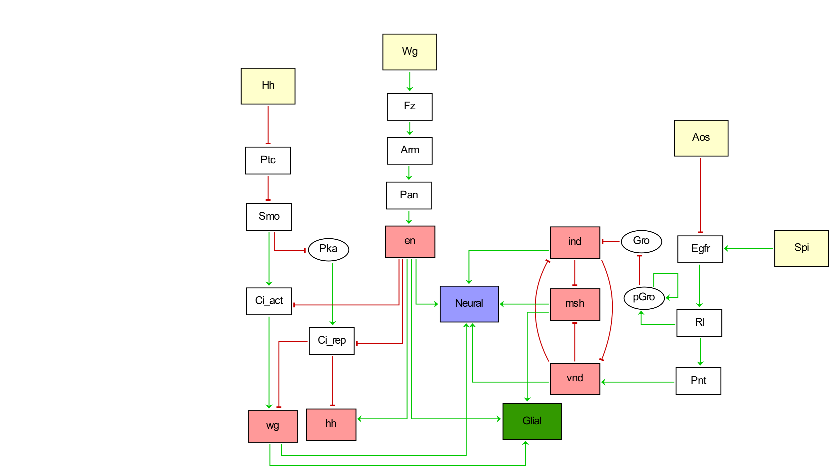

|  |  |  |
| --- | --- | --- |
| **Gene symbol** | **Gene ID** | **Gene name** |
| hh | FBgn0004644 | hedgehog |
| ptc | FBgn0003892 | patched |
| smo | FBgn0003444 | smoothened |
| ci | FBgn0004859 | cubitus interruptus |
| Pka-C2 | FBgn0000274 | Protein kinase, cAMP-dependent, catalytic subunit 2 |
| wg | FBgn0284084 | wingless |
| fz | FBgn0001085 | frizzled |
| dsh | FBgn0000499 | dishevelled |
| pan | FBgn0085432 | pangolin |
| arm | FBgn0000117 | armadillo |
| en | FBgn0000577 | engrailed |
| Egfr | FBgn0003731 | Epidermal growth factor receptor |
| spi | FBgn0005672 | spitz |
| aos | FBgn0004569 | argos |
| rl | FBgn0003256 | rolled |
| pnt | FBgn0003118 | pointed |
| aop | FBgn0000097 | anterior open |
| gro | FBgn0001139 | groucho |
| ind | FBgn0025776 | intermediate neuroblasts defective |
| vnd | FBgn0261930 | ventral nervous system defective |
| msh | FBgn0000492 | muscle segment homeobox, Drop |

|  |  |
| --- | --- |
| **Node** | **Boolean functions** |
| Fz | Wg_external |
| Arm | Fz |
| Pan | Arm |
| En | Pan |
| Hh | En & !Ci_Rep |
| Ptc | !Hh_external |
| Smo | !Ptc |
| Ci_Act | Smo & !En |
| Pka | !Smo |
| Ci_Rep | Pka & !En |
| Wg | Ci_Act & !Ci_Rep |
| Egfr | Spi & !Aos |
| Rl | Egfr |
| Pnt | Rl |
| Aop | !Rl |
| pGro | Rl | pGro |
| Gro | !pGro |
| Ind | !Vnd & !Gro |
| Vnd | Pnt & !Ind |
| Msh | !Vnd & !Ind |
| Glial Cell Fate | Msh & (Wg | En) |
| Neural Cell Fate | (Vnd | Ind | Msh) & (Wg | En) |

1. **Fz = Wg_external**

The Wg signal is transduced across the membrane involving Frizzled proteins (such as Fz and DFz2) in the adjacent receiving cells1.

1. **Arm = Fz**

Wg binding to Fz and Arrow brings them together, thereby recruiting Dsh to the membrane. When the destruction complex is inactivated by receptor/Dsh activity, Arm/beta-catenin translocates to the nucleus where it binds the N-terminus of Tcf (also known as dTCF or Pan), displacing the Groucho co-repressor and recruiting activators to drive target gene expression. The recruitment of Dsh to the membrane is not included in our model. We considered the main event that Wg binding to Fz activates Arm translocation to the nucleus where it binds to ﻿the N-terminus of Pan, thereby recruiting activators to drive target gene expression. Wg protein that is transcribed and secreted from an anterior row of cells maintains the expression of a transcription factor, engrailed (en), in adjoining, posterior cells 2,3.

1. **Pan = Arm**

Please refer to the reaction 2 for the explanation of the Boolean update rule of Pan.

1. **En = Pan**

Please refer to the reaction 2 for the explanation of the Boolean update rule of En.

1. **Hh = En & !Ci_rep**

One of the functions of En is to maintain *hh* expression. ﻿ Ci_rep, a 75 kD transcriptional repressor moves to the nucleus and represses *hh*1.

1. **Ptc = !Hh_external**

Secreted Hh interacts with its receptor Ptc, thus relieving the repression of Ptc on Smo1,4.

1. **Smo = !Ptc**

Please refer to the reaction 6 for the explanation of the Boolean update rule of Smo.

1. **Ci_act = Smo & ! En**

Once Smo is freed of the inhibitory effects of Ptc, Smo signals through unknown mechanisms to the Fu/Cos2/Ci complex, causing hyperphosphorylation of Fu and Cos2 and causing the complex to loosen its hold on microtubules. This leads to the stabilization of full length Ci, which can then travel to the nucleus and function as a transcriptional activator, upregulating transcription of Hh target genes5,6.

1. **Pka = ! Smo**

In ﻿the absence of Hh ligand, repression of Smo allows Drosophila Protein Kinase A (PKA) phosphorylation of Ci on several sites and these phosphorylation events are required for the cleavage of Ci into Ci_rep 7.

1. **Ci_rep = Pka & ! En**

PKA phosphorylates Ci on several sites and these phosphorylation events are required for the cleavage of Ci into Ci_rep. ﻿Ci is repressed by En. Ci is a cytoplasmic protein and it is not known this form has a function. It can be cleaved to generate Ci_rep, a 75 kD transcriptional repressor or full-length Ci, a 155 kD transcriptional activator. Since the exact mechanism leading to generation of the different froms of Ci is not fully known, these reactions were omitted from the model. Ci repression by En is introduced into the model via two inhibitory edges to the both forms of Ci5,6**.**

1. **Wg = Ci_act & ! Ci_rep**

Ci_rep represses wg, ptc and hh transcription whereas Ci_act induces transcription of ptc and wg5,6.

1. **Egfr = Spi & !Aos**

Spi encodes ligand that activate Egfr. Aos functions as an inhibitor of the signaling triggered by Egfr8,9.

1. **Rl = Egfr**

Rl encodes the mitogen activated protein (MAP) kinase, core component of the RAS/MAPK pathway. Egfr activation induces RAS/MAPK pathway.﻿ Cells with a loss of function in Rl produce the same cell-death phenotype as seen in an EGF loss of function10.

1. **Pnt = Rl**

Activated Rl phosphorylates and activates transcription factors such as Pnt10,11.

1. **pGro = Rl | pGro**

Gro is phosphorylated by MAPK. Modification of Gro downregulates its repressor activity, causing derepression of pathway target genes. MAPK is no longer active after RTK signaling has been turned off, yet Gro remains stably phosphorylated and its activity attenuated, allowing for sustained RTK target gene expression. Phosphorylated Groucho is a nuclear and stable protein captured in our model by introducing self-loop and Gro inhibition12.

1. **Gro = ! pGro**

Please refer to the reaction 15 for the explanation of the Boolean update rule of Gro.

1. **Ind = ! Vnd & ! Gro**

Vnd represses ind and msh in the ventral neuroectoderm, and ind represses msh in the intermediate neuroectoderm. Gro is a nuclear repressor and represses ind transcription13–15.

1. **Vnd = Pnt & !Ind**

EGF signaling and Pnt either directly or indirectly maintain the expression of several genes in the neurogenic ectoderm including Ind and Vnd, which encode regulatory proteins that pattern the future ventral nerve cord. EGF signaling maintains expression of the Pointed transcription factor, which, in turn, sustains the expression of Vnd (previously activated by Dorsal and Twi), Rho, and Vn13–15.

1. **Msh = !Vnd & !Ind**

Please refer to the reaction 18 for the explanation of the Boolean update rule of Msh.

1. **Glial cell fate = Msh & (Wg | En)**

Boolean functions were driven based on the information on morphologies of the NBs observed in vivo around late stage 11 (according to Bossing et al., 1996). ﻿Gene expression along the A/P axis (e.g., wg, wingless; gsb, gooseberry; en, engrailed) and the dorso-ventral axis (vnd, ventral nervous system defective; ind, intermediate neuroblasts defective; msh, muscle segment homeobox) subdivide the vNR (ventral neuroectoderm) into a grid-like Cartesian coordinate system. This system provides positional information, which specifies the identities of proneural clusters. Each proneural cluster gives rise to one specific NB. For example, NB6-4 delaminates from a proneural cluster that expresses msh and engrailed. NB4-6 gives rise to glial cells exclusively. Proneural clusters expressing wg and gsb along A/P axis considered as wg domain since their expression is regulated by Hh signaling16–18.

1. **Neural cell fate = (Vnd | Ind | Msh) & (Wg | En)**

Please refer to the reaction 20 for the explanation of the Boolean update rule of neural cell fate.

**References:**

1. Bhat, K. M. Segment polarity genes in neuroblast formation and identity specification during Drosophila neurogenesis. *BioEssays* **21**, 472–485 (1999).

2. Bejsovec, A. Wingless/Wnt signaling in Drosophila: The pattern and the pathway. *Mol. Reprod. Dev.* **80**, 882–894 (2013).

3. Swarup, S. & Verheyen, E. M. Wnt/wingless signaling in drosophila. *Cold Spring Harb. Perspect. Biol.* (2012) doi:10.1101/cshperspect.a007930.

4. Im, S. H. *et al.* Tachykinin acts upstream of autocrine Hedgehog signaling during nociceptive sensitization in Drosophila. *Elife* **4**, 1–27 (2015).

5. Nybakken, K. & Perrimon, N. Hedgehog signal transduction: Recent findings. *Curr. Opin. Genet. Dev.* **12**, 503–511 (2002).

6. Eaton, S. & Kornberg, T. B. Repression of ci-D in posterior compartments of Drosophila by engrailed. *Genes Dev.* **4**, 1068–1077 (1990).

7. Ingham, P. W. & McMahon, A. P. Hedgehog signaling in animal development: Paradigms and principles. *Genes Dev.* **15**, 3059–3087 (2001).

8. Golembo, M., Schweitzer, R., Freeman, M. & Shilo, B. Z. Argos transcription is induced by the Drosophila EGF receptor pathway to form an inhibitory feedback loop. *Development* **122**, 223–230 (1996).

9. Hong, J. W., Hendrix, D. A., Papatsenko, D. & Levine, M. S. How the Dorsal gradient works: Insights from postgenome technologies. *Proc. Natl. Acad. Sci. U. S. A.* **105**, 20072–20076 (2008).

10. Brunner, D. *et al.* A gain-of-function mutation in Drosophila MAP kinase activates multiple receptor tyrosine kinase signaling pathways. *Cell* **76**, 875–888 (1994).

11. Oellers, N. & Hafen, E. Biochemical characterization of rolled(Sem) an activated form of Drosophila mitogen-activated protein kinase. *J. Biol. Chem.* **271**, 24939–24944 (1996).

12. Cinnamon, E. *et al.* Multiple RTK pathways downregulate Groucho-mediated repression in Drosophila embryogenesis. *Development* **135**, 829–837 (2008).

13. Cowden, J. & Levine, M. Ventral dominance governs sequential patterns of gene expression across the dorsal-ventral axis of the neuroectoderm in the Drosophila embryo. *Dev. Biol.* **262**, 335–349 (2003).

14. Golembo, M., Yarnitzky, T., Volk, T. & Shilo, B. Z. Vein expression is induced by the EGF receptor pathway to provide a positive feedback loop in patterning the Drosophila embryonic ventral ectoderm. *Genes Dev.* **13**, 158–162 (1999).

15. Levine, M. & Davidson, E. H. Gene regulatory networks for development. *Proc. Natl. Acad. Sci. U. S. A.* **102**, 4936–4942 (2005).

16. Skeath, J. B. At the nexus between pattern formation and cell-type specification: The generation of individual neuroblast fates in the drosophila embryonic central nervous system. *BioEssays* **21**, 922–931 (1999).

17. Technau, G. M., Berger, C. & Urbach, R. Generation of cell diversity and segmental pattern in the embryonic central nervous system ofDrosophila. *Dev. Dyn.* **235**, 861–869 (2006).

18. Schmidt, H. *et al.* The Embryonic Central Nervous System Lineages ofDrosophila melanogaster. *Dev. Biol.* **189**, 186–204 (1997).