ISTANBUL TECHNICAL UNIVERSITY

**FACULTY OF COMPUTER AND INFORMATICS**



**INFORMATION SYSTEMS ENGINEERING 2018-2019 SPRING**

**ISE 305 DATABASE SYSTEMS PIRIL OKUROGULLARI 150140228**

**OZLEM CINAR 150140221**

**ASST. PROF. DR. AHMET CUNEYD TANTUG**

**CONTENT**

DESCRIPTION OF PROJECT… 3

NORMALIZATION STEPS… 4

ER DIAGRAMS… 5-6

INTERFACES… 7-12

HOW DOES PREAN SYSTEM WORK?… 13-14

APPLICATION DETAILS… 15

**DESCRIPTION OF PROJECT**

**PREAN - PRICE ANALYZER**

**BEST VALUE IN MINIMUM TIME**



**PreAn is a price analyzer application that connects with markets’ databases and show the customer the best price for the specific product that he / she looks for.**

Surely the prices of the products could be looked for manually from Internet or in stores, and still the best prices could be found but in today’s world time is everything and almost no one has time for that process. So PreAn is found for saving the time to find the best value.

# NORMALIZATIOPN STEPS





**Before Normalizations:** There is only 1 table.



**1st Normal Form:** There are 2 tables.



**2nd Normal Form:** There are 3 tables.

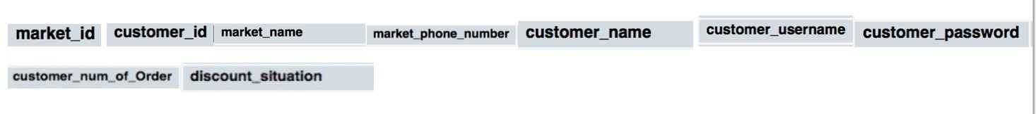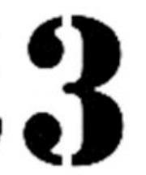



**3rd Normal Form:** There are 5 tables.

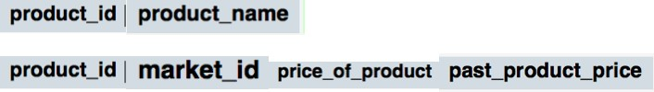

How the tables are connected in the database:

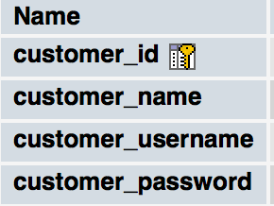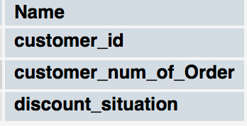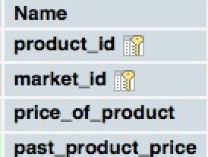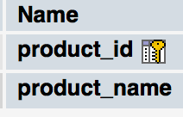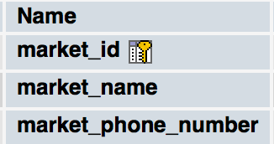

How all the system is connected:

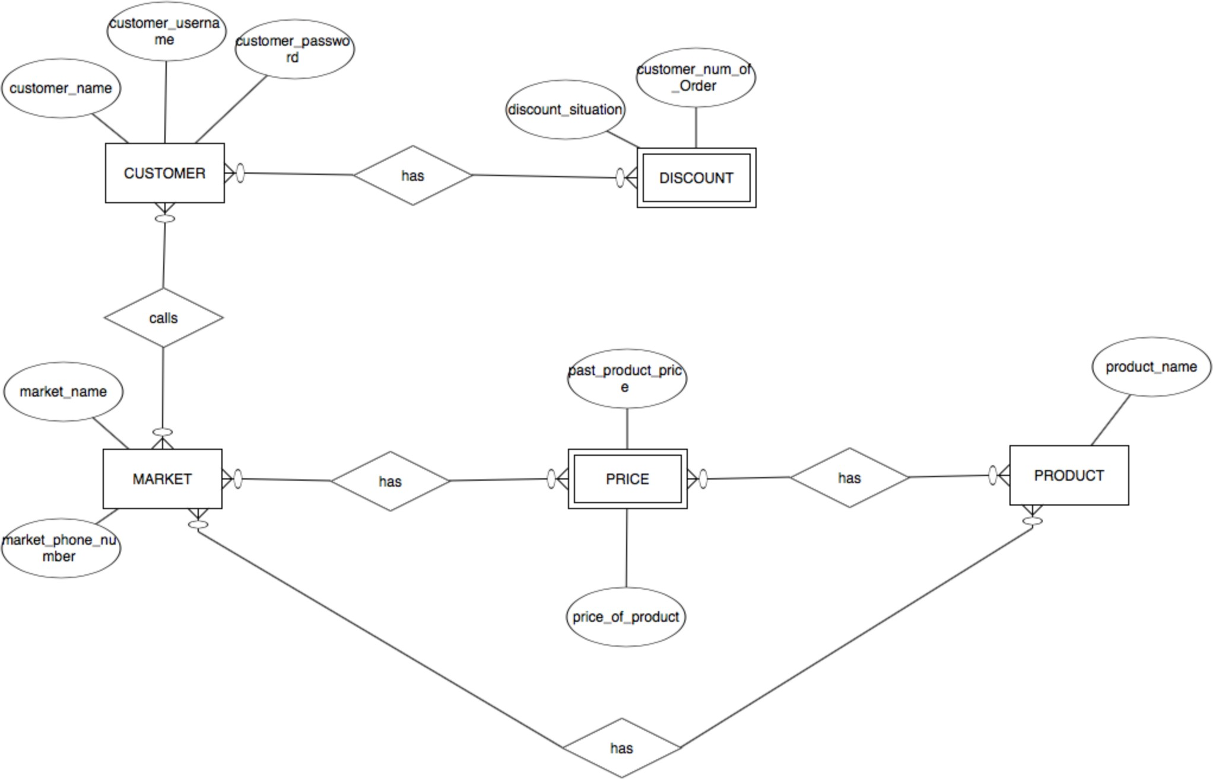

# INTERFACE

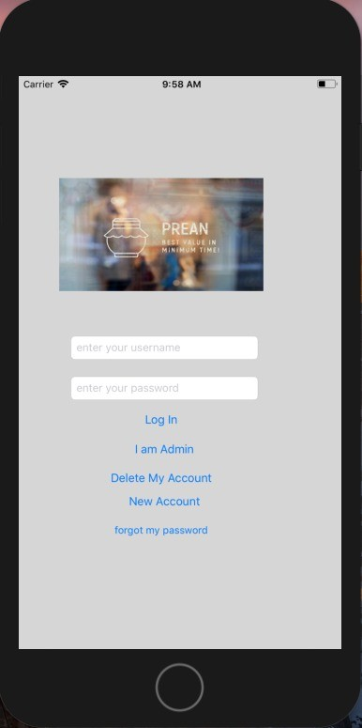

Main Page:

* When a customer wants to enter the system, the main page welcomes them with the Log In

page.

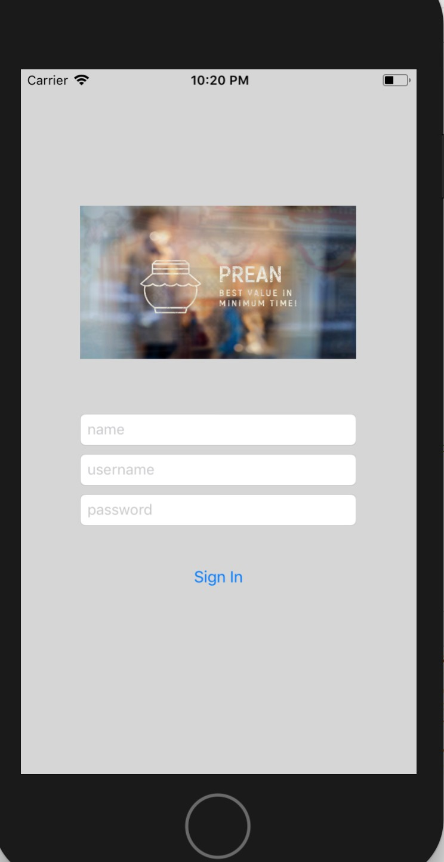When the customer enters ‘New Account’ button on new page:

* If the customer haven’t logged in before yet, there is a ‘New Account’ button right under the

Log In part on the main page. The customer can easily sign into the system through that button by entering the information of his name, surname and password.

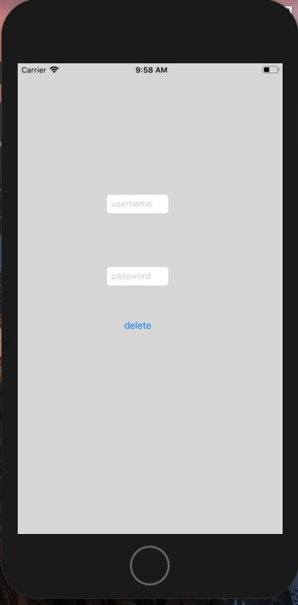When the customer enters ‘Delete My Account’ button on new page:

* + If anyone would like to delete their account, it is easily possible with the button at the

bottom of the main page.

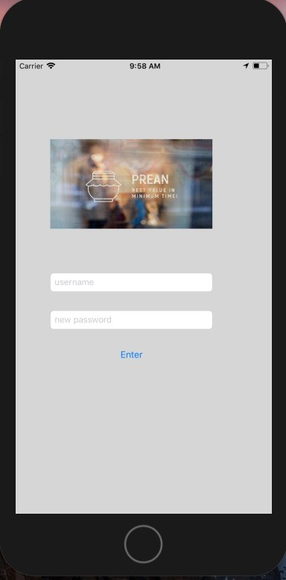When the customer enters ‘forgot my password’ button on new page:

* + If anyone would like to change their password, it is easily possible with the button at the

bottom of the main page.

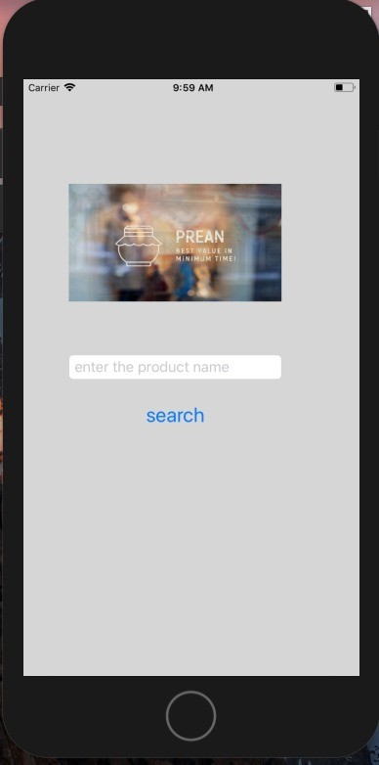When the customer enters the system through the log in button:

* + If anyone would like to search a product, it is easily possible with the search button.

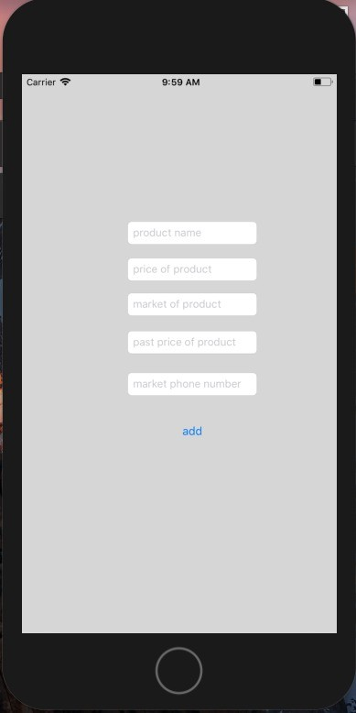When the admin enters ‘I Am Admin’ button on new page:

* When one of the admins want to make any updates or changes, it is possible through the admin

account.

NOTIFICATIONS

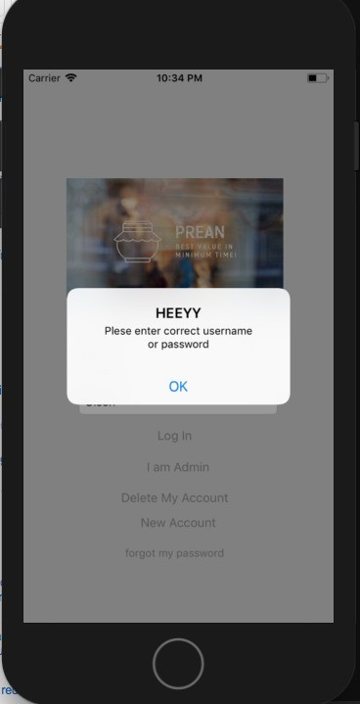

When the customer enters a wrong username or password:

* When the username that the user enters is not correct, the user sees this notification.

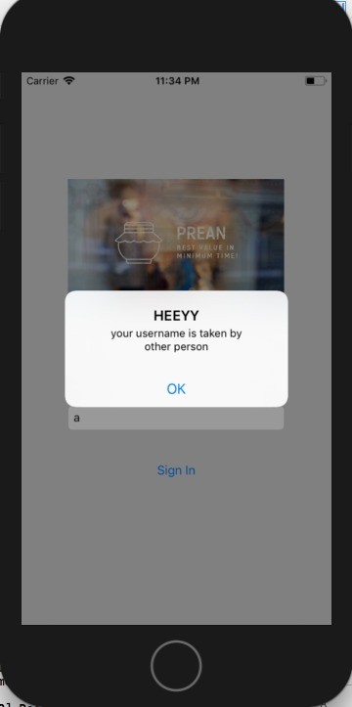When a new user wants to take a username which is already taken:

* When the username that a new user want to get is already had by another user in the system, the

user sees this notification.

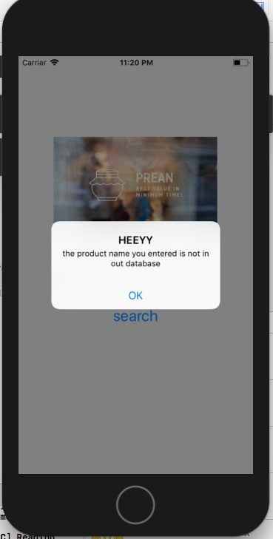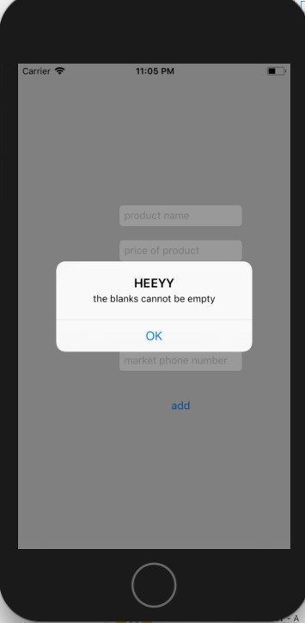

When a product that the user search for is not found on database:

* + When the product that the user seeks for is not found in the database, the user sees this

notification.

When the admin leaves any blank empty when entering the system:

* + When the admin leaves any blank empty when entering the system, the admin sees this

notification.

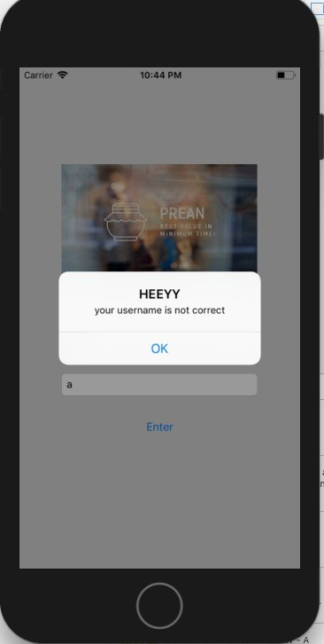When a user wants to delete his/ her account:

* + When a user wants to delete his/her account and enters a wrong username, sees this

notification.

# HOW DOES PREAN SYSTEM WORK?

PreAn in an IOS application that a user can search the best-value market products, and could compare the prices for the same product on various markets. There are a couple of programs are used in the background of PreAn:

-MyPhpServer database is connected with Php codes, which are created with PhpStorm application.

-Php codes are connected with Swift codes, which are created with Xcode application.

-JSON tool is used for Swift codes.

With all those connections, PreAn is capable to do lots of actions. PreAn can do:

-Log in a customer, whose data is already in the database.

-Sign in a customer, and save the new customer’s data to the database.

-Search for a product that user enters. Shows the results in descending order if there are any data in the database for that particular product, otherwise it shows a notification that tells the product is not found in any of the markets in the system.

-Delete a customer, deletes the data of the customer who wants to delete his/her account from the database.

-Change password if user forgets his/her password. It allows user to change the password in that circumstance, and it deletes the old password from the database, then writes the new one in the place of the old password.

-If any of the admins wants to enter to the system, he/she can easily enter the system through the main page.

-It shows notifications if any wrong data is entered by the user, for example if the user enters a wrong password or username, then the username-password does not matches on the database, so PreAn shows a notification that the entered data is wrong.

-It shows notifications if a new customer wants to get a username that is already in the database.

# APPLICATION DETAILS

**(Platform, High-Level Architecture,...)**

* macOS High Sierra 10.13.5
* MAMP 5.2 (351)
* PhP MyAdmin 4.8.3
* PhpStorm 2019.1.1
* Xcode 9.4.1, created for iPhone 6, swift 4.1, IOS Deployment target 9.3
* TextWrangler