REPORT-1

Our project topic is to predict sales data. While performing this task, we primarily have data separated as test and train data.These are materials that have been sold over a certain period of time.These are reserved for different stores.

As purchases increase in today's digital world, data has reached enormous dimensions. The most prominent of the concepts brought by the industry has been the multidimensionality curse. For this reason, businesses have great difficulty in making purchasing decisions. Failure to make a correct sales forecast in the long or short term will cause many problems such as customer dissatisfaction, loss of money, and the need for raw materials. Many parties, from supply chain elements to manufacturers, retailers, suppliers and customers, may suffer from wrong or incomplete sales forecast. Machine learning, which is one of the innovations brought by the age of artificial intelligence, is an area that can quickly respond to sales prediction problems as well as the problems brought by many engineering applications.

1.INTRODUCTİON

In today's world, where even production has become digital,consumption is showing an increasing acceleration.People can now shop with one clicktheir presence is the main reason for this situation. Sellin this age of increasing purchasing, sales forecastto be able to and according to him to keep stock or productionmaking planning has gained great importance.Without a forecast, neither the revenues of enterprises northe expenses are predictable. Production planning of the enterprise,many such as purchasing, sales and marketingthe department analyzed these estimates based onhe does it. Sales in the long or short termthe customer's prediction cannot be made correctlydissatisfaction, loss of money, need for raw materialsit will lead to many problems, such as. Guessstrategic decisions for the future without being madesince the plans and policies of the enterprise cannot be takenit causes him to be unable to create. This situation is justnot only does it affect the business itself, but the supply manufacturer of chain elements, retailer,the damage of many parties, up to the supplier and the customer it will cause him to see. The situation is from being an individualit comes out, and manypeople, it can't be done or it's wronghe will suffer from the prediction made. A good saleas a result of the estimated work, only the company profitsnot only that, but the entire supply chainthere may be an increase in productivity in employees.Thus, the continuity of enterprises in the sectornot only maintaining, but also the entire supply chainthey will be able to offer profit margins for their employees.Large-scale sales without using any methodbeing able to predict makes it impossible for businesseshe's here. The classical methods are that big datathe answer to the sales generated by their stacksunable to provide or their flexibility and special situationshe cannot calculate. For this reason, it is new to literaturethe artificial intelligence components acquired are similarhe has responded to the results. How much artificial intelligencemethods such as robotics or telecommunicationsalthough there is an impression that it is used in the fields, over time thisbias will change and wherever there is datait will begin to be used. The age of artificial intelligencemachine learning, which is one of the innovations it brings, is alsobrought by many engineering applicationsit is an area that can respond to problems quickly.Although there are some applications, there is still a very newthere are many assumptions in the field and in the literatureis available. Most businesses are similar to data scienceproblems in a short time compared to traditional methodsand since you don't think you're answering truthfully, thisthe fact that the study is a guide for businessesit is expected.

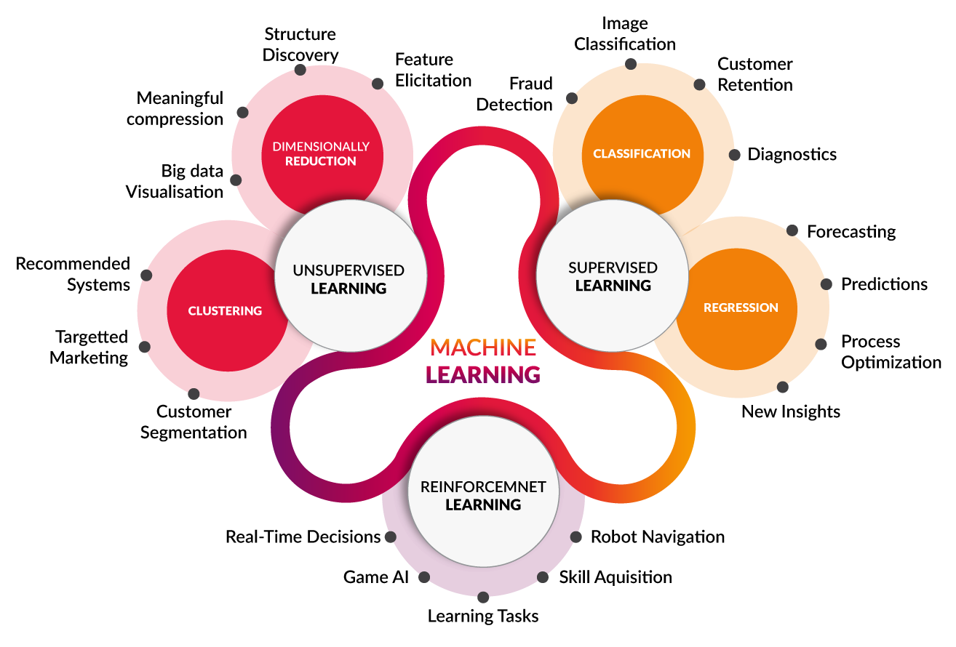

2. Machine Learning

Machine learning; probability, statistics andon the subfields of mathematics such as optimizationit is built. The model is created and the machinepredicting the future by learning past data it is expected.

Machine learning has become an increasingly widespread fieldand it will continue to be. There are many reasons for thisThere are. First, symbolic machine learning,computational learning theory,neural networks,separate in the field of statistics and pattern recognitionresearch communities have discovered each other andthey started working together. Secondly,machine learning techniques, knowledge in databasesexploration, language processing, robot control and combinedto new types of problems, such as optimization, and alsospeech recognition, facial recognition, handwriting recognition, medicalmore traditional problems such asit can be applied.

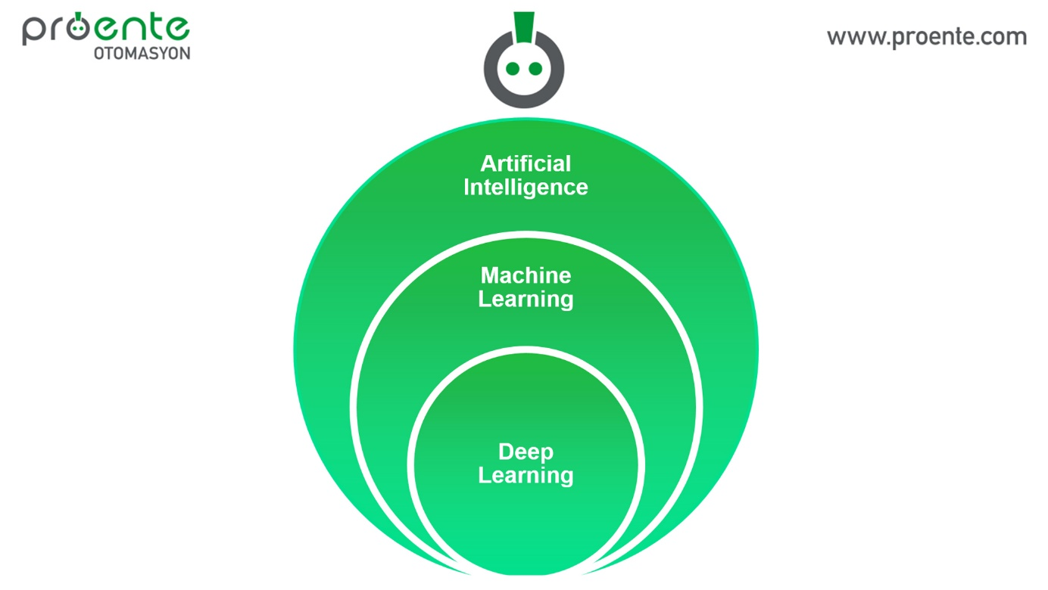

3. Machine Learning in Sales Forecasting Applications

The subject of sales forecasting has mostly been until today solved by traditional time series methods and it is a topic that has existed in literature for a long time.Basically, sales forecasts are based on historical datato predict future sales by taking advantage oftargets. Sales forecasting models can be divided into two types:(i) time series methods and (ii) deep learning andartificial intelligence involving machine learning algorithms methods of intelligence. Machine learning with algorithms of another product in the Sunday making a sales forecast using the data it is possible XGBoost method, European pharmacy retail to estimate the possible sales of your company Random Forest and Linear Regressioncompared with their methods. According to the result The XGBoost method is much more than othersit has been observed that it works successfully. In the futurefor the work to be done, in addition to the sales forecastthe same actions in these 6 area sit has been suggested that it can be performed: advertising, recommendations,demand forecast, customer-based pricing, holidays /extended sales planning and product classification.

References

1) Antipov, E. A., & Pokryshevskaya, E. B. (2020). Interpretable machine learning for demand modeling with high-dimensional data using Gradient Boosting Machines and Shapley values. Journal of Revenue and Pricing Management, 19(5), 355–364.

2) Helmini, S., Jihan, N., Jayasinghe, M., & Perera, S. (2019). Sales forecasting using multivariate long short term memory network models. PeerJ PrePrints, 7, e27712v1.

3) Dietterich, T. G. (1997). Machine-Learning Research. AI Magazine, 18(4), 97–136. D

4) Armstrong, J. S. (1989). Combining Forecasts: The End of the Beginning or the Beginning of the End? International Journal of Forecasting, 5(4), 585–588.