What is the Time Series and Forecast?

A data consisting of observation values sorted by time is called a time series. Time series data is an important resource for information and strategy used in various enterprises. saat, zaman, süre, duvar saati içeren bir resim

Açıklama otomatik olarak oluşturulduTime series prediction is a technique used to predict events through a time series. The technique is used in many fields of study, from geology to behavior and economics. The techniques predict future events by analyzing trends of the past on the assumption that future trends will be similar to historical trends.

Some areas where time series estimation is used are as follows:

Earthquake prediction

Econometrics

Pattern recognition

Signal processing

Control Engineering

In many modern applications, while time series estimation is performed, the following computer technologies are used.

Machine learning

Artificial neural networks

Fuzzy logic

Gaussian processes

The time series prediction starts with a past time series. Analysts-examines historical data and checks four time decomposition models such as trends, seasonal models, cyclical models and stasis(regularity). Many areas in organizations, including marketing, finance, and sales, use some form of time series estimation to assess possible technical costs and consumer demand.

1)INTRODUCTION

In this project, we performed time series forecasting on the historical sales data of a retail store. The main libraries we use include pandas, matplotlib, sklearn, xgboost and numpy.Dec. Under this heading, we can summarize the overall purpose of the project and the tools used.

2)Data Set Introduction

In the first stage, train using Google Colab.csv and testing.we have read two CSV files named csv. In this step, we have obtained information about the general structure of data sets, their dimensions and the columns they contain. We also examined the unique values of the "store" and "item" columns in the training dataset.

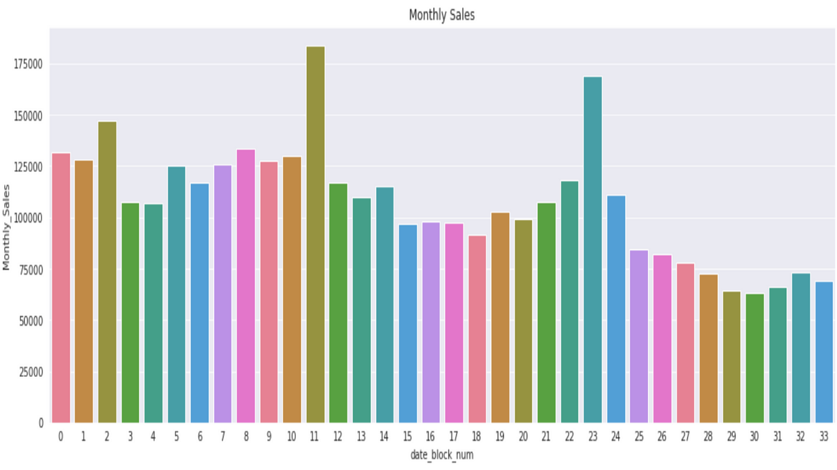

3) Data Visualization

It is becoming increasingly difficult to scan information to understand what is important and what is not. Visuals make analysis easier and faster, while offering the ability to see important issues at a glance. Moreover, most people react much better to images than text. 90 Percent of the information sent to the brain is visual, and the brain processes images 60,000 times faster than text1. These points strongly demonstrate the importance of using data visualization to analyze and transmit information

Why is visual analytics important?

Good data visualization is necessary to analyze data and make decisions based on this data. It allows people to quickly and easily see and understand relationships with structures, detect trends that cannot be noticed only in tables consisting of raw numbers. And in many cases, no special training is required to interpret what is presented in the graphs, universal understanding is provided.

A well-designed chart not only provides information, but increases the impact of this information with a powerful presentation, attracts attention and keeps people's interest strong to the extent that no spreadsheet can.

