Predictions and Results

Machine learning models often form the basis of a project, and the performance of these models on real-world data is a critical element that determines the success of the project. Therefore, the predictions of a trained model on the test data set and the evaluation of the obtained results represent a critical stage in the completion of a project.

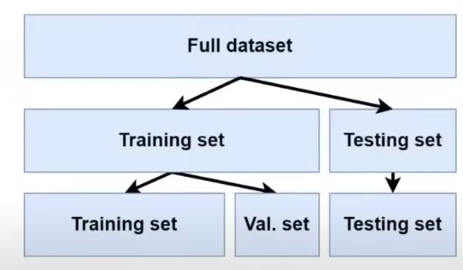We made predictions on the model trained within the scope of the project and the test data set. These prediction results are usually saved in a DataFrame and used for detailed analysis later. This step helped us understand how well the model matched real-world data.

Evaluation of Results:

The results obtained are evaluated according to the determined success criteria. The performance of the model is measured using metrics such as accuracy, precision, and recall. At this stage, we analyzed in which areas the model is strong and in which areas it is weak.

