Moving Average

Moving Averages are an indicator calculated by taking the average of the price of a financial instrument for a certain period. Moving averages are often used when performing technical analysis. Because the moving average can give a hint about the direction of price movement, as well as it is also used to determine support and resistance points.

The moving average is by its nature a delayed indicator. In other words, it occurs as a result of realized price movements. Therefore, it is used not to make forecasts for future price movements, but to provide analyses for the current state of the financial instrument.

Moving Averages are also the basis for other popular technical analysis indicators such as Bollinger Bands and MACD. In particular, the 50-day moving average, the 200-day moving average and the RSI indicator examination are among the most commonly used methods when performing the technical analysis of an investment instrument.

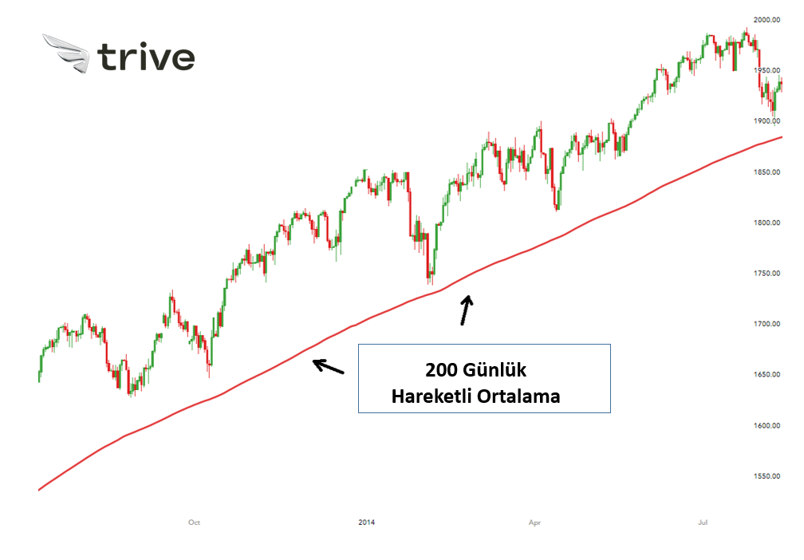

Feature Engineering

Model properties are the inputs that machine learning (ML) models use during training and inference to make predictions. The accuracy of the ML model is based on a precise set and combination of features. For example, features in an ML application that suggests a music playlist may include song scores, which songs have been listened to previously, and the song listening time. Creating the features may require significant engineering work. Feature engineering involves the process of extracting and converting variables from raw data, such as price lists, product descriptions, and sales volumes, so that you can use features for training and forecasting. Among the steps required to improve features are data extraction and Decontamination, followed by feature creation and storage.

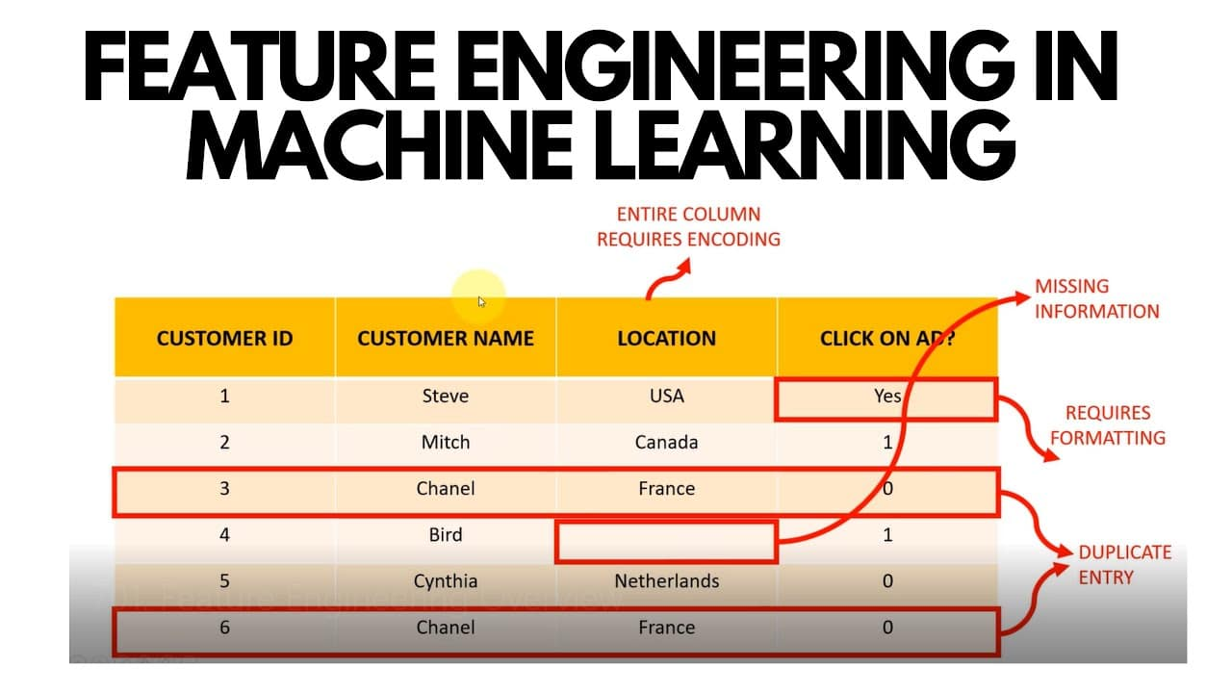

The features you use affect the result more than anything else. As far as I know, no algorithm can complete the information acquisition provided by the correct feature engineering alone. - Luca Massaron

metin, yazı tipi, ekran görüntüsü, tasarım içeren bir resim

Açıklama otomatik olarak oluşturuldu

Property Engineering with Moving Average

Moving Average with Feature Engineering refers to the process of using moving averages in feature engineering, particularly in the context of time series data. Here are the key components:

Simple Moving Average (SMA):

The Simple Moving Average calculates the arithmetic mean of data points over a specific time window (e.g., the last 10 days). It helps smooth out fluctuations in the time series and can highlight trends more clearly.

Exponential Moving Average (EMA):

The Exponential Moving Average is a type of moving average that assigns more weight to recent data points. This makes it more responsive to changes in trends. EMA is more adaptive compared to SMA.

Shifted Moving Averages:

Moving averages are often used by shifting them forward or backward in time. Shifting can be employed for predicting future values.

Choosing Window Size:

When using moving averages, selecting the window size (i.e., how many data points to include in the average) is crucial. The window size can be adjusted based on the characteristics of your dataset and the purpose of your analysis.

In Feature Engineering, moving averages can be applied to create new features by calculating averages over specific time windows. These features can capture trends, reduce noise, and provide insights into future values in time series data.

For example, if you have a time series dataset with daily sales information, you might calculate the 7-day moving average to smooth out daily fluctuations and highlight weekly trends. This new feature can then be used as input for machine learning models.

In summary, Moving Averages in Feature Engineering help derive meaningful insights from time series data by creating new features that capture trends and patterns over time.

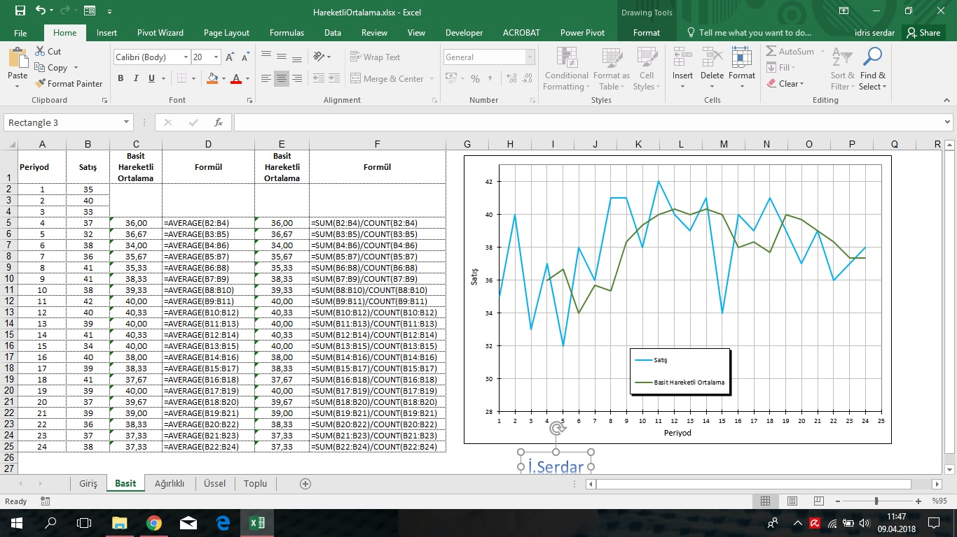Formun Üstü