**CENG327 - Hw-1**

Özlem KÜÇÜKSAĞIR 19050111021

1)

|  |  |
| --- | --- |
| Symbolic LU Elapsed Time | 3140.625 ms |
| Symbolic Inverse Elapsed Time | 6015.625 ms |
| Numeric LU Elapsed Time | 0.8169999928213656 ms |
| Numeric Inverse Elapsed Time | 0.15219999477267265 ms |

Numeric Inverse gave the fastest result. Additionally, numeric calculations are much faster than symbolic calculations.

2)

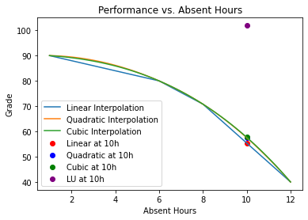

3)

