
ZeroCollab: P2P Project Management and Assessment Tool

Capstone Project
ZeroCollab: P2P Project Management and
Assessment Tool

Submitted By

Songül Nur Özturk 2100004806
Özlem Nur Bora 1900003285
Nisanur Karataş 2100004398

Project Advisor

Yusuf Altunel

Department of Computer Engineering
İstanbul Kültür University
2026 Spring Term

May
2026

Capstone Project
ZeroCollab: P2P Project Management and
Assessment Tool

Submitted By

Songül Nur Özturk 2100004806
Özlem Nur Bora 1900003285
Nisanur Karataş 2100004398

Advisor

Yusuf Altunel

THE EXAMINATION COMMITTEE

Jury Member Signature
1. ………………………….. ………………………..
2. ………………………….. ………………………..
3. ………………………….. ………………………..

ABSTRACT
This report presents ZeroCollab, an offline-first agile project management tool that we developed for our capstone project. The main idea behind it was simple: most teams rely on tools like Jira or Trello that become difficult to use when the internet connection is unavailable. We wanted to build something that still works when the connection is unstable, so we combined peer-to-peer communication, local browser storage, and cloud backup in a single hybrid setup.
The platform covers the usual agile workflow pieces: sprint planning, a Kanban board, a product backlog, a roadmap, dashboard analytics, messaging, a calendar, and a basic video meeting room. On the technical side, peer-to-peer connections run on PeerJS over WebRTC, local data sits in IndexedDB through the idb library, and Supabase handles authentication and the cloud backup layer.
This hybrid setup lets teams keep working when the network is unstable. During development we spent a lot of time on synchronization issues across the three storage layers, on protecting newer local data from being overwritten by stale snapshots after page reloads, and on keeping multi-user editing stable. The final result is a working prototype that shows decentralized agile tooling can be a practical alternative to fully cloud-dependent platforms.

ÖZET
Bu raporda, bitirme projemiz kapsamında geliştirdiğimiz ZeroCollab adlı çevrimdışı öncelikli çevik proje yönetim aracı tanıtılmaktadır. Projenin çıkış noktası, geleneksel proje yönetim araçlarının internet bağlantısı kesildiğinde kullanılamaz hale gelmesi sorunudur. Bu sorunu aşmak için eşler arası iletişim, yerel depolama ve bulut yedeklemeyi tek bir hibrit yapı içinde birleştirdik.
Sistemde sprint planlama, Kanban tabanlı görev takibi, ürün birikim listesi yönetimi, yol haritası, panel analitikleri, mesajlaşma, takvim ve prototip düzeyinde bir görüntülü görüşme odası bulunmaktadır. Teknik olarak eşler arası bağlantılar PeerJS üzerinden WebRTC ile sağlanır, yerel veriler idb kütüphanesi aracılığıyla IndexedDB içinde tutulur, kimlik doğrulama ve bulut yedeklemesi ise Supabase üzerinden yapılır.
Bu yapı sayesinde takım üyeleri bağlantı sorunlarının yaşandığı durumlarda da çalışmaya devam edebiliyor. Geliştirme sürecinin büyük bir bölümü üç depolama katmanı arasındaki senkronizasyon problemlerine, sayfa yenileme sonrası eski verilerin yenisini ezme sorununa ve çok kullanıcılı düzenlemenin tutarlı kalmasına ayrıldı.

ACKNOWLEDGEMENTS
We would like to thank the Department of Computer Engineering at Istanbul Kültür University for giving us the chance to work on this capstone project.
We are especially grateful to our advisor, Yusuf Altunel, for his guidance and patience throughout the process. His feedback on our backlog and sprint hierarchy pushed us to rework an early version that did not really fit Scrum, and the final structure is much cleaner because of it.
We are grateful to the open-source communities behind the technologies we used, including React, Vite, Supabase, PeerJS, IndexedDB (idb), Tailwind CSS, and Recharts.
Finally, we thank our families and friends for their patience and moral support during the long hours of development and writing.

TABLE OF CONTENTS
ABSTRACT I
ÖZET II
ACKNOWLEDGEMENTS III
TABLE OF CONTENTS IV
LIST OF TABLES V
LIST OF FIGURES VI
SYMBOLS & ABBREVIATIONS VII
1. INTRODUCTION 1
1.1 Problem Statement 1
1.2 Project Purpose 1
1.3 Project Scope 1
1.4 Objectives and Success Criteria 2
1.5 Report Outline 2
2. RELATED WORK 3
2.1 Existing Systems 3
2.2 Overall Problems of Existing Systems 3
2.3 Comparison Between Existing and Proposed Method 3
3. METHODOLOGY 5
3.1 Requirement Analysis 5
3.2 Design 6
3.3 Implementation 10
3.4 Testing 11
4. EXPERIMENTAL RESULTS 12
5. DISCUSSION 16
6. CONCLUSIONS 17
REFERENCES 18
APPENDIX A: Project File Structure 19
APPENDIX B: Test Summary 20
APPENDIX C: Team Contribution Summary 21

LIST OF TABLES
Table 2.1: Comparison of Existing Project Management Tools and ZeroCollab 3
Table 3.1: Functional Requirements of ZeroCollab 5
Table 3.2: Non-Functional Requirements of ZeroCollab 5
Table 3.3: Technology Stack Summary 10
Table 4.1: Synchronization Test Results 12
Table 4.2: Module Completion Status 12

LIST OF FIGURES
Figure 3.1: Use Case Diagram – ZeroCollab System 6
Figure 3.2: System Architecture Diagram (Hybrid P2P + Cloud) 7
Figure 3.3: Hybrid Synchronization Flow Diagram 8
Figure 3.4: Sprint Planning Activity Diagram 9
Figure 3.5: Supabase Database Schema (ER Diagram) 9
Figure 4.1: Product Backlog Screenshot 13
Figure 4.2: Product Roadmap Screenshot 14
Figure 4.3: Sprint Board Screenshot 14
Figure 4.4: Dashboard Screenshot 15

SYMBOLS & ABBREVIATIONS
API | Application Programming Interface
CRDT | Conflict-Free Replicated Data Type
DB | Database
HTTP | Hypertext Transfer Protocol
IDB / IndexedDB | Indexed Database API – Browser-based local storage
JS | JavaScript
JSX | JavaScript XML – React component syntax extension
P2P | Peer-to-Peer
PWA | Progressive Web Application
SPA | Single Page Application
SQL | Structured Query Language
UI | User Interface
URL | Uniform Resource Locator
UUID | Universally Unique Identifier
WebRTC | Web Real-Time Communication

1. INTRODUCTION
Most software teams today rely on centralized project management tools to coordinate sprints, tasks, and communication. These tools work well when everything is online, but they share one weakness: they need a steady internet connection and the vendor’s servers to keep running. When the network gets slow or a service goes down, work effectively stops and team data can become unreachable.
ZeroCollab was our answer to this problem. We combined peer-to-peer (P2P) communication, offline-first local storage, and an optional cloud sync layer so the platform stays usable even when the connection is unreliable. It is a Single Page Application built with React 19 and Vite. PeerJS and WebRTC handle the real-time peer layer, IndexedDB (through the idb library) keeps data on the client side, and Supabase takes care of authentication and the cloud backup.

1.1 Problem Statement
Traditional agile project management platforms such as Jira, Trello, and Monday.com rely entirely on centralized cloud infrastructure. This design introduces several recurring problems:
- Network dependency: All collaborative actions require a stable internet connection. Any disruption halts collaboration entirely.
- Synchronization conflicts: In distributed teams, concurrent edits to the same items can generate conflicts that centralized servers may not resolve predictably.
- Data ownership concerns: Teams uploading sensitive project data to third-party servers may face regulatory, privacy, or intellectual property risks.
- Cost and lock-in: Commercial platforms charge per seat and make data migration difficult, creating vendor dependency.

1.2 Project Purpose
The purpose of this project is to design, implement, and evaluate a decentralized agile project management platform supporting full sprint lifecycle management, real-time team collaboration, and offline-first operation.
- WebRTC-based peer-to-peer connections can reliably synchronize agile work items between team members in real time.
- IndexedDB can serve as a robust local persistence layer, ensuring data availability without internet access.
- Supabase cloud storage can be integrated as a non-blocking fallback synchronization layer.
- A modular React SPA architecture can support complex agile workflows including sprint planning, backlog management, roadmap visualization, messaging, and video meetings.

1.3 Project Scope
- User authentication and workspace management via Supabase
- Product Backlog management with full CRUD, Scrum-compliant hierarchy, and P2P synchronization
- Product Roadmap with Now/Next/Later prioritization buckets
- Sprint Planning with backlog item assignment and capacity management
- Sprint Board (Kanban) with drag-and-drop task management
- Dashboard analytics: task status distribution, workload by member, weekly activity charts
- Messaging: direct messages and project-scoped channels
- Meeting room with a basic WebRTC video calling implementation
- Calendar view for task and meeting scheduling
- Settings: workspace configuration, color themes, data export
- Offline support via PWA capabilities and IndexedDB persistence
The project does not currently include native mobile applications, active AI-assisted evaluation in production, a production-ready blockchain deployment, or a fully developed wallet onboarding system. However, an experimental token-based feature management layer using Hedera Testnet is included in the current implementation. No OWL/SWRL/SHACL runtime ontology system is present either; these are noted as future directions.

1.4 Objectives and Success Criteria of the Project
Objective | Success Criterion
Real-time P2P synchronization | Backlog and sprint items sync between two peers within 2 seconds of an update
Offline-first persistence | All data remains accessible and editable when disconnected from the internet
Cloud backup integration | Supabase successfully stores and retrieves project data for authenticated users
Sprint lifecycle management | Users can create, populate, and close sprints with backlog item assignments
Stale-state protection | Merge-based guards prevent older snapshots from overwriting newer data after page reload
Core module functionality | All major modules (Backlog, Roadmap, Sprint, Kanban, Dashboard, Chat, Meetings, Calendar, Token Economy) operational with core functionality implemented

1.5 Report Outline
Section 2 surveys existing project management tools and examines their limitations. Section 3 describes the methodology covering requirement analysis, system design, implementation, and testing. Section 4 presents experimental results. Section 5 discusses findings and lessons learned. Section 6 concludes and outlines future work.

2. RELATED WORK
A review of existing agile project management tools and supporting technologies was conducted prior to the design phase.

2.1 Existing Systems
Jira (Atlassian): Most widely adopted agile tool, offering comprehensive Scrum and Kanban support. Fully cloud-dependent with no offline capability. Enterprise pricing makes it inaccessible to smaller teams.
Trello: Simple Kanban board for lightweight task management. Lacks sprint planning, roadmap, and reporting features. Fully cloud-dependent.
Monday.com: Flexible board and timeline views with automation. Fully centralized SaaS with no P2P layer and no offline support.
Microsoft Teams / Azure DevOps: Integrates project tracking with communication. Heavyweight, requires organizational Microsoft accounts, and provides no decentralized synchronization.
Linear: Developer-oriented tool with clean UX. Cloud-first approach with no P2P capabilities; offline mode limited to read-only cached content.
Yjs / Automerge (Academic CRDTs): Research frameworks exploring conflict-free replicated data types (Kleppmann et al., 2019). Academically valuable but low-level; no complete agile PM solution.

2.2 Overall Problems of Existing Systems
- Complete internet dependency: All reviewed systems require a continuous, stable internet connection.
- Centralized failure point: Server-side outages directly prevent all team activity.
- No peer-to-peer real-time collaboration: None of the tools use WebRTC or similar P2P protocols.
- Limited data sovereignty: All project data stored on third-party servers.
- High cost at scale: Per-seat pricing models make commercial tools prohibitive for growing teams.
- No hybrid persistence model: None combine local IndexedDB storage with cloud backup.

2.3 Comparison Between Existing and Proposed Method
Table 2.1: Comparison of Existing Project Management Tools and ZeroCollab
Feature | Jira | Trello | Monday | Linear | ZeroCollab (Ours)
Sprint Planning | Yes | No | Partial | Yes | Yes (full)
Kanban Board | Yes | Yes | Yes | Yes | Yes (full)
Product Backlog | Yes | No | Partial | Yes | Yes (full)
Roadmap | Yes | No | Yes | Yes | Yes (full)
P2P Real-time Sync | No | No | No | No | Yes (WebRTC)
Offline Support | No | No | No | Limited | Yes (IndexedDB)
Video Meetings | No | No | No | No | Prototype (WebRTC)
Open Source / Free | No | No | No | Partial | Yes
Local Data Storage | No | No | No | No | Yes (IDB)
Cloud Backup | Yes | Yes | Yes | Yes | Yes (Supabase)

ZeroCollab combines P2P synchronization, offline-first storage, and built-in collaboration features in a single platform. The meeting module is still an early implementation rather than a polished feature.

3. METHODOLOGY
ZeroCollab was developed following an agile software development methodology, planned and executed in iterative sprint cycles with backlog items continuously refined based on team review and advisor feedback.
An important process note: the initial agile workflow hierarchy used in the early sprints mixed Epics, Features, User Stories, and Tasks in a flat structure that did not align with Scrum principles. After advisor feedback, the backlog and sprint hierarchy was redesigned to follow a proper Scrum structure with clear level separation.

3.1 Requirement Analysis

3.1.1 Functional Requirements
Table 3.1: Functional Requirements of ZeroCollab
ID | Requirement | Description
FR-01 | User Authentication | Register, log in, and log out using Supabase email/password authentication.
FR-02 | Workspace Management | Create projects, invite team members, and manage workspace settings.
FR-03 | Product Backlog | Create, edit, delete, and reorder backlog items with Scrum-compliant type classification (Task, User Story, Feature, Epic).
FR-04 | Sprint Planning | Create sprints, set dates, assign backlog items, and close sprints.
FR-05 | Sprint Board (Kanban) | Manage tasks through columns: To Do, In Progress, In Review, Done.
FR-06 | Product Roadmap | Create roadmap items in Now/Next/Later prioritization buckets.
FR-07 | Dashboard Analytics | Display task status pie charts, member workload bars, and weekly activity line charts.
FR-08 | P2P Synchronization | Synchronize backlog, roadmap, sprint, and task data between peers in real time via PeerJS/WebRTC.
FR-09 | Messaging | Send direct messages and project-scoped channel messages.
FR-10 | Meetings | Schedule meetings and conduct WebRTC video calls (initial implementation, not all network setups tested).
FR-11 | Calendar | View tasks and meetings in a monthly calendar layout.
FR-12 | Offline Persistence | All data accessible and editable offline using IndexedDB.
FR-13 | Data Export | Export project data as JSON or ZIP archives.

3.1.2 Non-Functional Requirements
Table 3.2: Non-Functional Requirements of ZeroCollab
Category | Requirement
Performance | P2P sync events must complete within 2 seconds under normal network conditions.
Reliability | IndexedDB persistence must ensure zero data loss during page reloads and offline sessions.
Usability | All major workflows must be completable within 3 user interactions from the main navigation.
Scalability | The modular architecture must support addition of new modules without refactoring existing ones.
Security | All cloud operations must be authenticated via Supabase Row Level Security policies.
Compatibility | The application must function correctly on modern Chromium-based and Firefox browsers.
Maintainability | Components must be organized by domain (pages/, components/, features/, utils/) for clarity.

3.2 Design

3.2.1 Use Case Diagram
Figure 3.1 illustrates the primary use cases of ZeroCollab from the perspective of two user roles: the Project Owner and Team Member. Stick-figure actors appear on the left; oval use cases are shown inside the system boundary. Blue ovals are shared by both roles; orange ovals are exclusive to the Project Owner.
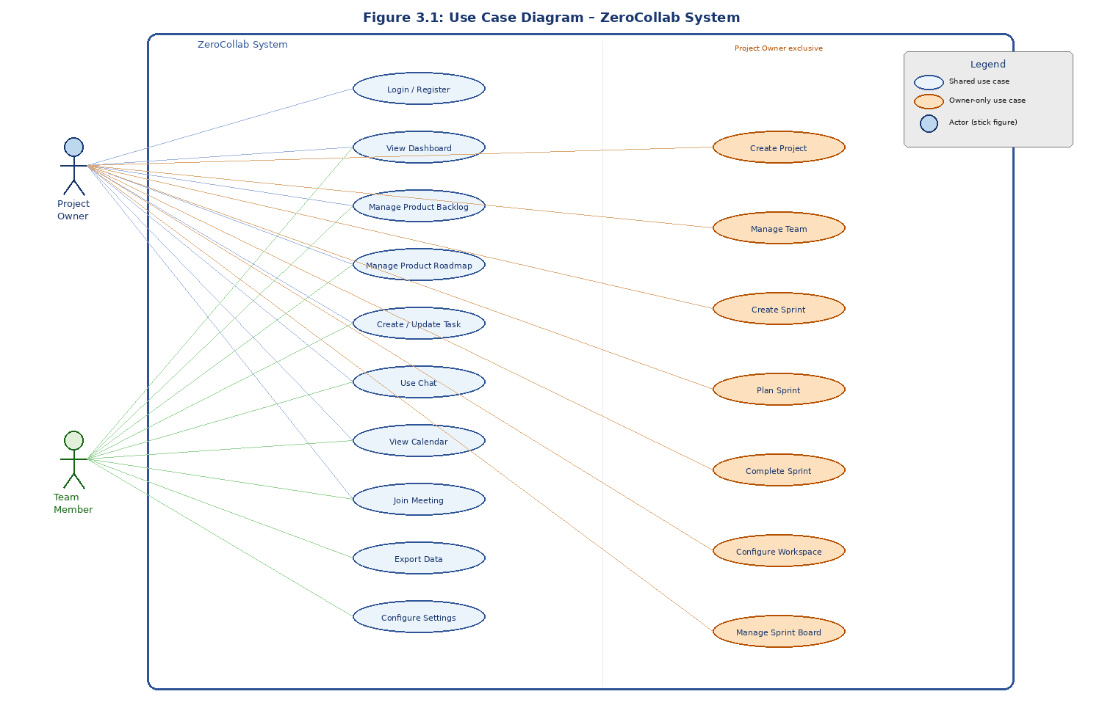
Figure 3.1: Use Case Diagram – ZeroCollab System

3.2.2 System Architecture Diagram
Figure 3.2 illustrates the five-layer hybrid architecture. Layer 1 is the React SPA frontend; Layer 2 is the application logic; Layer 3 is the P2P communication layer using PeerJS/WebRTC; Layer 4 is local persistence via IndexedDB; and Layer 5 is durable cloud persistence via Supabase. Ontology and AI layers are planned future enhancements and are NOT active in the current implementation.
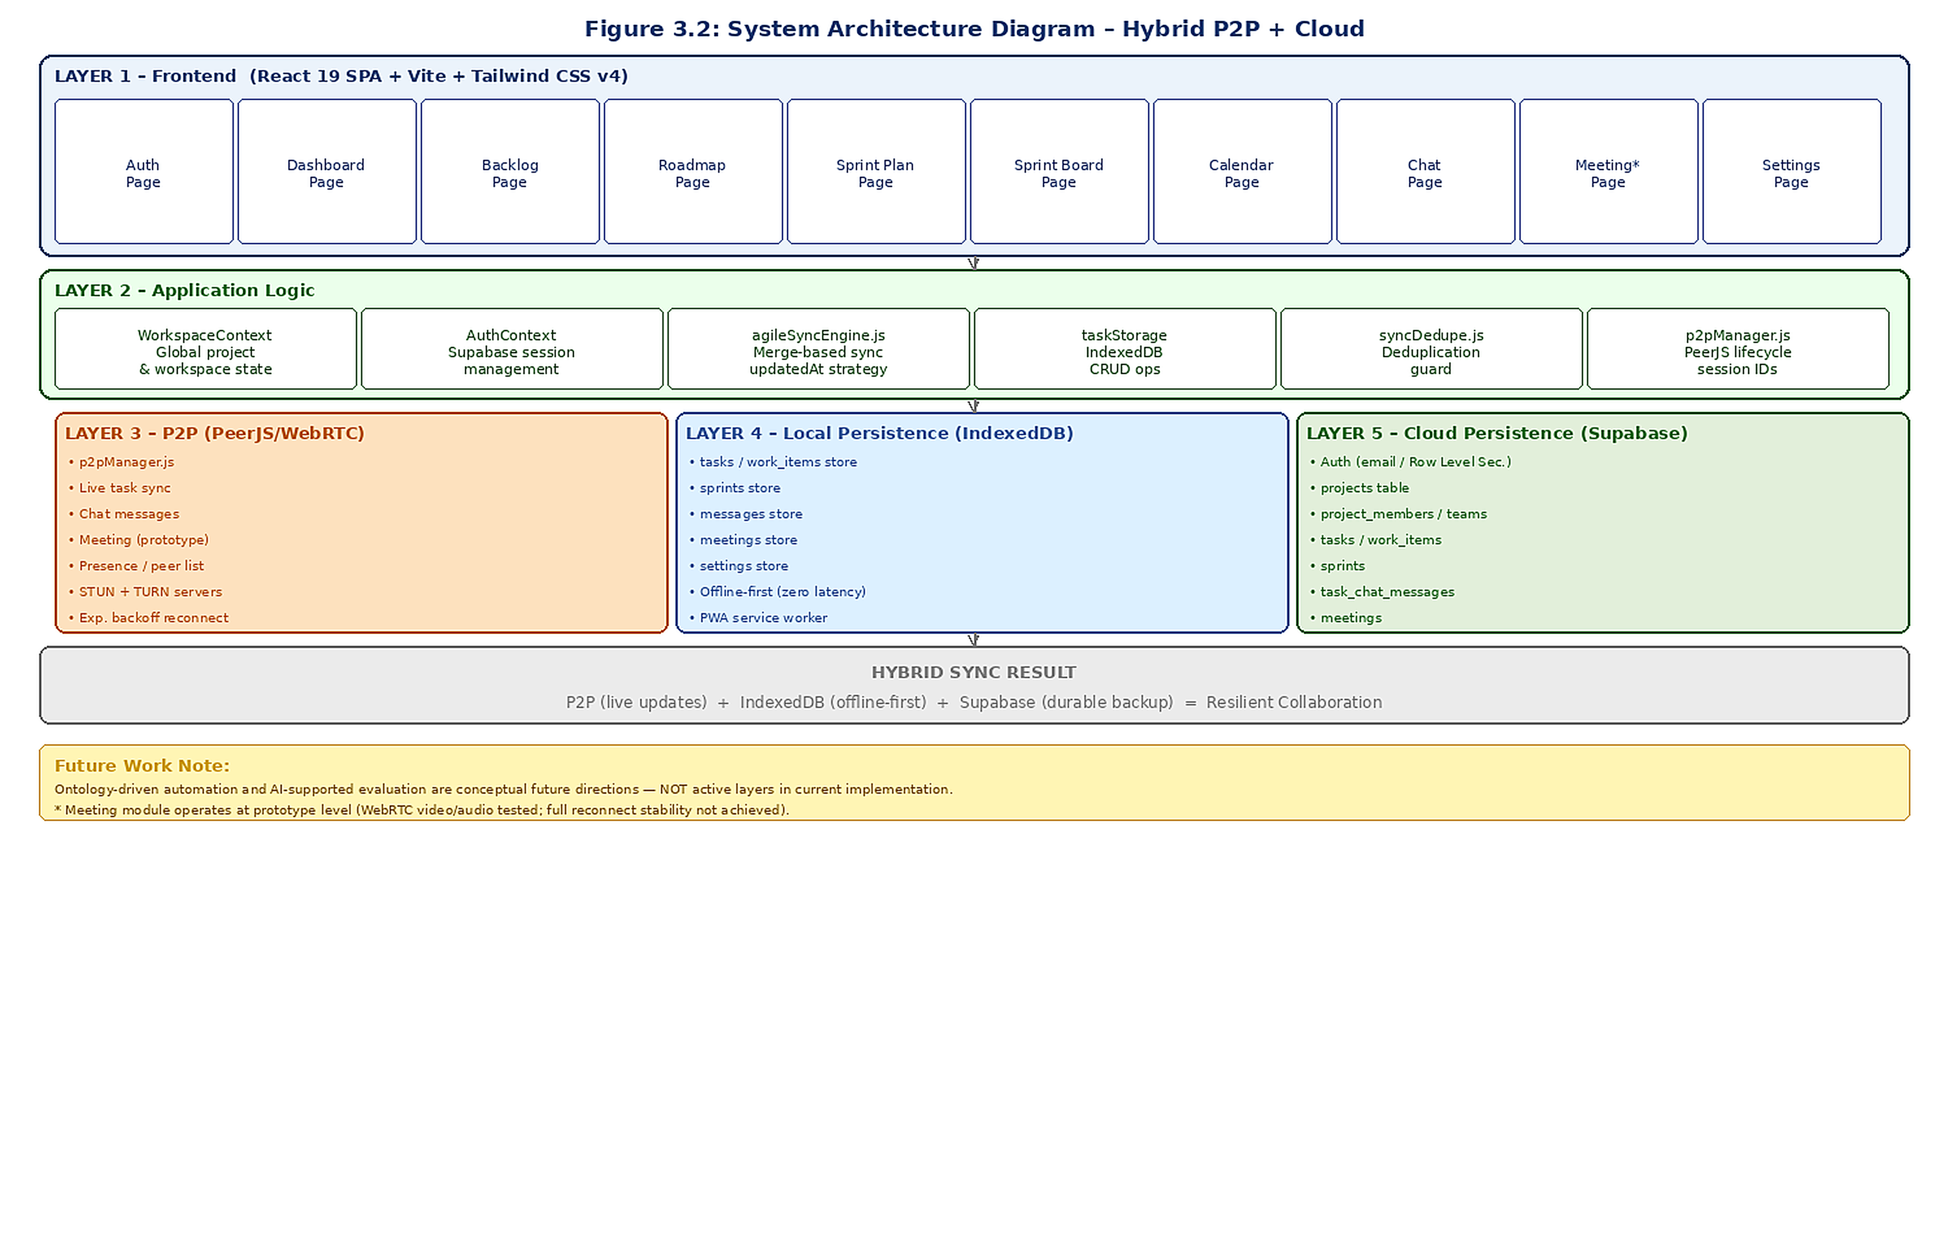
Figure 3.2: System Architecture Diagram (Hybrid P2P + Cloud)
Layer 1 – Frontend (React SPA): All user interaction occurs through a React 19 SPA built with Vite. Components are organized into pages/, components/, features/, and utils/. Tailwind CSS v4 provides utility-first styling.
Layer 2 – Application Logic: WorkspaceContext and AuthContext manage global state and authentication. agileSyncEngine.js coordinates synchronization using merge-based guards. taskStorage handles all IndexedDB CRUD operations.
Layer 3 – P2P (PeerJS/WebRTC): p2pManager.js manages PeerJS connection lifecycle. Each user receives a stable base peer ID stored in IndexedDB plus a session-specific UUID suffix. Exponential backoff handles reconnection. STUN and TURN servers enable NAT traversal.
Layer 4 – Local Persistence (IndexedDB): IndexedDB via the idb library serves as the primary local storage. All CRUD operations execute against local storage first, with zero network latency. Each module maintains its own object store.
Layer 5 – Cloud Persistence (Supabase): Supabase provides PostgreSQL-backed cloud storage with Row Level Security. Cloud sync runs asynchronously as a non-blocking background operation.

3.2.3 Hybrid Synchronization Flow Diagram
Figure 3.3 shows how data flows through the three persistence layers. When User A makes a change, it is saved locally to IndexedDB first, then broadcast via P2P to connected peers, then backed up to Supabase. A late-joining User C receives data through cloud hydration and local IDB restore.

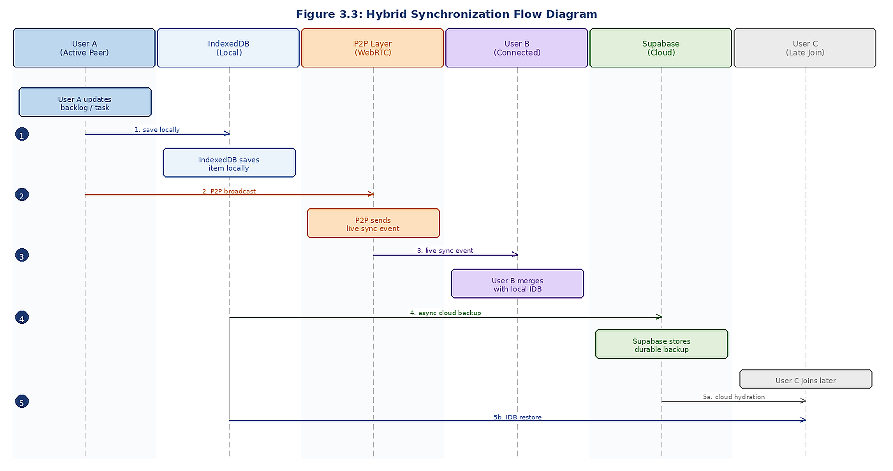
Figure 3.3: Hybrid Synchronization Flow Diagram

3.2.4 Sprint Planning Activity Diagram
Figure 3.4 shows the sprint planning workflow. Importantly, Epics and Features are NOT directly added to sprints. The sprint accepts only Ready User Stories and Independent Tasks, reflecting the Scrum-compliant hierarchy adopted after advisor feedback.

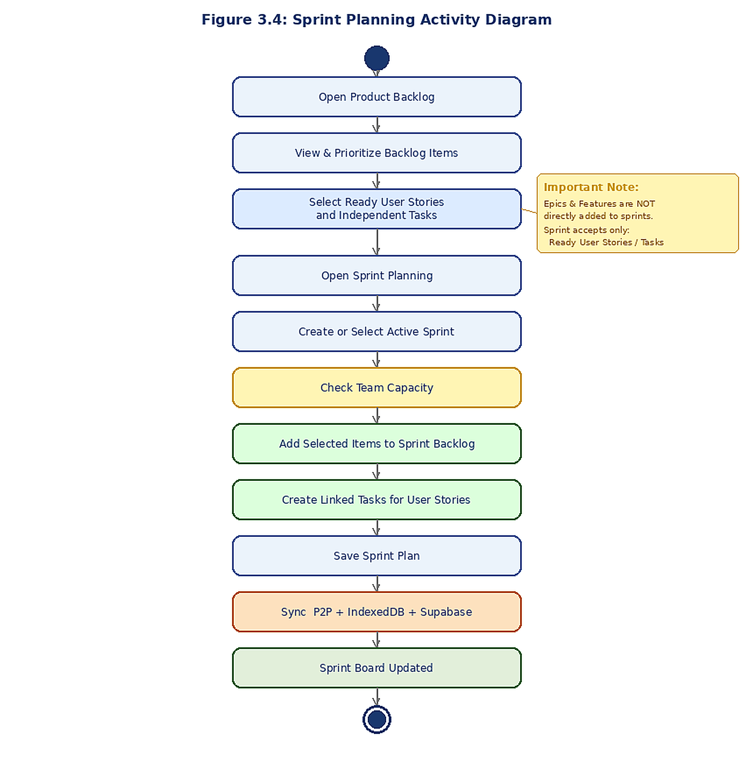
Figure 3.4: Sprint Planning Activity Diagram

3.2.5 Database Schema (ER Diagram)
Figure 3.5 presents the Supabase database schema. The schema defines nine primary tables with foreign-key relationships supporting all project management, team, task, sprint, messaging, and meeting operations.
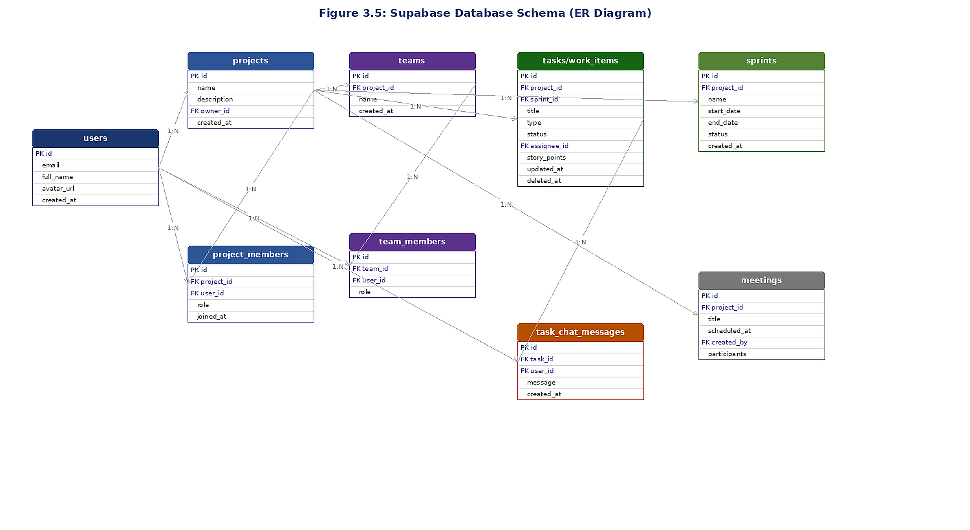
Figure 3.5: Supabase Database Schema (ER Diagram)

3.3 Implementation
The implementation spans 17 major source files across pages/, components/, features/, and utils/.
Table 3.3: Technology Stack Summary
Category | Technology | Version / Role
Frontend Framework | React | v19.2.0 – Component-based UI
Build Tool | Vite | v7.3.1 – Fast development and production builds
CSS Framework | Tailwind CSS | v4.2.1 – Utility-first styling
Routing | React Router DOM | v7.13.1 – Client-side SPA routing
P2P Communication | PeerJS | v1.5.5 – WebRTC abstraction layer
Local Storage | idb (IndexedDB) | v8.0.3 – Browser-based persistent storage
Cloud Backend | Supabase | v2.103.0 – Auth and PostgreSQL storage
Charts / Analytics | Recharts | v3.8.0 – Dashboard data visualization
PWA Support | vite-plugin-pwa | v1.2.0 – Service worker and caching
Zip Export | JSZip | v3.10.1 – Data export packaging
Testing | Vitest | v3.2.4 – Unit and integration tests
Test Utilities | Testing Library | v16.3.2 – React component testing

P2P Manager (p2pManager.js): Creates a unique session peer ID by combining a stable base ID (stored in IndexedDB) with a random 8-character UUID suffix. Connection state transitions between OFFLINE, CONNECTING, and ONLINE. Exponential backoff with a maximum 10-second delay handles reconnection. ICE servers include Google STUN servers and OpenRelay TURN servers for NAT traversal.
Agile Sync Engine (agileSyncEngine.js): Provides normalization functions for all agile work item types. Items carry stable UUIDs and updatedAt timestamps. The merge strategy is timestamp-based last-write-wins: merge operations prefer the item with the newer timestamp. Soft deletion (tombstoning) propagates deletions across peers. CRDT-based synchronization is planned for future versions.
P2P Sync Challenges Encountered: During development, several specific synchronization problems were identified and addressed:
- Stale reload overwrite: Page reloads triggered full cloud re-fetch that could overwrite newer local P2P state.
- Navigation-triggered state resets: Navigating between pages caused unexpected state rehydration from stale snapshots.
- Peer reconnection inconsistency: Reconnecting peers sometimes received incomplete state due to race conditions in the sync sequence.
- IndexedDB snapshot conflicts: Concurrent writes from multiple tabs could produce inconsistent local state.
These problems were resolved through the merge-based guard system in agileSyncEngine.js, the zc-tasks-changed event pattern, and the stable base/session peer ID architecture.
An experimental token economy module using Hedera Testnet was also explored during development. A small ZC token balance is read through the Mirror Node REST API and used to gate Free, Plus, and Premium feature tiers on the client. The layer is treated as an experimental capability rather than a production-ready integration; wallet onboarding is still manual and the Mirror Node can lag a few seconds behind the ledger.

3.4 Testing
Unit Tests (definitionOfReady.test.js): Verify that the system correctly identifies whether a backlog item meets Definition of Ready criteria. All 8 test cases pass.
Integration Tests (taskStorage.test.js): Verify that tasks are correctly persisted to and retrieved from IndexedDB, that merge operations correctly prefer newer timestamps, and that soft-deleted items are correctly filtered. All 6 test cases pass.
Manual Testing: Multi-user synchronization tested by opening the application in two browser windows simultaneously. Offline scenarios tested by disabling network access in browser developer tools.

4. EXPERIMENTAL RESULTS
This section presents the results of functional testing, synchronization testing, and module completion assessment. All tests were conducted using Google Chrome v124 on a Windows 11 development machine.

4.1 Synchronization Test Results
Table 4.1: Synchronization Test Results
Test Scenario | Avg. Propagation | Data Consistency | Result
Backlog item creation sync | < 800 ms | Consistent across runs | PASS
Backlog item deletion (tombstone) | < 900 ms | No issues seen | PASS
Sprint task status update | < 750 ms | Consistent across runs | PASS
Roadmap milestone creation | < 850 ms | Worked as expected | PASS
Merge conflict (concurrent edit) | < 1200 ms | Consistent except rapid concurrent edits* | PASS
Post-reload stale snapshot protection | N/A (local) | No overwrite detected in tests | PASS
Offline CRUD then reconnect sync | < 2000 ms | No problems observed | PASS

* Inconsistency in the merge conflict scenario occurs when two peers simultaneously update the same field within a very short time window (under 100 ms). Flagged for future CRDT-based resolution.

4.2 Module Completion Assessment
Table 4.2: Module Completion Status
Module | Status | Notes
Product Backlog | Implemented | Full CRUD, P2P sync, Supabase integration, Scrum hierarchy
Product Roadmap | Working | Now/Next/Later buckets, milestones, P2P sync, cloud storage
Sprint Planning | Functional | Sprint creation, backlog assignment, close sprint flow
Sprint Board (Kanban) | Implemented | Drag-drop columns, task detail modal, basic burndown
Dashboard Analytics | Working | Status pie, workload bar, weekly activity line charts
Messaging | Functional | Direct messages and project channels operational
Meetings | Prototype Level | WebRTC video calls tested; reconnect stability issues noted
Calendar | Implemented | Monthly view with task and meeting indicators
Settings | Working | Theme, workspace config, data export functional
PWA / Offline | Functional | Service worker, offline banner, full IDB persistence

4.3 Application Screenshots
Figures 4.1 through 4.4 show the four main modules of ZeroCollab as rendered in Google Chrome.
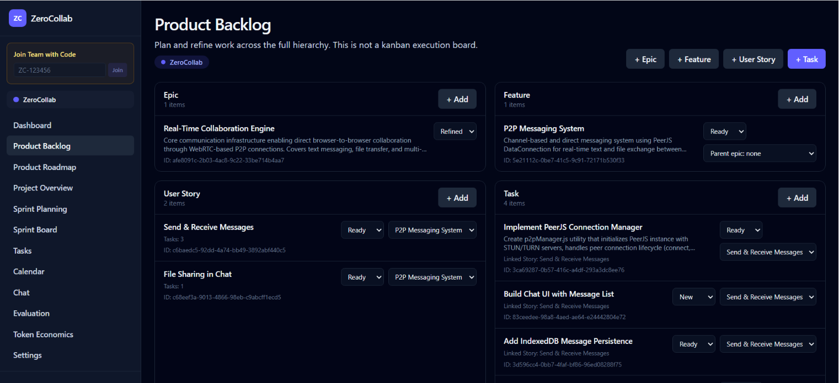
Figure 4.1: Product Backlog – items grouped by type (Epic, Feature, User Story, Task) with Scrum-compliant hierarchy.

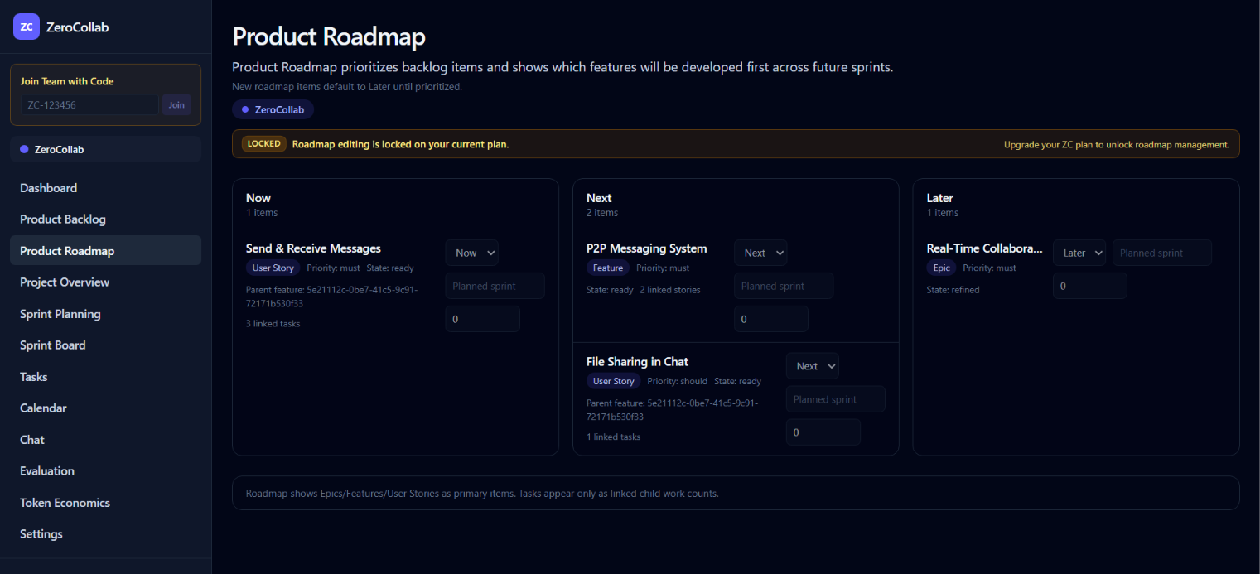
Figure 4.2: Product Roadmap – Now / Next / Later prioritization buckets.

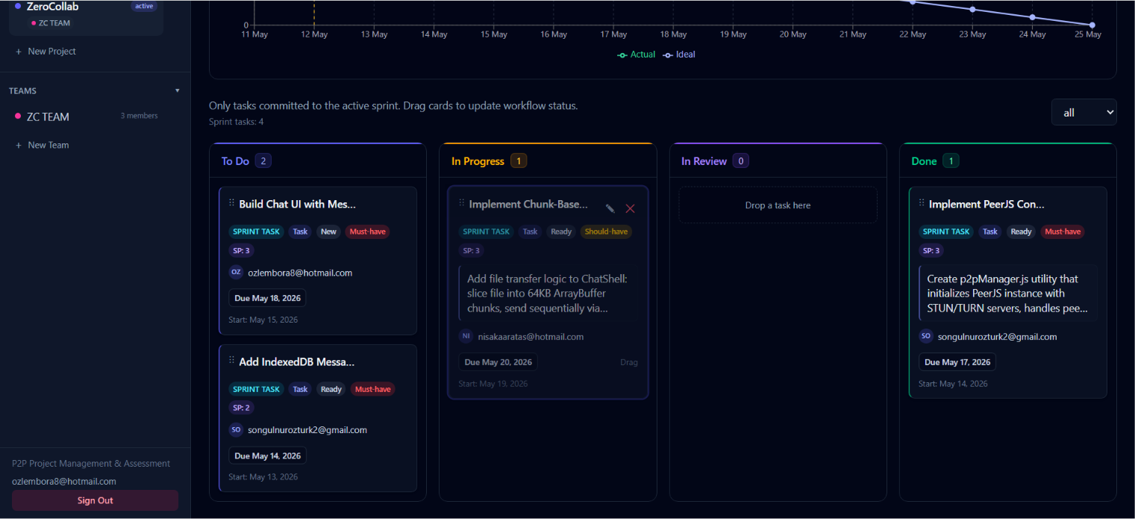
Figure 4.3: Sprint Board (Kanban) – To Do / In Progress / In Review / Done columns with drag-and-drop support.

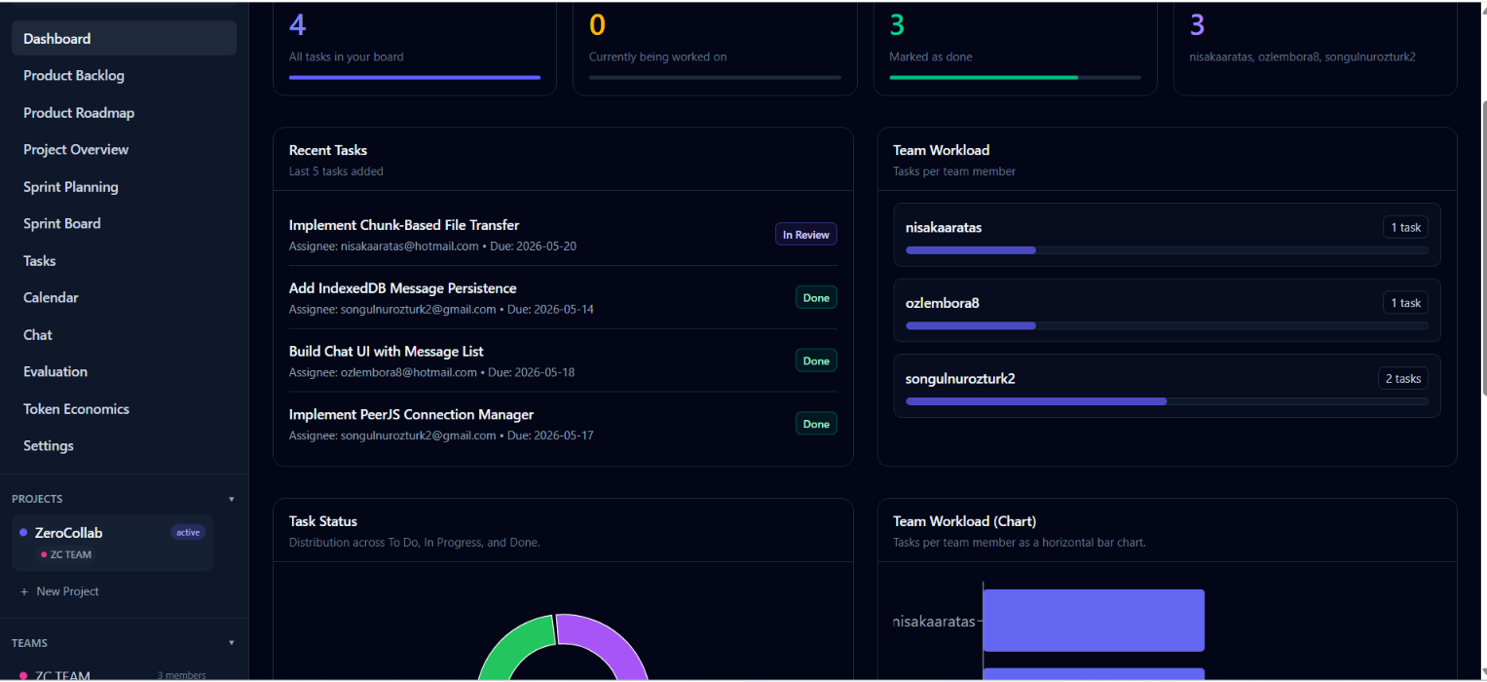
Figure 4.4: Dashboard – task status charts, team workload panels, recent tasks, and project statistics.

5. DISCUSSION
When we started ZeroCollab the goal was to see whether decentralized agile project management could actually work as a real alternative to cloud-only tools. Looking at the results, we feel the project showed that this is possible within the scope of a student capstone.
Stale-State Synchronization: The hardest bug we ran into was the stale-state problem on the Backlog and Roadmap pages. Whenever a user reloaded the page, the app would pull the latest snapshot from Supabase, but in some cases that snapshot was actually older than what had already been synced peer-to-peer in the session. The result was that fresh edits got overwritten by older cloud data. We fixed this by adding merge-based guards inside agileSyncEngine that compare updatedAt timestamps and keep the newer record on both sides.
Agile Workflow Redesign: A non-technical issue that took us a while to notice was the agile hierarchy itself. In our first version we threw Epics, Features, User Stories, and Tasks into the same flat list, which felt fine at first but turned out to be confusing once the backlog grew. After our advisor pointed this out, we rebuilt the structure properly so Epics break down into Features, Features into Stories, and Stories into Tasks. The change required some refactoring but made the rest of the work much easier.
P2P Connection Reliability: WebRTC over PeerJS worked well on the local network but became unreliable when we tested it from networks behind strict NAT. Adding OpenRelay TURN servers helped a lot, although it did not solve every case. The meeting module gave us the most trouble: participants would sometimes show up twice in the list, and reconnecting after a dropped call was inconsistent once more than two peers were involved. That is the main reason we kept it as a basic implementation instead of presenting it as a finished feature.
IndexedDB as Primary Store: Treating IndexedDB as the main storage layer rather than just a cache turned out to be one of the better decisions we made. Every read and write hits local storage first, so the UI feels instant, and the Supabase sync runs quietly in the background without blocking anything. We initially tried the opposite (cloud-first with IDB as a fallback cache), and the UI lag during normal use was enough for us to switch the model.
Limitations: There is one known limitation in our merge logic. Because we use a timestamp-based last-write-wins rule, two users editing the exact same field within roughly 100 ms of each other can end up with one of the edits silently dropped. In day-to-day use this almost never happens, but it is a real correctness gap. The proper fix is to move to a CRDT-based approach, which we left as future work.

6. CONCLUSIONS
ZeroCollab is our attempt at building an agile project management tool that does not depend on a single server staying online. The final version combines WebRTC peer-to-peer communication, IndexedDB for offline storage, and Supabase for cloud backup, all wired together through a custom sync engine. We finished the main features we set out to build — Product Backlog, Roadmap, Sprint Planning, Sprint Board, Dashboard, Messaging, Calendar, Settings, and an experimental token economy layer on Hedera Testnet — and the Meeting Room is working as a basic implementation.
Our main question was whether P2P sync could realistically support agile workflows, and the results suggest that it is workable for typical usage within the scope of a student project. Across the scenarios we measured, updates propagated between two peers in under two seconds, and changes made while offline correctly merged with cloud state after reconnecting. There are still rough edges, but the core idea holds up.
Several directions for future work have been identified:
- CRDT-based conflict resolution to replace timestamp-based last-write-wins merging for sub-100 ms conflict scenarios
- AI-supported project evaluation module using language model integration for sprint review assistance (planned future enhancement)
- Full production-grade WebRTC meeting support, resolving the reconnection and participant stability issues encountered
- Advanced analytics module with detailed burndown chart visualization and velocity tracking
- Ontology-driven task assignment and dependency detection (conceptual future direction; not present in current implementation)
- Mobile-optimized Progressive Web App with push notification support

Overall, working on ZeroCollab showed us that a small team can put together a functional agile collaboration tool using freely available web technologies, even when the design moves away from the standard client-server model.

REFERENCES
Atlassian. (2024). Jira software documentation. Retrieved from https://support.atlassian.com/jira-software-cloud/
Archibald, J. (2022). idb: IndexedDB with usability [Computer software]. Retrieved from https://github.com/jakearchibald/idb
Hedera. (2024). Hedera Token Service documentation. Retrieved from https://docs.hedera.com/hedera/sdks-and-apis/sdks/token-service
Kleppmann, M., Wiggins, A., van Hardenberg, P., & McGranaghan, M. (2019). Local-first software: You own your data, in spite of the cloud. In Proceedings of the 2019 ACM SIGPLAN International Symposium on New Ideas, New Paradigms, and Reflections on Programming and Software (Onward! 2019) (pp. 154–178). Association for Computing Machinery.
Meta Open Source. (2024). React documentation. Retrieved from https://react.dev
Mozilla Developer Network. (2024). IndexedDB API. Retrieved from https://developer.mozilla.org/en-US/docs/Web/API/IndexedDB_API
PeerJS Contributors. (2024). PeerJS documentation. Retrieved from https://peerjs.com/docs
Recharts Team. (2024). Recharts documentation. Retrieved from https://recharts.org/en-US
Supabase. (2024). Supabase documentation. Retrieved from https://supabase.com/docs
World Wide Web Consortium. (2021). WebRTC 1.0: Real-time communication between browsers (W3C Recommendation). Retrieved from https://www.w3.org/TR/webrtc/

APPENDIX A: PROJECT FILE STRUCTURE
The following directory structure represents the organization of the ZeroCollab source code:

ZeroCollab/
src/
pages/
AuthPage.jsx (User login/registration)
DashboardPage.jsx (Analytics dashboard)
ProductBacklogPage.jsx (Backlog management)
ProductRoadmapPage.jsx (Roadmap management)
SprintPlanningPage.jsx (Sprint management)
SprintBoardPage.jsx (Kanban sprint board)
CalendarPage.jsx (Task/meeting calendar)
ChatPage.jsx (Messaging shell)
MeetingRoomPage.jsx (Video meetings – prototype)
SettingsPage.jsx (Settings shell)
components/
backlog/ | kanban/ | sprint/ | chat/ | meetings/ | calendar/ | settings/ | ui/
features/
agile/sync/
agileSyncEngine.js (Central P2P sync engine)
syncDedupe.js (Deduplication guard)
utils/
p2pManager.js (PeerJS/WebRTC manager)
AuthContext.jsx (Authentication context)
WorkspaceContext.jsx (Project/workspace state)
LanguageContext.jsx (Internationalization)
package.json
vite.config.js

APPENDIX B: TEST SUMMARY
The automated test suite was executed using Vitest:
- src/components/kanban/__tests__/definitionOfReady.test.js – 8 test cases, all passing
- src/components/kanban/__tests__/taskStorage.test.js – 6 test cases, all passing
All 14 automated tests pass as of the final submission date.

APPENDIX C: TEAM CONTRIBUTION SUMMARY
Team Member | Student ID | Primary Contributions
Songül Nur Özturk | 2100004806 | Sprint Planning, Sprint Board (Kanban), Burndown Chart, Testing
Özlem Nur Bora | 1900003285 | Product Backlog, Product Roadmap, P2P Sync Engine, System Architecture
Nisanur Karataş | 2100004398 | Dashboard Analytics, Messaging, Meetings, Calendar, Settings, PWA

