***ANALYSIS***

**Subject and Summary**

First of all, the aims and needs of the project were determined. The project also aimed to provide the user with the best possibilities. The ease of design is designed to be the most comfortable. The interface was created in the NetBeans program. Tables were adapted to the program with MY SQL Server.

**Needs Analysis**

The subject of the project was determined as the hospital appointment system. The list was prepared to meet the needs of the user from the construction stage.

**Media Analysis**

The media required for automation were determined. The needs analysis of the personal computer and necessary programs we need were made and loaded. The programming language to be used has been selected. Database program has been determined and provided for database connection.

1. **Environment Analysis**

The project was developed electronically. Java was chosen as the coding language. It was decided that the most suitable platform for the language was NetBeans. The user environment was developed to be used even on a personal computer.

1. **What is the purpose of its construction?**

The aim of the project is to enable the user to use this automation comfortably. Considering these, I try to make the most comfortable and useful automation application.

**Components and Tasks of the Project**

* Patient Login
* Doctor Login
* Clinic
* Patient Registration
* Password Update
* Choosing Date and Time and a Doctor
* Confirmation Screen

My hospital automation system that I will design consists of two parts;

***Patient Login***

In this section, the user can login with the ID number and password. Also, I tried to design my designed LOGINPAGE form so that the user can focus. For example, colors, design and contents.

This focus,it enables users to adapt to this system more comfortably and to increase its usage.

There are also New Account, Remember ME and Forget Password sections in the LOGINPAGE form.

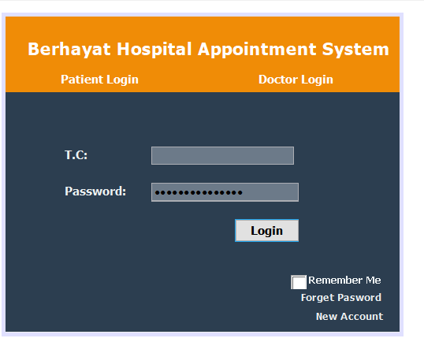

***Doctor Login***

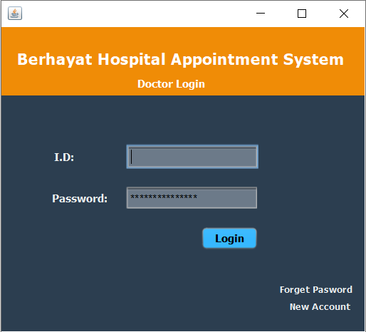

**Doctor’s Patient Screen**

Doctors can see the patient information entered in the system and the appointment time in this table.

Error: None of these commands work because I can't connect to SQL.

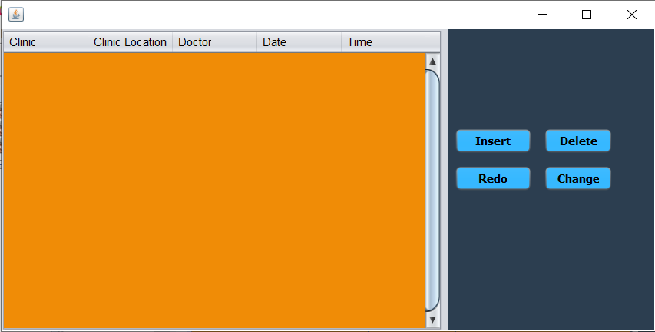

***Forget Password***

When the user forgets his / her password, a password reminder is made from this part of the system. 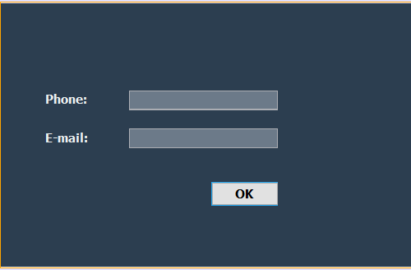

***New Account***

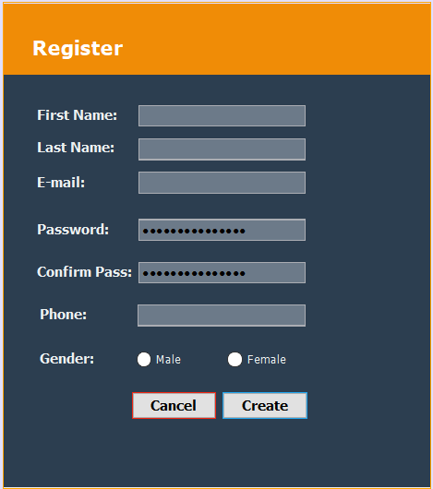If the user does not have an account, it is necessary to be a member of this section to log in to the system.

***Appointment Screen***

The user searches here by selecting the department and doctor, and then comes to the date and time forum.

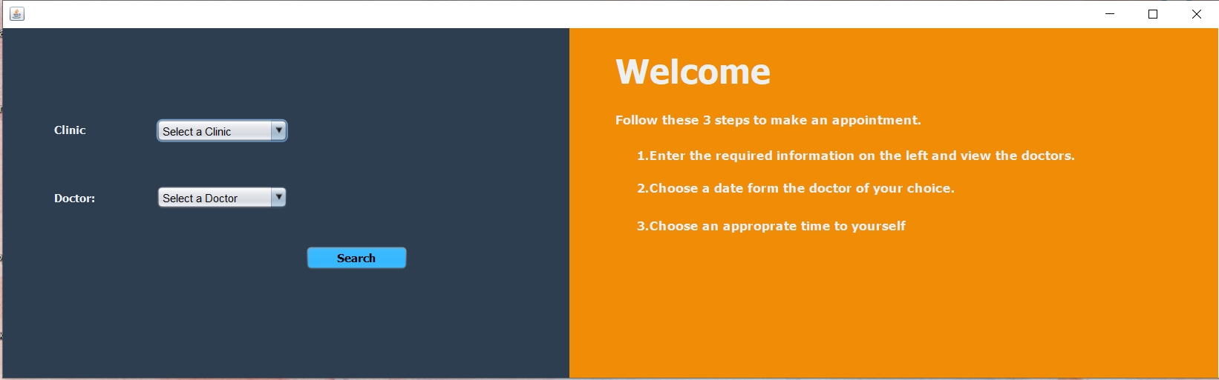

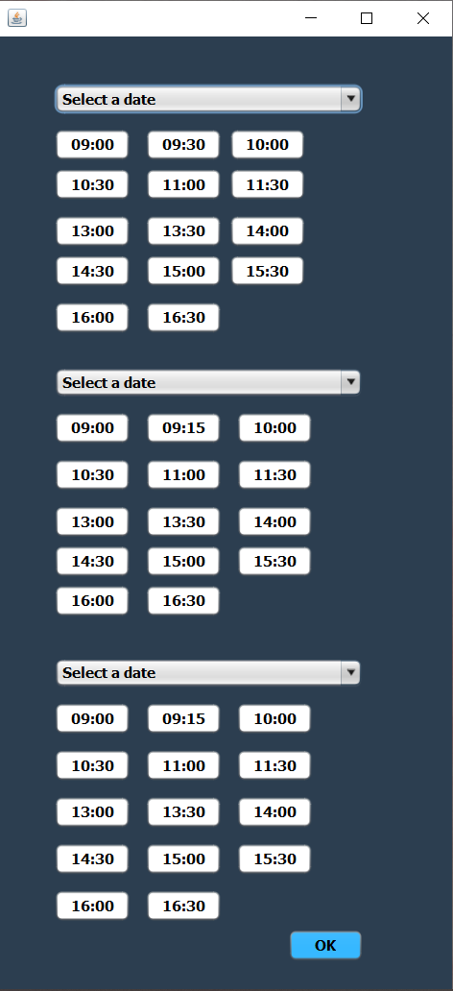***Date and Time***

After the user switches to this screen, they come across a choice of 3 months. They have to choose the time they want on the date they want.

Error: After choosing the time and date, I aimed to register on the system but I couldn't do it.

***Confirmation Screen***

After all the choices about the appointment are made, the confirmation screen appears.

Error: I aimed to show the information entered by the user on this screen, but I could not do it because I did not know how to write the code.

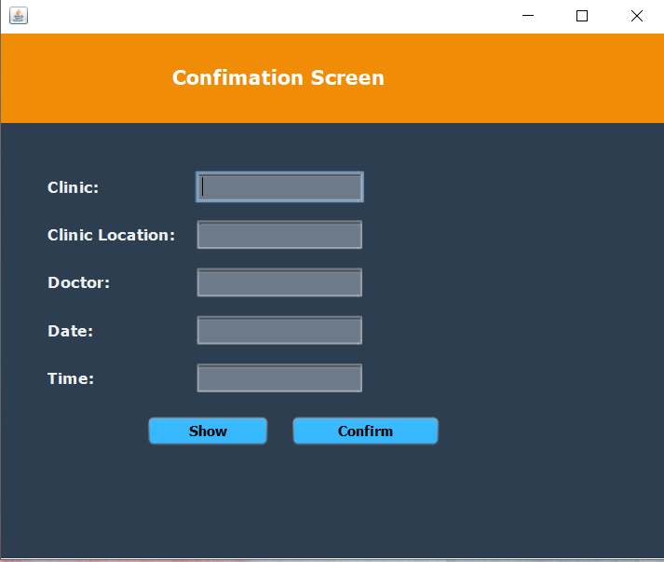

***Show***

The selected operations will appear in this table. In this section, adding, removing, deleting and changing operations can be made.

Error: None of these commands work because I can't connect to SQL.

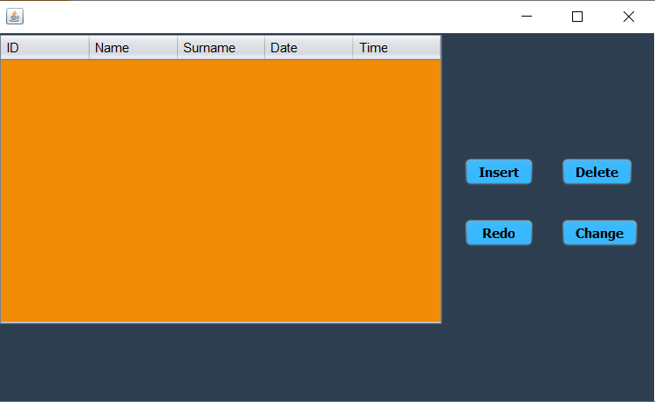

***Complete***

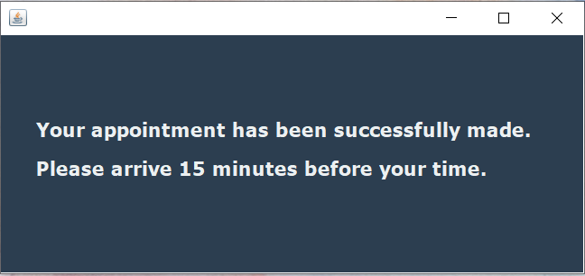

**Sections from the Project**

The screens used in the project were checked one by one, necessary arrangements were made and the revisions were finalized.

**User's Guide**

The platform used for the software is the NetBeans IDE interface. Necessary information was specified.

**Evaluation**

During the evaluation phase, the design and development stages of the project were reviewed step by step. User needs were taken into consideration.