1. 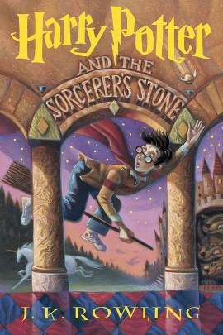Title --Harry Potter and the Sorcerer's Stone (1997)
2. type- fantasy novel
3. Author - J.K. Rowling
4. Description-[Harry Potter](https://en.wikipedia.org/wiki/Harry_Potter_(character)) lives with his abusive uncle and aunt, [Vernon](https://en.wikipedia.org/wiki/Vernon_Dursley) and [Petunia Dursley](https://en.wikipedia.org/wiki/Petunia_Dursley), and their bullying, spoiled son, [Dudley](https://en.wikipedia.org/wiki/Dudley_Dursley). On Harry's eleventh birthday, he learns that he is a wizard. A man named [Rubeus Hagrid](https://en.wikipedia.org/wiki/Rubeus_Hagrid) tells him that he can attend [Hogwarts](https://en.wikipedia.org/wiki/Hogwarts), a school of magic. Hagrid explains that when Harry was an infant, a [Dark](https://en.wikipedia.org/wiki/Dark_arts_(Harry_Potter)) wizard named [Voldemort](https://en.wikipedia.org/wiki/Lord_Voldemort) murdered his parents and tried to kill him as well. However, Voldemort's [killing curse](https://en.wikipedia.org/wiki/Avada_Kedavra) rebounded and seemingly destroyed him, leaving a lightning bolt-shaped scar on Harry's forehead. Unbeknownst to Harry, this event made him famous among wizards.

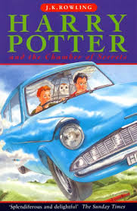

1. Title --Harry Potter and the Chamber of Secrets
2. type- fantasy novel
3. Author - J.K. Rowling
4. Description-The plot follows Harry's second year at Hogwarts School of Witchcraft and Wizardry, during which a series of messages on the walls of the school's corridors warn that the "Chamber of Secrets" has been opened and that the "heir of Slytherin" would kill all pupils who do not come from all-magical families

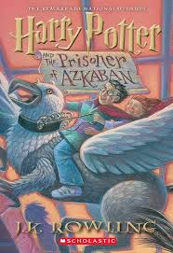

1. Title -- Harry Potter and the Prisoner of Azkaban – Fantasy, Adventure (1999)
2. type- fantasy novel
3. Author - J.K. Rowling
4. Description - For twelve long years, the dread fortress of Azkaban held an infamous prisoner named Sirius Black. Convicted of killing thirteen people with a single curse, he was said to be the heir apparent to the Dark Lord, Voldemort.  
   Now he has escaped, leaving only two clues as to where he might be headed: Harry Potter's defeat of You-Know-Who was Black's downfall as well. And the Azkban guards heard Black muttering in his sleep, "He's at Hogwarts...he's at Hogwarts."  
   Harry Potter isn't safe, not even within the walls of his magical school, surrounded by his friends. Because on top of it all, there may well be a traitor in their midst.

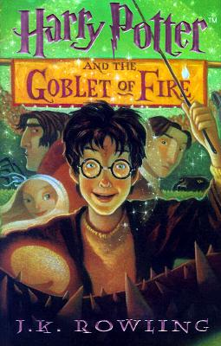

1. Title -- Harry Potter and the Goblet of Fire
2. type- fantasy novel
3. Author - J.K. Rowling
4. Description - It is the fourth novel in the Harry Potter series. It follows Harry Potter, a wizard in his fourth year at Hogwarts School of Witchcraft and Wizardry, and the mystery surrounding the entry of Harry's name into the Triwizard Tournament, in which he is forced to compete.

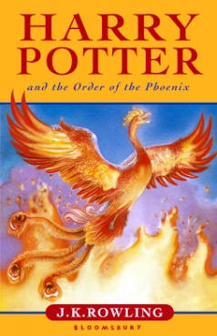

1. Title -- Harry Potter and the Order of the Phoenix – Fantasy, Adventure (2003)
2. type- fantasy novel
3. Author - J.K. Rowling
4. Description - Harry Potter and the Order of the Phoenix is a fantasy novel written by British author J. K. Rowling. It is the fifth and longest novel in the Harry Potter series. It follows Harry Potter's struggles through his fifth year at Hogwarts School of Witchcraft and Wizardry, including the surreptitious return of the antagonist Lord Voldemort, O.W.L. exams, and an obstructive Ministry of Magic.

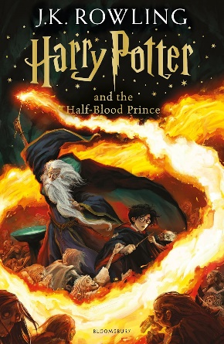

1 title - Harry Potter and the Half-Blood Prince – Fantasy, Adventure (2005)

2 type- fantasy

3 Author-J.K Rowling

4 description- Harry Potter and the Half-Blood Prince is a fantasy novel written by British author J. K. Rowling. It is the sixth and penultimate novel in the Harry Potter series, and takes place during Harry Potter's sixth year at the wizard school Hogwarts. The novel reveals events from the early life of Lord Voldemort, and chronicles Harry's preparations for the final battle against him.

1 title - Harry Potter and the Deathly Hallows – Fantasy, Adventure (2007)

2 type- fantasy

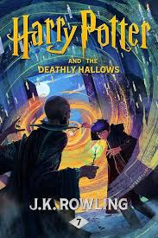3 Author-J.K Rowling

1. description-Harry Potter and the Deathly Hallows is a fantasy novel written by British author J. K. Rowling. It is the seventh and final novel in the Harry Potter series.The novel chronicles the events directly following Harry Potter and the Half-Blood Prince (2005) and the final confrontation between the wizards Harry Potter and Lord Voldemort.

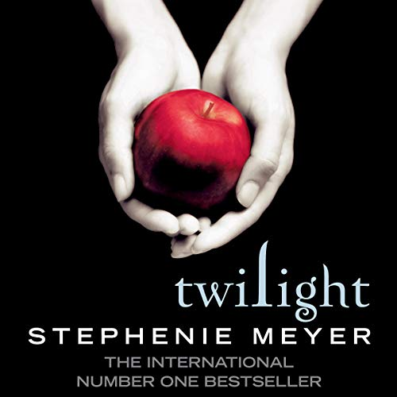

1. title-Twilight (2005) – Introduces Bella Swan and Edward Cullen’s love story.
2. type- romantic fantasy novel
3. author-Stephenie Meyer
4. description-Themes: The struggle between defying instincts and satisfying desires.The danger of falling in love with a vampire
5. 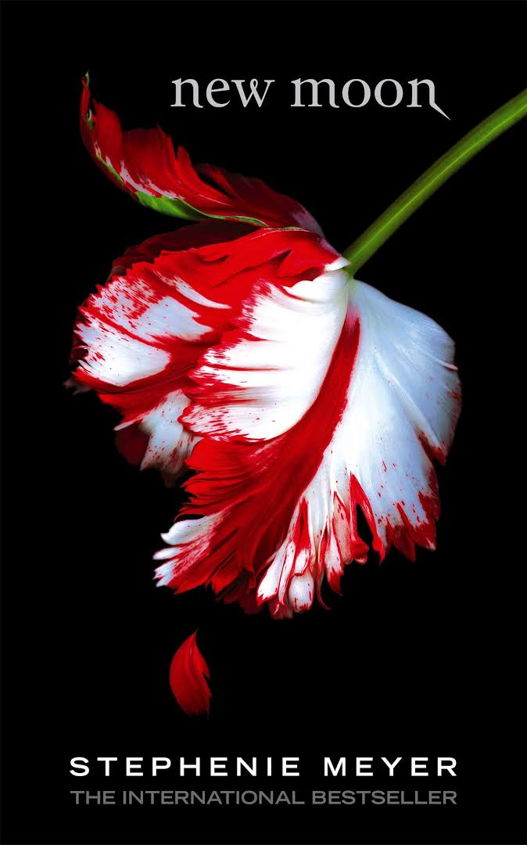title-New Moon (2006) – Focuses on Bella’s heartbreak and Jacob Black’s role.
6. type-romantic fantasy novel
7. author-Stephenie Meyer
8. description-The second installment in the Twilight series, the novel continues the story of Bella Swan and her relationship with vampire Edward Cullen as she enters her senior year of high school.

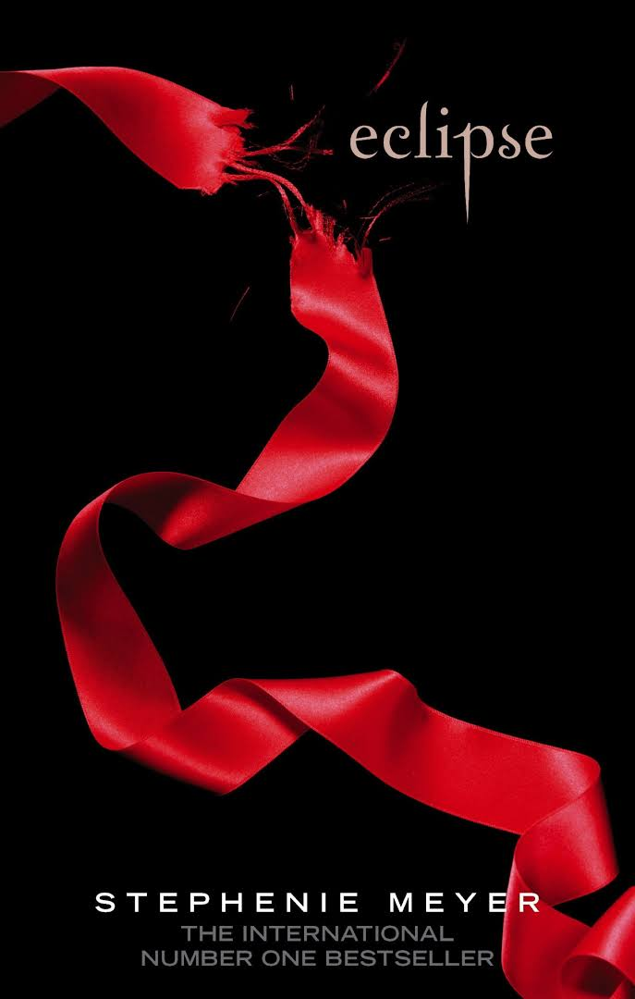

1. title-Eclipse (2007) – Bella faces a choice between Edward and Jacob.
2. type-romantic fantasy novel
3. author-Stephenie Meyer
4. description-Eclipse (stylized in lower caps) is the third novel in the Twilight Saga by Stephenie Meyer. It continues the story of Bella Swan and her vampire love, Edward Cullen. The novel explores Bella's compromise between her love for Edward and her friendship with shape-shifter Jacob Black, along with her dilemma of leaving her mortality behind in a terrorized atmosphere, a result of mysterious vampire attacks in Seattle.

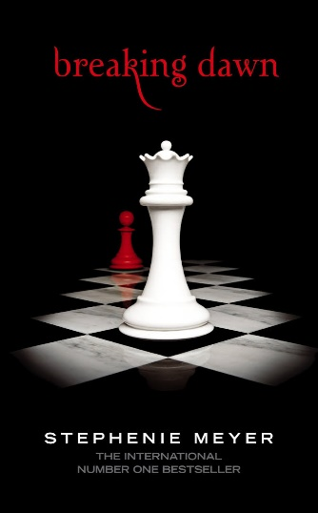

1. title- Breaking Dawn (2008) – Concludes Bella and Edward’s journey..
2. type-romantic fantasy novel
3. author-Stephenie Meyer
4. description- Breaking Dawn (stylized as breaking dawn) is the 2008 fourth novel in The Twilight Saga by American author Stephenie Meyer. Divided into three parts, the first and third sections are written from Bella Swan's perspective, and the second is written from the perspective of Jacob Black. The novel directly follows the events of the previous novel, Eclipse, as Bella and Edward Cullen get married, leaving behind a heartbroken Jacob. When Bella faces unexpected and life-threatening situations, she willingly risks her human life and possible vampire immortality.
5. 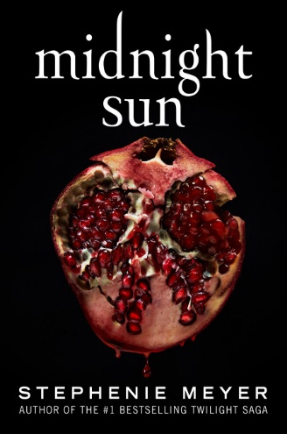title- Midnight Sun (2020) – Twilight retold from Edward’s perspective.
6. type-romantic fantasy novel
7. author-Stephenie Meyer
8. description- Midnight Sun is a 2020 companion novel to the 2005 book Twilight by author Stephenie Meyer. The work retells the events of Twilight from the perspective of Edward Cullen instead of that of the series' usual narrating character Bella Swan..

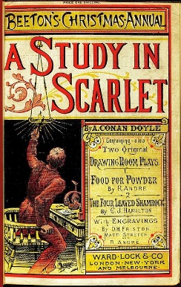

1. title- A Study in Scarlet
2. author-Conan Doyle
3. description- The story marks the first appearance of Sherlock Holmes and Dr. Watson, who would become the most famous detective duo in English literature. The book's title derives from a speech given by Holmes, a consulting detective, to his friend and chronicler Watson on the nature of his work, in which he describes the story's murder investigation as his "study in scarlet": "There's the scarlet thread of murder running through the colourless skein of life, and our duty is to unravel it, and isolate it, and expose every inch of it."

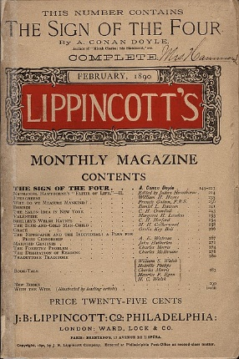

1. title- The Sign of the Four
2. author-Conan Doyle
3. description- The Sign of the Four, also called The Sign of Four, is an 1890 detective novel, and it is the second novel featuring Sherlock Holmes by British writer Sir Arthur Conan Doyle. Doyle wrote four novels and 56 short stories featuring the fictional detective.
4. 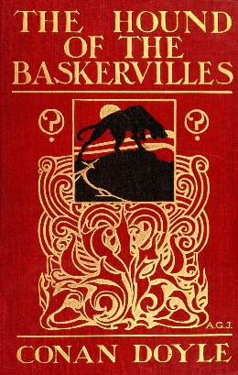.title- The Hound of the Baskervillestype-romantic 2.
5. fantasy novel
6. author-Conan Doyle
7. description- featuring the detective Sherlock Holmes. Originally serialised in The Strand Magazine from August 1901 to April 1902, it is set largely in Dartmoor, Devon, in England's West Country and follows Holmes and Watson investigating the legend of a fearsome, diabolical hound of supernatural origin. This was the first appearance of Holmes since his apparent death in "The Final Problem", and the success of The Hound of the Baskervilles led to the character's eventual revival.

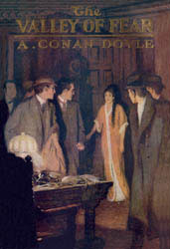

1. title- The Valley of Fear
2. fantasy novel
3. author-Conan Doyle
4. description- The Valley of Fear is the fourth and final Sherlock Holmes novel by British writer Arthur Conan Doyle. It is loosely based on the Molly Maguires and Pinkerton agent James McParland.

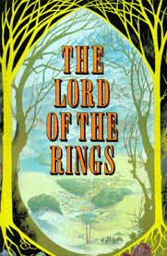

1. title- The Lord of the Rings
2. high fantasy novel
3. author- J. R. R. Tolkien
4. description- Set in Middle-earth, the story began as a sequel to Tolkien's 1937 children's book The Hobbit but eventually developed into a much larger work. Written in stages between 1937 and 1949, The Lord of the Rings is one of the best-selling books ever written, with over 150 million copies sold.
5. 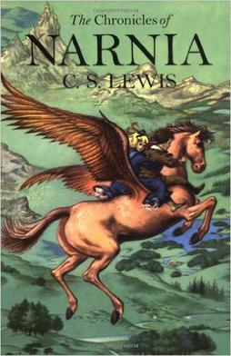title- The Chronicles of Narnia
6. high fantasy novel
7. author- C. S. Lewis
8. description- the series is set in the fictional realm of Narnia, a fantasy world of magic, mythical beasts, and talking animals. It narrates the adventures of various children who play central roles in the unfolding history of the Narnian world. Except in The Horse and His Boy, the protagonists are all children from the real world who are magically transported to Narnia, where they are sometimes called upon by the lion Aslan to protect Narnia from evil. The books span the entire history of Narnia, from its creation in The Magician's Nephew to its eventual destruction in The Last Battle.

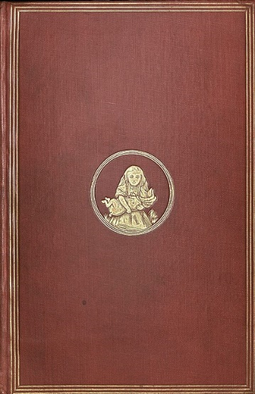

1. title- Alice's Adventures in Wonderland
2. high fantasy novel
3. author- Lewis Carroll,
4. description- It details the story of a girl named Alice who falls through a rabbit hole into a fantasy world of anthropomorphic creatures. It is seen as an example of the literary nonsense genre. The artist John Tenniel provided 42 wood-engraved illustrations for the book.
5. 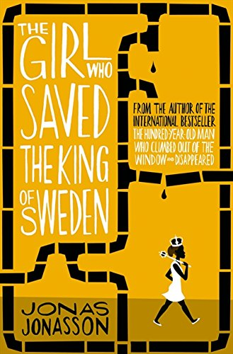title- The Girl Who Saved the King of Sweden
6. author- Jonas Jonasson
7. description- Nombeko Mayeki is on the run from the world's most ruthless secret service - with three Chinese sisters, twins who are officially one person, and an elderly potato farmer. and the fate of the King of Sweden - and the world - rests on her shoulders.

Born in a Soweto shack in 1961, Nombeko is destined for a short, hard life. When she is run over by a drunken engineer, her luck changes. Alive, but blamed for the accident, she is sent to work for the driver - the brandy-soaked head of a project vital to South Africa's security. Nombeko may be good at cleaning, but she's amazing with numbers. The drunken engineer isn't - and has made a big mistake. And only Nombeko knows about it...