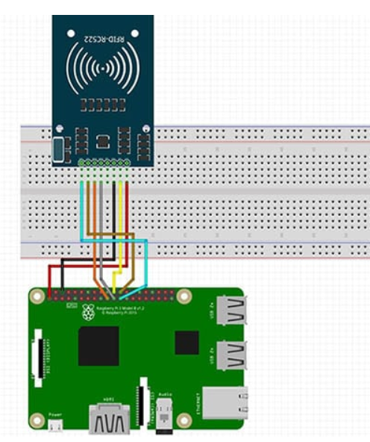

**NFC Reader Pins:**

**SDA** connects to **Pin 24**.

**SCK** connects to **Pin 23**.

**MOSI** connects to **Pin 19**.

**MISO** connects to **Pin 21**.

**GND** connects to **Pin 6**.

**RST** connects to **Pin 22**.

**3.3v** connects to **Pin 1**.

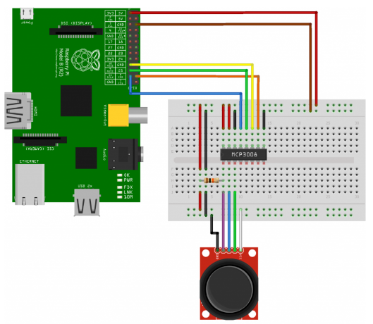

**JoyStick Pins:**

**GND** conntects to **Pin 20  
3.3V** conntects to **Pin 17  
SW** conntects to **Pin 36  
VRx** conntects to **Pin 38  
VRy** conntects to **Pin 40**

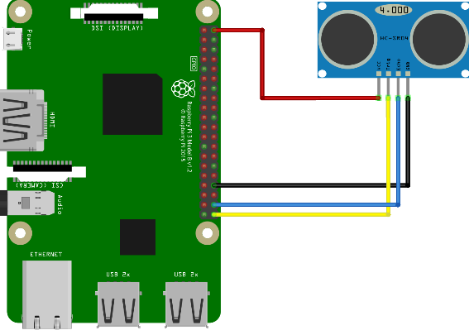

**Sensor Pins:**

**VCC** Connects to **Pin 2 (5v)**  
**Trig** Connects to **Pin 7 (GPIO 4)**  
**Echo** Connects to **Pin 11**   
**GND** Connects to **Pin 6 (Ground)**