Project Task 2 – Uploading of HTML5 Website
Osamu Morozumi

Table of Contents
Review and select FTP client 3
Choices of FTP clients: 3
Client chosen: 3
Document entered client details: 3
Test and verify configuration by connecting to web hosting server 3
Perpare data content and back up on local computer 4
Identify data as compressed or uncompressed 4
Ensure files are in appropriate form 4
Ensure receiving directory structure is applicable for the data to be uploaded 4
Log on to remote server using account details 4
Proceed through security layers basd on organisational guidelines 4
Initiate FTP program and locate destination directory 5
Select files to be transferred and choose mode 5
Run antirus software on downloaded files 5
Move, rename, copy and delete files on the server 5
Store and order files according to requirements and file extensions 5
Conduct appropriate steps for downloaded files 5
Confirm data transfer and content functionality and close connection 6

Review and select FTP client

Choices of FTP clients:
1. Command line via terminal emulator
2. FileZilla

Client chosen:
I have chosen to use FileZilla as my FTP client for the following reasons:
• It is a trusted application for use on Linux machines and is easily installed from the software
repository via synaptic package manager
• It is easy to set up and use
• There is no need to learn new commands to use the program unlike the command line
• There is less chance of using an incorrect command and making a mistake when
uploading/downloading
• FTP logs are created automatically and easy to access

Document entered client details:
- User ID: zen@zenjournal.pcwebsites.com.au
- password: ***********
- host name: ftp.pcwebsites.com.au
- port: 21

Test and verify configuration by connecting to web hosting server
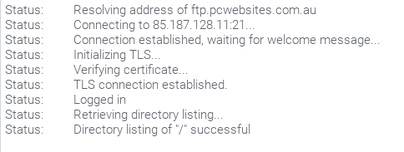 | 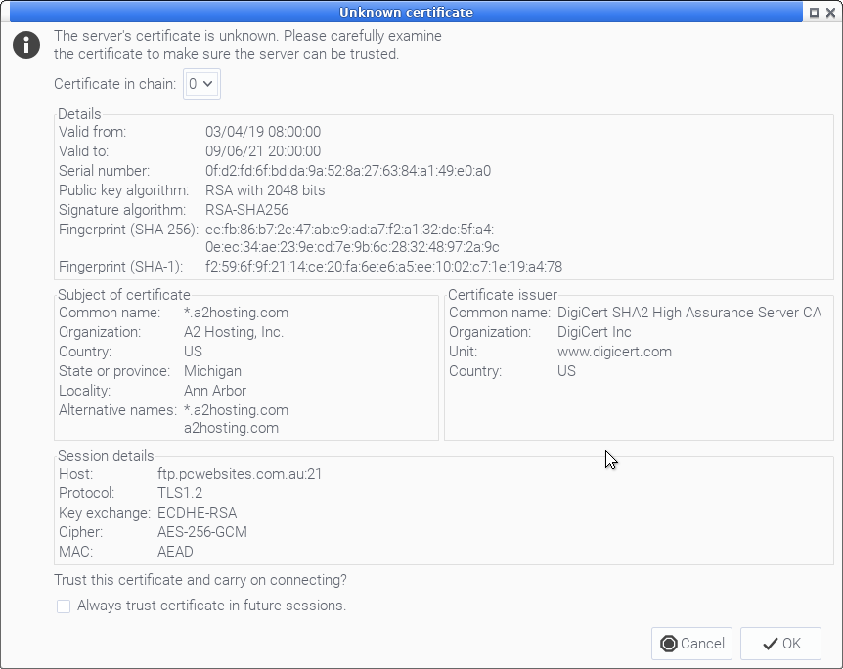 | 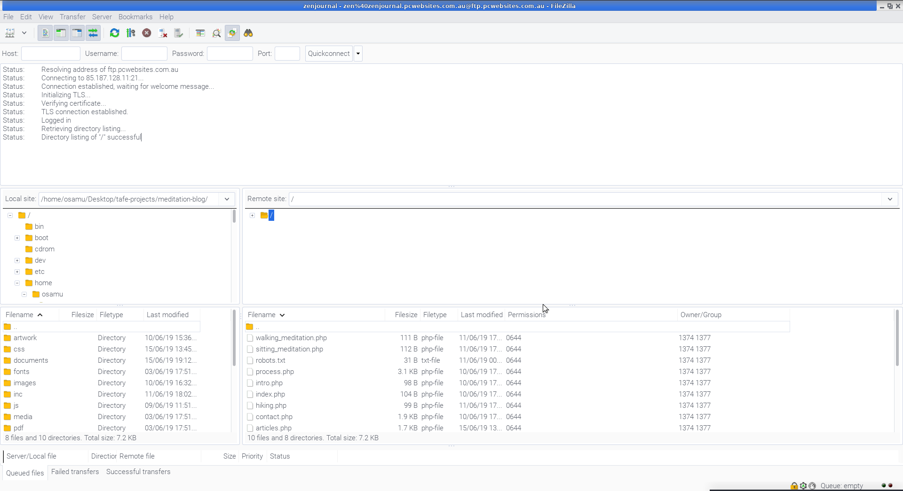
* full size screen shots provided separately

Perpare data content and back up on local computer
- Index page present
- All images are optimised and in correct folder
- Correct folder structure present
- Artwork and documents folder omitted
- Markup and CSS validated
- Clients sign-off not applicable
- Internal links are relative not absolute
- Local back up made and zipped, stored in back up folder

Identify data as compressed or uncompressed
HTML and CSS files remain uncompressed but images have been scaled down and reduced to the minimum size while preserving quality.

Ensure files are in appropriate form
Mark up and serverside scripting files are in .php format, main css file is in .css format, images are .jpg or .png, icons are .png or .svg. No inappropriate file formats are present

Ensure receiving directory structure is applicable for the data to be uploaded
Uploading to empty directory. Original (correct) folder structure preserved when uploading.

Log on to remote server using account details
Connection successful, screenshots provided.

Proceed through security layers basd on organisational guidelines
My webhost (A2 hosting) uses the following security measures which I have adhered to:
- Anonymous FTP is disabled so a username and password must be created and used when connecting via FTP. Passwords must pass a minimum of 5 character long and score 50 using their password strength score to be permissable
- TLS connection is used. “TLS stands for Transport Layer Security and is the successor to SSL (Secure Sockets Layer). TLS provides secure communication between web browsers and servers. The connection itself is secure because symmetric cryptography is used to encrypt the data transmitted.” (https://kinsta.com/blog/tls-1-3/)
Other than this there are no organisational guidelines provided

Initiate FTP program and locate destination directory
FTP account was created (by myself) to connect directly to the correct subdirectory in my home folder on the remote server. Screenshots provided

Select files to be transferred and choose mode
Files have been selected and uploaded using auto detect (which defaults to binary mode). As no errors were encountered during the upload there was no need to force either binary or ascii mode. Should I have needed to upload a large amount of text based files (such as html, css and javascript) I may have chosen ascii mode for those particular files and switched to binary or auto detect for media based files (images, videos and pdfs). I have provided a screenshot to demonstrate that I can switch modes if necessary.

Run antirus software on downloaded files
Back up folder (unzipped) scanned using clamAV. No malware detected. Scan results and screenshot provided.

Move, rename, copy and delete files on the server
Screencast provided: “move-delete-rename-files.mp4”

Store and order files according to requirements and file extensions
Original structure and file extensions preserved which are corrected

Conduct appropriate steps for downloaded files
No steps necessary as files are ready to use in their current state. Back up zipped for storing on Dropbox.

Confirm data transfer and content functionality and close connection
Screenshot provided confirming successful uploading and downloading of data. Screenshots provided showing webite renders on several browsers (content functionality)

