ANALYSIS

Subject and Summary

Firstly, the subject and purpose of the project was determined. The project was planned according to time. Easy to use and clear interfaces were determined for the user. It was tested after the project was finished.

Needs Analysis

The subject of the project was determined as hotel automation. Requirements during the construction were determined. Interfaces were created in the NetBeans program. As a result of some problems, keeping the information in a digital environment has become more reliable. Therefore, this kind of automation was needed.

User Analysis

I tried the automation I made by myself and found the shortcomings and errors and corrected them.

DESIGN

About the Project

Before the project's build phase, the goal was determined and drafts were created. The interfaces are determined and designed to be comfortable for the user. Needs were determined and met.

Content of the Project

Interfaces in the content of automation;

**+** User login

**+** New Registration

**+** I Forgot My Password

**+** Necessary information for reservation

**+** Booking confirmation

User Login

Our user logs in on this page.

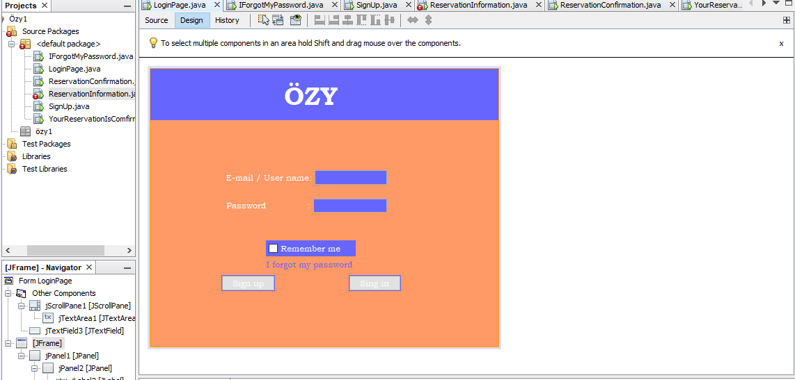

New Registration   
 Interface for creating new users.

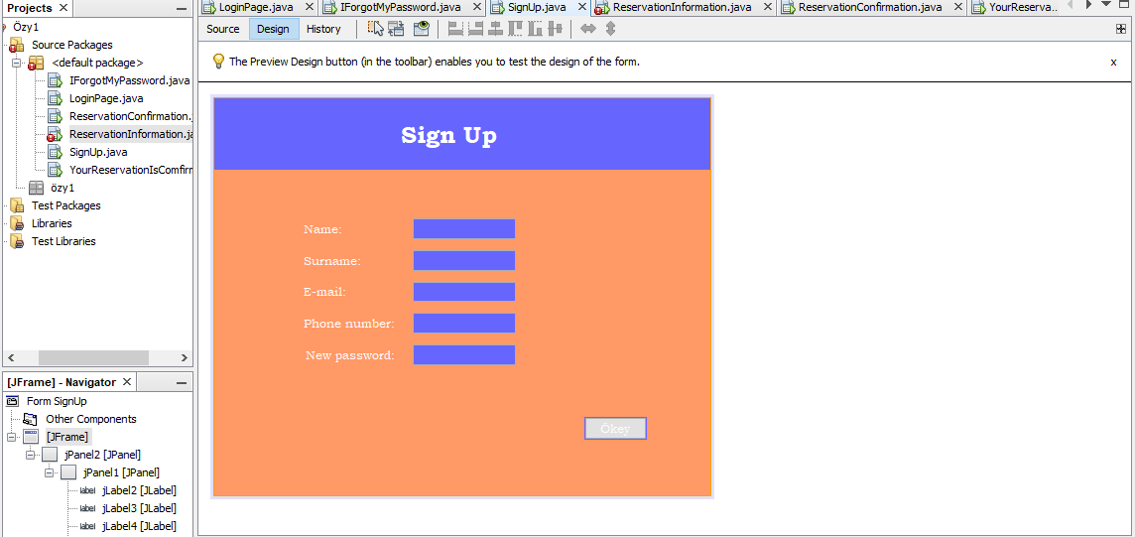

I Forgot My Password

New password import page for users who forget their password.

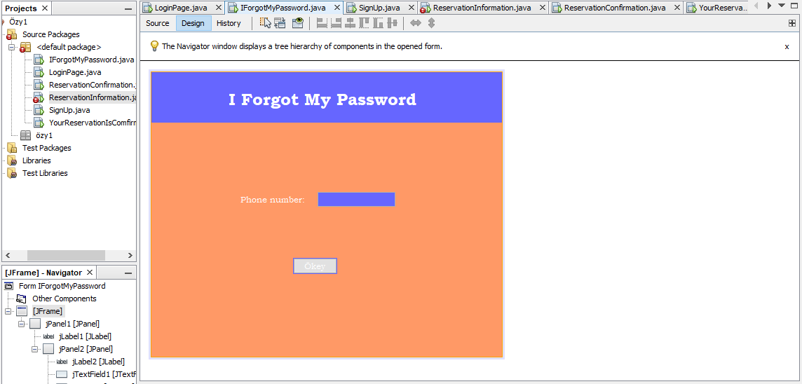

Information Required for Reservation

Screen where the necessary information is entered to make a reservation.

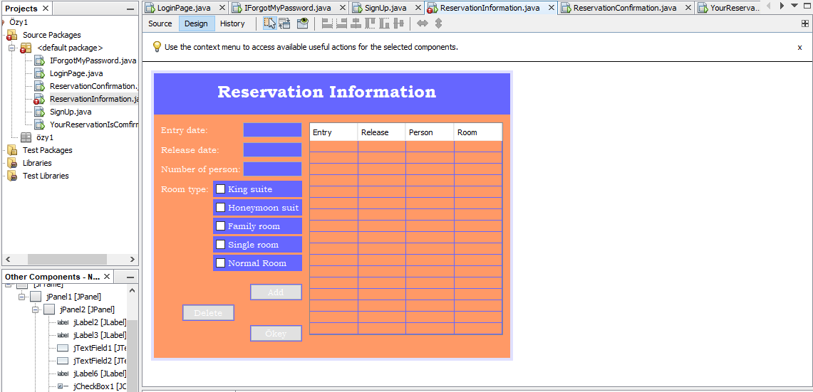

Since I can't combine mysql and netbeans, these codes are not complete right now and it doesn't work.

Booking Confirmation

Reservation confirmation section.

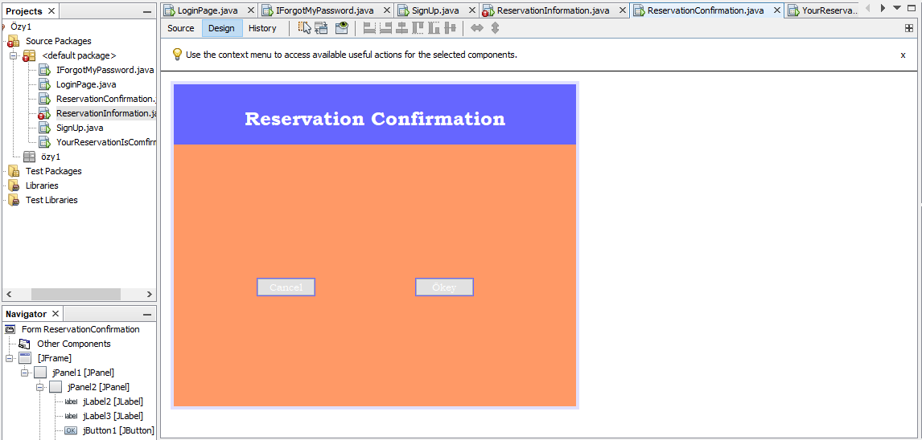

Interface stating that the reservation has been successful.

