Korzinka Inventory Management System
Simple Use Case Diagram and Business Process Model (BPM)
These diagrams are based on the project requirements in the provided IT Project Agreement: product information management, inventory and stock level management, incoming/outgoing product transactions, and stock/movement reports.
1. Use Case Diagram
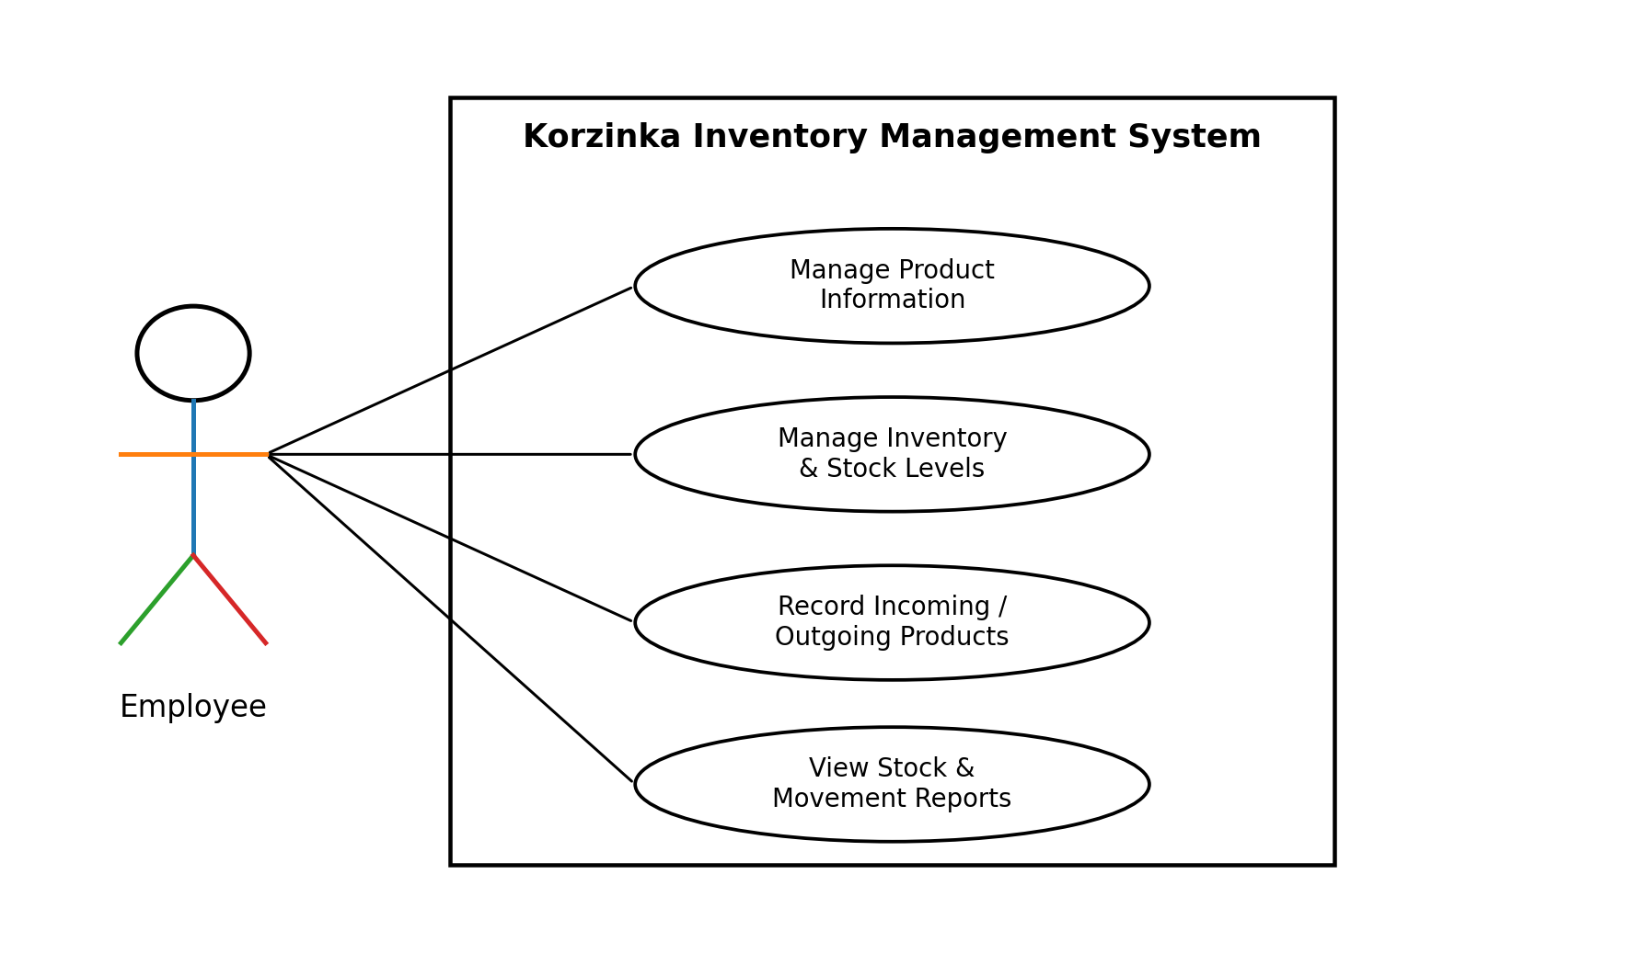
Main actor: Employee
Main use cases: Manage Product Information; Manage Inventory & Stock Levels; Record Incoming/Outgoing Products; View Stock & Movement Reports.

2. Business Process Model (BPM)
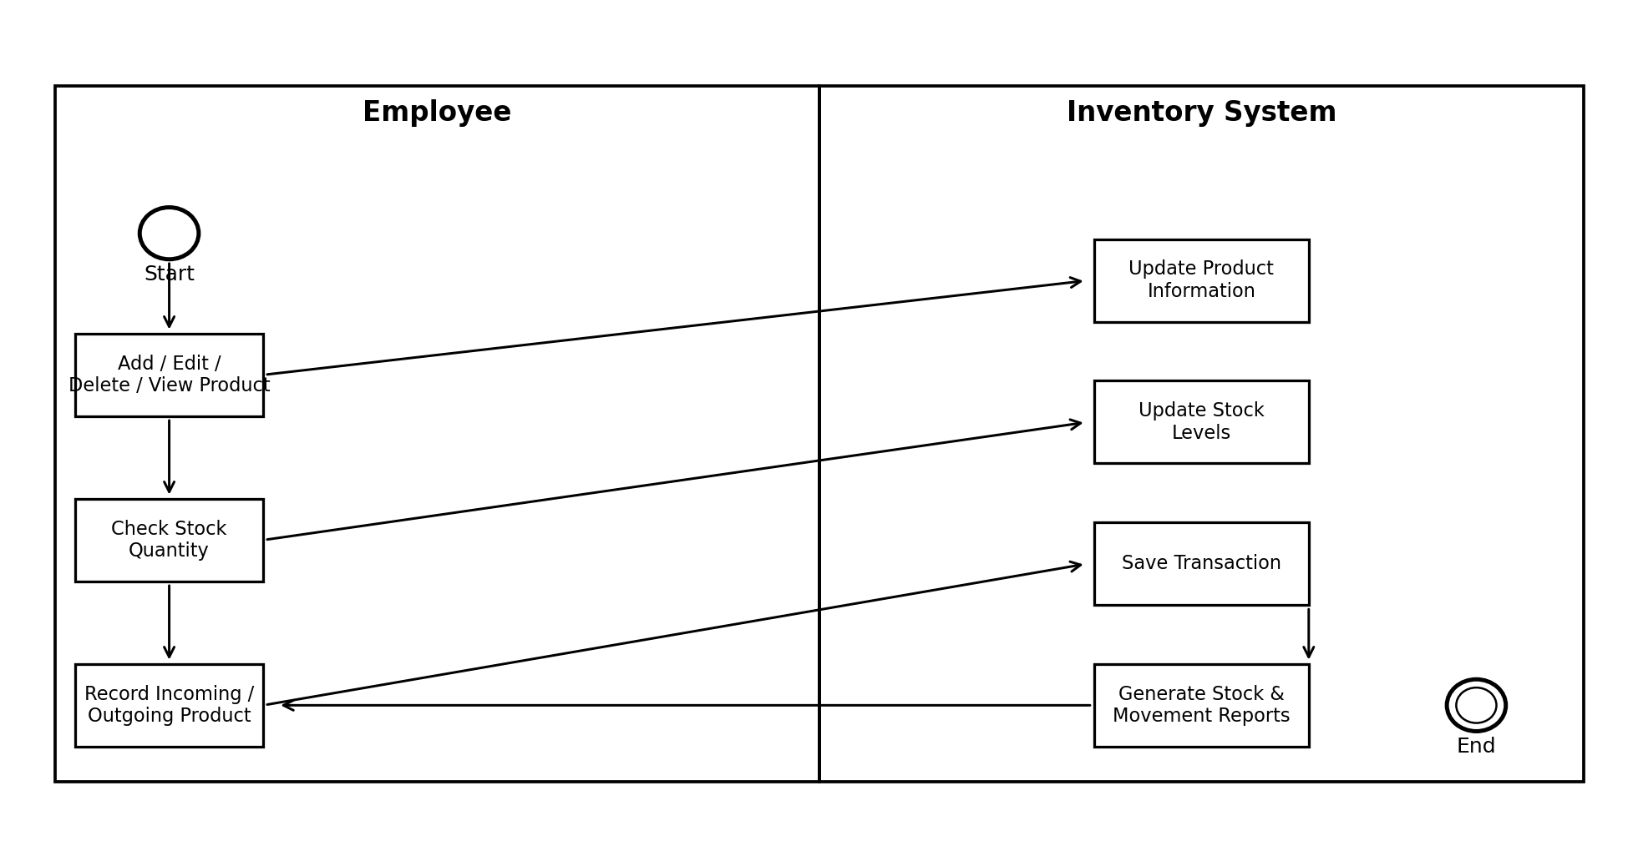
Simple process: Employee manages product information → checks stock → records incoming/outgoing products → the system updates stock and transactions → reports are generated.

Source basis: The diagrams use the terminology and requirements stated in the provided IT Project Agreement, including the listed project deliverables and customer requirements.

