**The predicted yield by the model**

array([0.45537757, 0.3444075 , 1.33002528, 0.46228411, 0.42289478,

1.29683025, 1.59873329, 1.03452972, 0.42720926, 1.58496155,

0.42629951, 1.13111368, 0.43852443, 1.41964741, 1.33448556,

1.34414209, 0.34748444, 1.28398274, 0.49646611, 0.34255421,

0.3852425 , 0.37102916, 0.93567376, 0.94055311, 0.37691961,

1.57841473])

**Table of the dataset and the predicted yield**

**It consist of 5 columns**

ID leaf_length stem_diameter yield predicted yield

0 155.30 2.12 0.116 0.41484

16 277.68 2.01 0.331 0.27717

49 974.50 2.65 1.925 1.50171

2 766.16 2.01 0.927 0.77611

9 550.00 2.02 0.563 0.44811

65 836.94 2.65 1.311 1.39788

115 1188.20 2.82 2.167 2.08110

129 491.00 2.51 0.841 0.77688

30 620.81 2.01 0.204 0.88966

107 1131.13 2.82 2.105 2.01535

77 617.04 2.01 0.505 0.88694

56 679.52 2.55 0.755 0.68850

95 667.70 2.01 0.317 0.73446

106 499.00 2.81 1.466 1.06212

42 781.26 2.69 1.837 1.29569

111 1033.00 2.65 1.938 1.73199

6 237.50 2.02 0.232 0.26407

69 783.70 2.65 1.261 1.29350

101 907.81 2.01 0.642 0.84257

29 270.00 2.01 0.353 0.25393

119 446.90 2.01 0.450 0.65949

86 388.00 2.01 0.328 0.40371

87 610.65 2.41 0.714 1.15751

35 630.87 2.41 0.756 1.01193

114 412.41 2.01 0.856 0.55653

105 1104.00 2.82 2.011 2.02010

Knearest neighbour accuracy was == 0.5596

Random forest accuracy was == 0.8585

Linear regression accuracy was == 0.7610

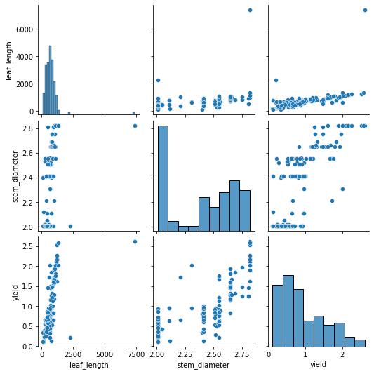

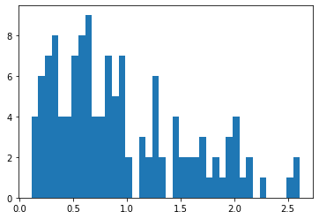

Correlation analysis results

