Located in Sungai Udang, Melaka, Petronas Penapisan (Melaka) Sdn. Bhd. (PPMSB) is the second refinery complex consisting of Petronas Second Refinery Phase 1 (PSR1) and Petronas Second Refinery Phase 2 (PSR2). PSR1, wholly owned by Petronas, was incorporated in 19 September 1987. Plant operations were commissioned in 1994 with the design capacity of 100,000 barrels per day (BPSD). PSR2, incorporated in 1991, is operated by the Malaysian Refining Company (MRC), consisting of Petronas (45%), Conoco (40%) and Statoil (15%). Production for PSR2 with deep conversion facilities, started in 1998 with a capacity of 100,000 BPSD.
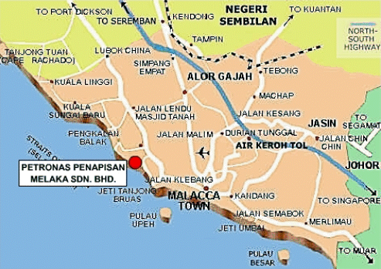

PSR1 processes local sweet crude (crude low in sulfur) and gas condensates with hydroskimming facilities. Products from PSR1 include liquefied petroleum gas (LPG), petrochemical naphtha (PCN), gasoline, kerosene and low sulfur waxy residue (LSWR). This first phase was primarily built to provide the country with a sufficient supply of petroleum products. Imports and exports of refined products are also increased and thus increasing the net in flow of foreign exchange.
Progress has been made since the commissioning of PSR2 allowing PPMSB more options in choosing the type of feed crude to process and thus extending their market to foreign buyers. Fed with sour crude (high sulfur in crude) imported from the Middle East, PSR2 produces LPG, PCN, gasoline, kerosene, sulfur, fuel oil, asphalt and coke. Since PSR2 was built after PSR1, PSR2 is imminently the more sophisticated in terms of technology. Although, both phases have units in common, there are some facilities provided for PSR2 that were not included in PSR1. For example, PSR2 has a hydrogen plant that caters for the hydrogen demand coming from the deep conversion units. Although only PSR1 is wholly owned by PETRONAS, PSR2 operations are also in line with the mission and vision of PPMSB.
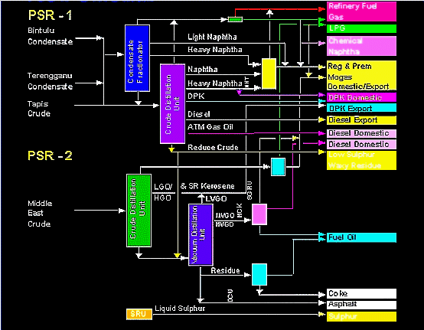

PETRONAS being a multinational company has had to employ various subsidiaries at home as well as abroad to support its technical development and business ventures. These subsidiaries can be classified as wholly owned (100% shares), partially owned (more than 50% shares) and those subsidiaries in which PETRONAS owns less than 50% of the shares.
(Please refer to Figure 1 for details)
Exploration & Production
PETRONAS Carigali Sdn. Bhd.
PETRONAS has had to compete with other leading Petroleum companies, like Shell and Esso, in its pursuit of being an internationally recognized company. Since 1990, one of the ways that it has tried to do so, is by investing in exploration, development and production of crude oil and natural gas. This is achieved by PETRONAS Carigali Sdn. Bhd. and PETRONAS Carigali (Overseas) Sdn. Bhd. through offshore drilling activities, both at home and abroad. All activities are managed through Production Sharing Contracts (PSC) along with a number of international oil and gas companies. Currently, the company is involved in upstream activities in thirteen countries.
At present, there are thirty-seven producing oil fields, which produce five high quality blends of crude: Tapis, Labuan, Miri, Bintulu and Dulang. All oil and gas fields being currently developed are those found offshore Peninsular Malaysia and East Malaysia. Two hundred and fourteen gas fields have been found and only eleven are producing with several more in progress of being developed. As of today, Malaysia produces about 630,000 barrels of oil per day and five billion cubic feet of gas per day.
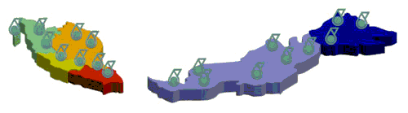
Overall as of the year 2000, Malaysia has approximately, 3.6 billion barrels of crude oil reserves and 85.8 trillion standard cubic feel of gas reserves which puts the country at 27th and 12th places respectively in terms of world ranking. As a result of increasing overseas activities, PETRONAS has acquired international reserves of about 2 billion barrels of oil equivalent, excluding the reserves from the Malaysia-Thai Joint Development Area.
Refineries
PETRONAS Penapisan (Melaka) & PETRONAS Penapisan (Terengganu)
Since crude oil has a limited number of uses in its raw state, it must first be processed or refined into products with added value. Some of these products include motor gasoline, diesel, lubricants, jet fuel, kerosene, naphtha and residual fuel oil that are available for domestic use and for export. Currently, PETRONAS has two refineries, Petronas Penapisan (Melaka) Sdn. Bhd. (PP(M)SB) and Petronas Penapisan (Terengganu) Sdn. Bhd. (PP(T)SB), with a combined capacity of 240,000 barrels per day (bpd).
Gas Production
PETRONAS Gas Supply (Labuan) Sdn Bhd & PETRONAS NGV Sdn Bhd
Malaysia has an abundance of natural gas reserves being three times more than its oil reserves. With so much in supply, Malaysia has used natural gas not only as an energy source but also as a raw material in the manufacturing of various petrochemical products.
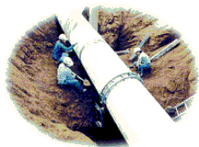 | To augment Malaysia's gas resources, there are many projects on gas processing, transmisson, development and utilization in Peninsular Malaysia, Sabah and Sarawak. These projects include the liquefied natural gas (LNG) plants in Bintulu (Sarawak), the Peninsular Gas Utilization Project (PGU) in Peninsular Malaysia, gas supply to the western coast of Sabah and other gas-based projects.
Natural gas has a variety of applications in homes, industries, and vehicles. So to further encourage the use of gas, PETRONAS is implementing projects involving the supply of chilled water for air conditioning through the use of natural gas as the main fuel for the generation plants (Gas District Cooling) and as fuel for vehicles (Natural Gas Vehicles).
Overseas, PETRONAS has equities in Argentina and Australia in gas transportation and is involved in other pipeline projects, namely the Trans-Thailand-Malaysia Gas Pipeline System in Thailand and the PNG-Queensland Gas Pipeline in Australia.
Petrochemical Business

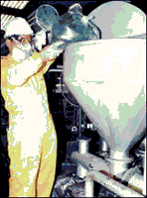 | With Malaysia being rich in gas reserves and through the implementation of the Peninsular Gas Utilization (PGU) project, PETRONAS has been able to engage in various large scale gas-based petrochemical projects with joint venture partners. In addition to making natural resources more valuable, these projects also run in parallel with PETRONAS' desire to promote the country into a regional petrochemical center.  With this objective in mind, the company is committed to a well-planned development of Integrated Petrochemical Complexes (IPCs) with all the necessary common infrastructural facilities and supplementary utilities to maximise synergy. Currently, two IPCs in the process of being developed, such as the ethylene-based Kertih IPC in Terengganu and the propylene-based Gebeng IPC in Pahang.

Marketing Activities
Malaysian International Trading Corporation Sdn.Bhd. (MITCO)
Motor gasoline, diesel, lubricants, aviation and bunker fuels, liquefied petroleum gas (LPG) and kerosene are sold by PETRONAS as refined petroleum products. These products are from less than half of the company's crude oil production while the rest of the crude is exported.
PETRONAS Dagangan Bhd (PDB) sells the company's refined petroleum products to the domestic market. Crude and some of its other refined products and petrochemicals are sold internationally through the Crude Oil Group and LPG and Petroleum Products Group of PETRONAS Oil Business and the subsidiaries, PETRONAS Trading Corporation Sdn Bhd (PETCO) and Malaysian International Trading Corporation Sdn Bhd (MITCO).
Maritime & Logistics Business
Maritime and Logistics is a relatively new addition to the company's list of core activities. In 1994, PETRONAS made its first shipment to support its LNG business by delivering liquefied natural gas (LNG) tankers, the Puteri Intan, to support its LNG business.
As the LNG business prospered, the ships the Puteri Delima, the Puteri Nilam, the Puteri Zamrud and the Puteri Firus were added to the fleet owned by PETRONAS Tankers Sdn Bhd. At this time PETRONAS Tankers was a wholly owned subsidiary with each vessel having a volume capacity of 130,000 cubic meters and an overall length of 274 meters. Currently, all five ships are on long-term charters to transport LNG to PETRONAS customers.
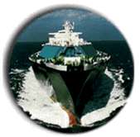

Rationalizing The Shipping Industry
PETRONAS acquired 29.3% in Malaysia International Shipping Corporation Bhd (MISC), Malaysia's leading shipping company listed on the Kuala Lumpur Stock Exchange in August 1997. This provided benefits to both parties since now Malaysia could integrate and rationalize logistics and shipping support for its operations in LNG, crude oil and petroleum product exports.
MISC become a 62% percent owned subsidiary of PETRONAS by acquiring the entire shareholding in PETRONAS Tankers through a share issue exercise in 1998. MISC expanded its assets further by transforming itself into the largest shipping company in Malaysia and the biggest LNG operator in the world. MISC's fleet include 13 LNG carriers, 52 bulk carriers, 15 chemical tankers, 31 container ships, 12 chemical tankers, nine crude tankers, six product tankers and three liquefied petroleum gas (LPG).
The LNG tankers charter for Malaysia LNG Sdn. Bhd. for the transport of LNG to Japan, Korea and Taiwan are on a twenty-year charter. Other vessels are used to transfer crude oil, petroleum products, petrochemical products, dry bulk and containers. The petroleum vessels are used for the transports of Malaysian crude oil, fuel oil and condensates for PETRONAS and other customers in the Asia-Pacific region.
The shipping industry is global and highly competitive. Many have merged their operations and MISC with its current fleet and size of operations has been able to meet the demands and performance of an international shipping company.

