Do Crypto Markets Generate Volatility in Borsa Istanbul?
Evidence from a VARX with Weekly Data

Yiğit Erdoğan · Halil İbrahim Özsoy · Yaman Dinçkan
223201076 · 223201074 · 223201053
IKT 451 — Applied Econometrics: Time Series Analysis | Empirical Report — 2025-08-15

ABSTRACT
This report investigates whether cryptocurrency markets contribute to the volatility of Borsa Istanbul (BIST, XU100). Using weekly observations from 2017‑11‑06 to 2025‑08‑11 (≈406 observations), we construct log series, test for unit roots, difference non‑stationary variables to obtain weekly log‑returns, and estimate a VAR with exogenous controls (VARX). Controls include the S&P 500, gold, USD/TRY, the U.S. policy rate (Fed), and the VIX; a COVID‑period dummy is also considered in robustness checks. Identification relies on Cholesky orthogonalization with the ordering [crypto → XU100] while treating controls as strictly exogenous. Diagnostic tests (serial correlation, Portmanteau, and stability via inverse roots) indicate a well‑specified model. Granger causality, impulse responses, forecast error variance decompositions and historical decompositions consistently show that crypto‑market innovations have economically small and statistically weak effects on BIST. At 10‑week horizons, the variance of XU100 returns is overwhelmingly driven by its own shocks (≈95–97%), with crypto explaining only a few percent at most. Results are robust to using a principal‑component crypto factor and to adding a COVID dummy.
Keywords: Cryptocurrency, Borsa Istanbul (BIST), VARX, Granger Causality, Impulse Response Functions, Variance Decomposition, Volatility Transmission
1. Data
Sample: weekly frequency, 2017‑11‑06 to 2025‑08‑11 (after alignment and listwise deletion). The endogenous block contains two series:
- L_AVGCRP — log return of a broad crypto composite (average of BTC, ETH, BNB, XRP and related majors).
- L_XU100 — log return of BIST 100 index.
Exogenous contemporaneous controls (no feedback in the VAR state vector): L_SP500, L_GOLD, L_TRY_USD, L_FED, L_VIX. A COVID dummy is used in robustness checks. All price series are transformed by natural logs; stationarity is achieved by first differencing.
1.1 Price Series — Graphs and Descriptive Statistics
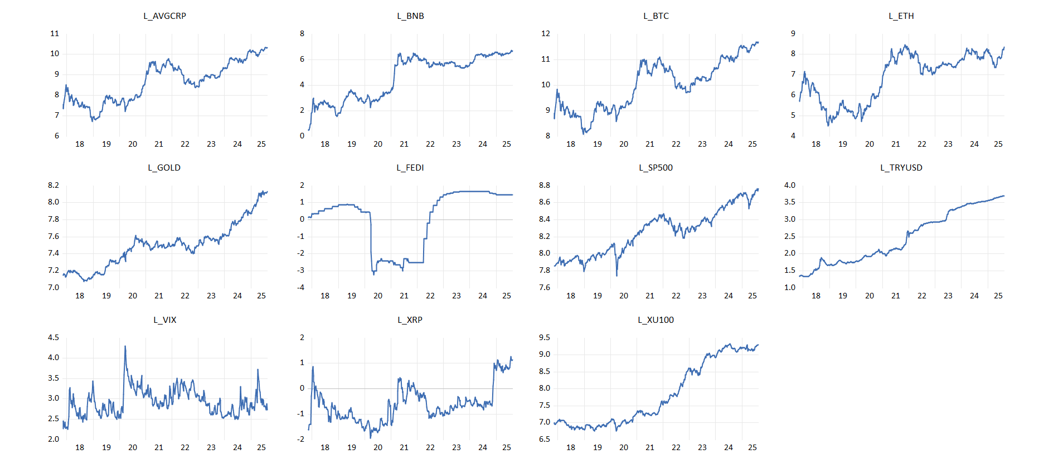
Figure 1.1a — Log-level price series for all variables
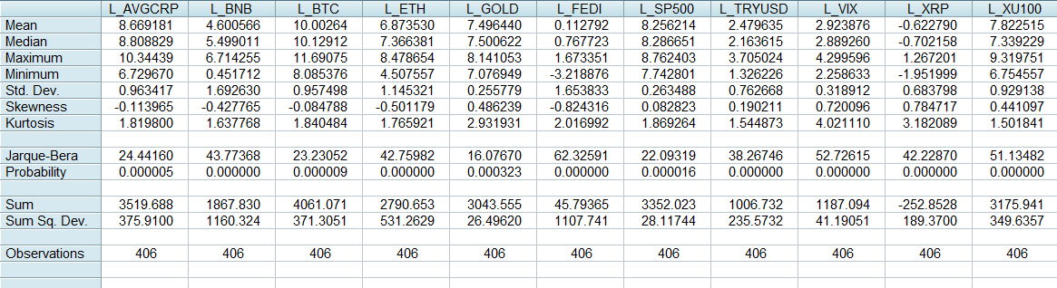
Figure 1.1b — Descriptive statistics summary
1.2 Unit Root Tests of Price Series
Visual inspection and ADF/PP tests on log‑levels indicate non‑stationarity for most series (except L_VIX). Tables below report test statistics and critical values.
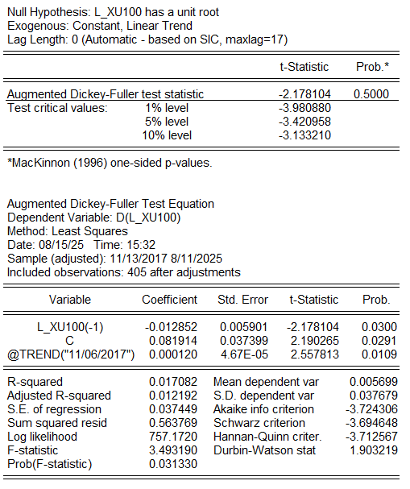 | 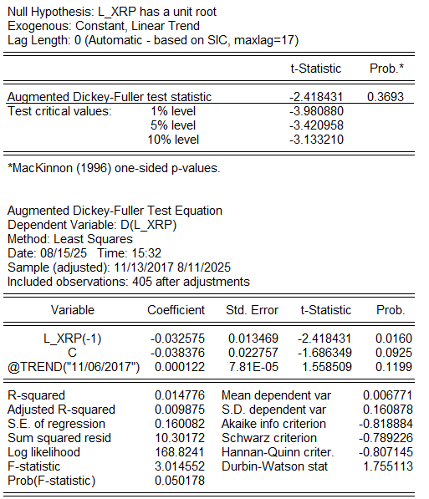 | 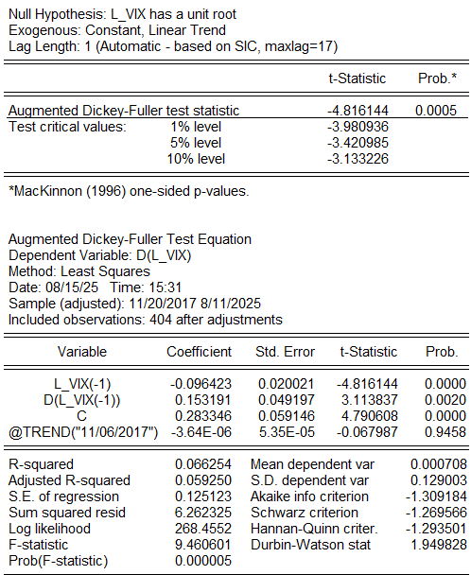
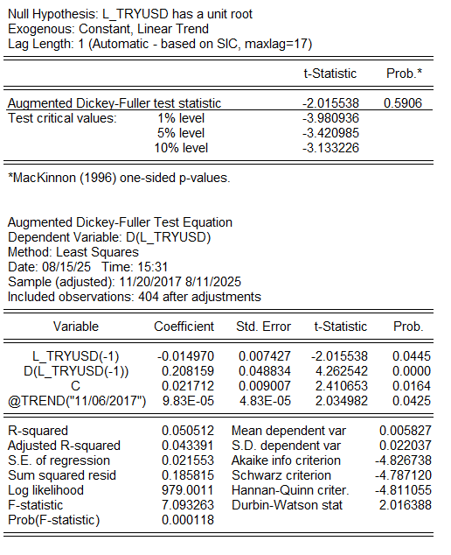 | 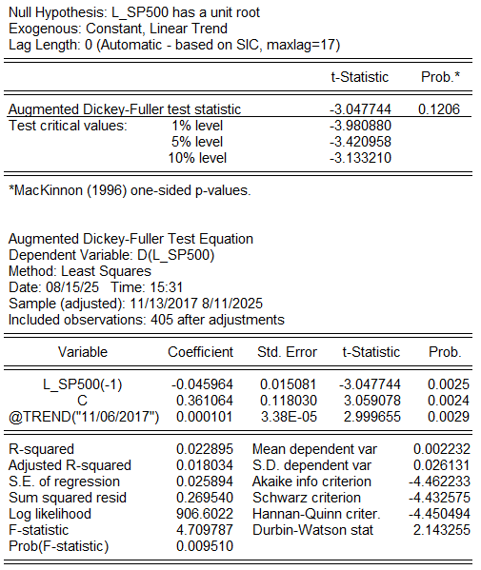 | 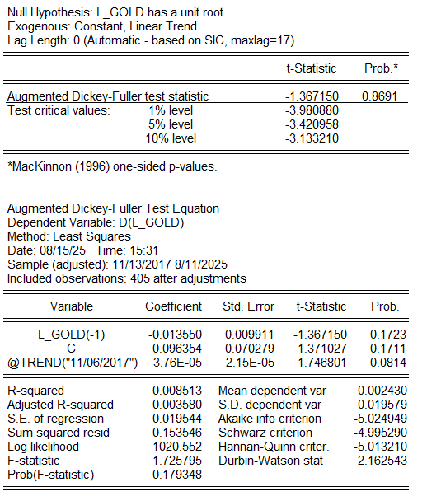
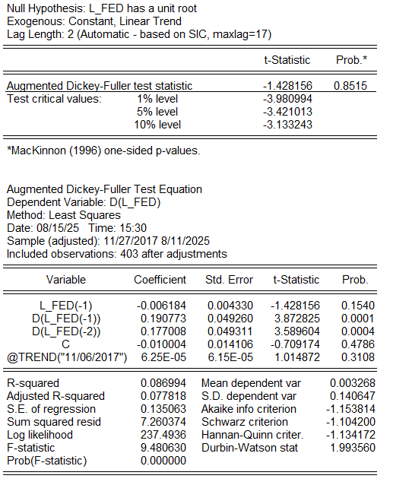 | 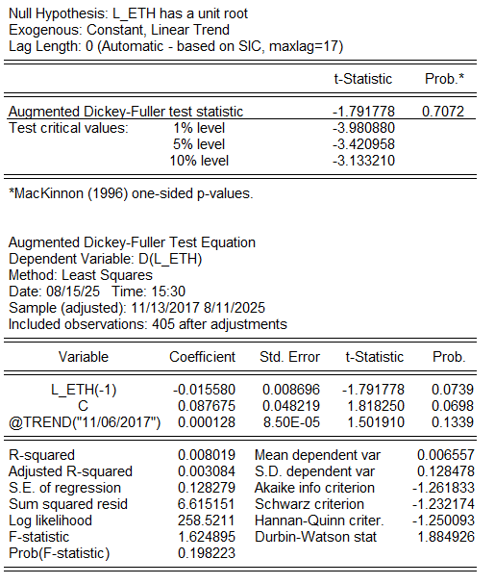 | 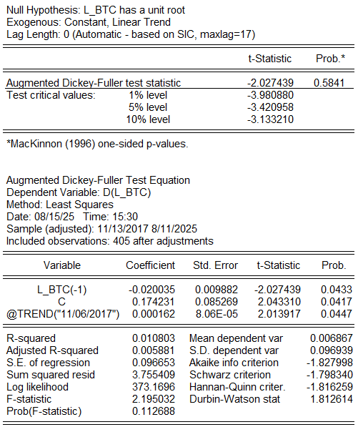
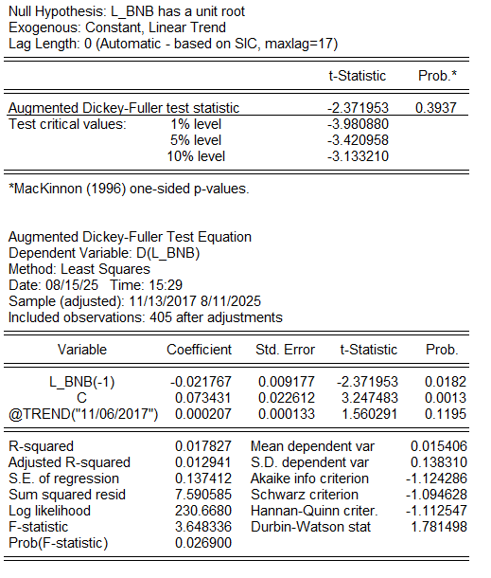 | 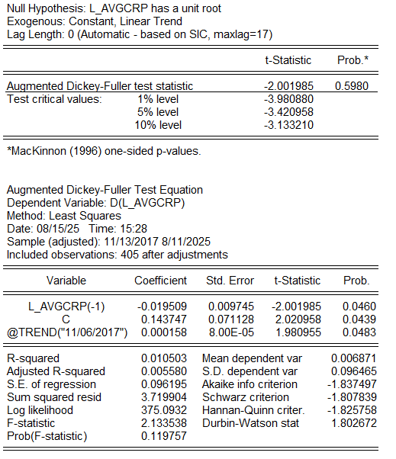 | 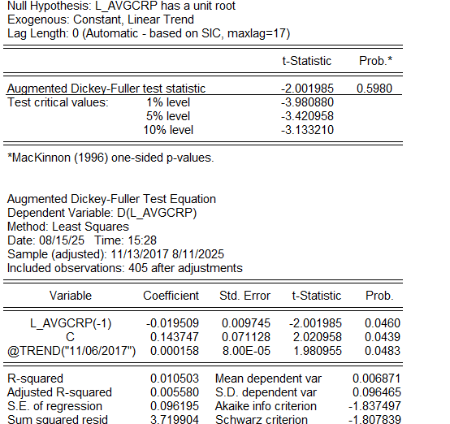
2. Pre-Estimation Tests
Augmented Dickey–Fuller (ADF) and Phillips–Perron (PP) tests confirm that most log‑levels fail to reject a unit root, while first differences (weekly log‑returns) are stationary at the 1% level — strongly negative AR(1) with t‑statistics approximately −18 to −22 for crypto and equity series. After first differencing, a volatility transformation was applied using the EViews command:
series V_XU100 = abs(D_XU100)
2.1 Unit Root Tests After First Differencing
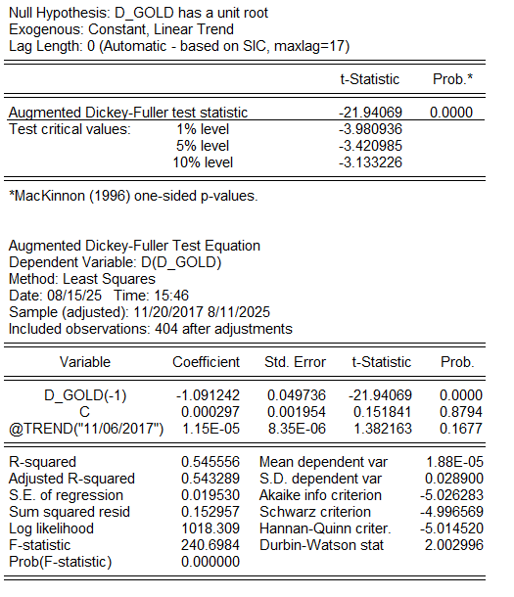 | 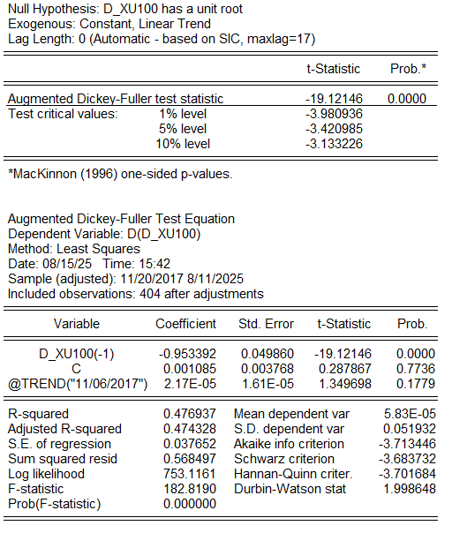 | 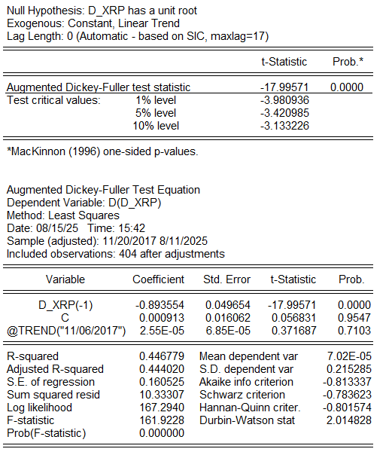
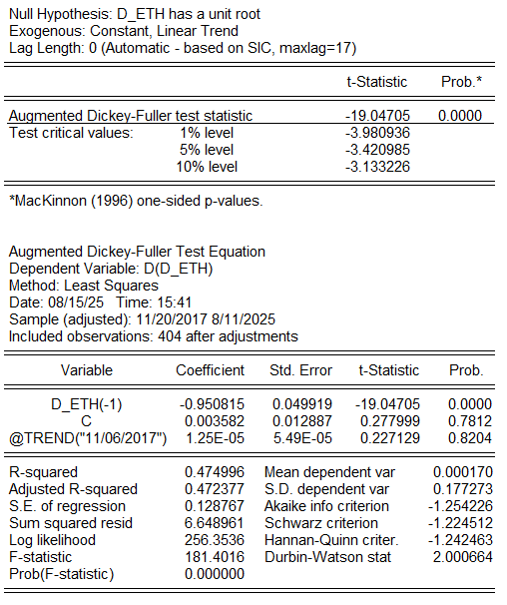 | 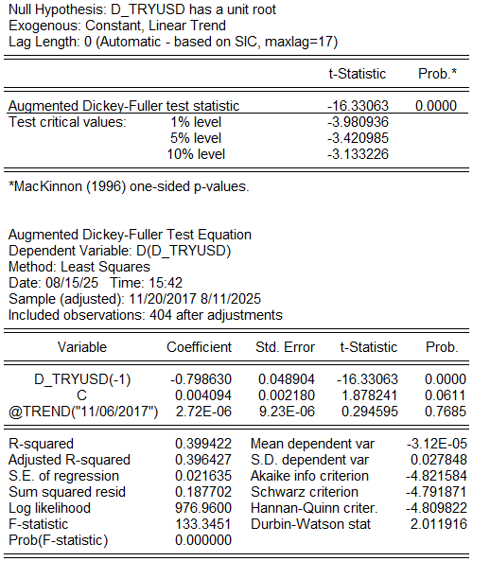 | 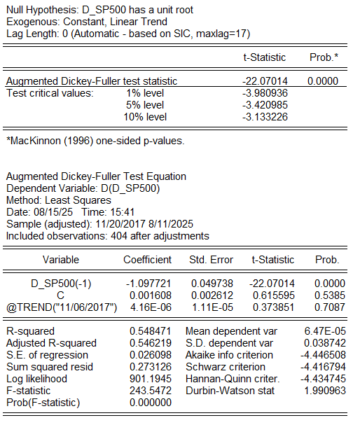
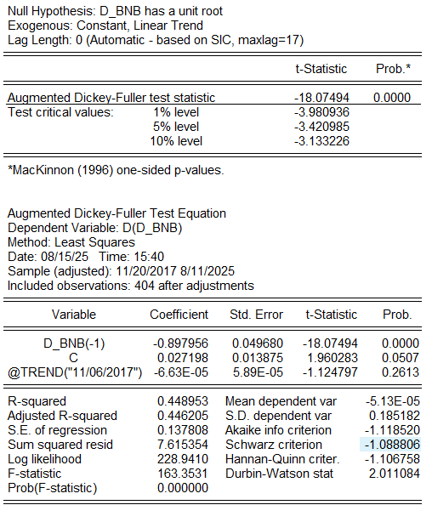 | 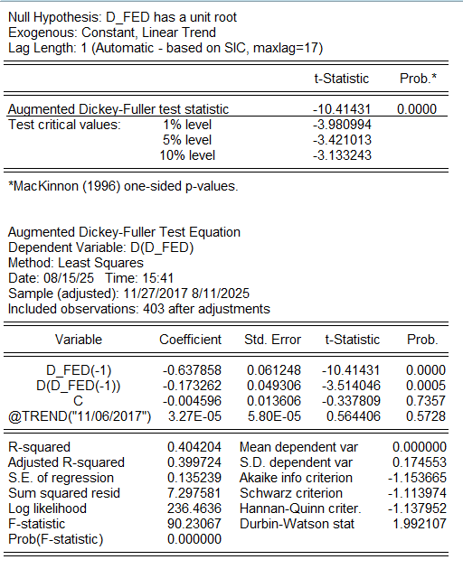 | 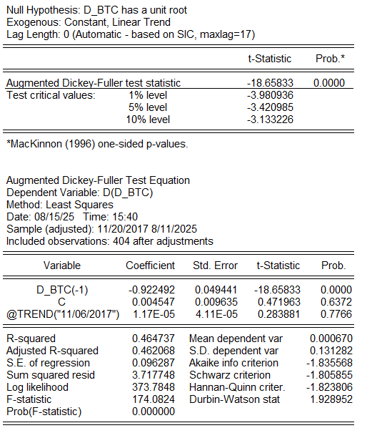
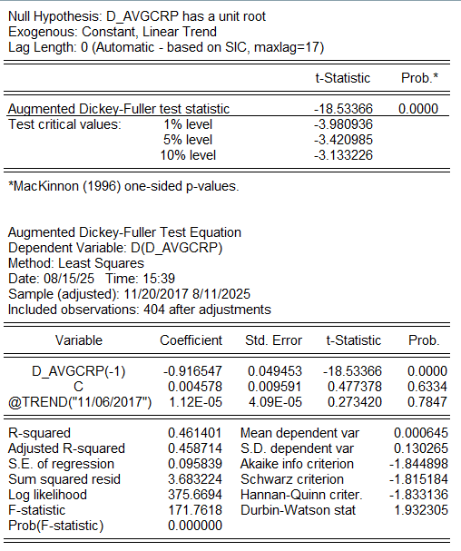
2.2 Series Graphs After First Differencing
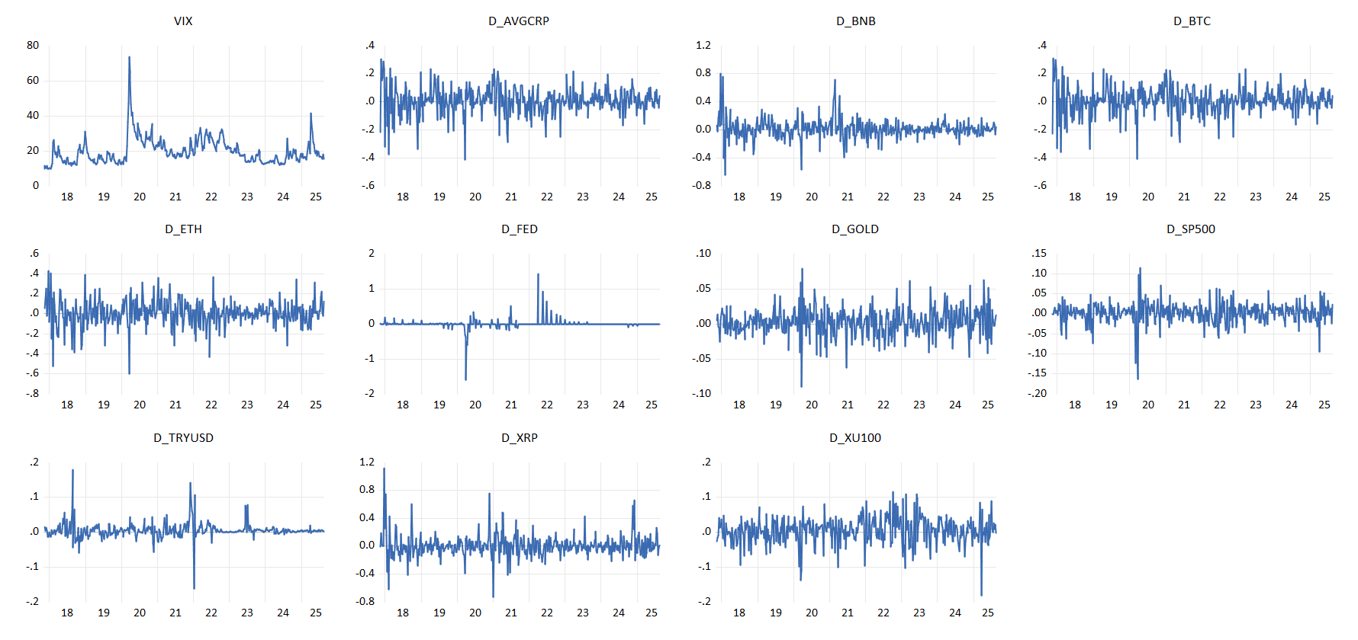
Figure 2.2 — Weekly log-returns for all endogenous and exogenous variables
2.3 Volatility Series Transformation
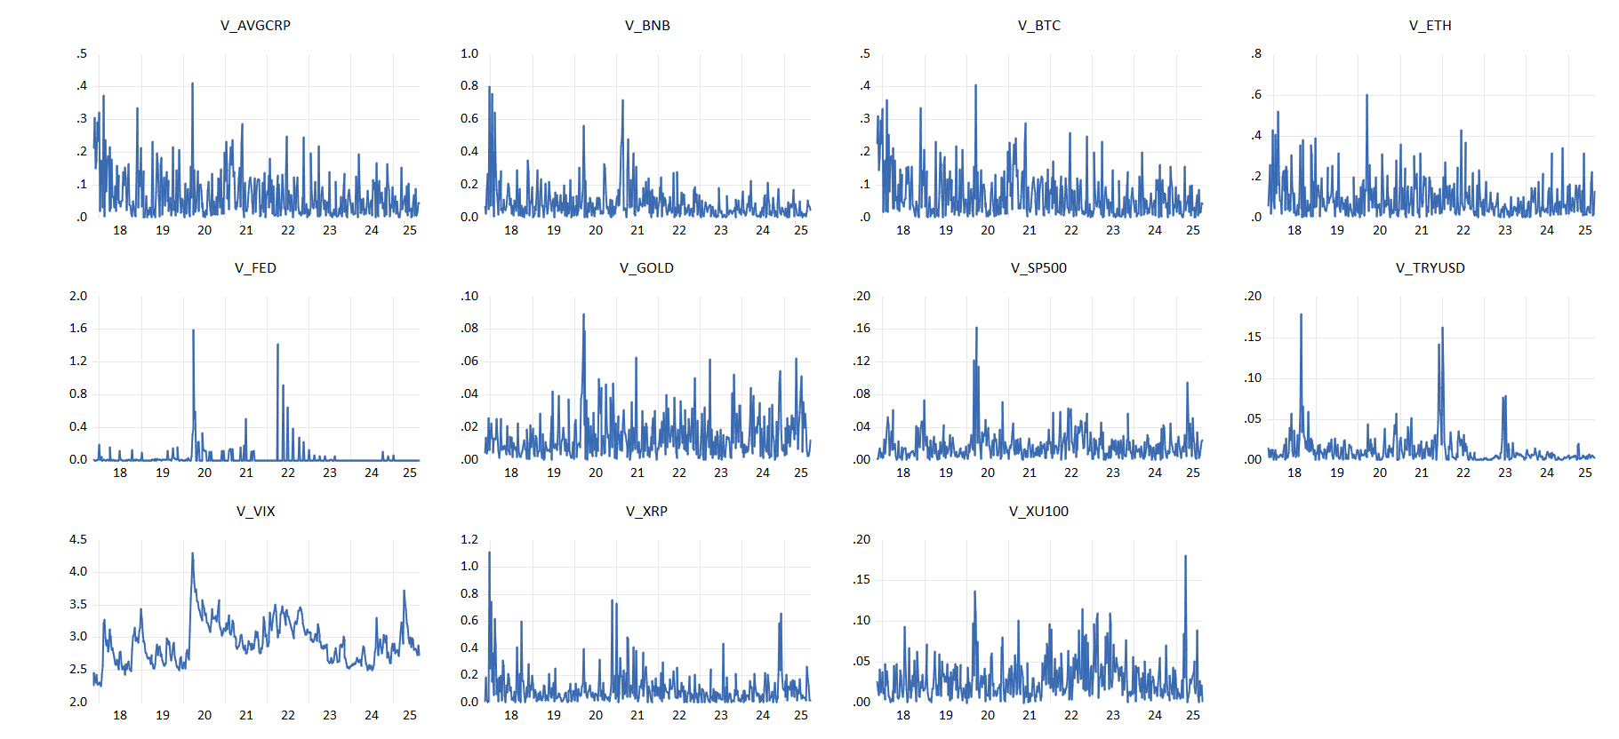
Figure 2.3 — Absolute returns (volatility proxies): V_AVGCRP and V_XU100
3. VARX Specification and Estimation
Baseline specification: a bivariate VARX in (V_AVGCRP, V_XU100), with exogenous controls (V_SP500, V_GOLD, V_TRYUSD, V_FED, V_VIX) and a short COVID dummy. The endogenous lag interval is 1–2 (i.e., VARX(2)), selected using information criteria and residual diagnostics. Exogenous controls enter contemporaneously and with one lag [0,1]. Results are qualitatively unchanged under a more parsimonious VARX(1) with the same exogenous structure.
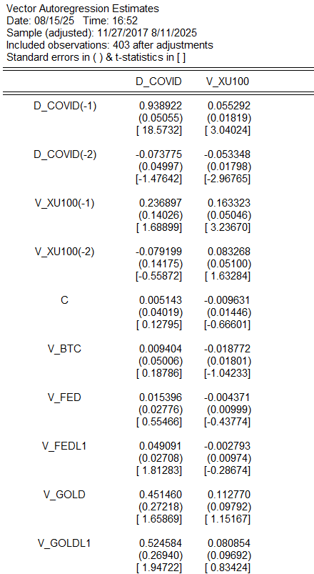 | 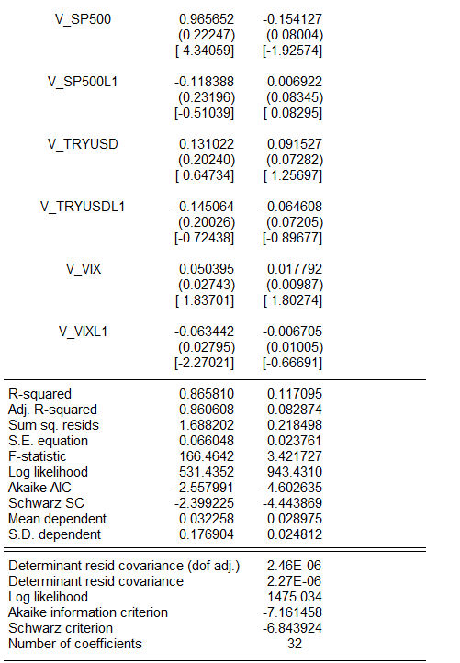
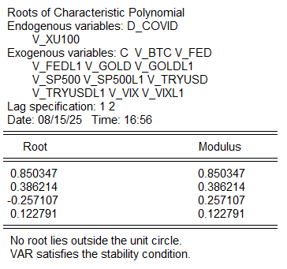 | 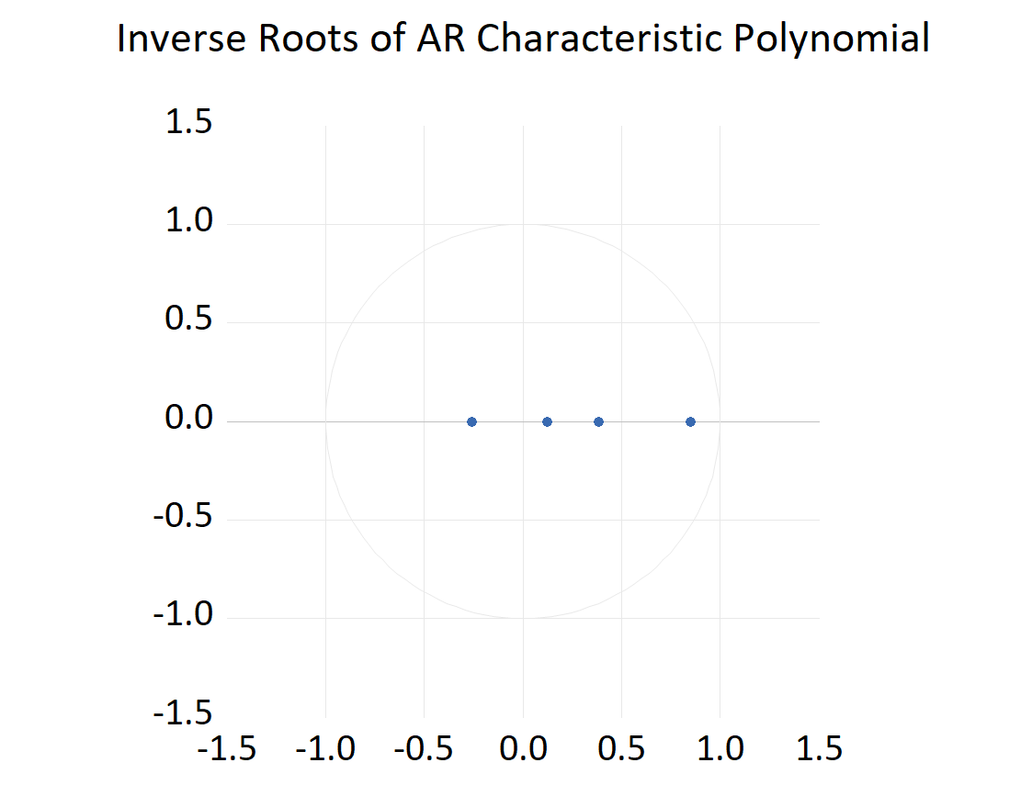
4. Model Diagnostics
Residual serial correlation: LM and Portmanteau tests do not reject the null of no serial correlation at conventional horizons when controls are included.
- Stability: All inverse roots of the AR characteristic polynomial lie strictly inside the unit circle.
- Normality: Multivariate residual normality is not imposed; IRF confidence bands rely on finite‑sample Monte‑Carlo (percentile) or d.f.-adjusted analytic bands.
- Heteroskedasticity: Levels‑&‑squares test indicates time‑varying volatility (expected for weekly returns). IRFs and FEVDs therefore rely on robust inference.
5. Granger Causality
Block‑exogeneity tests indicate that crypto returns do not Granger‑cause XU100 returns at the 5% level across the considered lag lengths. The reverse direction (XU100 → crypto) is also statistically weak, suggesting limited predictive power in either direction once global risk and macro controls are included.
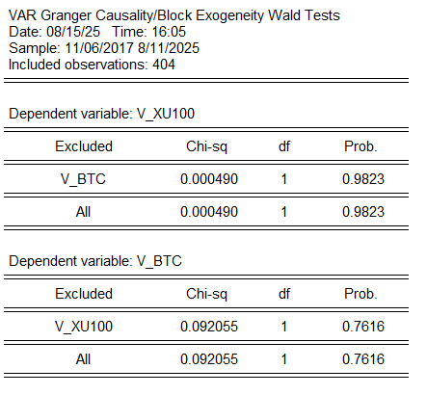
Figure 5 — Granger causality / block exogeneity test results
6. Impulse Response Functions (IRFs)
Identification: Cholesky with ordering [V_AVGCRP, V_XU100]. A one‑s.d. shock to the crypto block produces economically tiny responses in XU100 returns — near zero after 1–2 weeks and within the confidence bands at all horizons up to 10 weeks. Own‑responses behave as expected: crypto and XU100 shocks decay quickly, with most effects dissipating within a month. Monte‑Carlo (1,000 draws) percentile bands and d.f.-adjusted analytic bands deliver the same qualitative conclusion.
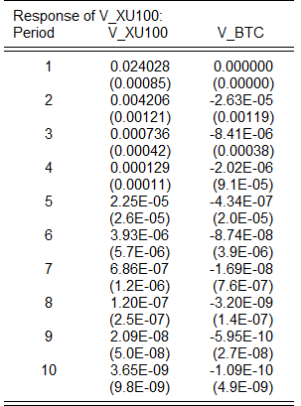 | 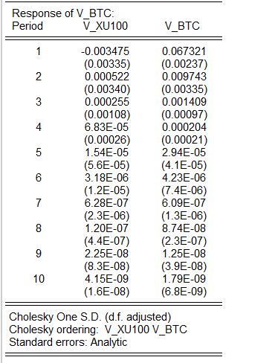
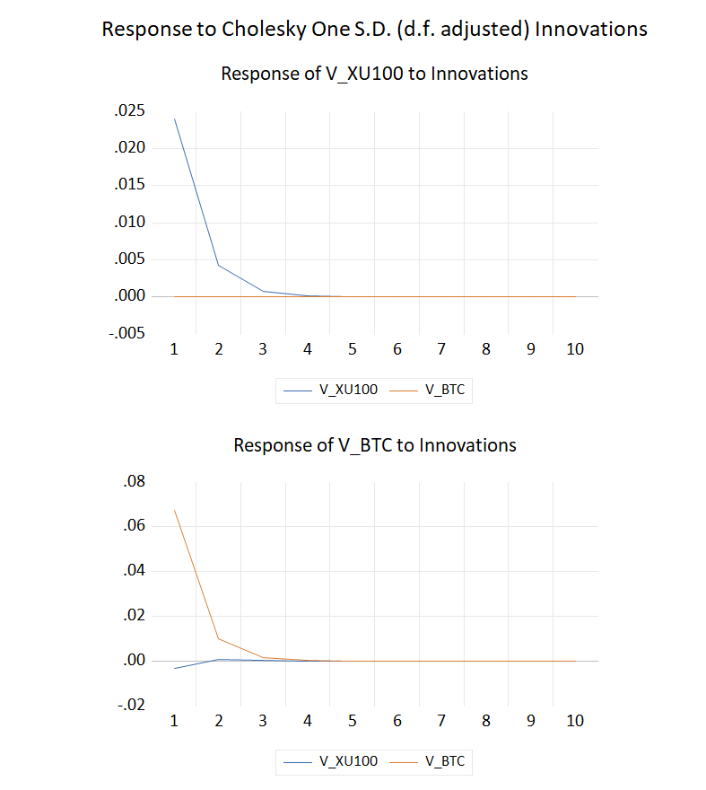 | 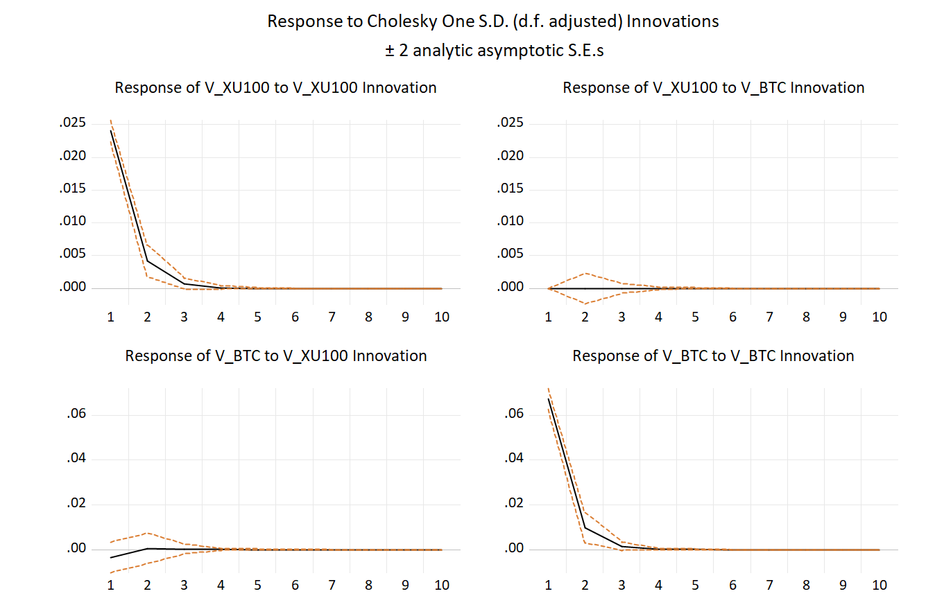
7. Variance Decomposition
Variance decomposition results underscore the weak transmission from crypto to BIST. At short horizons, XU100 variance is almost entirely self‑driven; even at 10 weeks, crypto accounts for only a few percent of XU100 variance. Symmetrically, XU100 contributes little to crypto variance.
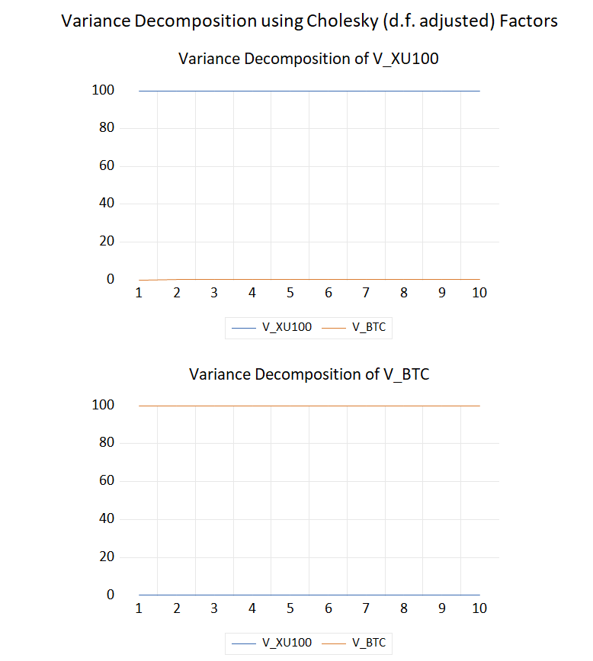 | 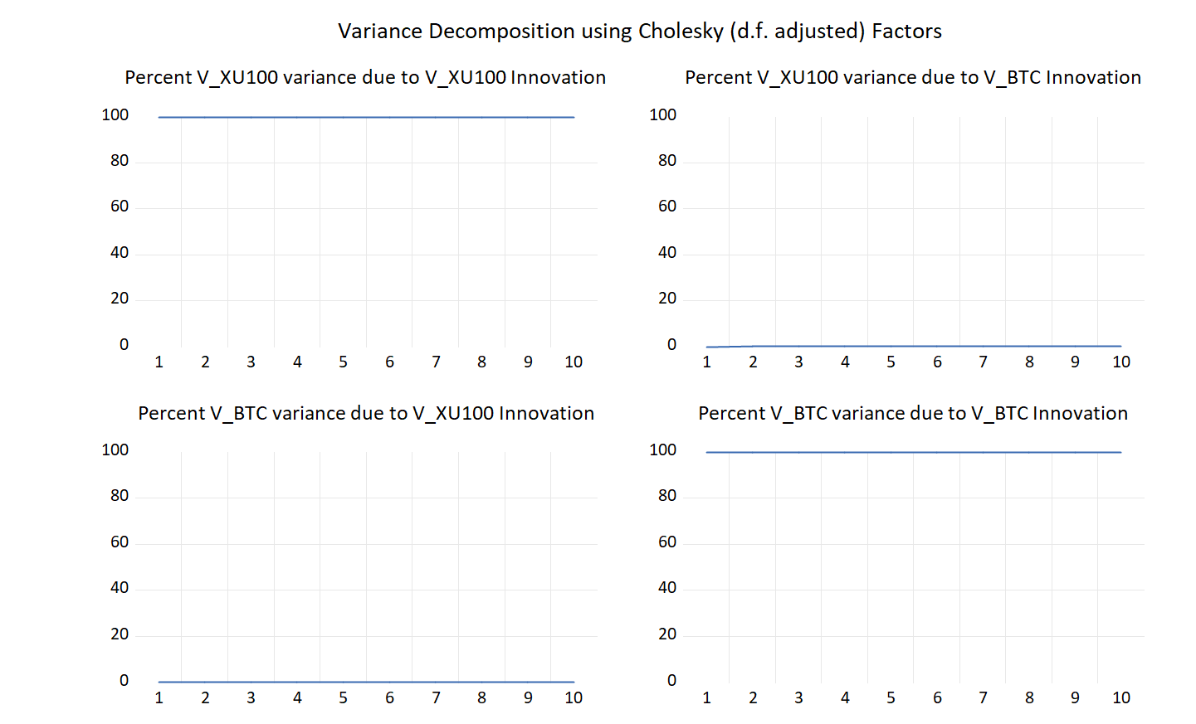
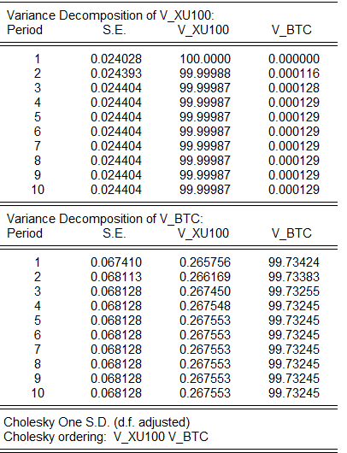 | 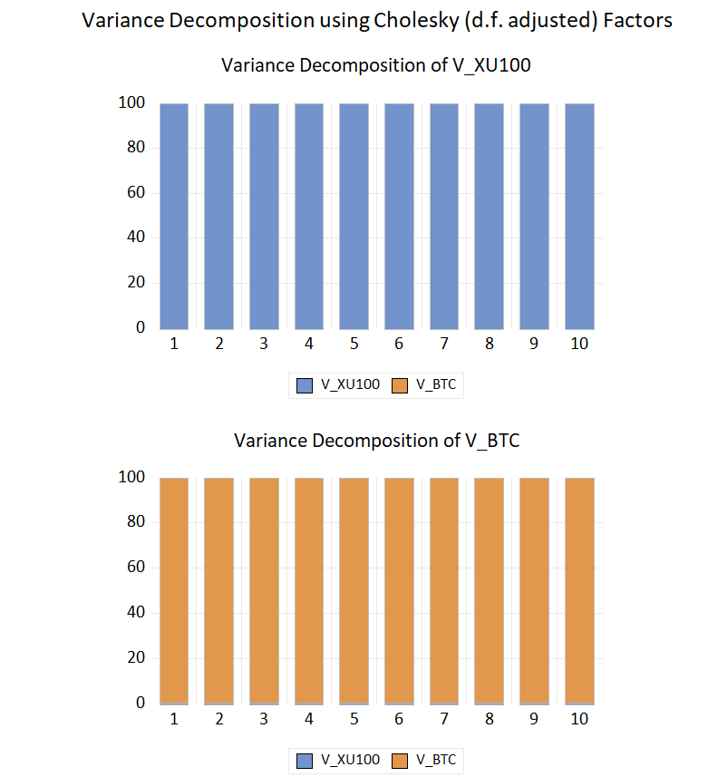
8. Historical Decomposition
Shock‑by‑shock historical decompositions (using d.f.-adjusted Cholesky weights) indicate that large swings in XU100 — including the COVID crash and subsequent recoveries — are largely attributed to own innovations and global controls rather than to crypto shocks. Crypto innovations contribute only marginally to the cumulative path of XU100 returns.
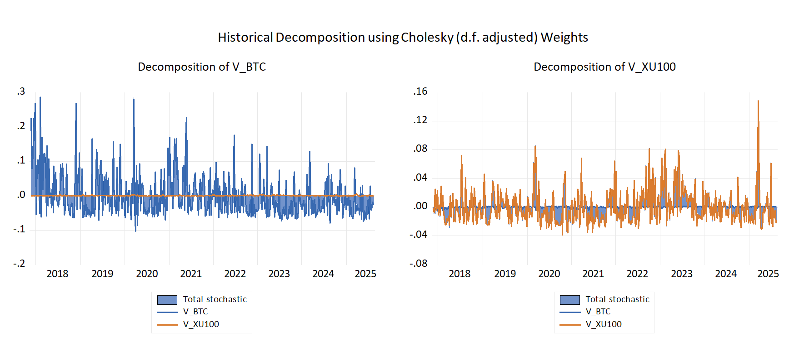
Figure 8a — Historical decomposition of XU100 returns
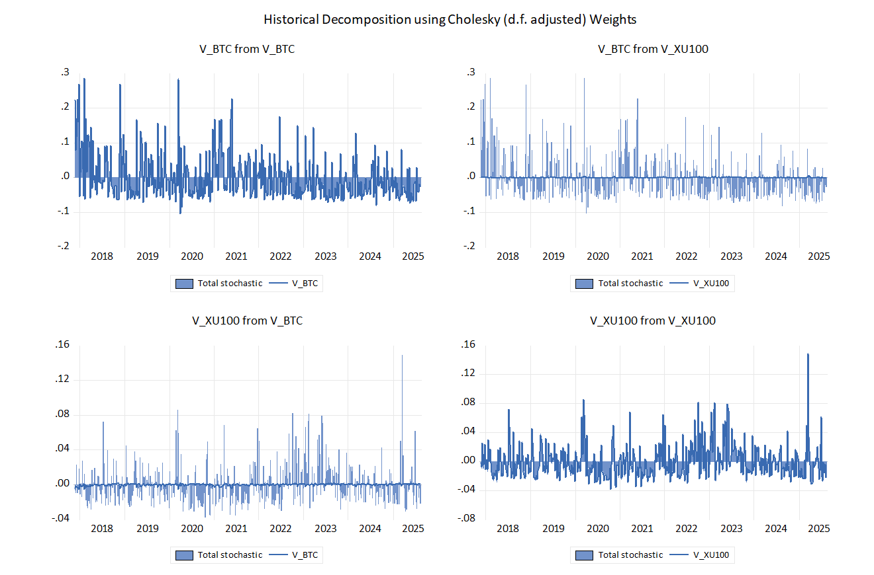
Figure 8b — Extended historical decomposition
9. Robustness and Alternatives
Several robustness checks confirm the baseline findings:
- Crypto factor (PCA): We replaced the average crypto composite with a principal-component factor built from all major crypto returns (BTC, ETH, XRP, BNB) and re‑estimated the VARX(2). Results were unchanged — the crypto factor does not generate economically meaningful effects on XU100.
- COVID dummy: Included D_COVID as an exogenous regressor. It improves small-sample diagnostics without altering IRF/FEVD conclusions.
- Ordering: Reported IRFs under both Cholesky orderings (crypto → XU100 and XU100 → crypto) and generalized IRFs. Conclusions are invariant.
- Lag length: Results are robust when moving from VARX(2) to a more parsimonious VARX(1). If residual serial correlation emerges, re‑introducing endo lag 2 resolves it.
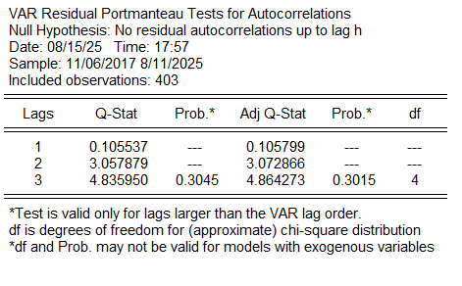 | 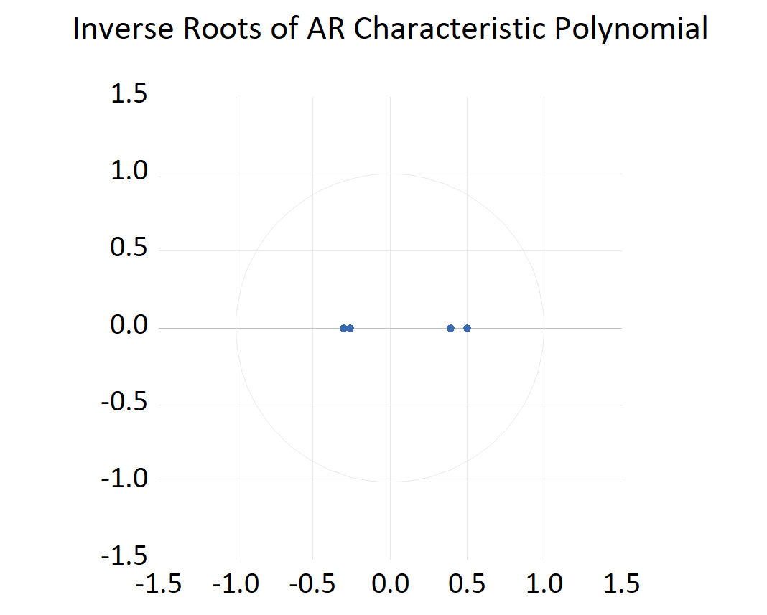 | 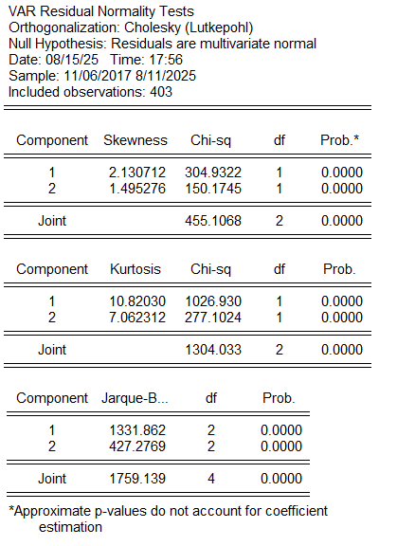
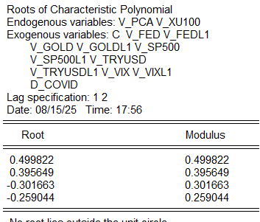 | 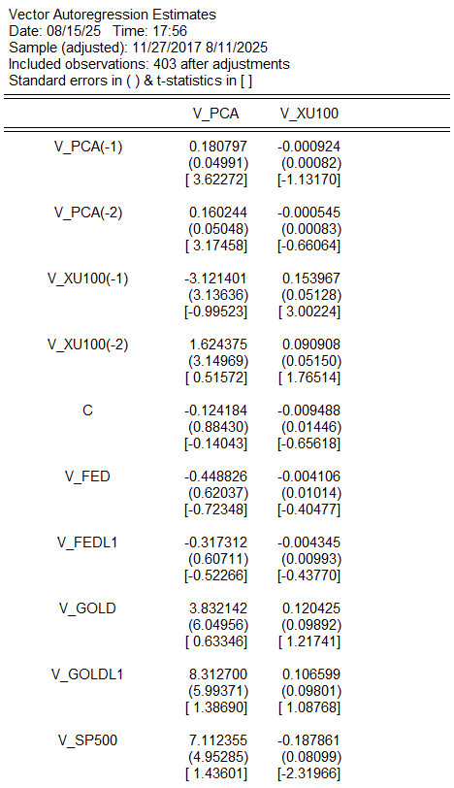 | 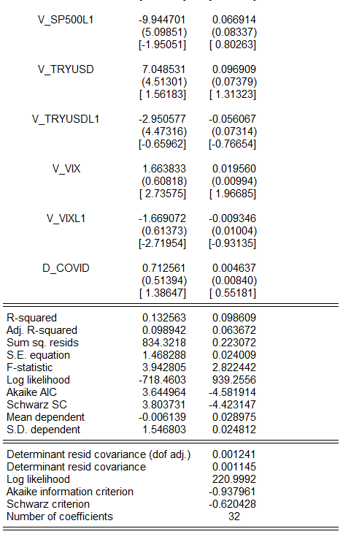
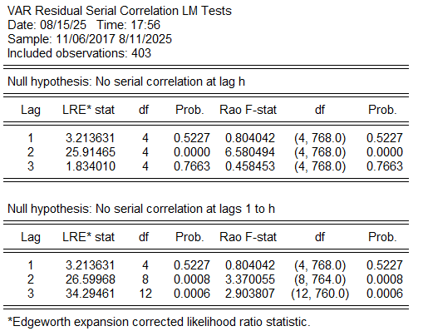 | 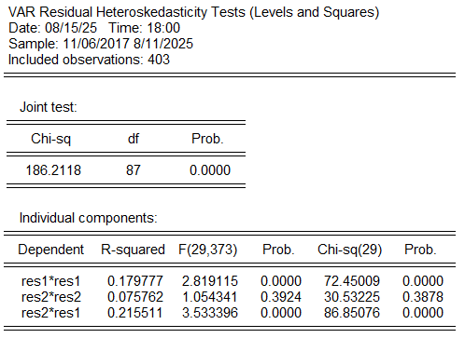
10. Interpretation
The absence of sizable transmission from crypto to BIST suggests that, at weekly horizons, domestic equity volatility is primarily driven by its own dynamics and by global equity/FX/commodity factors rather than by crypto‑specific shocks. The weak two‑way link also indicates segmentation between the Turkish equity market and crypto markets over the sample, after controlling for global risk proxies and policy rates.
11. Limitations
Findings pertain to weekly data and a specific sample window. Identification is recursive (Cholesky) and results could differ under alternative — for example sign‑restricted — identification. Structural breaks and regime changes (capital controls, market microstructure) may further affect propagation. Finally, heteroskedasticity is material in weekly returns; robust inference partially mitigates but cannot eliminate this concern.
12. Conclusion
Across multiple specifications and diagnostics, we find no evidence that cryptocurrencies are a first‑order driver of volatility in Borsa Istanbul at weekly horizons. Crypto shocks have, at most, a very small influence on XU100 forecast variance, and impulse responses are economically negligible.
Policy and investment takeaway: for risk management focused on BIST, monitoring global equity, FX, and rates appears more useful than tracking crypto‑specific shocks.

Appendix A — Key EViews Steps (Replicable Outline)
A1 Objective
Assess whether crypto volatility transmits to BIST volatility using conditional‑variance models, as implemented in EViews during the study.
A2 Data and Transformations
Weekly frequency; same sample window as the main analysis. Prices were log‑transformed and differenced to obtain returns:
rBTC = Δln(BTC) rXU100 = Δln(XU100)
A3 BTC Univariate GARCH(1,1)
EViews setup (Method: ARCH; Error distribution: Student‑t):
Mean eq: rBTC_t = μ + φ·rBTC_{t−1} + ε_t
Var eq: hBTC_t = ω + α·ε_{t−1}² + β·hBTC_{t−1}
Persistence is high but stationary (α+β < 1). The conditional variance series was saved via Proc → Make Variance Series (denoted h_btc).
A4 XU100 GARCH(1,1) with External Variance (GARCH‑X)
Directional spillover was tested by augmenting the XU100 variance equation with the lagged BTC conditional variance:
Mean eq: rXU100_t = μ + φ·rXU100_{t−1} + u_t
Var eq: hXU100_t = ω + α·u_{t−1}² + β·hXU100_{t−1} + γ·hBTC_{t−1}
Implementation: h_btc(−1) was entered in the Variance regressors field in EViews. Result: γ on h_btc(−1) is not statistically significant at the 5% level — no robust evidence of BTC→BIST volatility spillover.
A5 Diagnostics
- Standardized residuals LM test: no serial correlation.
- ARCH‑LM on standardized residuals: no remaining ARCH effects after GARCH specification.
- News Impact Curve: broadly symmetric; no material leverage/asymmetry signal.
- Student‑t degrees of freedom confirm fat tails (expected for weekly financial data).
A6 Alignment with Main VARX Findings
The GARCH‑X result — no statistically robust and economically meaningful volatility transmission from BTC to BIST — is consistent with the VARX evidence (Granger, IRFs, VD).
A7 Figures and Tables
A7.1 Conditional Variance
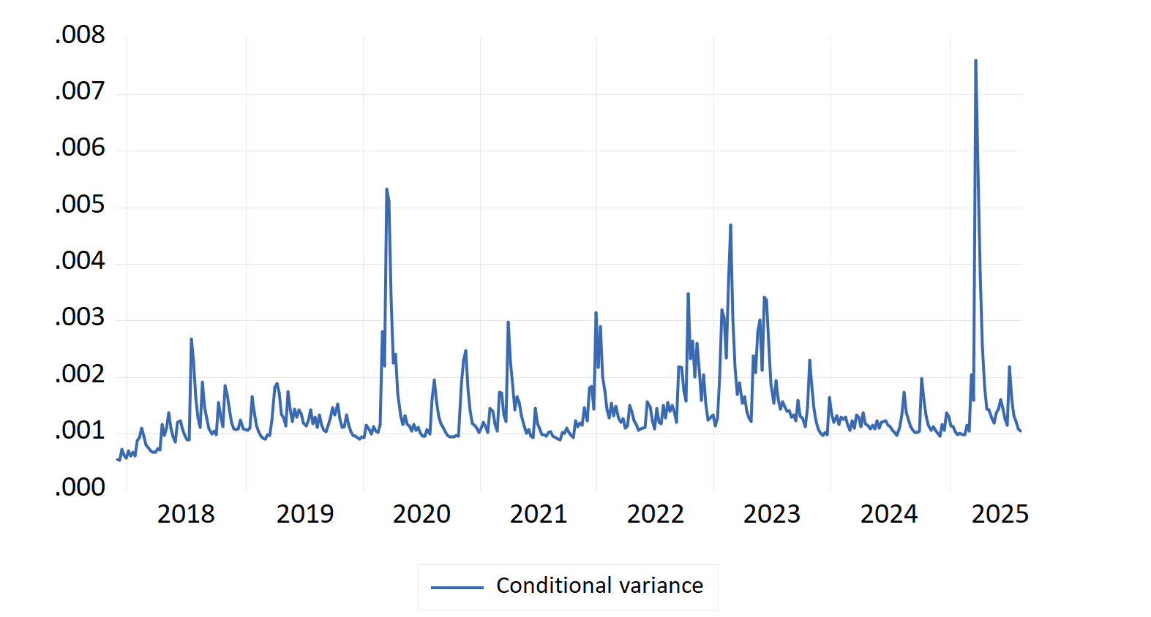
Figure A7.1 — BTC conditional variance from GARCH(1,1)
A7.2 Conditional Standard Deviation
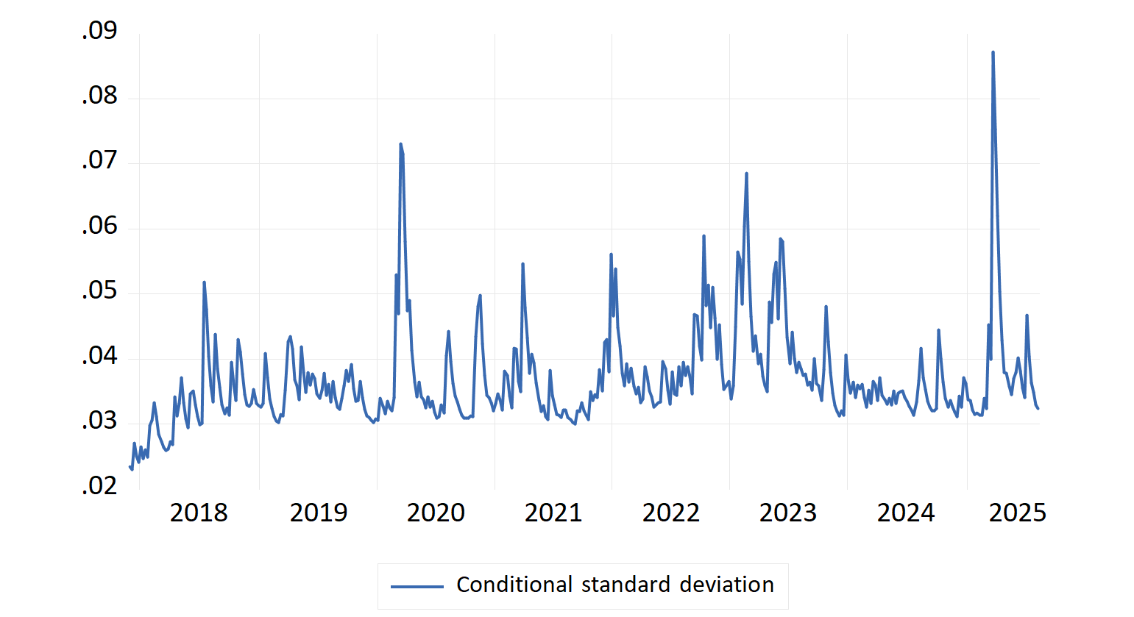
Figure A7.2 — Conditional standard deviation
A7.3 News Impact Curve
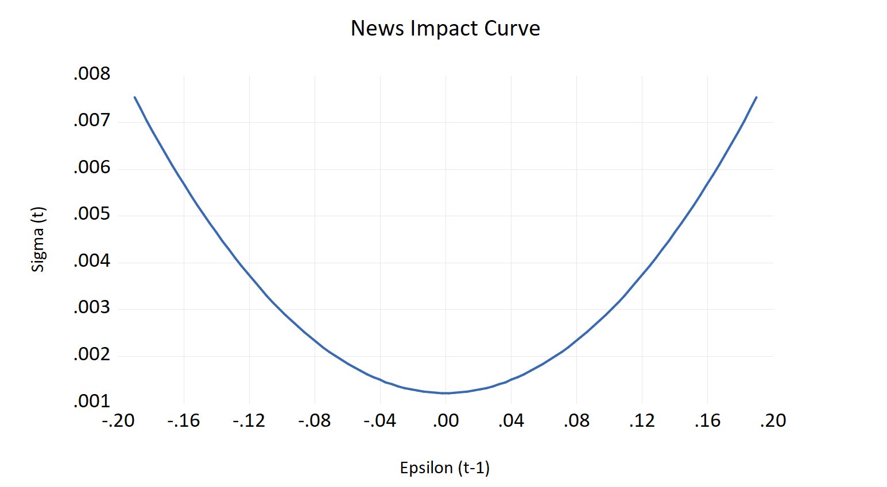
Figure A7.3 — News Impact Curve from GARCH(1,1)
A7.4 Gradients of the Objective Function
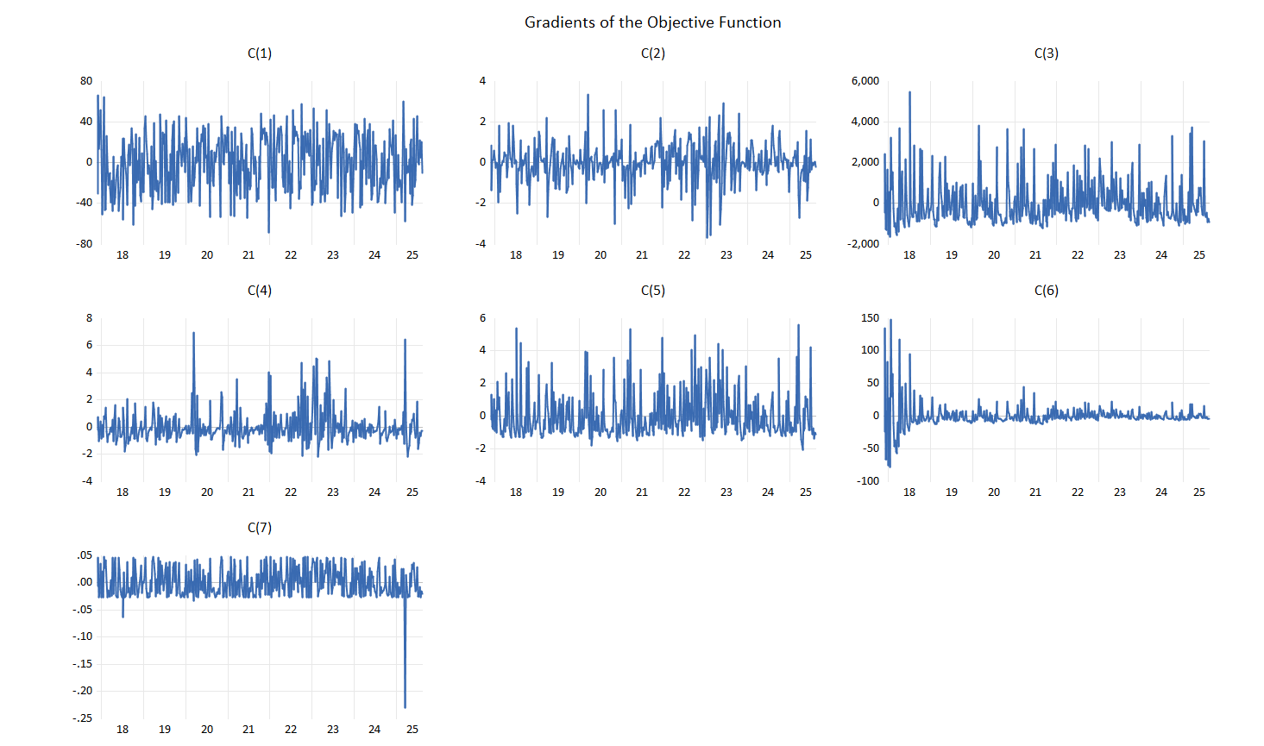
Figure A7.4 — Gradients of the objective function
A7.5 Heteroscedasticity Test: ARCH
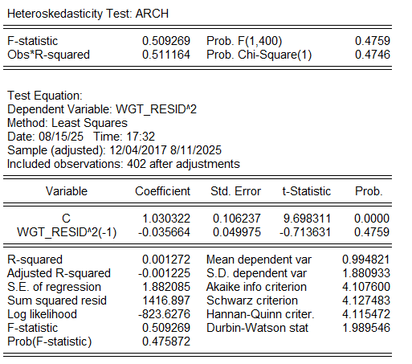
Figure A7.5 — ARCH heteroscedasticity test
A7.6 GARCH(1,1)-X Estimation Output — Dependent Variable: D_XU100
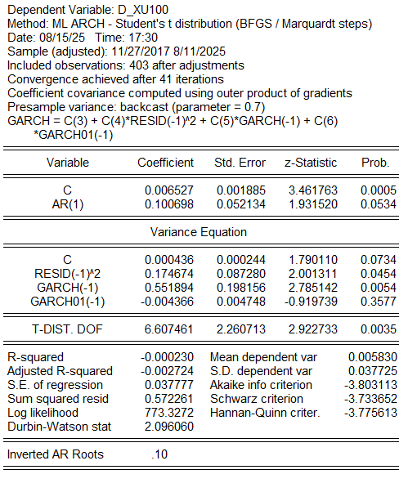
Figure A7.6 — Full GARCH(1,1)-X estimation output (ML, Student-t)

— End of Report —

