Introduction
Asasa

Database schema documentation for the public data dump and SEDE.

Stack Exchange releases "data dumps" [1] of all its publicly available content roughly every three months on each site, and also makes that information queryable over the Internet at the Stack Exchange Data Explorer (SEDE) (updated weekly, on Sunday). Over time, as new features and other bits of data are introduced to Stack Exchange sites, the "anatomy" of the data dump is likely to change.

StackOverflow Trends 2026
In this medium post, “StackOverflow Trends 2026: The Structural Shift from Human Support to Generative AI” [2], Kanshi Tanaike analyzes some trends using the Stackexchange data.
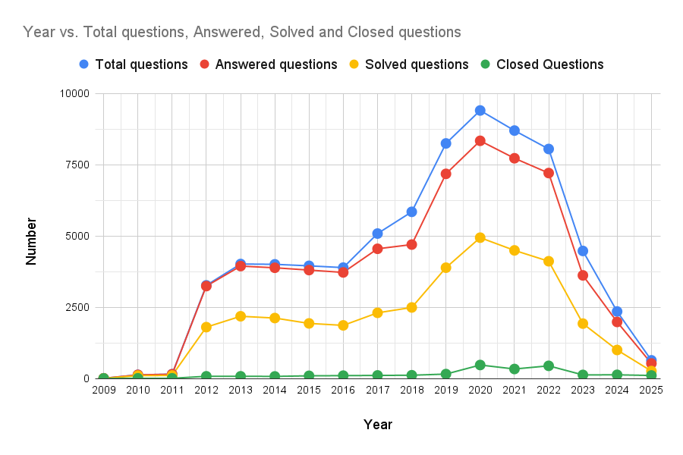

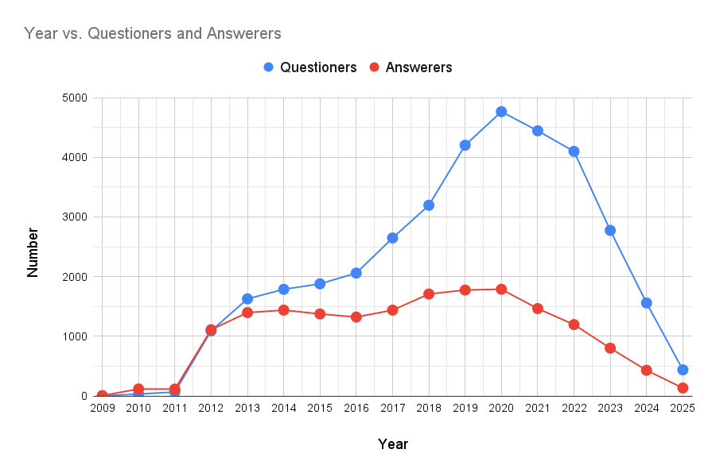

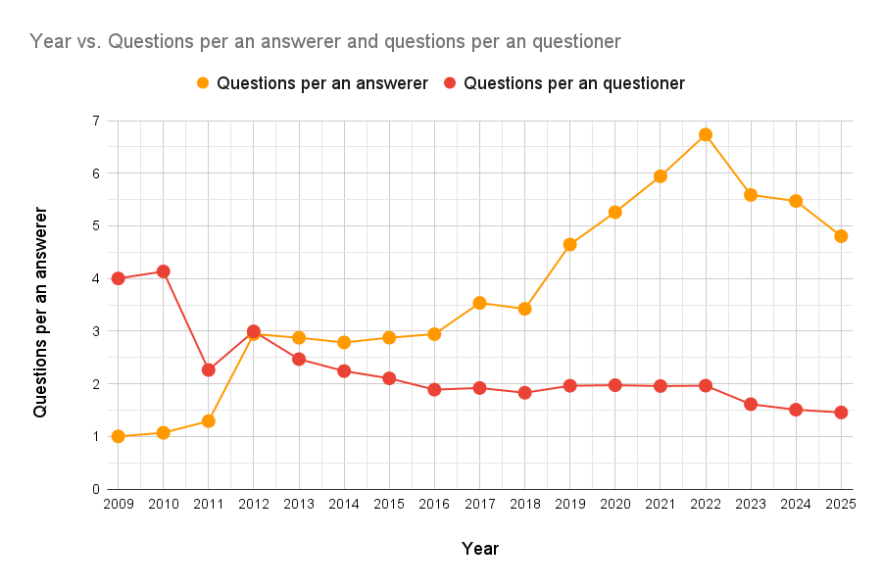
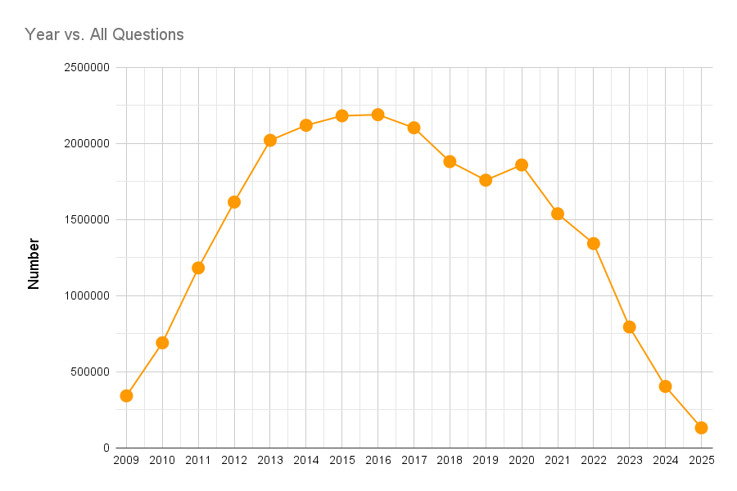

Has Stack Exchange's traffic decreased since ChatGPT?
In this discussion, users argue whether ChatGPT was actually the cause of the demise of Stack Exchange forums.

New Question Activity Dropped

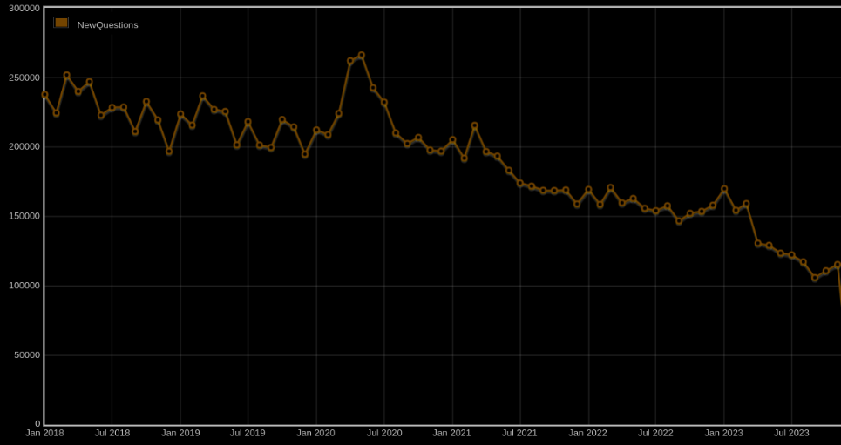

New Answers dropped

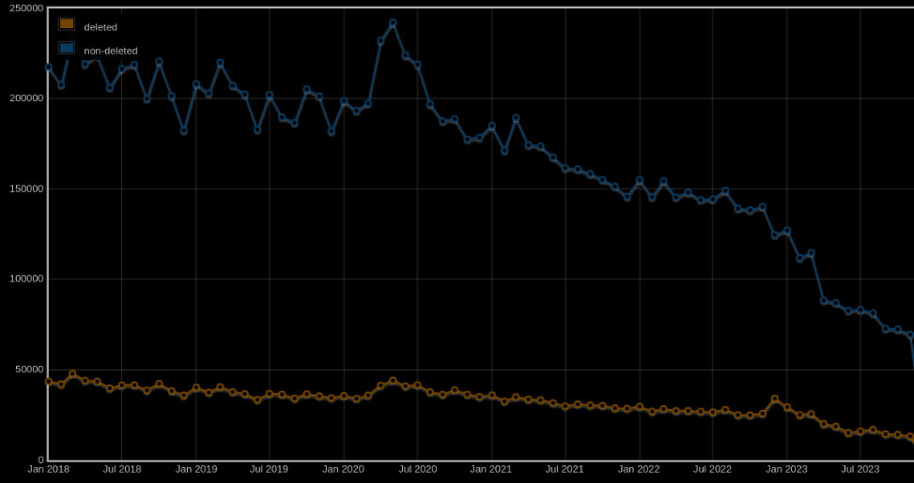

New User Registration Activity Dropped
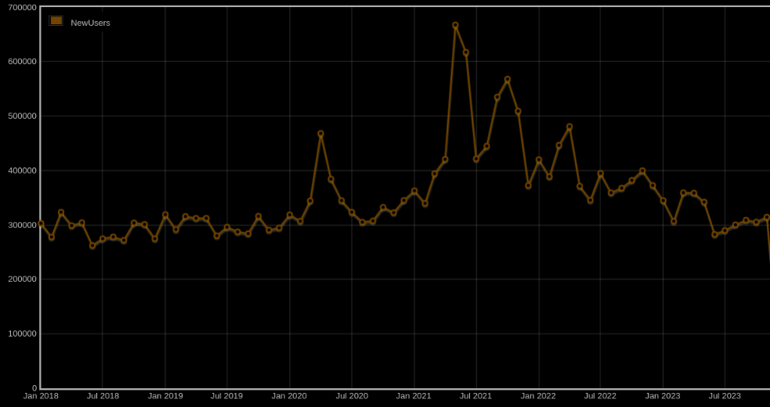

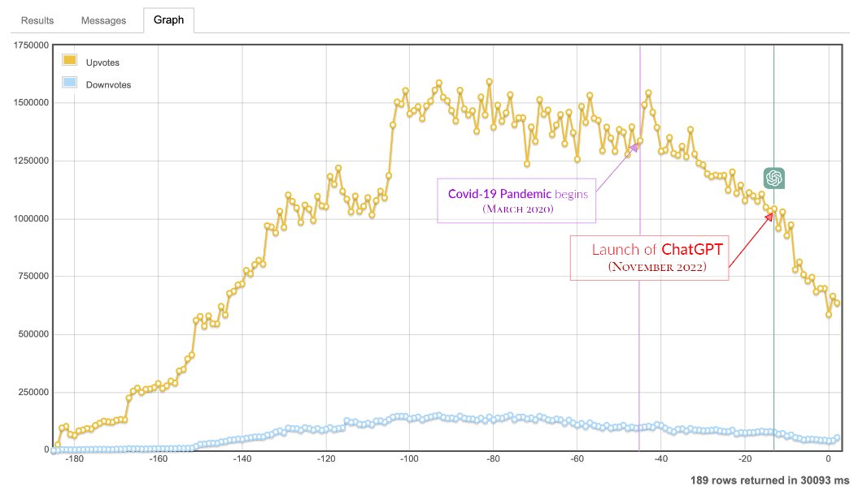

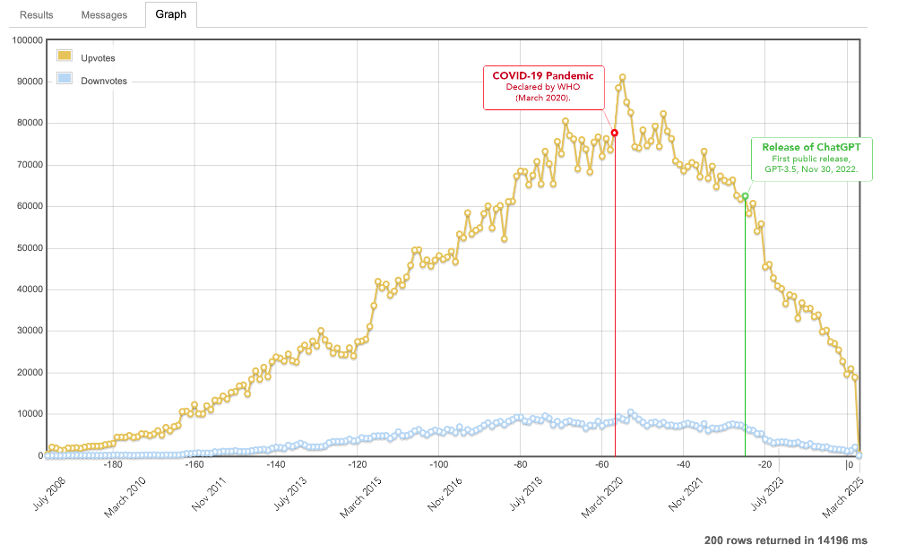

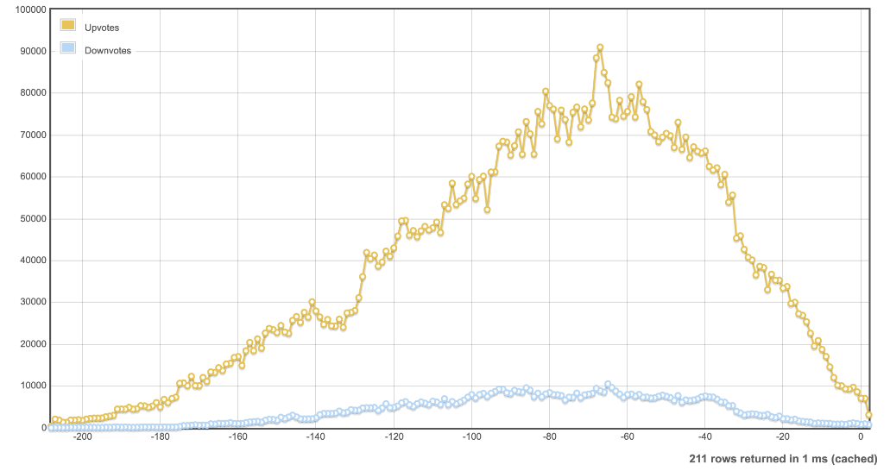

Database schema documentation for the public data dump and SEDE

References
[1] Database schema documentation for the public data dump and SEDE.
https://meta.stackexchange.com/questions/2677/database-schema-documentation-for-the-public-data-dump-and-sede
[2] Kanshi Tanaike. StackOverflow Trends 2026: The Structural Shift from Human Support to Generative AI. Medium, Google Cloud.
https://medium.com/google-cloud/stackoverflow-trends-2026-the-structural-shift-from-human-support-to-generative-ai-b921930ff29d
[3] Meta Stack Exchange. Has Stack Exchange’s traffic decreased since ChatGPT?
https://meta.stackexchange.com/questions/387278/has-stack-exchanges-traffic-decreased-since-chatgpt
[4] Meta Stack Exchange. Database schema documentation for the public data dump and SEDE.
https://meta.stackexchange.com/questions/2677/database-schema-documentation-for-the-public-data-dump-and-sede
[5] Stack Exchange Data Explorer. New question activity per month since 2018.
https://data.stackexchange.com/stackoverflow/query/1717975/new-question-activity-per-month-since-2018#graph
[6] Stack Exchange Data Explorer. History sum by month per year of votes by tag.
https://data.stackexchange.com/stackoverflow/query/1827427/history-sum-by-month-per-year-of-votes-by-tag#graph
[7] Stack Exchange Data Explorer. Portuguese Stack Overflow query, ID 1949972.
https://data.stackexchange.com/pt/query/edit/1949972
[8] Stack Exchange Data Explorer. New answers per month since 2018.
https://data.stackexchange.com/stackoverflow/query/1717973/new-answers-per-month-since-2018#graph
[9] Stack Exchange. All Sites.
https://stackexchange.com/sites

