**Specific Goals**:

Our task is to produce a device for psychology experiments observing the use of simple tools by young children. In this capacity, the model “tool” needs to be able to sense and record its own acceleration and orientation, as well as impact at the end of the tool. The trial data can be used to compare the motions and forces children employ, relative to how adults use the tool, in an effort to deduce whether there exist instincts in humans for how to use tools.

**Approach**

In order to accurately measure the required data, the tool incorporates a sensor package consisting of an IMU (inertial measurement unit) along with a pair of load cells to measure force. The IMU should contain at the minimum a 3-axis accelerometer and a 3-axis gyroscope for 6 total degrees of freedom, with reasonable resolution and accuracy. The load cells are used to measure impact force when striking/hammering with the tool.

The body of the tool itself is 3D-printed from a durable plastic and should be the right size for the children to easily grip. The experiment will involve the subjects using the tool to chip at a block of art foam or other breakable material, and measuring the orientation and impact forces generated during each trial.

**Design**

The tool itself is 3D-printed with a conical design and is small enough such that a child can grasp it firmly. The tool has placements for the load cells and Arduino board as well as a moveable component which strikes against the load cell to efficiently distribute the force.

The force sensing circuitry for the load cell was designed according to the following schema at: <http://www.proto-pic.com/Resources/Application%20Example%20of%20using%20the%2050kg%20Load%20Sensor%20PPSEN-10245.pdf>

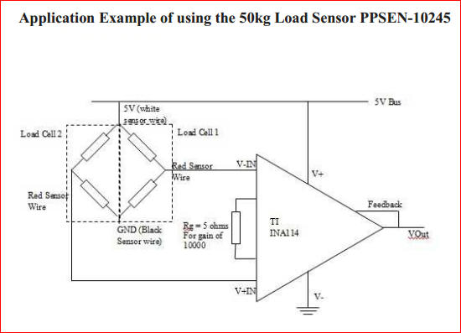

The 3D print final design is as according to this design:

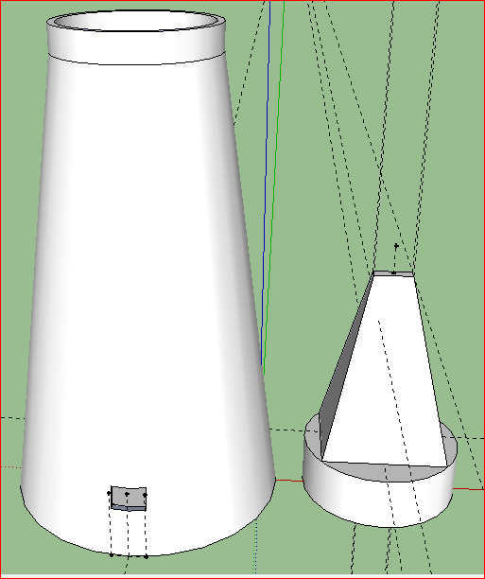

**Current iteration**

Hardware

Currently we have the near-final 3D design for the case complete with chisel shaped/pyramidal head. There are slots for switches and wiring to contain all circuitry inside, as seen in the previous figure. The circuitry includes an ArduIMU, which contains the accelerometers, gyros, and an Atmega328 microprocessor for on-board processing and preparation of data to send it via bluetooth for data collection at a computer. A pair of load cells are used in force sensing when the tool is used to strike the test surface/object. The load cells have their own circuit for correct operation as shown in the figure previously.

Software

We also have all the software written for collecting, sending, and displaying accelerometer and force data. This data is collected as it is received via bluetooth from the tool. Data is received with Acceleration data as x, y, z in m/s^2; Gyro data as x, y, z radians; and force data as Newtons. This data is written to a csv file with each row being one sample of data. A graph is also created in the data recording procedure. The data recording is completed by a python program which calibrates the load cells for force sensing and takes many samples of the tool as data is received from the tool. At the end of a recording trial, the graph of each data type is plotted and presented for saving, along with the raw data being saved in CSV format.

**Materials**

The test material which will be struck is artist’s carv foam: <http://www.dickblick.com/buy/product/150885-stone-carving-materials-carv-foam.html>. This material is easy to break while also being heavier than air so there is no issue of dust or airborne particles. The case is made with 3D printer plastic.

The electronic boards and chips consist of the following:

Item Quantity Link

Load Sensor 2 <https://www.sparkfun.com/products/10245>

ArduIMU 1 <https://www.sparkfun.com/products/11055>

BlueSMIRF modem 1 <https://www.sparkfun.com/products/10269>

LiPower regulator 1 <https://www.sparkfun.com/products/11260>

Lithium battery 1 <https://www.sparkfun.com/products/339>

10 Ohm Resistor 1

Instrumentation 1

Amplifier (TI INA114)

**Next Steps**:

With the tool ready, we can begin testing and running through the experimental procedure. Possible changes to the way data is collected may be necessary to best suit the desired procedure. Further improvements to the case may also be necessary once obtaining results from the initial experiments with the tool. The circuitry housed within can continue to be stripped down with better components and smaller boards for saving space and reducing the size of the overall tool.