Video Watermarking Benchmark
DCT-QIM vs. Adobe TrustMark — quality, robustness, and failure-mode characterisation under realistic codec and geometric attacks.

1. Problem framing
Embedding a recoverable identifier into video frames is the basis for provenance, leak tracing, and tamper detection. Two families of techniques dominate: classical signal-processing methods that modulate transform-domain coefficients (DCT-QIM, spread-spectrum), and learned methods that train an encoder/decoder pair to embed a payload as an imperceptible residual. This project benchmarks one representative from each family — a custom DCT-QIM scheme and Adobe TrustMark — on a common 56-bit payload, common video codec round-trip, and a shared attack suite, so the trade-offs can be compared on equal terms.
The benchmark answers three questions:
- How invisible is each watermark on real content (PSNR, SSIM)?
- How robust is each watermark after a realistic H.264 / H.265 round-trip and downstream attacks (per-frame BER, exact-match rate)?
- Which frames are easier to recover from than others, and why?

2. Assumptions and constraints
- Payload size is fixed at 56 bits (7 bytes). This matches both the DCT scheme's BCH(127, t=11) data field and TrustMark's BCH_5 61-bit capacity (with 5 unused bits of headroom).
- Watermarking is per-frame and independent. No temporal exploitation across frames during embedding; the decoder is free to majority-vote across frames after the fact.
- Encoder and decoder share a secret key and operate on a fixed frame geometry. The DCT scheme's PN block selection depends on frame dimensions, so geometric distortions break it unless the dimensions are restored before decode.
- The reference codec is H.264 (libx264) at CRF 23 — a common streaming quality. H.265 (libx265) is used to test cross-codec robustness.
- Evaluation is run on a 1920×800 cinematic clip excerpted from Tears of Steel, sampled at 24 frames. Frames with degenerate luma (e.g. opening black title cards) are excluded because the QIM scheme is mathematically unable to embed in a flat Y=0 block.

3. Embedding strategy

3.1 DCT-QIM
The frame is converted to BT.601 full-range YCbCr; embedding happens only in the Y plane. The Y plane is tiled into 8×8 blocks (the same grid H.264 uses for transform coding) and a 2-D orthonormal DCT-II is applied to each block.
The 56-bit payload is expanded by BCH(n=127, k=57, t=11) into a 127-bit codeword. Each of the 127 codeword chips is embedded in a pseudo-randomly chosen block via Quantisation Index Modulation (QIM) of a mid-band AC coefficient (zigzag indices 5–14). The block-selection sequence is keyed by SHA-256 of the user-supplied secret. With num_blocks=4, each chip is written to four distinct blocks at four different mid-band coefficients, trading payload density for an inner majority-vote on decode in addition to the outer BCH correction.
After modification, the inverse DCT reconstructs the luma plane; YCbCr is converted back to RGB, rounded, and cast to uint8 for storage. QIM step δ = 30 is chosen empirically to survive H.264 down to CRF 28 while preserving PSNR ≈ 60 dB on smooth content.

3.2 TrustMark
TrustMark is a learned encoder/decoder pair (Adobe, 2023). The encoder operates internally at 256×256 and re-projects a learned residual onto the input frame. We wrap it in a per-frame adapter that exposes the same encode/decode interface as the DCT scheme.
The 56-bit payload is serialised as a 56-character binary string ('01001...') and passed to TrustMark.encode() with MODE='binary' and BCH_5 encoding (35 ECC bits, corrects up to 5 bit-flips, 61-bit capacity). MODE='binary' is critical: the default MODE='text' packs the string as ASCII text, which then does not round-trip when decoded with MODE='binary' — see §9 failure analysis.

4. Detection strategy

4.1 DCT-QIM
Decode mirrors encode: RGB → BT.601 YCbCr → 8×8 block tiling → DCT. For each of the 127 chips the decoder reads num_blocks (default 4) QIM coefficients and takes the soft mean as the chip's value (≥ 0.5 → bit = 1). The 127 hard chips are then BCH-decoded; up to 11 chip errors are corrected and the 56-bit payload is recovered. The decoder also returns n_errors_corrected (or −1 for an uncorrectable codeword), which is useful for confidence reporting.

4.2 TrustMark
Each frame is passed through TrustMark.decode(MODE='binary'), which returns the recovered binary string, a watermark-present flag, and a schema id. The first 56 characters of the string are converted back to a (56,) uint8 array. The model's own presence flag is reported alongside per-frame BER.
At the video level, both methods support a soft majority vote across all decoded frames as an additional aggregation step (reported as 'majority-vote BER' in the attack results).

5. Attack model
Attacks are applied as a separate stage after the main encode + codec round-trip. Each attack reads the watermarked MP4, transforms it, and writes a new MP4 — either with the user's chosen CRF (compression attacks) or near-lossless CRF 18 (non-codec attacks, to isolate the attack from extra codec noise). Twelve presets across six attack families ship by default:
Family | Presets | What it stresses
Re-encode (compression) | recompress_crf28, crf32, crf36 | Codec quantisation increasing in severity
Transcode (codec switch) | transcode_x265 (CRF 28) | Different codec, different quantisation matrix
Spatial rescale | resize_0.75, resize_0.5 | Downscale → upscale (player resizing, sharing pipelines)
Spatial crop | crop_0.8, crop_0.6 | Center-crop fraction → rescale back (camera-zoom mimic)
Additive Gaussian noise | noise_sigma2, sigma5, sigma10 | Sensor noise, generation loss, transcoding artefacts
Frame drop | frame_drop_0.5 | Frame-rate reduction; the surviving frames must still decode
The attack model is intentionally non-adversarial. There is no watermark-aware adversary trying to remove the signal; the presets approximate distortions that occur naturally in real distribution pipelines (re-streaming, mobile playback, format conversion). Stronger attacks (collusion, oracle attacks, deep-learning removal) are out of scope for this benchmark.

6. Evaluation methodology
The pipeline is one CLI invocation per run (python -m video_watermark.benchmark.run). For each frame in the input clip:
- Load the original frame as (H, W, 3) uint8 RGB via PyAV.
- Run the chosen watermarker's encode(frame, payload_bits) — watermarked frames stay in memory.
- Write all watermarked frames out as an MP4 at the user-chosen codec/CRF — this is the main codec round-trip.
- Re-read the watermarked MP4 frame-by-frame, call decode(frame) per the per-method API, and compute per-frame quality and robustness metrics against the original frame and the known payload bits.
- If --attacks is given, for each attack preset: re-encode the watermarked MP4 into a per-attack file, decode each frame, score per-frame BER and success against the expected payload, and emit the full per-frame trace (frame_idx, ber, success) alongside the aggregate stats.
All numbers are saved to benchmark_results.json. The per-frame trace is the entry point for the 'which frames are easier?' analysis.

7. Metrics used
Quality (watermarked vs original frame):
- PSNR (dB) — peak signal-to-noise ratio. Target ≥ 42 dB for invisible watermarking; ≥ 38 dB is the perceptibility floor.
- SSIM — structural similarity index, channel-averaged. Target ≥ 0.98.
- Mean |Δpx| — average per-pixel absolute difference, on the 0–255 scale.
Robustness (decoded bits vs. expected payload):
- Per-frame BER — fraction of the 56 bits that differ. 0.0 is perfect, 0.5 is random output (watermark destroyed).
- Exact-match rate (recovered / total) — fraction of frames where all 56 bits decode correctly. Reported as the primary headline number in the attack table.
- Per-bit BER — error rate per individual payload bit across frames. Surfaces whether errors are uniform or concentrated.
- Majority-vote BER — soft mean of all per-frame decoded bits, thresholded to 0/1 and compared to expected. Models a real video-level decoder that aggregates across frames.
- BCH n_errors_corrected (DCT only) — number of chip errors the BCH decoder fixed per frame (or −1 = uncorrectable).

8. Experimental results
Test setup: ToS-1920_60s.mp4 (1920×800), 24 frames, payload "ABCDEFG" (0x41424344454647), main pipeline at H.264 CRF 23. Both methods recover 100% of payload bits on the baseline (post-codec, no attack) after the fixes documented in §9. Quality numbers per method:
Metric | DCT | TrustMark
PSNR mean (dB) | 56.46 | 48.07
SSIM mean | 0.9987 | 0.9983
Mean |Δpx| | 0.035 | 0.426
Encode wall (s) | 0.5 | 0.6
Attack-suite results — frames perfectly recovered out of 24 (or 12 for the frame-drop preset). Bold numbers indicate the stronger method for that attack.
Attack preset | DCT (ok/n) | TrustMark (ok/n)
baseline (CRF 23, no attack) | 24/24 | 24/24
recompress_crf28 | 1/24 | 24/24
recompress_crf32 | 0/24 | 16/24
recompress_crf36 | 0/24 | 1/24
transcode_x265 | 1/24 | 20/24
resize_0.75 | 1/24 | 24/24
resize_0.5 | 0/24 | 24/24
crop_0.8 | 0/24 | 23/24
crop_0.6 | 0/24 | 0/24
noise_sigma2 | 24/24 | 24/24
noise_sigma5 | 24/24 | 24/24
noise_sigma10 | 24/24 | 24/24
frame_drop_0.5 | 12/12 | 12/12
Per-frame observation: under recompress_crf28, transcode_x265 and resize_0.75, the DCT decoder recovers frame 0 only — every other frame fails with BER ≥ 0.11. Frame 0 is the first decoded frame and almost certainly an I-frame, which is quantised more leniently than inter-coded frames. This confirms a key benefit of recording per-frame traces: aggregate BER alone would have hidden the I-frame-vs-P-frame robustness gap.

8.1 Visual reference (frame 12)
Frame 12 from each attacked clip, both methods side by side. The baseline image is the original un-watermarked frame for reference. For frame_drop_0.5 the corresponding kept frame (original index 12 → output index 6) is shown so the visual content lines up.
Preset | DCT | TrustMark
baseline  (original) | 
recompress_crf28 |  | 
recompress_crf32 |  | 
recompress_crf36 |  | 
transcode_x265 |  | 
resize_0.75 |  | 
resize_0.5 |  | 
crop_0.8 |  | 
crop_0.6 | 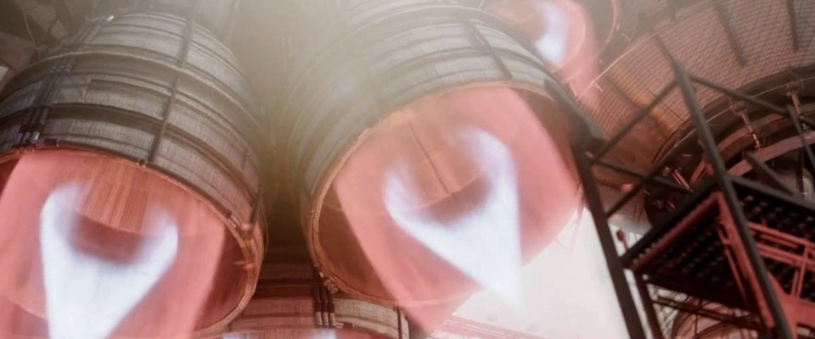 | 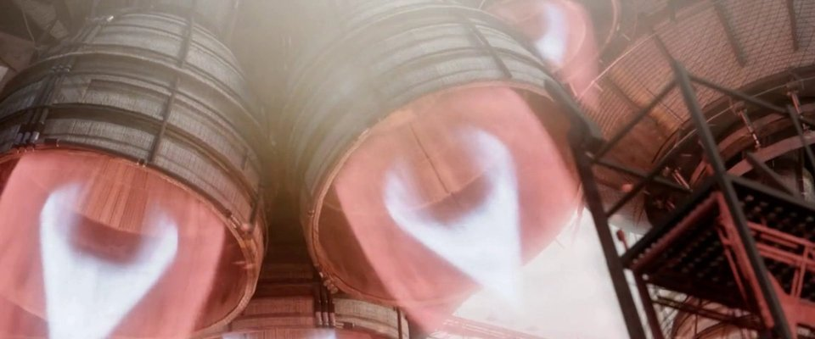
noise_sigma2 |  | 
noise_sigma5 |  | 
noise_sigma10 | 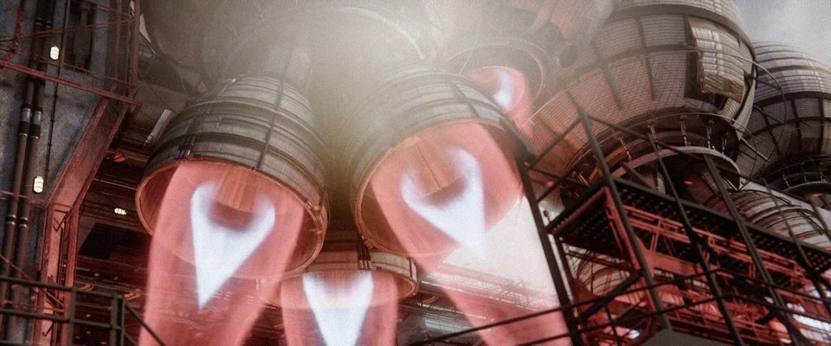 | 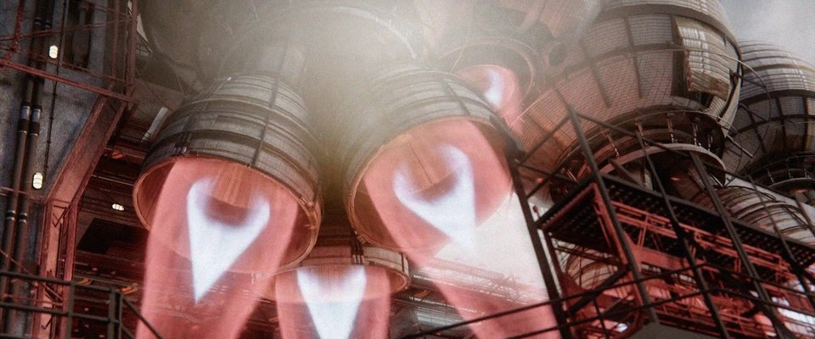
frame_drop_0.5 |  | 

9. Failure analysis
Two algorithmic failure modes account for the observed errors after the validated baselines were established.

9.1 DCT — degenerate input frames
QIM on flat luma is mathematically impossible. The opening title sequence of the original test clip had Y = 0 for ~195 frames. Modifying an AC coefficient produces a spatial perturbation with peak amplitude ≈ δ × 0.25 ≈ 7.5; the negative half clips at the floor (Y ≥ 0), and the surviving coefficient comes back at ≈ δ/2 — exactly the QIM decision boundary. Any downstream perturbation then flips the bit and BCH cannot recover. Resolution: exclude content-poor frames (handled at the dataset level for this benchmark; could be automated with a luma-variance gate in the runner). The same mechanism makes any flat-luma block — solid backgrounds, letterbox bars, blown-out highlights — locally un-embeddable; the impact is bounded as long as the watermark is spread across enough content-bearing blocks for BCH to correct the lost chips.

9.2 Genuine robustness limits
The remaining failures are genuine algorithmic limits, not implementation artefacts. Heavy crop (0.6×) breaks both methods: DCT loses its coordinate system as the block grid no longer aligns with the embedded positions, and TrustMark's learned receptive field saturates once 40% of the frame is discarded. Aggressive recompression (CRF 36) erases mid-band DCT coefficients faster than BCH(127, t=11) can recover, and is visible even in TrustMark's learned residual (1/24 frames survive). Codec quantisation is the dominant attacker for DCT across the moderate-CRF range (28–32); geometric distortion is the dominant attacker for TrustMark only at the extreme (crop 0.6×).

10. Tradeoff discussion
Dimension | DCT-QIM | TrustMark
Visual fidelity (PSNR) | Higher (~56 dB) | Lower (~48 dB)
Visual fidelity (SSIM) | Equivalent | Equivalent
Codec robustness (CRF 28) | Weak | Strong
Spatial resize robustness | Brittle | Strong (scale-invariant)
Crop robustness | Brittle (coord loss) | Robust to mild crop
Gaussian noise robustness | Strong | Strong
Compute / latency | CPU, ms/frame | GPU preferred, 100s of ms/frame
External dependencies | bchlib only | PyTorch + ~200 MB weights
Determinism | Fully deterministic, single secret key | Stochastic (model precision), single weights file
Payload headroom | 56 / 127 bits used | 56 / 61 bits used
Headline reading: DCT is a clean choice when invisibility and deployment simplicity dominate and the only threat is codec compression at moderate CRF or additive noise. TrustMark is the clear winner under any pipeline that may resize, crop, or transcode the video before decode — paid for with model weights and inference cost. For high-stakes provenance the two are complementary, not substitutable.

11. Future improvements
- Content-aware DCT embedding: skip blocks where the mean luma is within δ × peak-amplitude of 0 or 255 (where embedding would clip), or scale δ down on those blocks. Eliminates the failure mode in §9.2 without dataset curation.
- I-frame-aware embedding: PyAV exposes packet flags; raise δ selectively on I-frames (more aggressively quantised by the codec) and on cut-adjacent frames, lower it on stable runs.
- Hybrid pipeline: run DCT + TrustMark in parallel, decode both, and treat the two as independent channels (cross-check, fall back, or weighted vote). Coverage of each method's robustness gap is essentially disjoint (see §10).
- Temporal aggregation analytics: the runner already does soft majority voting across frames; export the per-frame confidence trajectory and plot how exact-match rate converges with number of frames aggregated.
- Scale-equivariant DCT embedding: estimate any scale factor between watermarked and attacked frame (via cross-correlation of a known marker) and rescale before decode. Would close the DCT–TrustMark gap on resize attacks.
- Adversarial attack additions: oracle attack (gradient-free search over the decoder), watermark-aware denoising, averaging attack across multiple watermarked copies.
- GPU-batched TrustMark adapter: today the per-frame loop incurs Python overhead per call; batching N frames at once would change the throughput characteristic from 'experimental' to 'production'.
- Quality of life: add a luma-variance gate to the runner so frames that cannot mathematically be watermarked (e.g. solid colour intros) are skipped automatically and reported in the summary, rather than silently inflating BER.

