1.1 Anwendung

3D printing has become the most trending, home applicable and favourite production method of the new age. Imagining an object and being able to produce it without any effort or hand work just in your living room was an irresistible idea to the maker communities. Thus, the development of the 3D Printing technologies was not only a topic for the commercial parties and the research institutes, but also for the individuals from all around the world, getting together on development hubs.

Although there are multifarious methods and materials to use, the main focus of the public is cumulated around FDM (Fused Deposition Modelling) using the polymers ABS (Acrylonitrile butadiene styrene) and PLA (PolyLactic Acid). The low melting point and ease of utilization were the main reasons, which caused them to stand out among other methods and materials. However, these materials do not provide any of the engineering properties of the metals like aluminium or steel, which are widely utilized in classical manufacturing methods.

An opportunity to produce the prototype of your idea with approximate material properties is delightful for any R&D department. Today a few methods already are known to the scientific world in the area of metal 3D printing. Those methods can be summarized under powder bed based, binder jetting, magnetojet printing, directed energy deposition and electron beam freeform fabrication.

 Each of these methods require a compatible electronics and software solution. The required electronics have to control various temperatures, tool position, chamber gas composition and provide a high baud rate communication for a high rate rapid prototyping process. The market and research fields are still too young to provide an all in one software solution, where only the defining the manufacturing method and outputs of the system is enough to get ready for the production. Therefore, the development of a new algorithm is necessary, if any new method is developed.

Incremental casting involves generating tiny drops by means of applying a pressure pulse to the chamber filled with molten metal, using a piezo valve. The pressure pulse jets the molten metal through the orifice. The generated drops solidify above and beside each other forming a nonporous surface. A high rate of drop generation is necessary for achieving large printing volumes in short time. Consistent drop characteristics require precise I/O switch times and stabile temperature levels. High accuracy positioning system is mandatory to provide continuous drop path due to the tiny drop dimensions.   
 The software and complementary control electronics for the pre-selected hardware have to fulfil some defined requirements. The system has to work on a real-time frame with watchdog assistance in order to guarantee continuous, in time response along the printing process. Adjusting the temperatures, controlling the axes, switching the pulse generating valve on and off at exact right time have to be processed parallel to each other, in despite of the classical sequential work flows.

1.2 State of the Technology   
 1.2.1 Commercially Available Systems

There are various approaches to metal 3d printing concept. All of these approaches use their own software for their patented methods.  
 Selective Laser Melting project was initialized at Fraunhofer ILT in 1995 and today the method is used in SLM 500 (SLM Solutions GmbH, Lubeck, Germany). This method utilizes a directed laser beam to melt selected areas of a single layer of metal powder. Then the next layer of powder is swept over the old layer.

SLS method is very similar to the SLM. The layers of metal particles are not molten but sintered together. Since the patent of the method is expired in 2014 there are multiple competitors using the SLS technology. One of the important competitors is EOS GmbH. The EOS M 400 (Electro Optical Systems, Munich, Germany) can produce large scale industrial parts using directed laser beams.

1.2.2 Systems in Development  
  
 Magnetojet Printing is inspired by the common inkjet printing process. Liquified metal is jetted through the orifice by the magnetohydrodynamic effects. Currently the MK1 Experimental (Vader Systems LLC, New York, USA) is planned to be released to the market in 2018 and the company has a pending patent.

EBF3 (Electron beam freeform fabrication) technology is initially developed by NASA at the Langley Research Center (US). The aim of the project is to design a system, which can produce objects out of metal using a metal wire and focussed electron beam under zero gravity conditions.   
  
 1.3  
 SLS method uses focussed laser in order to sinter metal dust. During the sintering process the surface of the dust particles diffuse into each other forming necks and hollow areas in between the metal particles. Due to this character of the sintering process not only the surface of the products but also the inner structure is porous. The products manufactured by the SLS process can theoretically be as tough and strong as cast products, due to lack of the strain hardening. However, the properties of a cast part are of course not reachable due to the porosity.

SLM causes the particles to melt together completely, which eliminates the general porous structure. However the inhomogeneity of the metal dust can cause fluctuations of the energy distribution on the spontaneous targeted area. This irregularity causes the problem known as balling, which is building random larger cumulations. This irregularity also causes porosity and leads to notch effect.

The powder bed method causes continuous support for the discontinuous layers of the product, which eliminates the need to print support columns with a weaker removable structure or a second material. These advantages also bring along a disadvantage. Since the whole area is swept over with metal powder after each layer, the inner volumes are also filled with powder. Thus, it is impossible to print hollow closed bodies. The product has to be modified opening a draining collar, in order to let the excess powder out.

The cost is also one of the most important aspects, because of the feasibility of the product and high competition in the market. The actual market price for aluminium is about 1.9 USD/kg, whereby the price for AlSi10Mg Aluminium powder is about 120 USD/kg and for 0.8mm 4043 aluminium wire about 4 USD/kg. The cost of material is beyond comparison.

Electron beam freeform fabrication uses an aluminium wire as supply material. Thus the material costs are rather reasonable. One of the main engineering problems is creating a vacuum. Otherwise the electrons would lose a noticeable amount of their energy before reaching the target. The created electron beam hits the aluminium wire on the target where it is supposed to melt. The electrons are decelerated when they hit their target and automatically create a deceleration radiation known as bremsstrahlung, which is practically X-ray. For that reason EBF3 requires an additional prevention against the X-ray radiation.

2.1 Aufgabenstellung

This thesis is framed with the development, implementation and deployment of a control solution for the experiment stand for additive manufacturing of aluminium parts. The control solution should implement the necessary equipment taking part in the control and adjustment of the experiment stand. These are for example temperature adjustment of the chamber, printing plate and the employed nozzles, the control of the material feed. The precise control of the movement of a cartesian XY-stage and the coordination of the movement and drop generation is necessary and the most important aspect of this solution.

The implementation of the software should be based on the software TwinCAT (Beckhoff Automation GmbH). The automation software TwinCAT is integrated with a package of a real time control system combined with PLC and NC functions. The programming should be followed in accordance to the software standard IEC 61131-3.

Before the termination of the project the developed solution has to be tested and put into operation. While doing so each of the functional abilities has to be tested and subsequently commissioned as a whole system.

2.2 Messbare Parameter und Kriterien??

2.3

In order to understand the software and how it works, it is inevitable to comprehend the hardware. The 3D Printer controlled and regulated by the following actuators and sensors:

● Two servo motors for X and Y axes

● Two absolute encoders for the servo motors

● Two stepper motors for Z axis and material feeder

● Two encoders for the stepper motors

● Two virtual Axes for the conversion of the motor movements to H-Bot coordinates

● Three heaters for the hot plate, nozzle for the main material and nozzle for the support material

● A cooler fan for adjusting the chamber temperature

● A lambda sensor for the continuous oxygen measurement in the chamber

● A valve for adjusting the argon flow rate

● Two Valves for the structure and main material nozzles

The precise coordination of all of the mentioned sensors and actuators is necessary to operate the 3D printer. A malfunction of any of the sensors or actuators leads to complete failure of the 3D printing process.

The main idea is melting the aluminium fed in the nozzle chamber and pulsing it out along the route with a constant rate, using a piezo valve to generate pulses of pressurised air. Each pulse is expected to cause ripples after the drop separation phase. Thus, it is necessary to generate the pulses with constant rate, if the aim is to generate identical drops. When the pulses meet the aluminium pool at a different phase of the surface ripple, the acquired drops are expected to have different dimensions and different satellite drop properties.

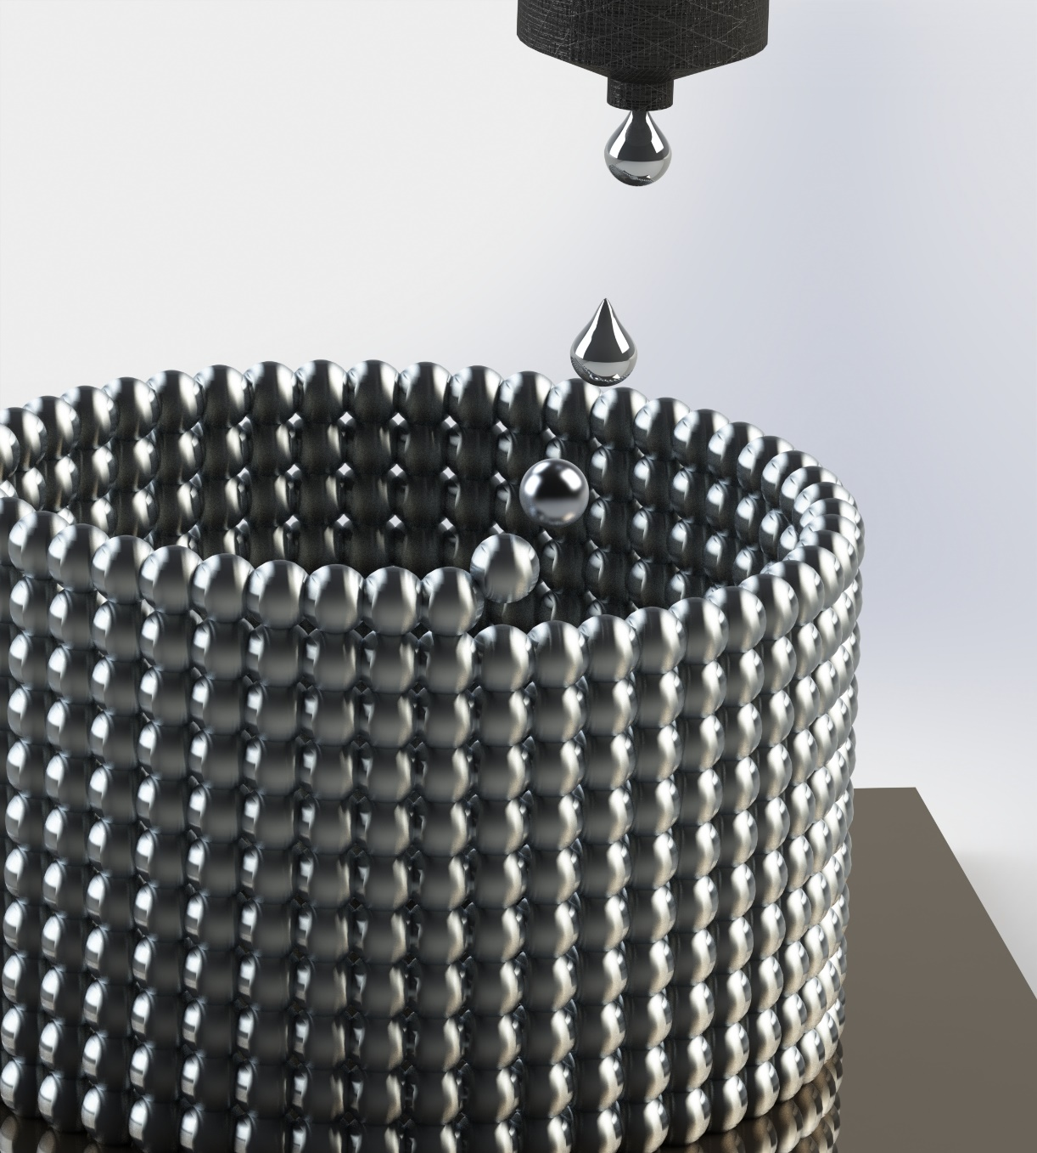

The movement of the printing platform is realised with two servo axes configured to build a H-Bot kinematic system for the movement in the XY-plane and a stepper motor is utilised to control the movement in the Z-direction, due to the absence of a power requirement as in the XY-plane. Additional virtual axes are used to build the kinematic transformation group, which acquire their input from the numerical control unit and deliver the output to the motor drivers as translated coordinates. The nature of 3d printing process requires fast moving X and Y axes, in order to accelerate the 3d printing process, but the z axis is only utilized once between the layers and does not need to be fast. However, the accuracy of the position is highly important for the Z axis, due to the effect of the distance between the nozzle and solidification point on the printed paths. Therefore, the servo motors are coupled with absolute encoders, which means that a calibration process is not necessary, but the stepper with a standard encoder combined with a homing switch. Another stepper-encoder combination is used to control the material feed rate based on the number of generated drops, in order to keep a constant level of molten aluminium above the nozzle.

The solution is designed to take printing data from a G-Code file, which has a slight dialect special to the TwinCAT development environment and is chosen due to the built-in G-Code Interpreter in the TwinCAT. The built-in G-Code interpreter allows the developer to read the orders like movements, real parameters, Boolean variables with and without handshake function from the NC files. Even though the G-Code initially was designed for conventional machining processes, it is today commonly used by the open source 3D printing communities. That also allows the user to choose between a variety of open source slicers to convert the designed 3D model into layers of routing coordinates.   
 As soon as the system is enabled, the heaters are turn on to reach the operating temperature. The temperature of each of the nozzles and the printing platform are regulated separately. The continuous material feeding generates a negative heat flow in the molten material, because of the wire stored at the room temperature, while each drop causes heat loss in the amount of the heat capacity of itself. The lost heat energy has to be compensated alongside the printing progress. The change in the temperatures also have to be measured in real time in order to prevent any damage caused by extreme temperatures or solidification due to the lack of required heat energy. The utilisation of a PID controller is inevitable for a stabile heating operation with continuous external excitation.

The most important step of the incremental casting surely is the drop generation. The drops are generated with the air pulse derive from an air valve, applied on the molten metal. The pulse causes a small amount of molten aluminium to leave the molten metal pool through the nozzle. The first drop is generated at the beginning of the line to be printed. The following drops are generated with a constant rate, depending on the time. The continuous and constant rate drop generation leads to the requirement of a constant printing platform speed along the route which is to be printed. Since a constant speed is necessary, a take-off length is also required, in case the velocity curve of the movement is not continuous. Otherwise equidistant drops would be acquirable only if an instant acceleration of the printing platform was possible or various periods between the drops were acceptable.

In summary, the software solution reads the printing data as a g-code and forwards the data to the g-code interpreter. The interpreter reads the required printing parameters and suspends the system until the system reaches the operation temperature. As soon as all the temperatures are read, virtual axes are commanded to move along the route described in the g-code. The virtual axes are synchronized with the real servos, through the H-Bot kinematic module. Depending on the g-code the drops are generated during the movement.

2.4

The software is developed in the TwinCAT 3 environment installed on Microsoft Visual Studio. TwinCAT environment is a commonly used automation technology in the industry, which supports IEC 61131, C/C++, Matlab/Simulink, C# and .NET.

The main program of the software solution is written in UML (Universal Modelling Language), which allows the user to differentiate various parts of the software without the extra effort of reading between the lines and following the beginnings and the ends of the loops, using a simple visualisation of the code with states and gates controlling the flow of data between the states. The UML can be portrayed as a state flow chart with Boolean switches to control the flow. Every frame has to have a Start and End states. The information or the workflow is conducted by the flow lines between the states from the start state in the direction of the end state.

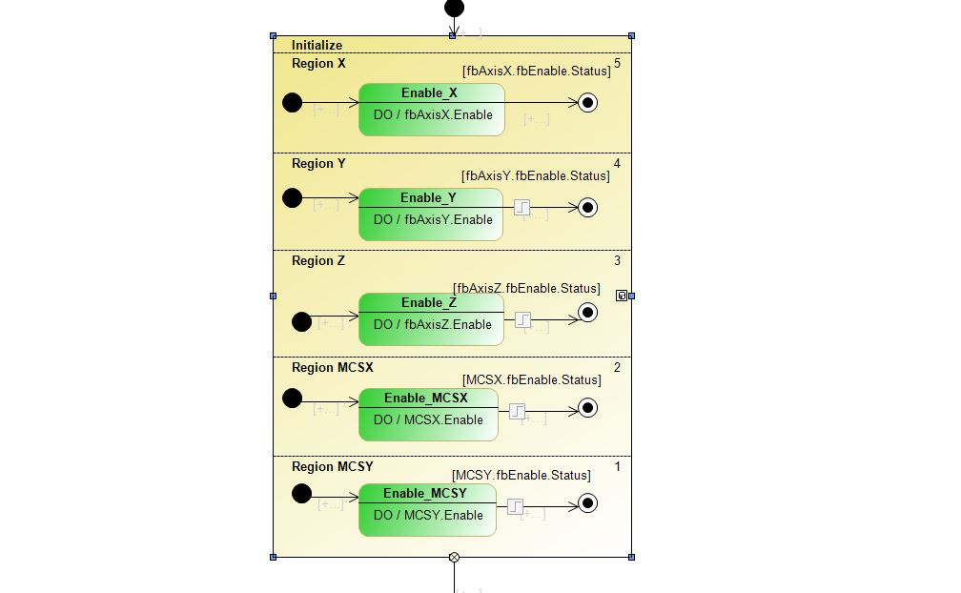

The UML is divided into two main parts, in order to separate the preparation and actual control processes from each other. The program starts the journey at black filled spot and dives into the initialization container. The first stage is checking the state of the motors in connection with the 4 actual axes and 2 virtual axes, which is followed by sending a command to the axis controller functions to enable each of the axes parallelly. Upon the reception of the ready signal from every axis controller function, the initialisation container forwards the signal to the next stage.

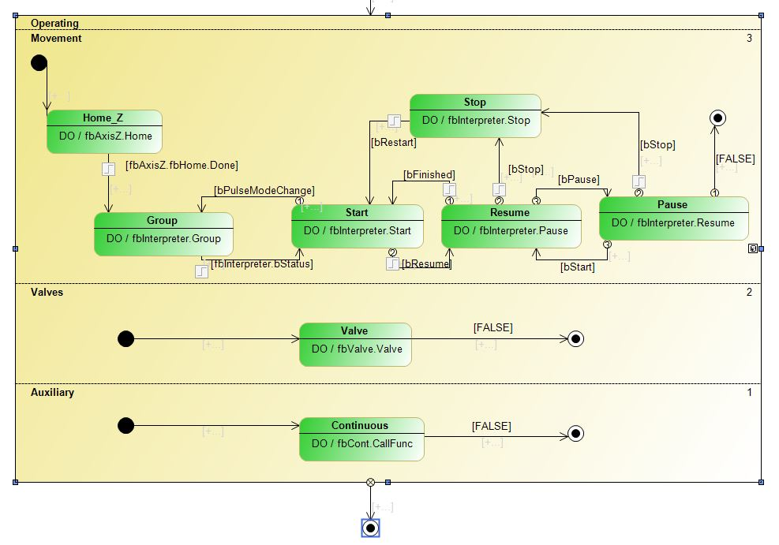

The next stage is the operating container, which is where the software loops as long as the printing process continues. The operating container is divided into three parallel chambers, thus every chamber is refreshed at each cycle without interrupting the others. These Chambers are called movement, valves and auxiliary.

Inside the movement chamber the signal is first received by the homing function, which allows the axes to calibrate before moving on to the printing. Secondly the control groups are to be built, depending on the control method. If the axes are to be controlled automatically by the interpreter depending on the NC code, two groups of axes are required; one for the kinematic transformation, one for the interpreter. However the axes are to be controlled manually for the test purposes, there will only be need for the kinematic transformation group, which is employed to transform the MCS (Motor Coordinate System) to the ACS (Actual Coordinate System) of the H-Bot configuration. If both groups are chosen to be built the rest of the program is responsible for switching between the states of start, pause, resume and stop just like an old cassette player.  
 The second region is for the control of the Valve alone. It is not called in the third region with the other continuously called auxiliary function, because of the higher priority timing.

The third region is responsible for the auxiliary processes, which have to be run the continuously as long as the system is enabled, like reading values out of the G-Code, measuring and controlling the nozzle chamber and platform temperatures. Thus, the flow without an interrupt at a constant pace is necessary. Exiting the second composite state is prohibited, since the system should never be stopped unless it is powered down.

All these regions and containers are there to control the flow of data between required functions. The incremental casting process is mainly divided into 5 functions, which are called FB_Aux, FB_Axis, FB_Interpreter, FB_Valve and FB_Continuous.

The function group FB_Aux stands for the auxiliary duties like regulating the heaters or the oxygen amount in the chamber. Function blocks FB_Heater and FB_Oxygen utilize other functions to provide a continuous and stabile regulation. Examining an instance of the FB_Heater should make the process clearer. The instance fb_heater_nozzle1 utilizes firstly an instance of FB_AnalogIn to read the temperature value of the first nozzle. FB_ControllerPID is instantiated to put out a PID controlled signal in order to reach the target temperature. Since the driver of the heater is not analogue but a digital switch, the output signal as percentage of power has to be converted to I/O states distributed over time with the function block FB_SigmaDelta. Last of all the rate of increase of the temperature is checked and output signal is delayed by the function fb_RampRate in order to limit the increase rate of the temperature, because of the mechanical risks caused by the rapid thermal expansion of the highly powerful resistance.

The function block FB_Axis takes the responsibility of getting axes ready before the interpreter or a manual commander takes the control. The contained methods as Enable, Home and Backlash are instanced for each of the axes separately. The method enable is called to enable the movement in both directions.

The method Home is used for homing the stepper motor coupled axes for calibration purposes at the beginning of the program, driving the platform against a switch located at the bottom of the whole travel distance. After the switch is turned on with the mechanical contact of the lowered platform, the platform is moved slowly upwards until the first stripe of the encoder is passed after the switch is released again. Those two methods are called at the initialization of the software only once, but the method Backlash has to be called in every cycle in order to compensate the errors in position of the platform. The method Backlash is called twice for the servo motor driven axes, in order to compensate the backlash in the system which is inevitable due to mechanical uncertainties in the gears and the belt in the H-Bot kinematic system but workable.

FB_Interpreter

The Function block FB_Interpreter takes the control after the axes are enabled and homed. Building the groups, switching between states like start, stop, pause and resume are regulated under the methods of the FB_Interpreter.

The method Group defines and couples the kinematic transformation and interpreter groups depending on the predefined configuration. If the Interpreter is configured to use the H-Bot kinematic transformation, the movement of the axes are defined and limited to be controlled by commands sent to the MCS axes. Otherwise the real servo axes can be commanded directly without the need to build the kinematic group.

The method pause holds the workflow inside of the state Resume in the main UML code. When a pause signal is received the state calls the pause method to interrupt the movement and let the signal pass to the pause state looping inside the method Resume.

The method Resume does almost the same thing as the method pause, but in the opposite manner. The signal gets trapped inside the loop by the method Resume until a Boolean signal bResume is received from either releasing the pause button or the pushing the play button in the main UML. Right after receiving the signal the program moves on to the earlier state Resume.

Start is the method containing the code to take control of the axes and load the G-Code. The path and the name of the G-Code is defined in and read from the main UML. As soon as the G-Code is loaded and the ready signal for the execution is received the state is triggered to switch to the state Resume.

FB_Valve

The generation of the drops and transfer of all the variables relating to the drop generation are regulated via the function block FB_Valve. This function block can be separated into three subcategories as the methods CoE, Trigger and Valve.

The method CoE (CANopen over EtherCAT) is used for managing the parameters of the EtherCAT devices, in this case the terms, which provide the electronic interface with the system to be controlled. The data which is to be carried over is addressed with a 16-bit index number to identify the term and an 8-bit subindex number to identify the parameter to be read or written. The term specific parameters can be changed and observed under the CoE list of the TwinCAT System Manager. However not all of the parameters regarding each term are constant throughout the whole process while printing. Examples for this situation can be changing the duration of applied voltage to the nozzle valve or different electrical current level for initial triggering and following holding periods of the valve. The on time of the power source is predefined and controlled by the term in order to provide a precise timing.

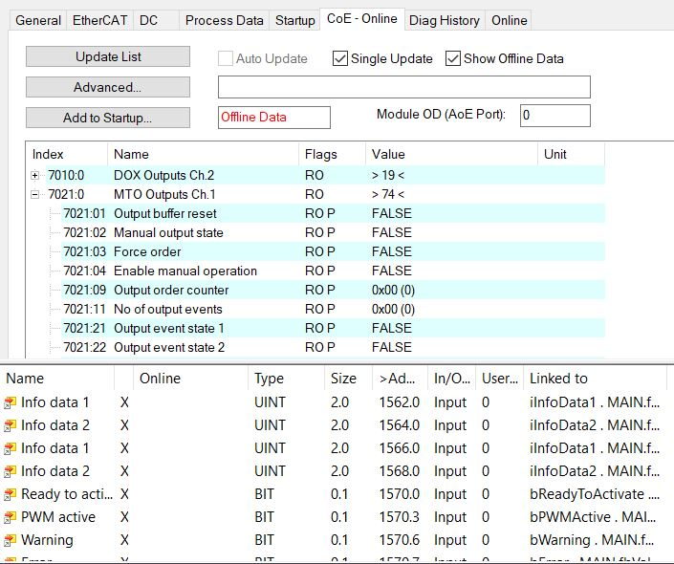  
  
 The above image is a view of the TwinCAT System manager showing the CANopen over EtherCAT parameters. Each of these values are firstly written on a temporary memory and then registered on an EEPROM memory for a long time memorialization. The problem with this method is the limited writing endurance of the EEPROMs. Exactly at this point is the method CoE considerably advantageous, because saving the paramaters to the long time memory from the temporary one can be prohibited inside the TwinCAT System Manager and the whole responsibility of the data can be left to the g-Code. The method CoE checks if any of the parameters show a difference compared to their saved state and if there is a change it replaces the old value with the new one. The parameters are updated one by one at each cycle to prohibit any collision or misrouting of the data. Since each task cycle is clocked at 125µs, changing a parameter inside a term does not take enough time to get noticed by the user.