

**MIDDLE EAST TECHNICAL UNIVERSITY**

**DEPARTMENT OF ELECTRICAL AND ELECTRONICS ENGINEERING**

**EE101 : Introduction to Electrical and Electronics Engineering  
Project I : Denoising an Audio Signal: How to Solve the Vuvuzela Problem during the 2010   
 World Cup**

**Names : Alperen Öztürk – Ömer Faruk Özmermer  
Student IDs : 2575868** - **2516789**

**3.1 Analyzing the Spectrum of the Noisy Signal**

1. Comment on what the noisy audio signal sounds like.

Noisy signal sounds like a endless car horns in Istanbul traffic while the Queen song is being played in the background.

1. Insert the plot you saved in Part 3.1.2 below.

çizelge içeren bir resim

Açıklama otomatik olarak oluşturuldu

1. Insert the spectrum magnitude plot for the noisy audio signal you saved in Part 3.1.3 below.

çizelge içeren bir resim

Açıklama otomatik olarak oluşturuldu

1. Look at the noisy spectrum you plotted in MATLAB, and comment whether you can already spot where the clean signal and the vuvuzela sound lie in the spectrum. Can you figure out around which value ***f0*** should be?

When it is looked close enough to the spectrum, the almost particular patterns can be seen and there are peaks between those patterns. The patterns should be the clean signal, and the peaks should be the frequencies of vuvuzela. It can be figured out that the f0 should be around 230 Hz – 240 Hz.

**3.2 Understanding the Spectrum of the Vuvuzela Sound**

1. Label the axes properly and insert the plot you saved in Part 3.2.2 below.

çizelge içeren bir resim

Açıklama otomatik olarak oluşturuldu

1. Plot the magnitude of the vuvuzela spectrum as a function of the frequency f in Hz. Label the axes and insert the plot you saved in Part 3.2.3 below

çizelge içeren bir resim

Açıklama otomatik olarak oluşturuldu

1. Inspecting the spectrum of the vuvuzela sound, can you figure out its fundamental frequency ***f0***? At which frequencies do you observe the harmonics?

We figured out that the fundamental frequency f0  is 236.1 Hz. We observed the harmonics at 470.8 Hz, 706 Hz, 941.5 Hz , 1182 Hz , 1410.5 Hz , 1650.4 Hz. These frequencies are almost integer multiples of 236.1 Hz.

* 1. **Removing the Vuvuzela Sound from the Noisy Audio Signal**

1. Plot your spectral mask as a function of the frequency in Hz. Label the axes and insert your plot below. Comment whether the spectral mask looks like what you want (you might need to zoom into the frequencies of interest for better visibility).

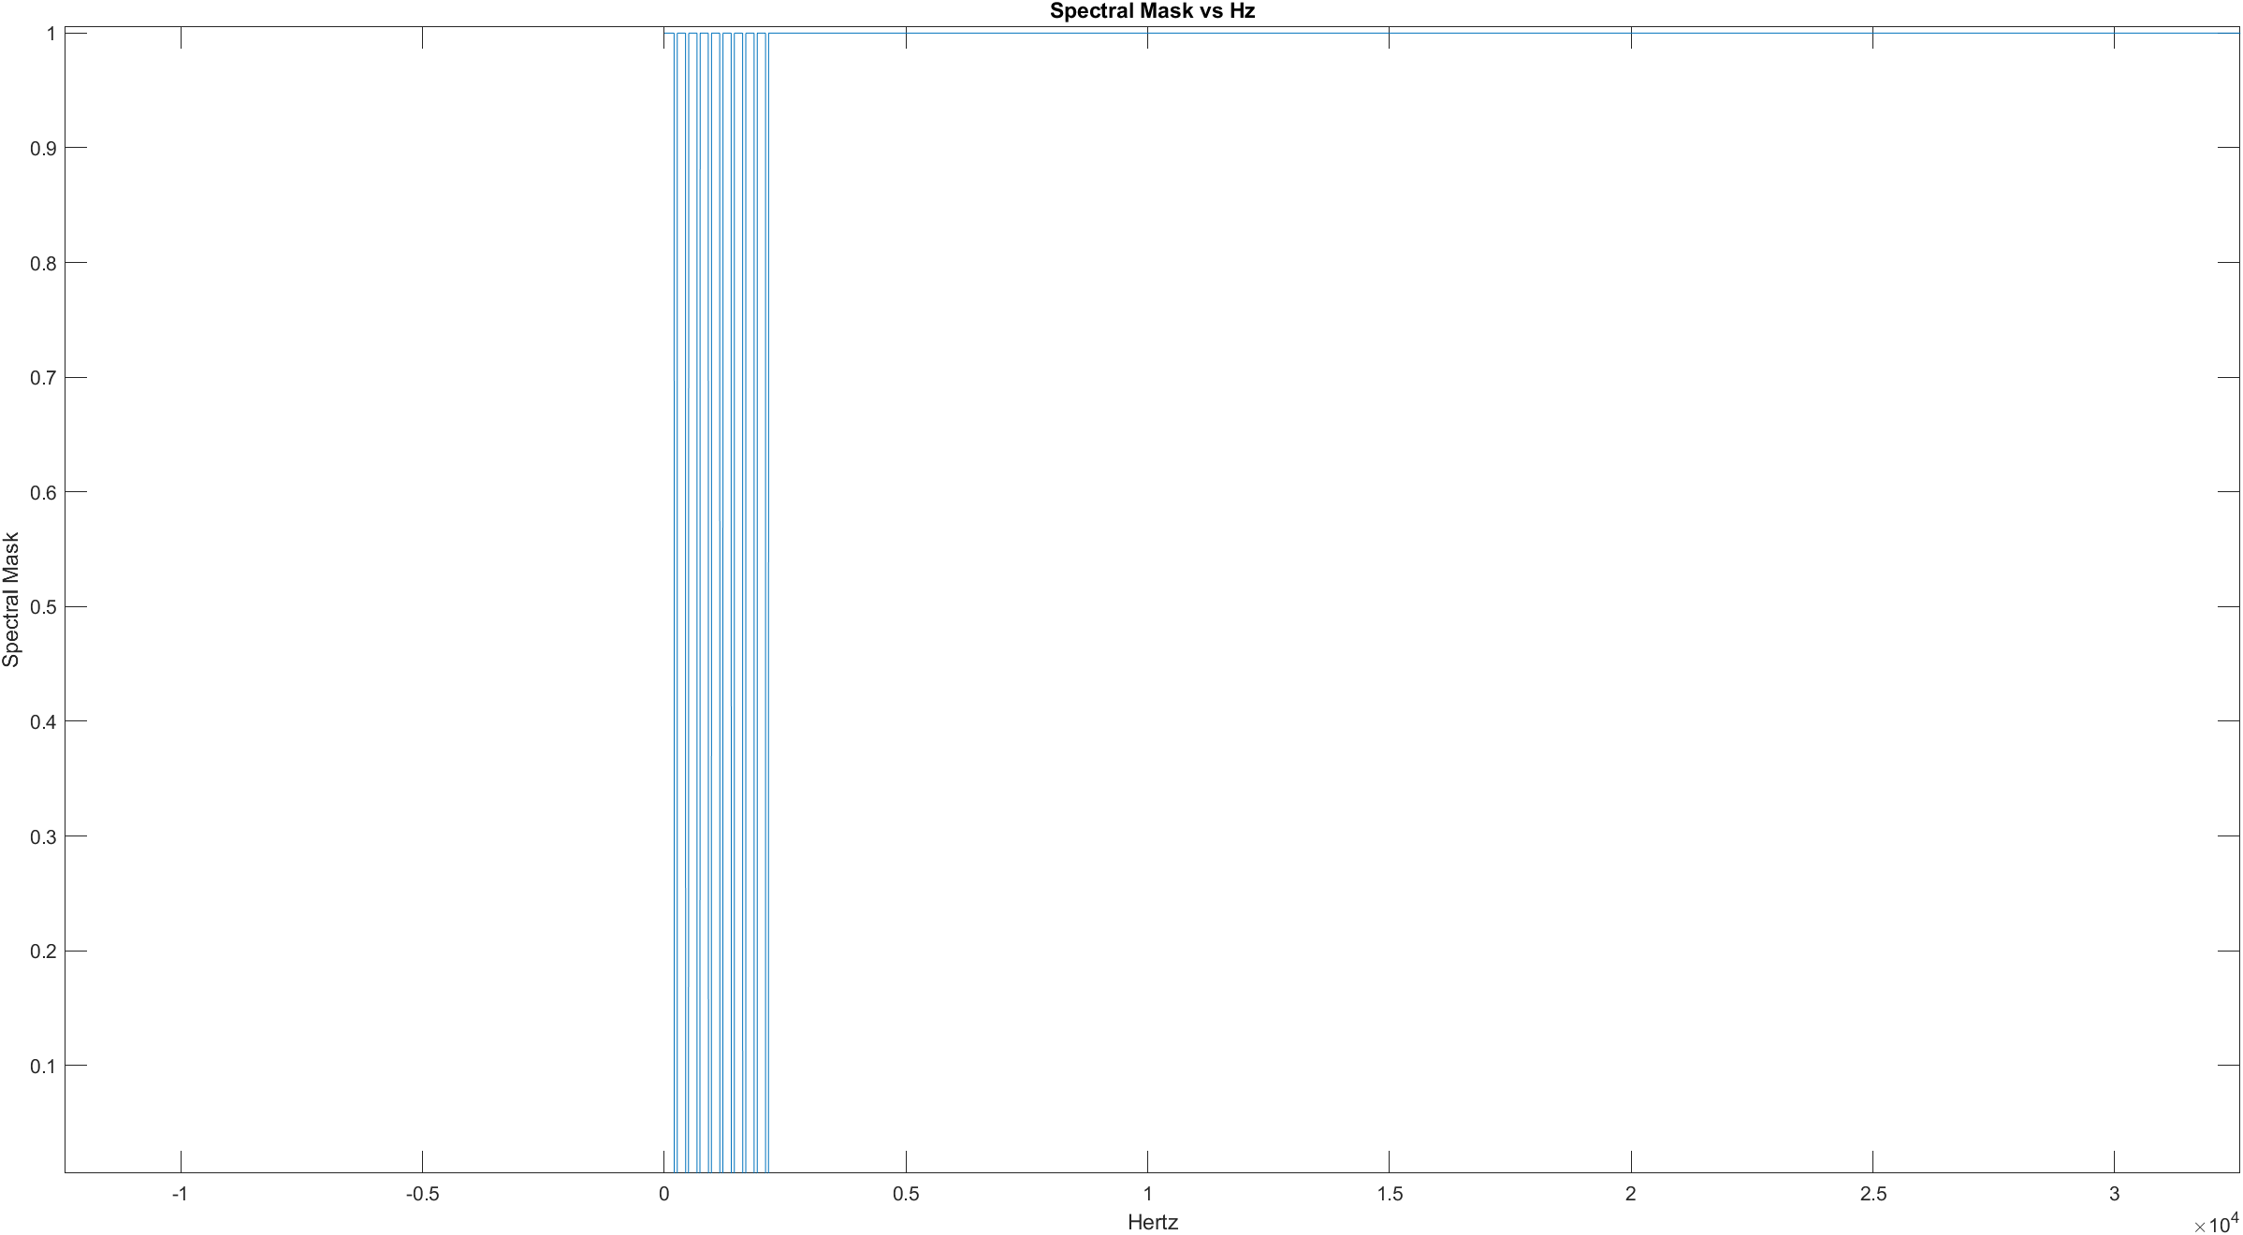 The values of frequencies which are f0 + - Δ and its integer multiples are 0 , and rest of the frequency values are 1. Hence, the spectral mask looks like what we want.

1. Obtain the magnitude of the spectrum of your denoised signal and plot it as a function of frequency. Label your axes and insert your plot below. Comment on what you see. Have the undesired peaks coming from the vuvuzela noise disappeared?

çizelge içeren bir resim

Açıklama otomatik olarak oluşturulduWe see a cleaner spectrum than the one in 3.1.3. The undesired peaks coming from the vuvuzela noise are disappeared.

1. Comment on what you hear. Have you been able to remove the vuvuzela noise from the audio signal? Also, try different values for the Δ and K parameters and comment on their effect on the quality of the denoised signal. What does the signal sound like when Δ is chosen too small or too large?

Now, we can hear the song without the noise, we have been able to remove the vuvuzela noise from the audio signal. With the Δ, we decide on the interval [f0- Δ, f0+ Δ] in the mask, and with the K, we decide how many times this interval will be repeated. If they are chosen wrong, some frequencies of the song itself will be masked, and the quality of the denoised signal will decrease. If Δ is chosen too small, vuvuzela noise become apparent, if it is chosen too large, since most of the signal will be masked, almost nothing will be heard.

**3.4 Analyze the Spectrum of Your Own Voice**

1. Plot your voice signal as a function of time in seconds and insert it below.

çizelge içeren bir resim

Açıklama otomatik olarak oluşturuldu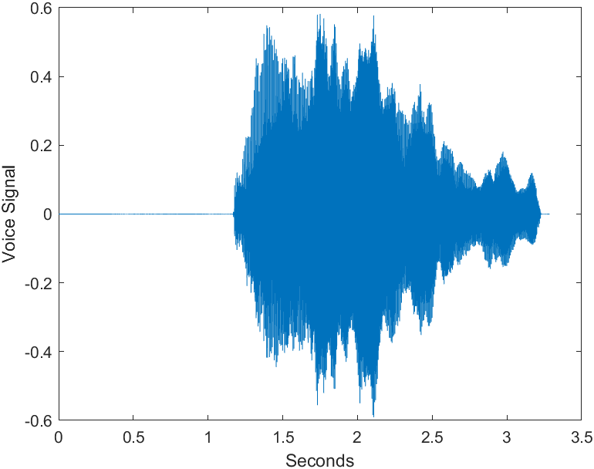

1. Plot the magnitude of the spectrum with respect to the frequency in Hz as you did in the previous exercises and insert it in below.

çizelge içeren bir resim

Açıklama otomatik olarak oluşturulduçizelge içeren bir resim

Açıklama otomatik olarak oluşturuldu

1. Comment whether the spectrum of your voice looks like the spectrum of the vuvuzela. What is the fundamental frequency of your voice signal? Are there any harmonics in its spectrum?

It looks like the spectrum of the vuvuzela in terms of the shape. Fundamental frequency of the voice signal is 161.3 Hz, and there are 8 visible harmonics in its spectrum.