AMS 526

Homework 1

Yuanyuan Peng

108734720

Report

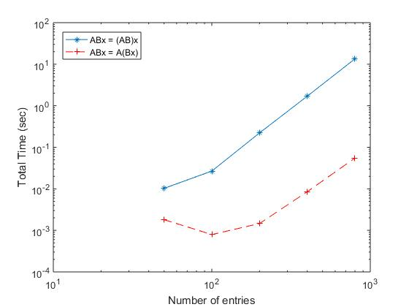

**Function 1**: Yvec = MatVecMultiply(Amat, Xvec)

**Function 2:** Bmat = MatMatMultiply(A1mat, A2mat)

**Observation**

* **Blue:**

The blue line shows do Function 2, which is the Matrix-Matrix multiplication function, first then do Matrix-Vector multiplication. According to the plot, the graph of function 2 increases slowly in the beginning then start increasing fast after it reaches ${10}^{2}$ entries.

* **Red:**

The red line shows do Function 1, which is the Matrix-Vector multiplication function, first then do Matrix-Matrix multiplication. According to the plot, the graph of function 1 starts decreasing at the beginning and when the graph reaches ${10}^{2}$ entries, the graph starts increasing slowly.

* In addition, the graph also shows that Blue line and Red line increase almost at the same rate after they both reach the ${10}^{2}$ entries, but the slope of red line (Function 1 then 2) is slightly lower than the blue line’s (Function 2 then 1) one. And the red line is always lower than the blue line on the plot, which means the red line always uses less time than the blue line. Even though the red line starting increase faster, it still stays below the blue line.

**Conclusion**

* No matter how many entries we are having, do Matrix-Matrix multiplication function, first then Matrix-Vector multiplication will always be **SLOWER** than do Matrix-Vector multiplication function, first then Matrix-Matrix multiplication.