AMS 526

Homework 2

Yuanyuan Peng

108734720

Report

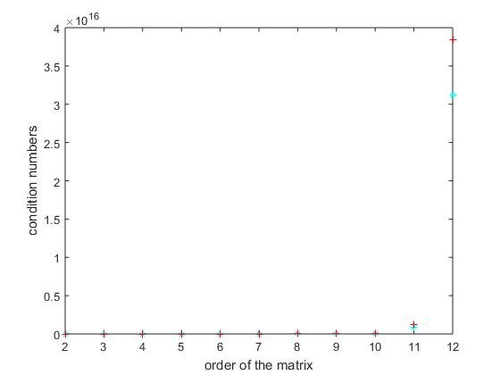

**+**: the condition number calculated by Cond function build in by MatLab

**\***: condition number calculated by myCond function

**Observation**

* The blue* is always above the red+

**Conclusion**

* The value that we got from explicitly computed condition is always bigger than the condition number we got from Matlab’s build in function cond.