AMS 526

Homework 4

Yuanyuan Peng

108734720

**Report**

* Two matrix A and B:

Matrix A is

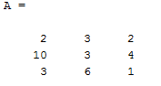

Matrix B is

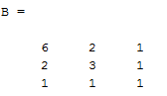

Compare the Result of function **QRshift_base** (for a) And function **QRshift** (for b) and the build in function **eig**

|  |  |  |  |
| --- | --- | --- | --- |
| Matrix | Function convergence | Function eig | result |
|  |  |  | The eigenvalues are the same |
|  |  |  | The eigenvalues are the same |