AMS 526

Homework 5

Yuanyuan Peng

108 734 720

Report

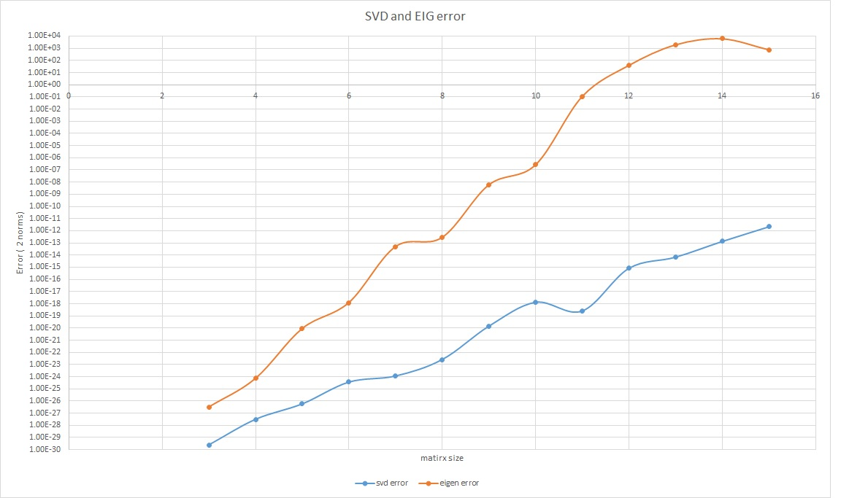

**Orange curve**: Eigenvalue error

**Blue curve**: SVD error

* **Observation**
  + **Orange curve**
    - The curve goes up smoothly and the highest point reaches around 1.006E+4
  + **Blue curve**
    - The curve goes up smoothly with the highest reaches 1.00E-11, and the curved dropped a little bit when the matrix is a 11x22 matrix.
* **Comparison**
  + The blue curve has a smaller slope than the orange one, and the error value of the blue curve is always smaller than the error value we got from the orange curve.
* **Conclusion**
  + **SVD** is more stable and accurate than the **Eigenvalue Decomposition**, which satisfied the with the textbook result.