# Udacity Capstone Project 5 Kemal Ozturk

## Steps

* Launch an instance for Jenkins
* Install Jenkins
* Install Plugins on Jenkins --Blue Ocean --AWS Plugin
* Install aws-cli,eksctl,kubectl
* Create Cluster and Nodes
* Dockerfile
* Jenkinsfile
* Pipeline

## Launch Instance

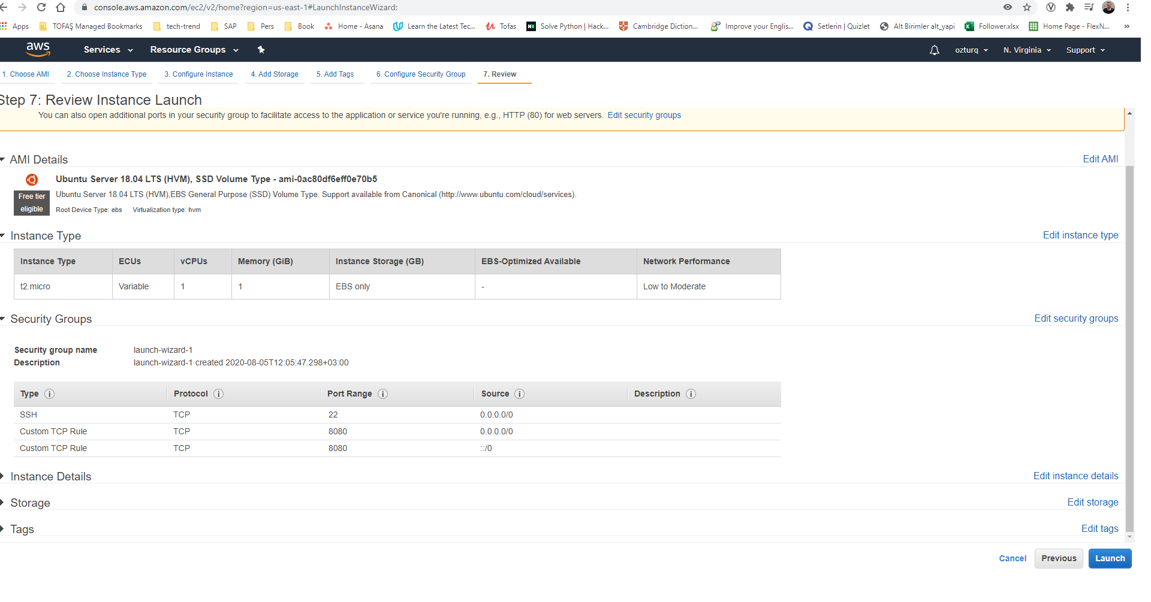

## Jenkins instalation

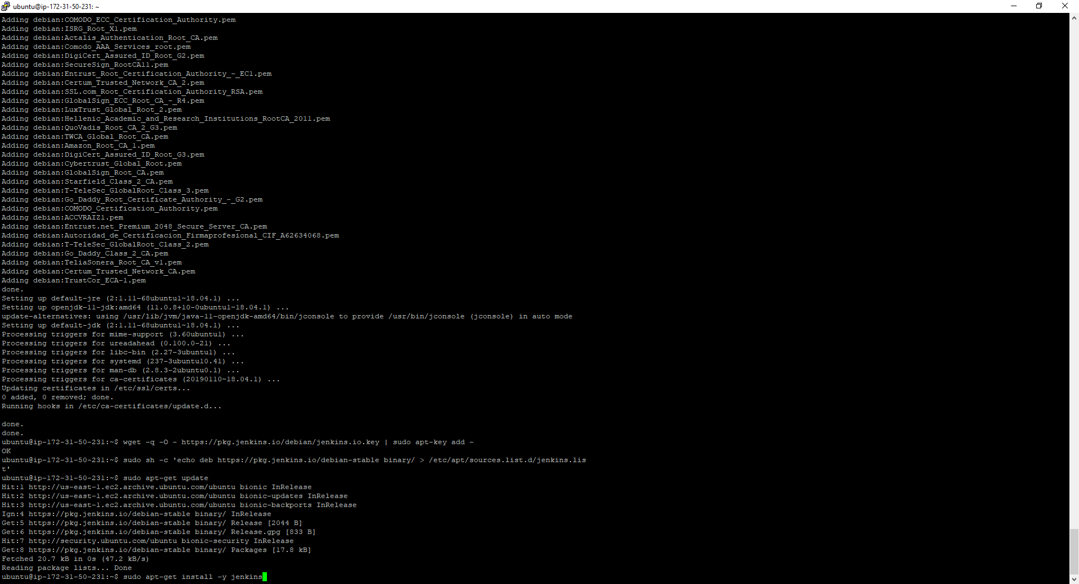

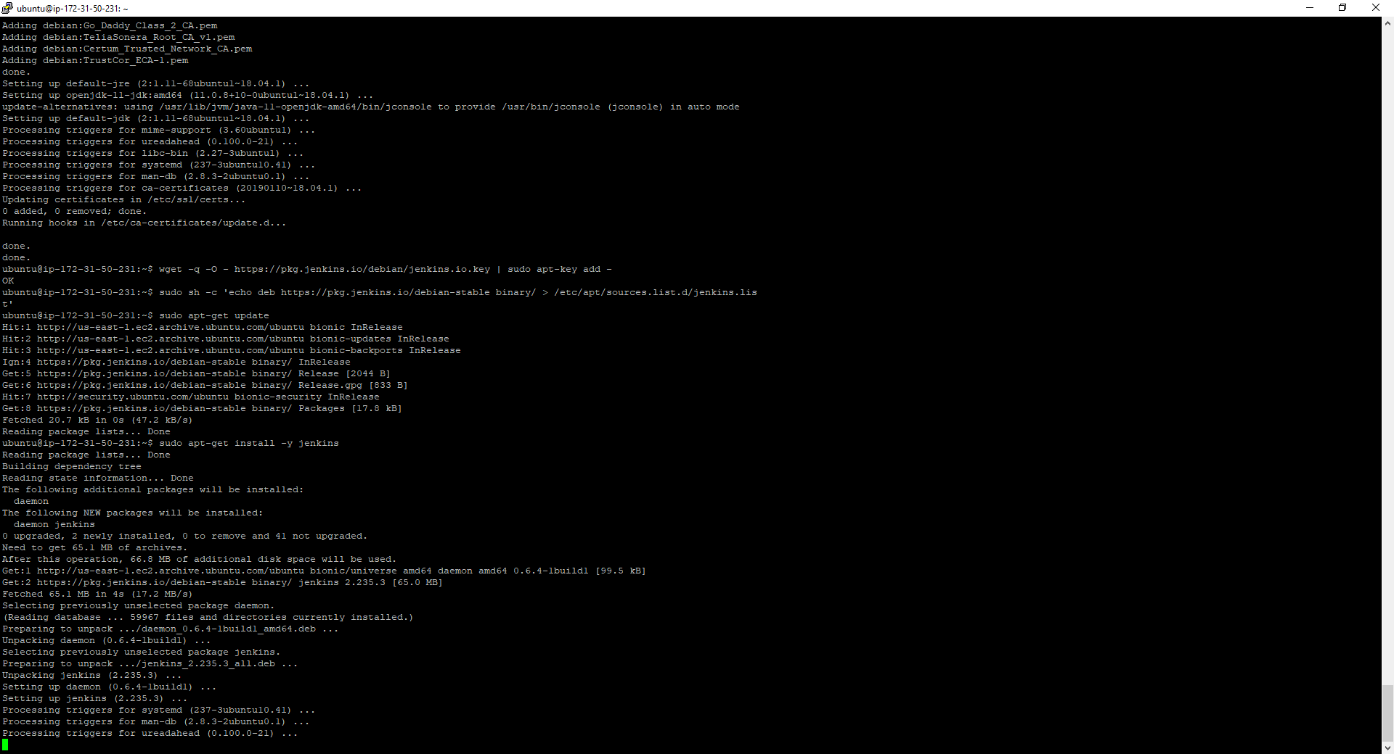

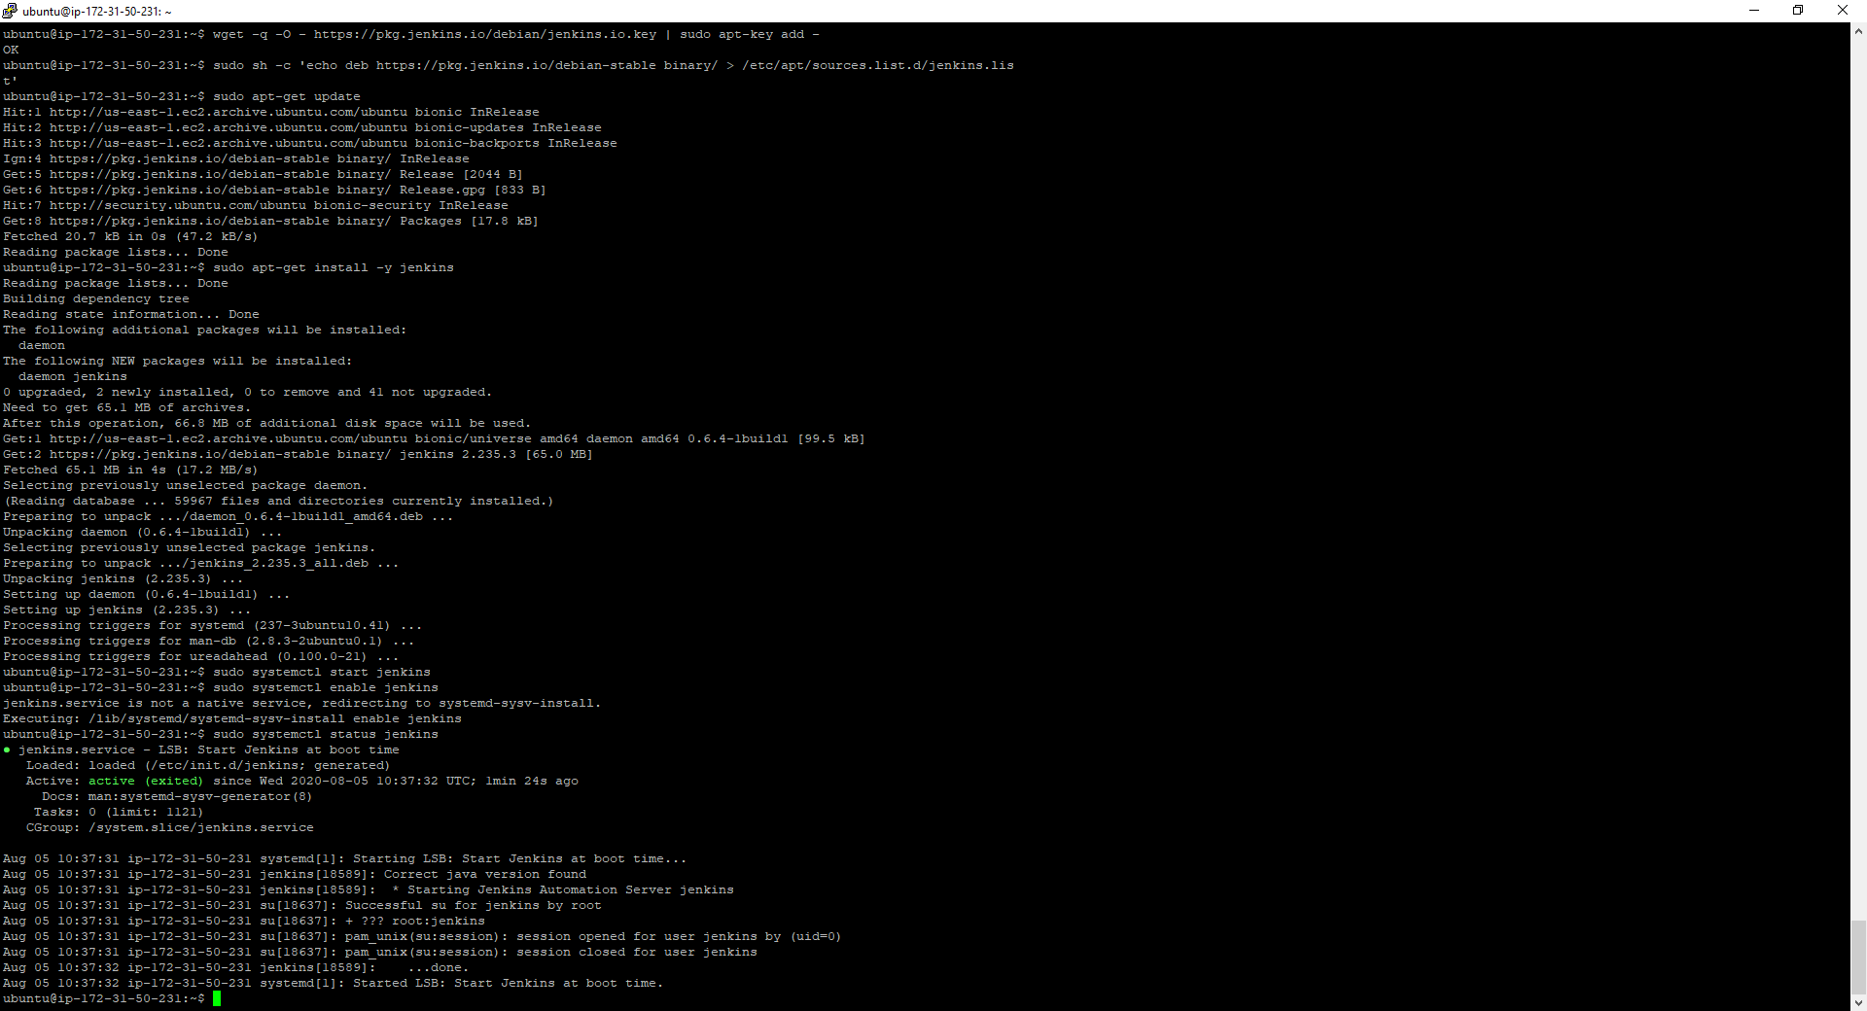

## Jenkins

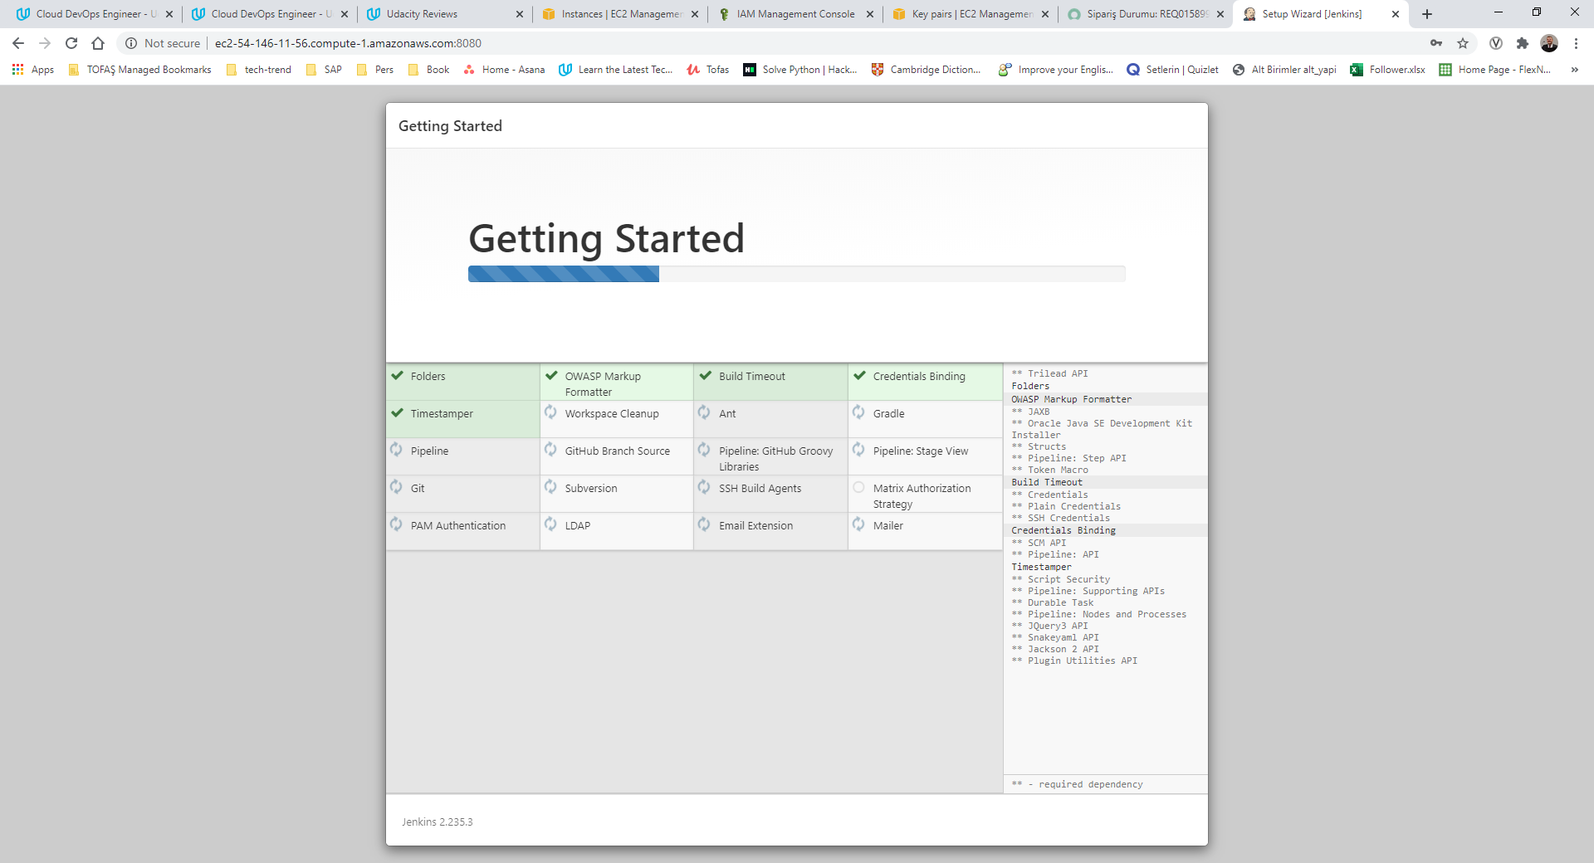

<http://ec2-54-146-11-56.compute-1.amazonaws.com:8080/>

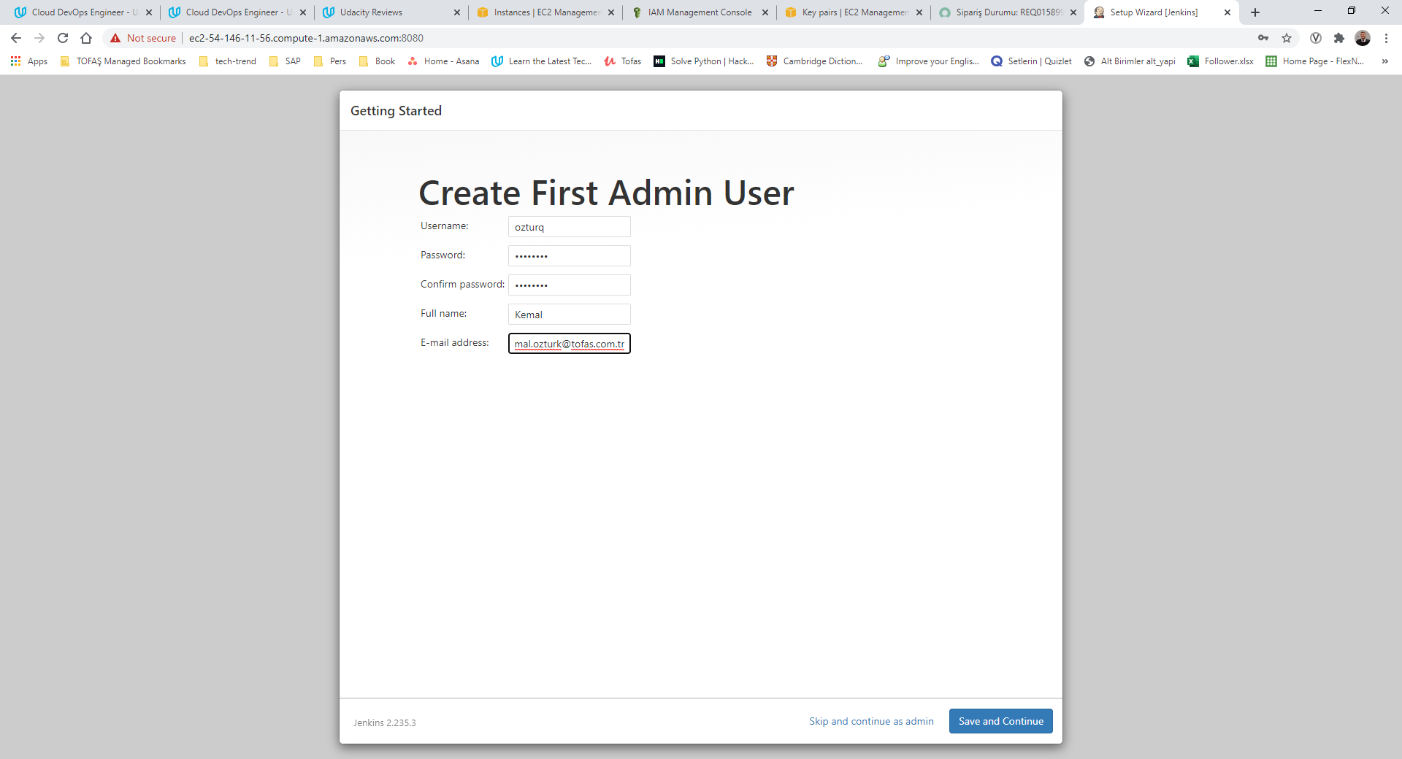

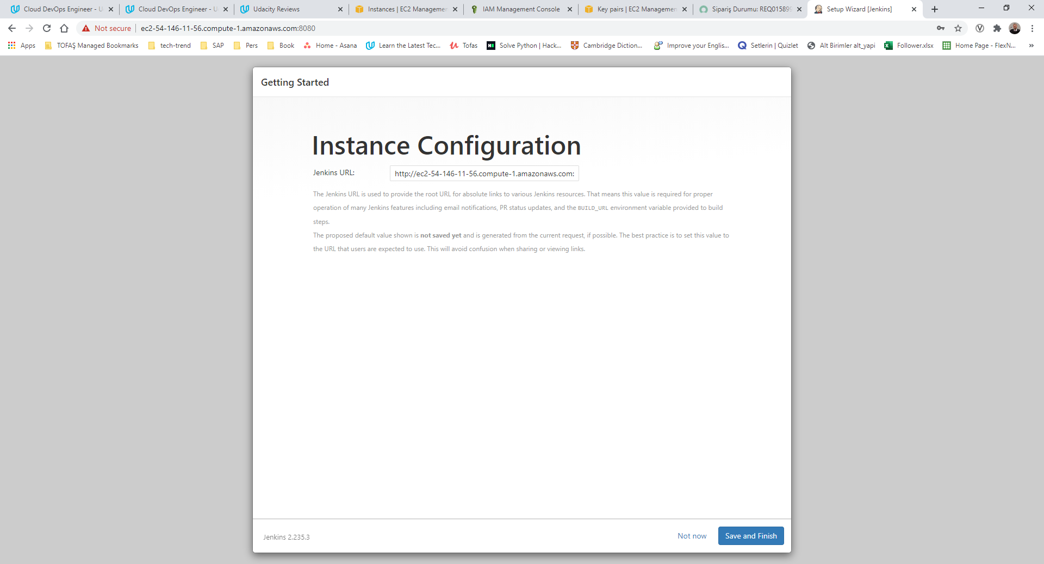

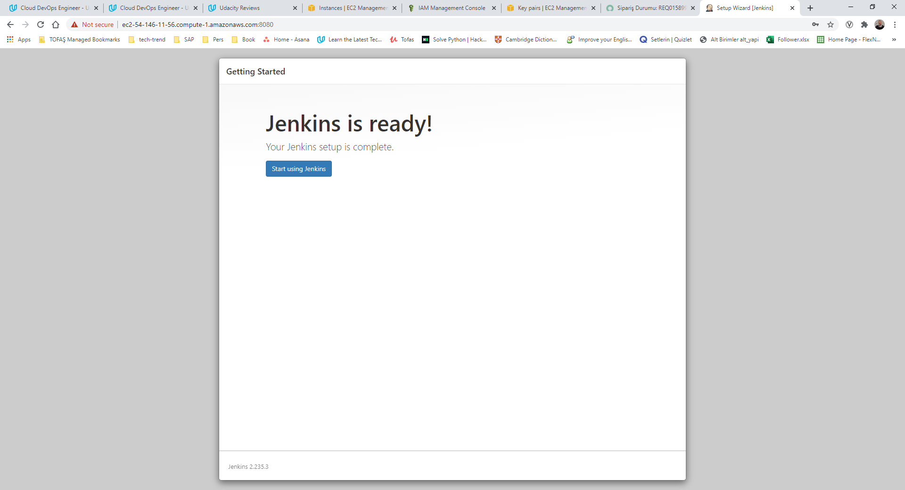

### Dashboard

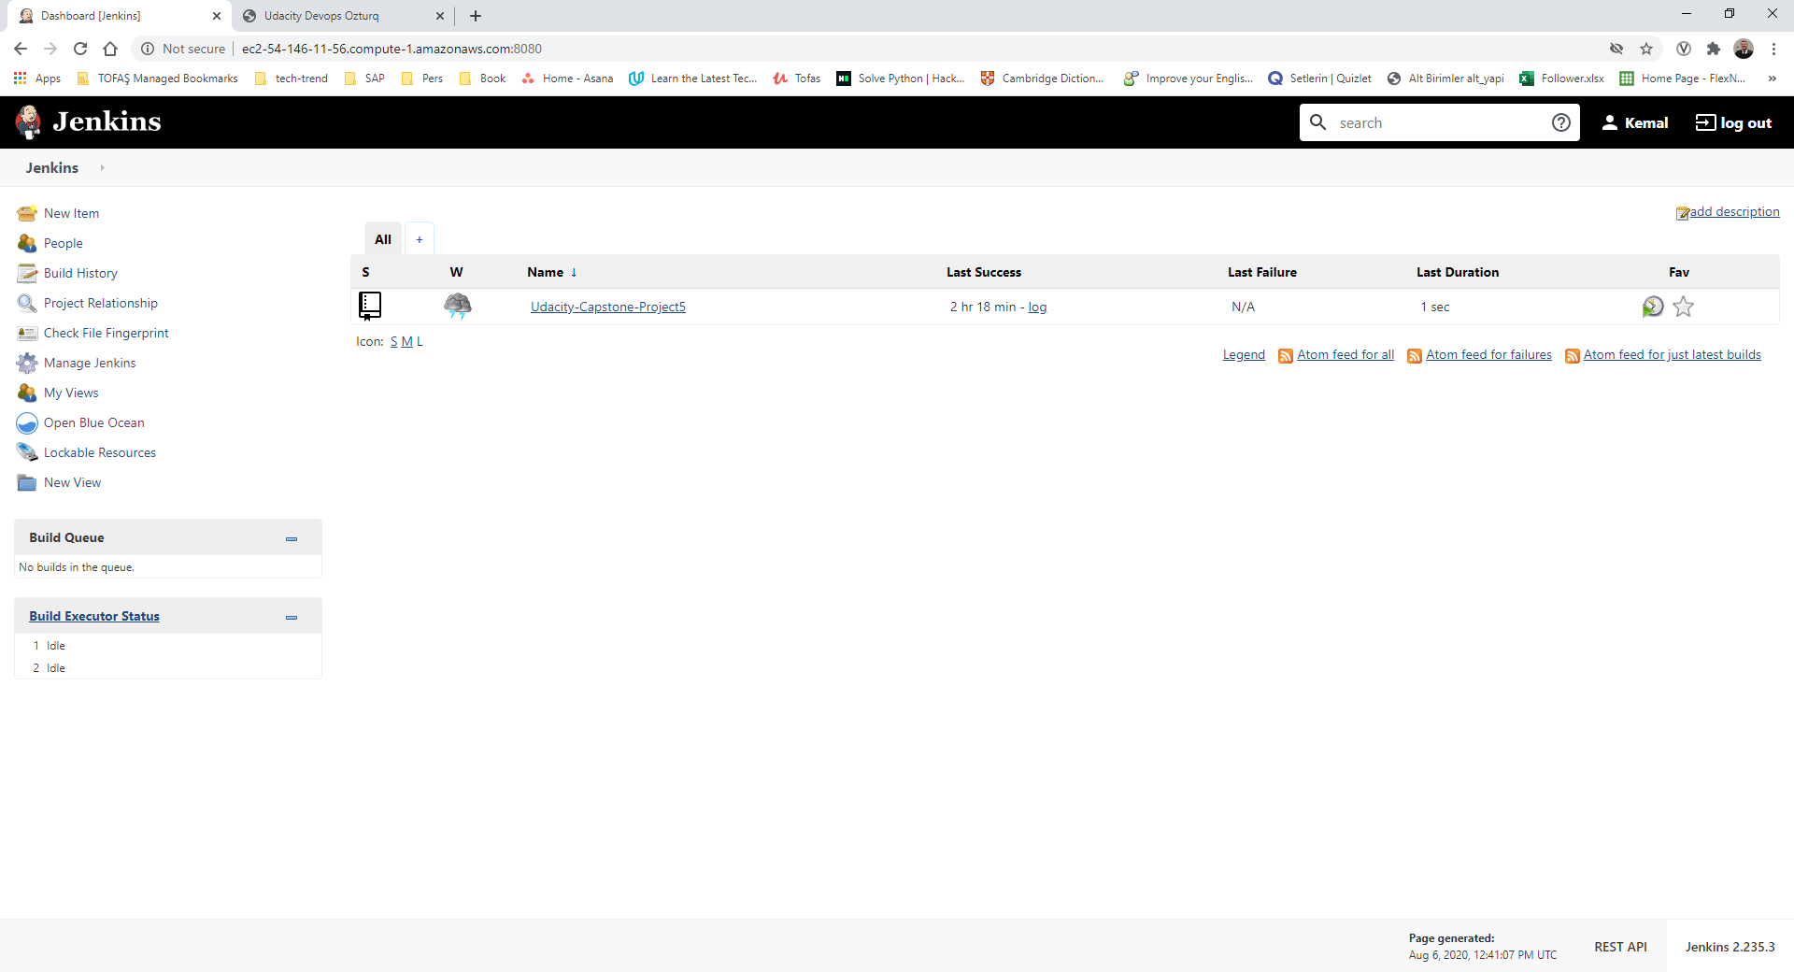

## AWS EKS

eksctl create cluster --name ozturqcapstonecls --version 1.17 --nodegroup-name ozturq-lnodes --node-type t2.small --nodes 2 --nodes-min 1 --nodes-max 3 --node-ami auto --region us-east-1

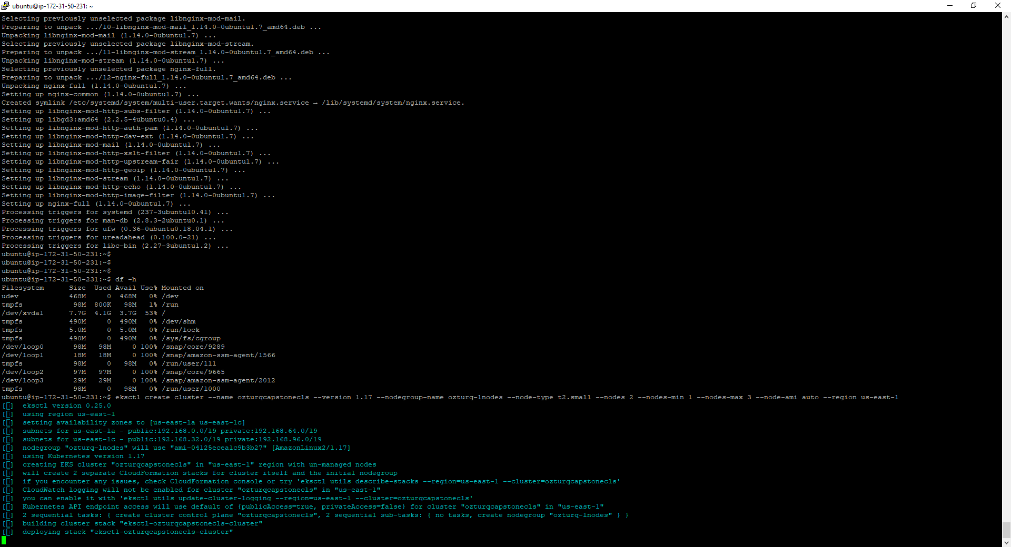

### EKS Cluster

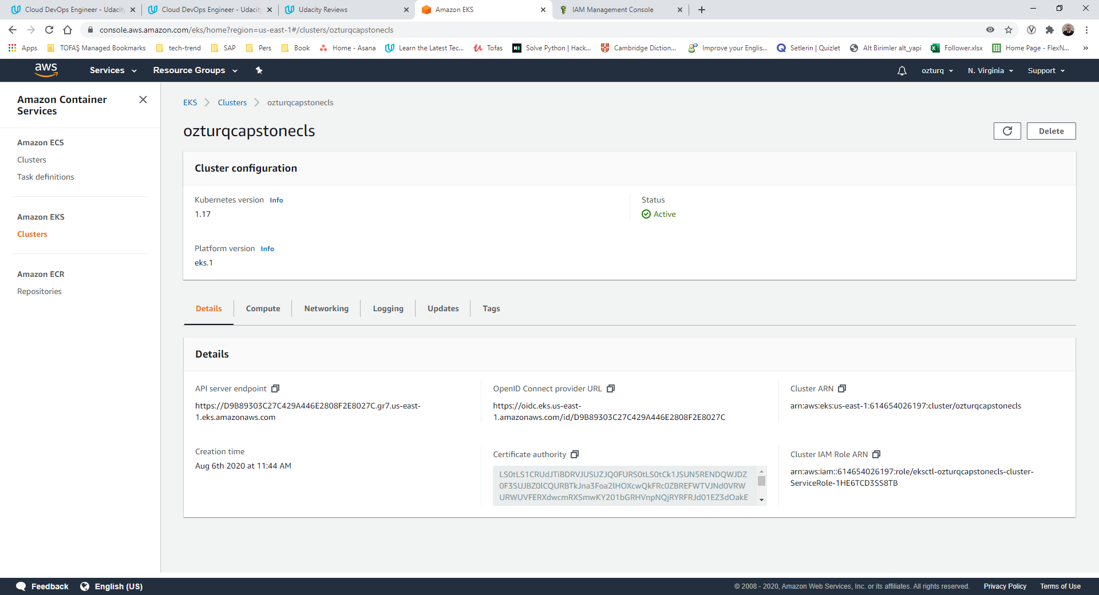

### EKS Ready message

EKS cluster "ozturqcapstonecls" in "us-east-1" region is ready

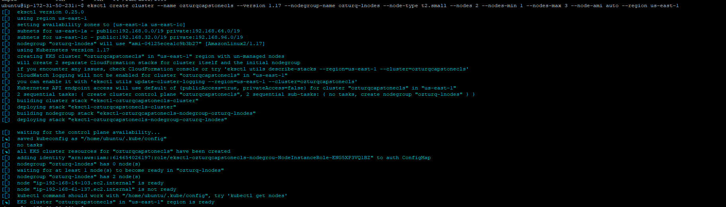

## Cloud Formation

### Cluster

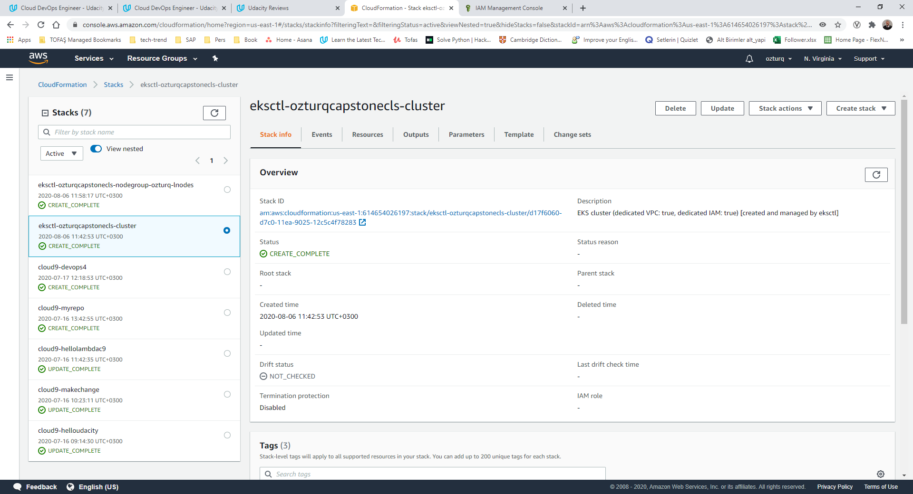

### Nodegroup

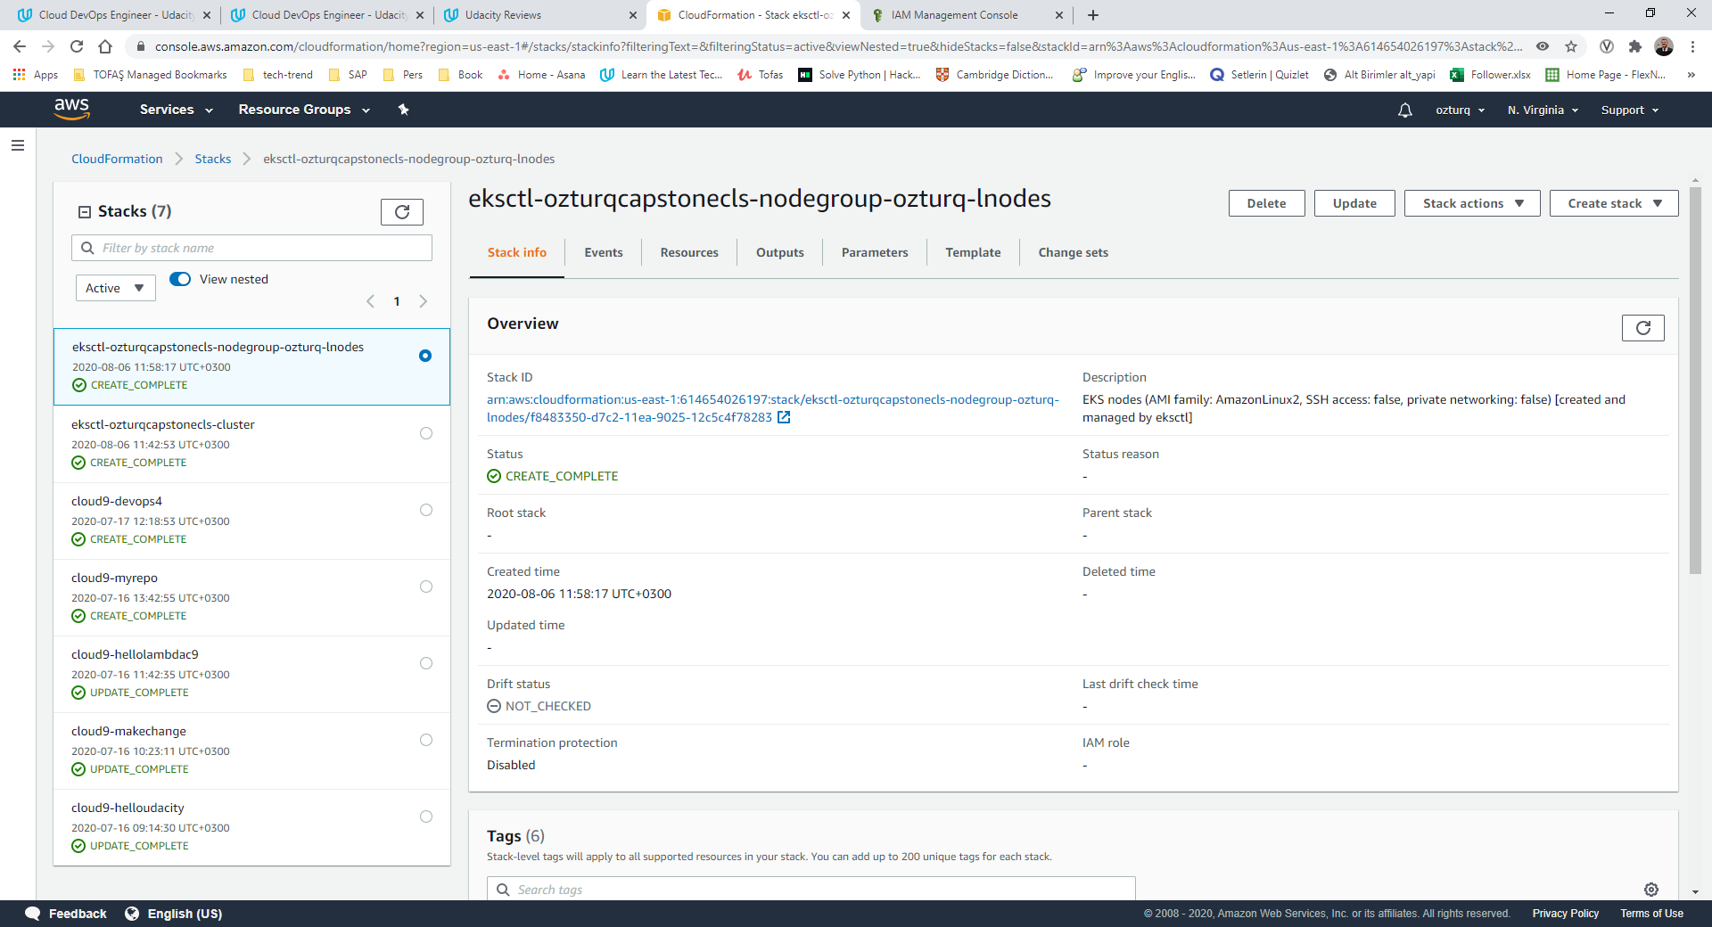

## Lint HTML

### Failed

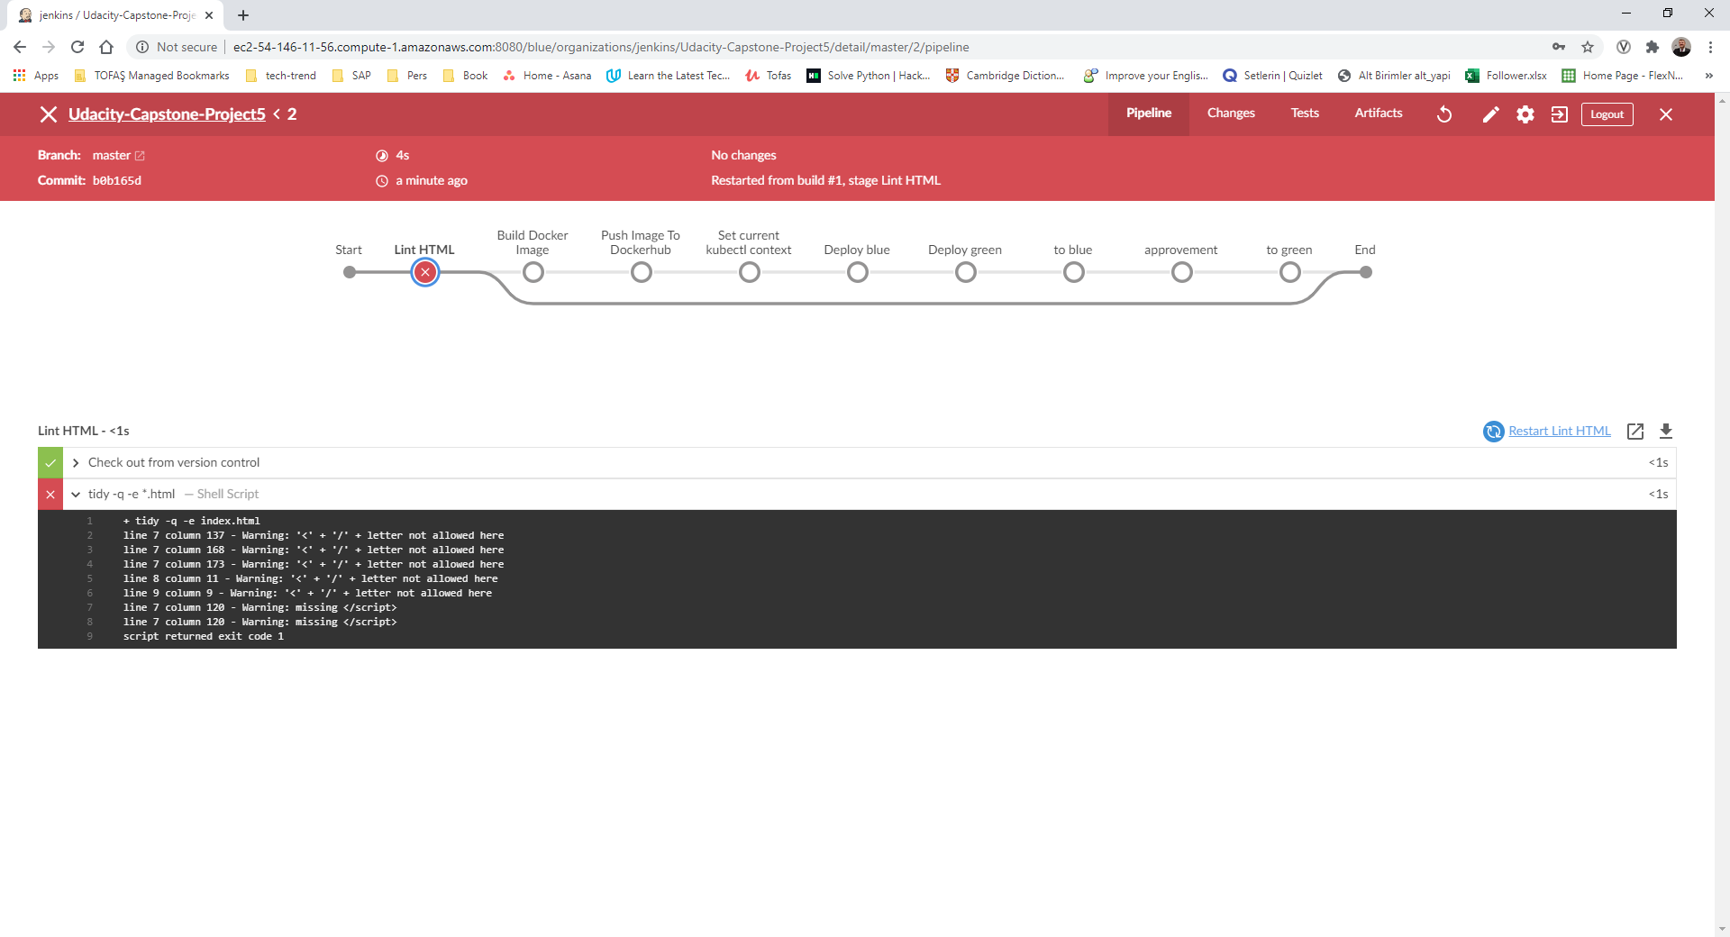

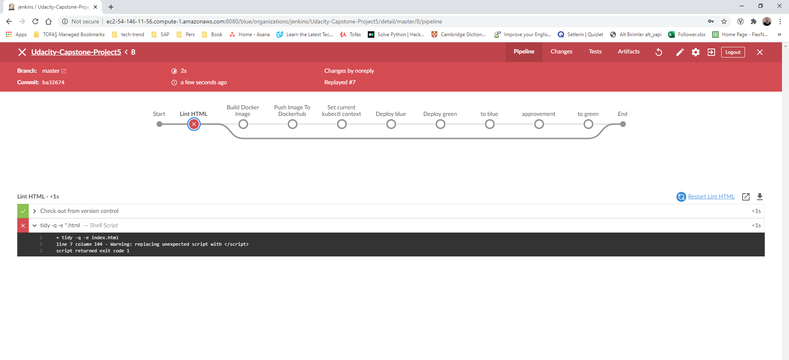

### Success

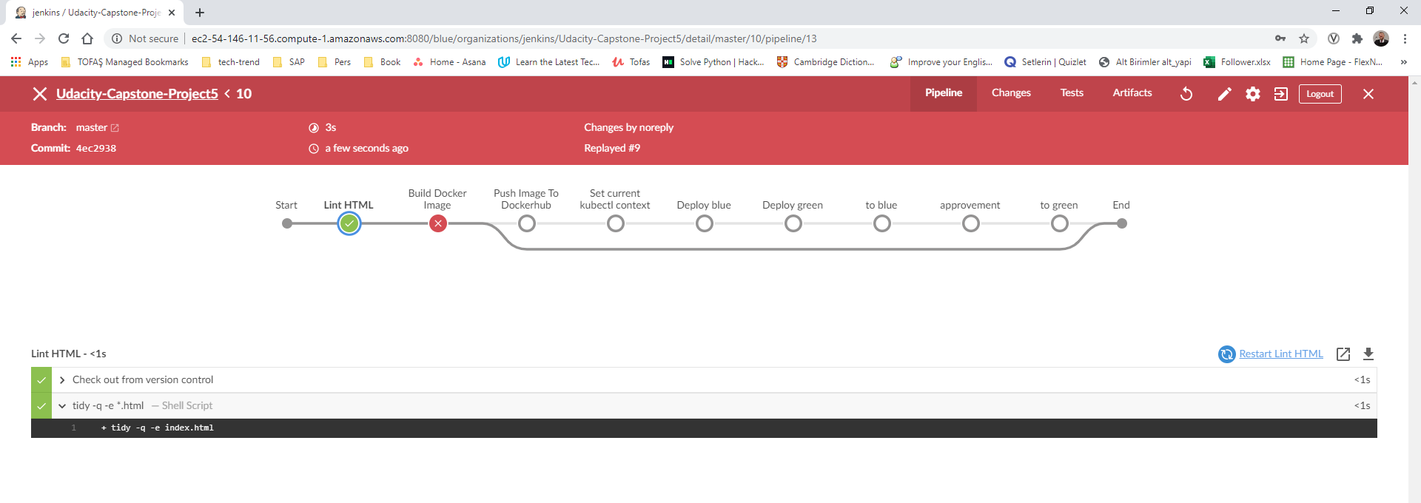

## Build Docker Image

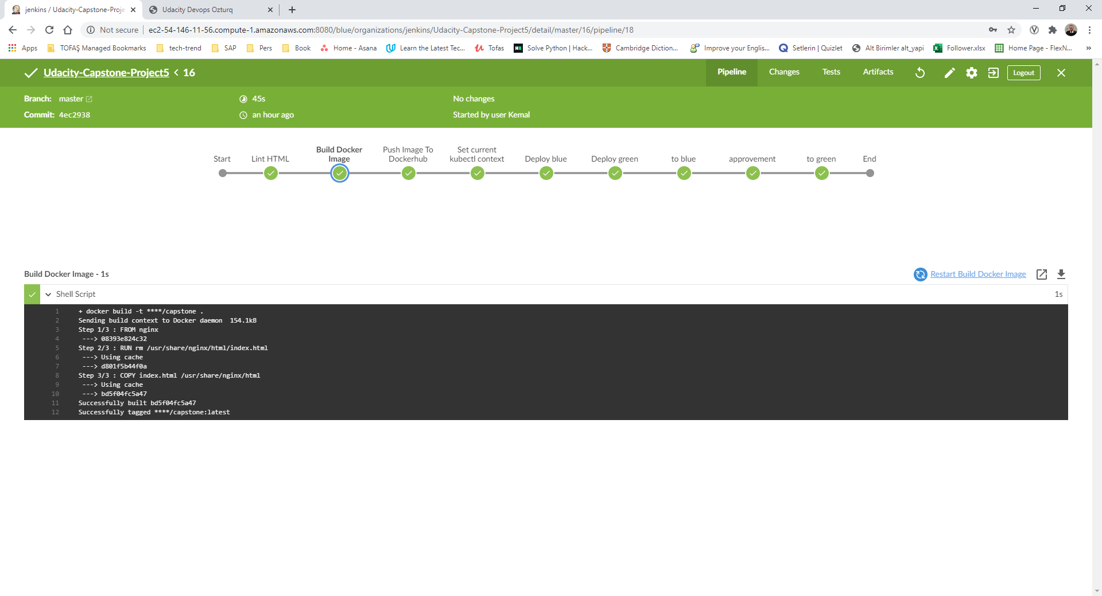

## Push image to dockerhub

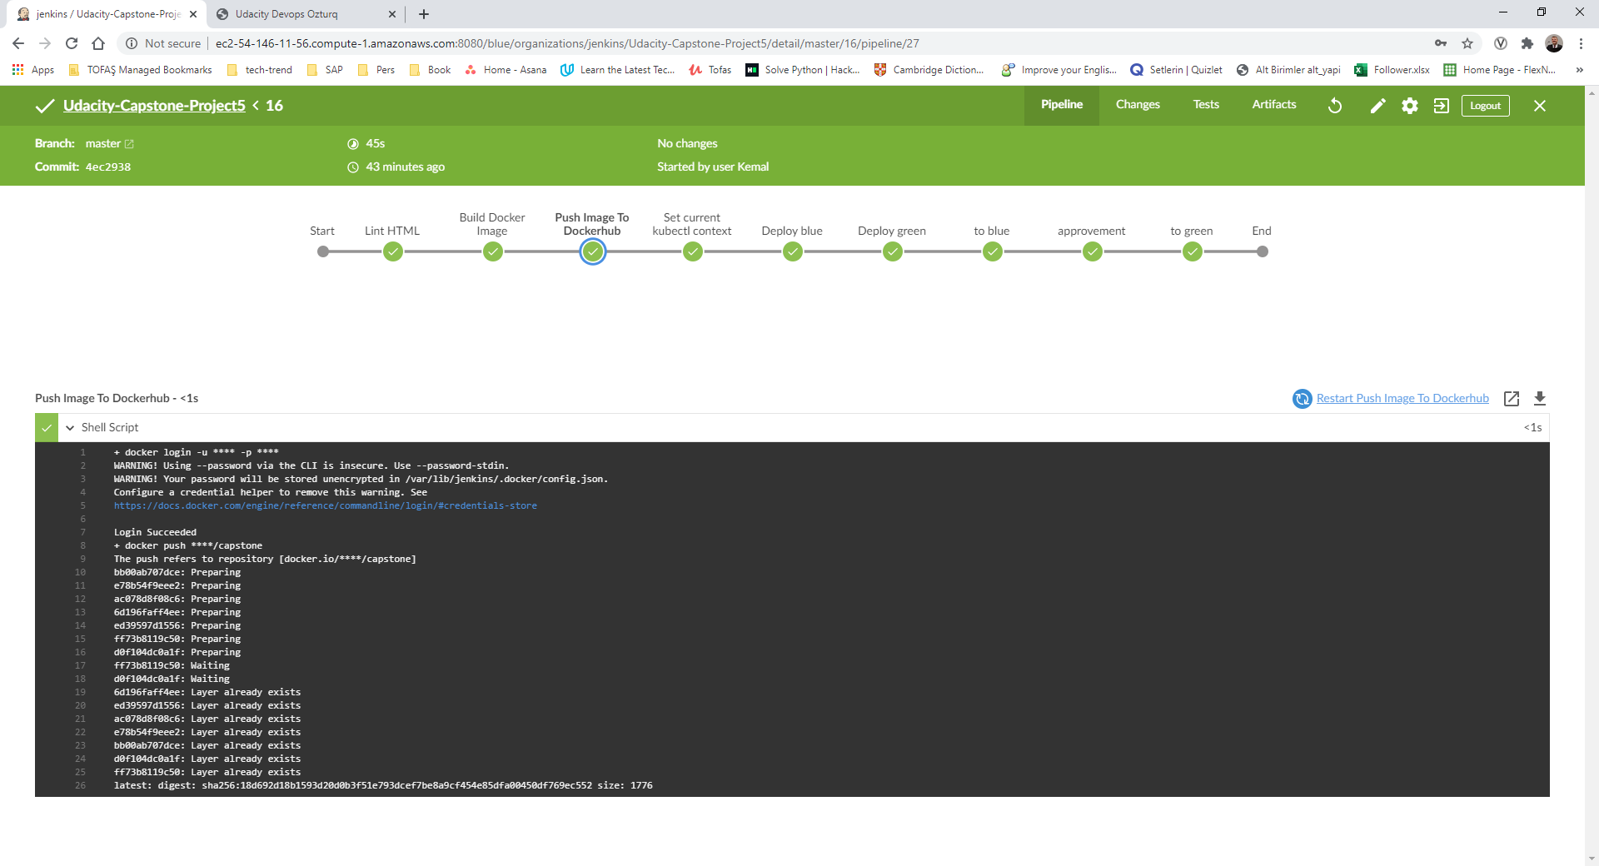

### Dockerhub

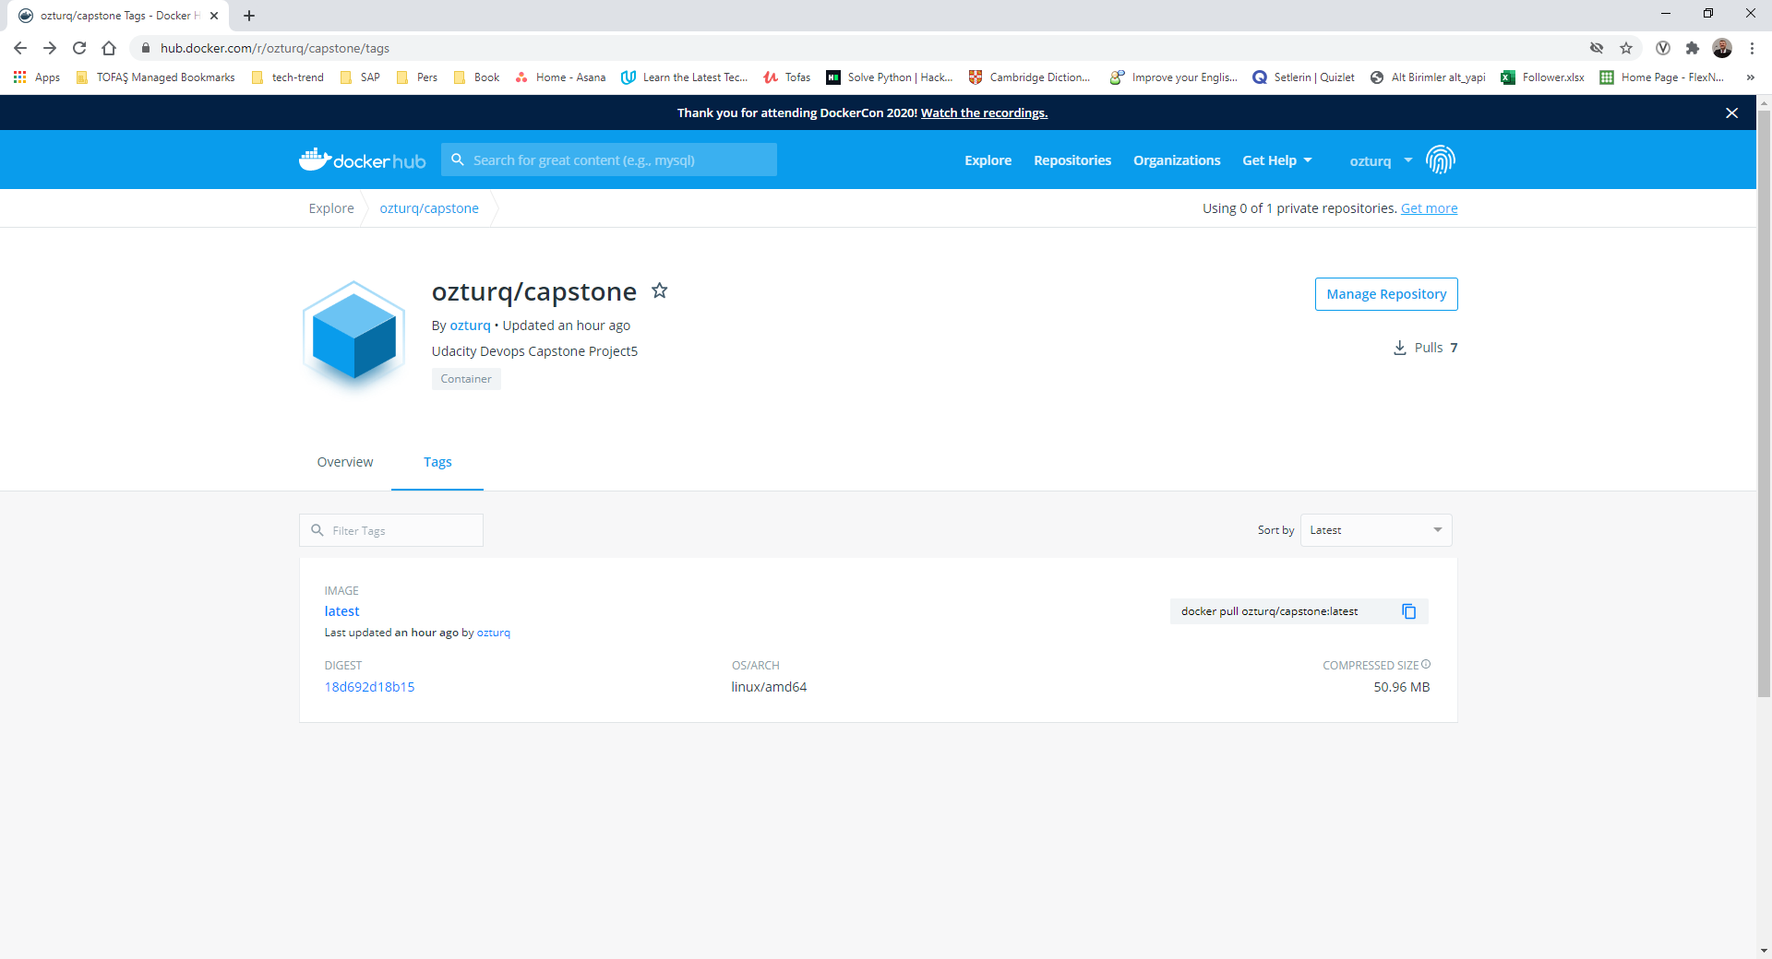

## Kubectl context

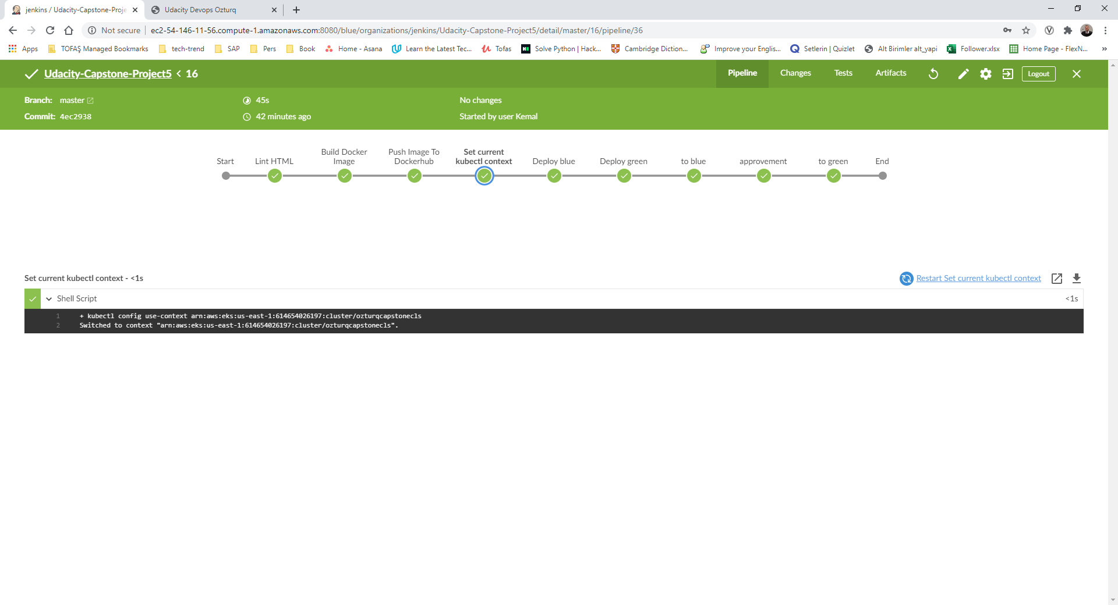

## Deploy blue

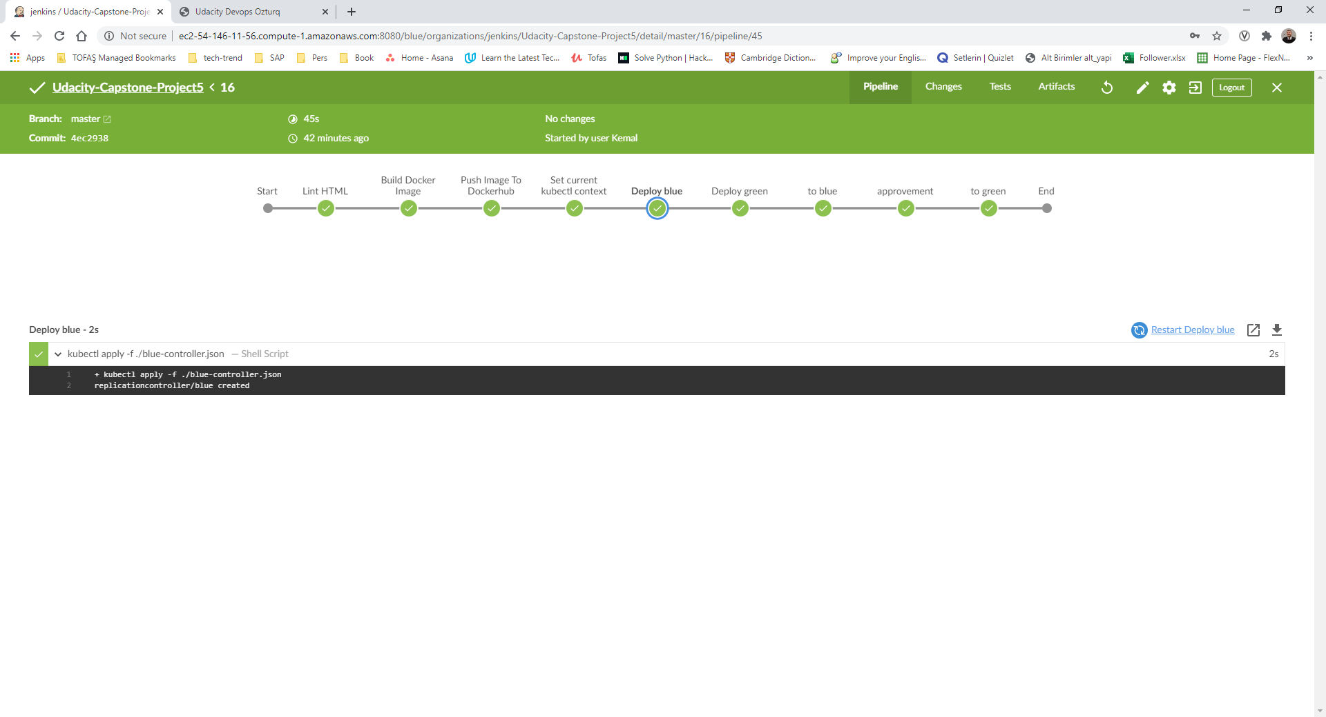

## Deploy green

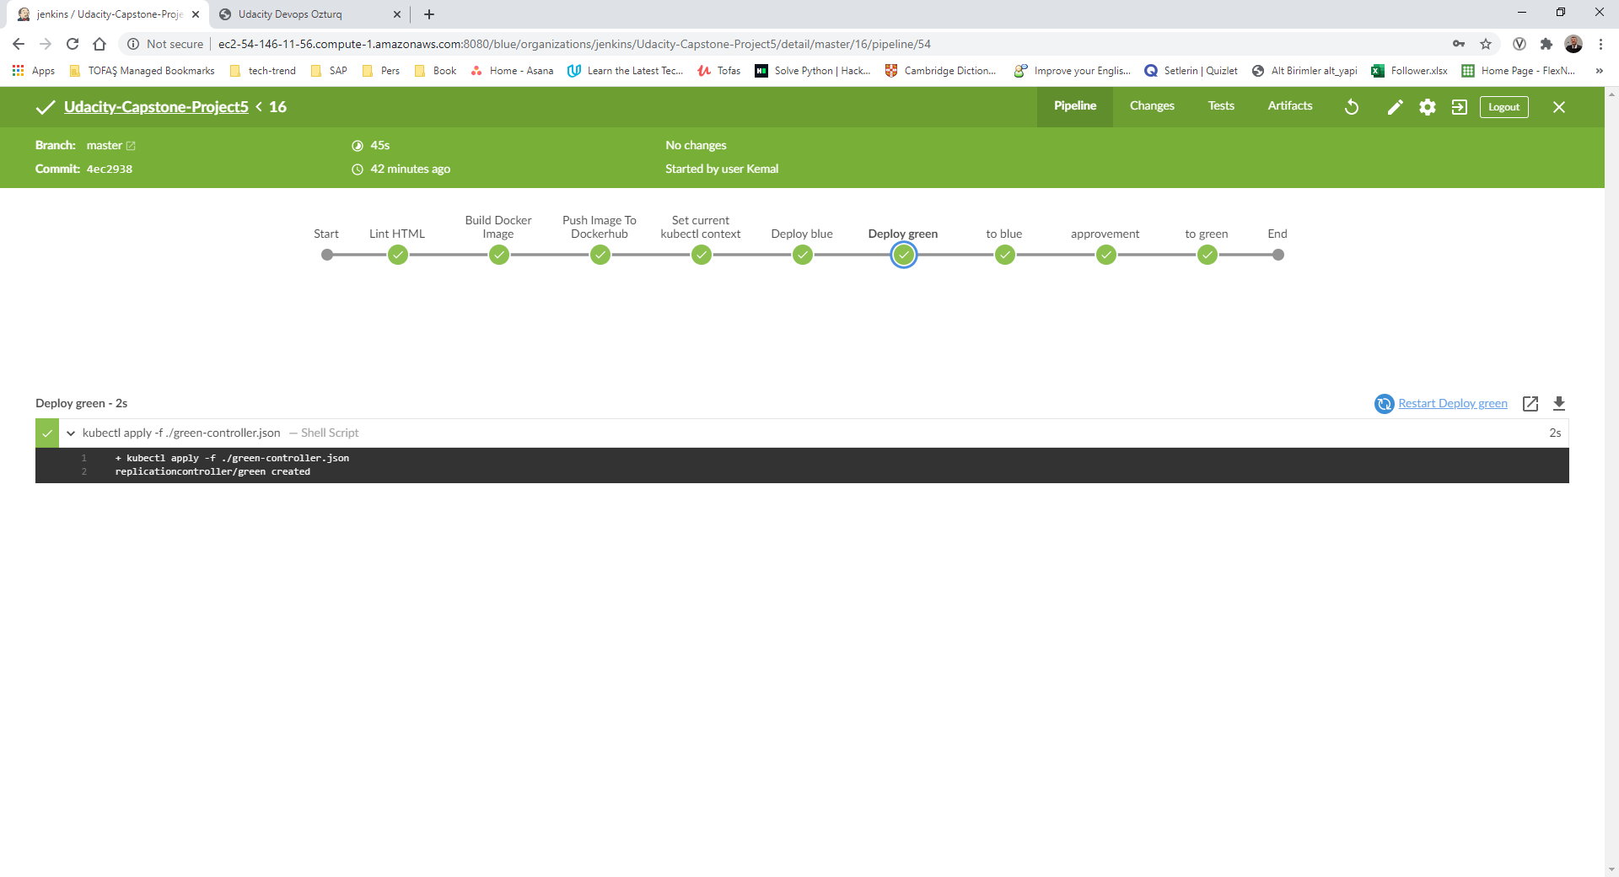

## To blue

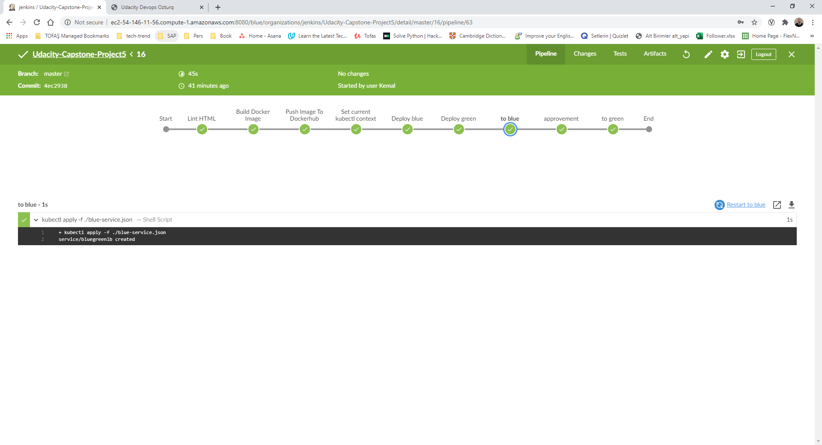

## Approve

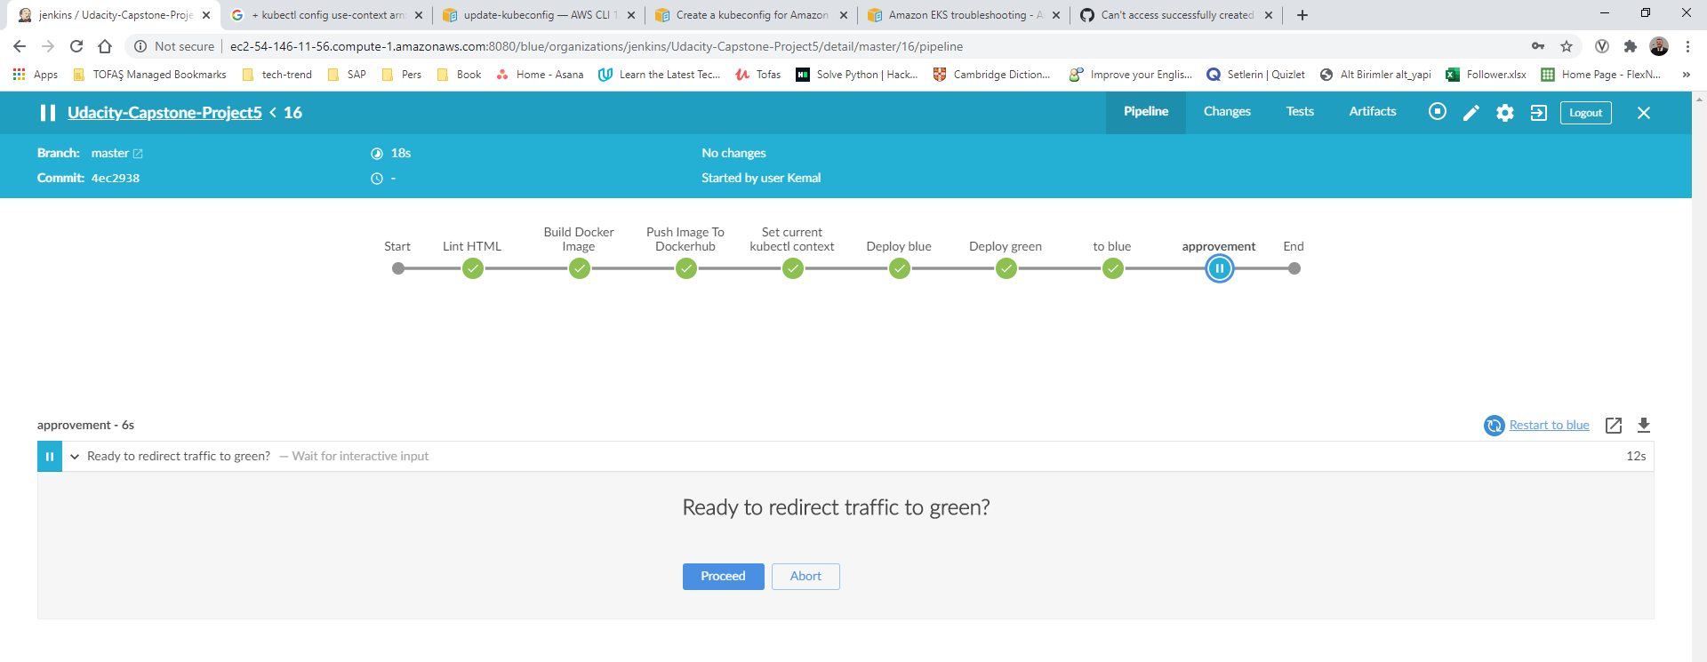

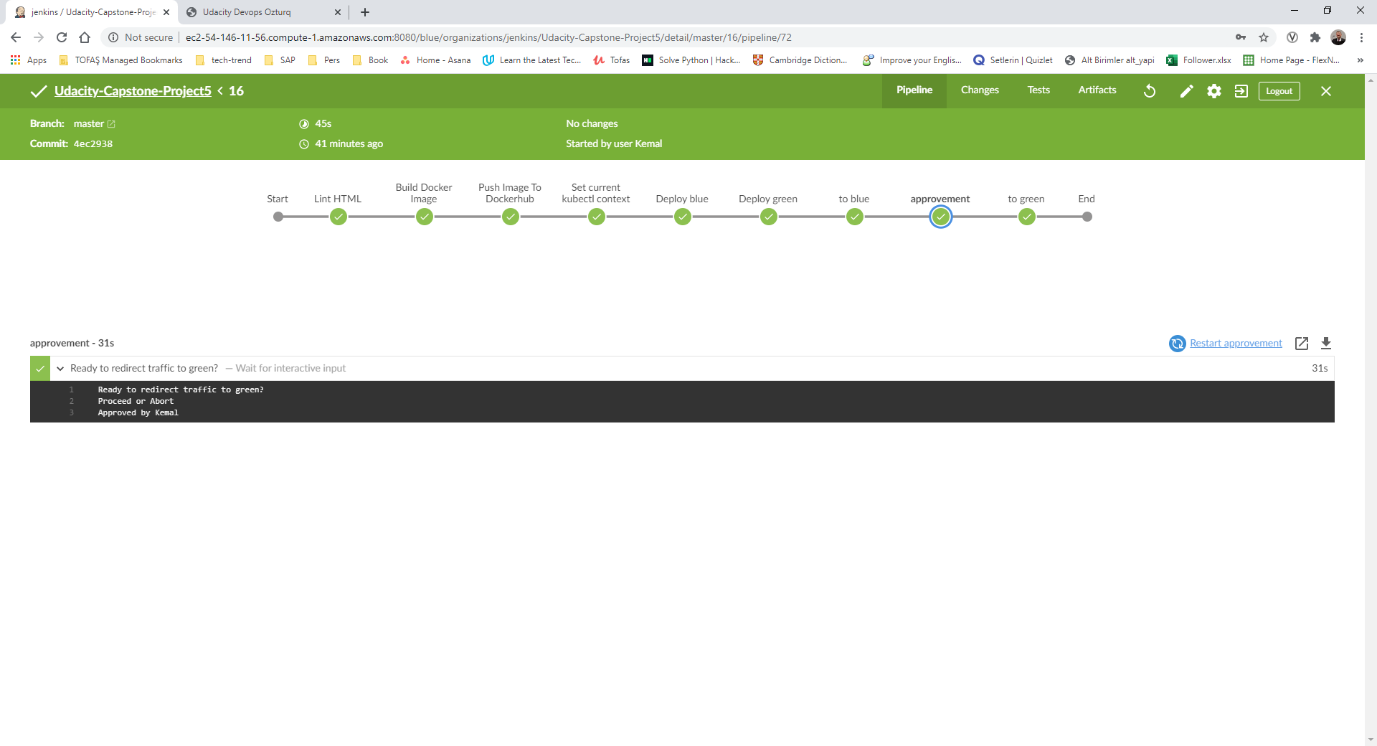

## To green

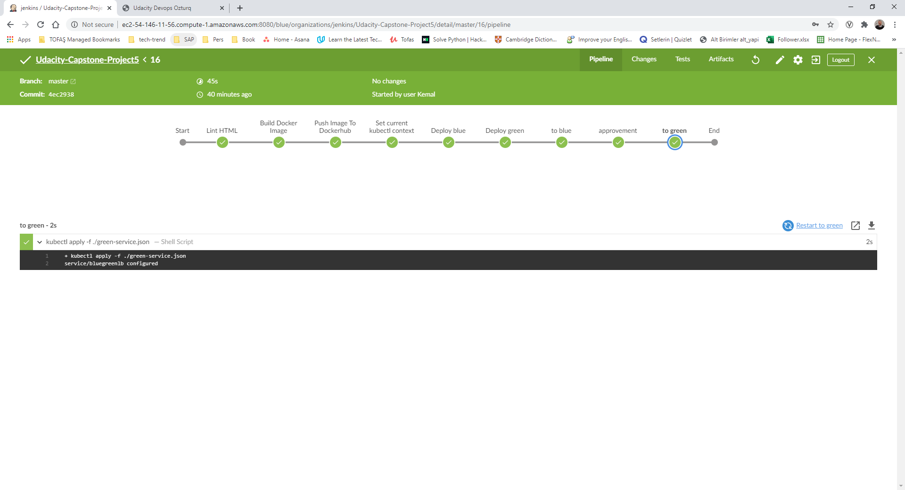

## Website

<http://aa9e9f355138c41c5a48a6fff0b01565-1704206919.us-east-1.elb.amazonaws.com:8000/>

