Learning Objective: The objective of this assignment is to apply your understanding of how packets move through an Access Points.

Instructions and Grading Criteria:
Download and Install Wireshark
Wireshark has become the industry standard packet-sniffer program used by network engineers. This open source software is available for many different operating systems, including Windows, Mac, and Linux. In this lab, you will download and install the Wireshark software program on your PC.
Note: Before downloading Wireshark, check with your instructor about your academy’s software download policy.
  - Download Wireshark.
    - Wireshark can be downloaded from www.wireshark.org.
    - Click Download Wireshark.
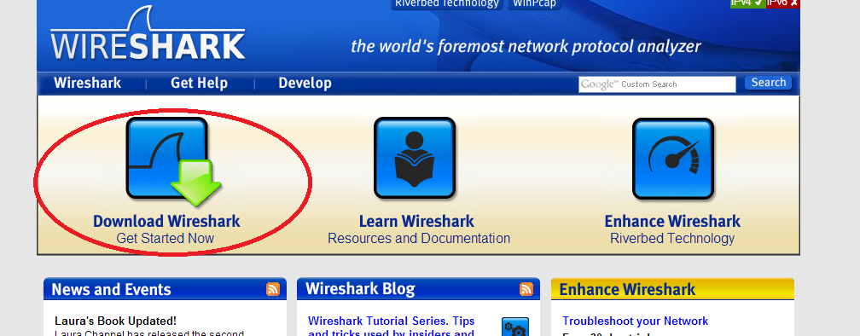
    - Choose the software version you need based on your PC’s architecture and operating system. For instance, if you have a 64-bit PC running Windows, choose Windows Installer (64-bit).
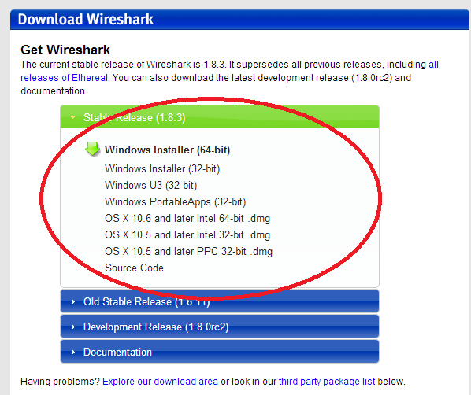
After making a selection, the download should start. The location of the downloaded file depends on the browser and operating system that you use. For Windows users, the default location is the Downloads folder.
  - Install Wireshark.
    - The downloaded file is named Wireshark-win64-x.x.x.exe, where x represents the version number. Double-click the file to start the installation process.
    - Respond to any security messages that may display on your screen. If you already have a copy of Wireshark on your PC, you will be prompted to uninstall the old version before installing the new version. It is recommended that you remove the old version of Wireshark prior to installing another version. Click Yes to uninstall the previous version of Wireshark.
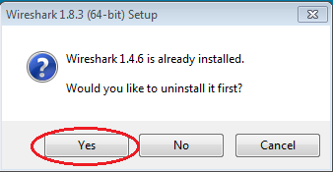
    - If this is the first time to install Wireshark, or after you have completed the uninstall process, you will navigate to the Wireshark Setup wizard. Click Next.
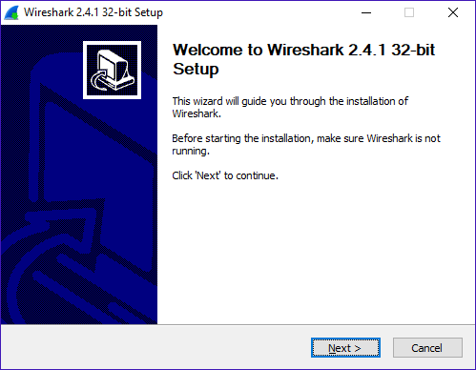
    - Continue advancing through the installation process. Click I Agree when the License Agreement window displays.
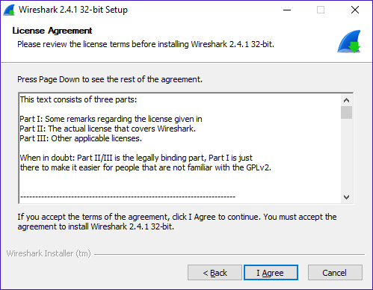
    - Keep the default settings on the Choose Components window and click Next.
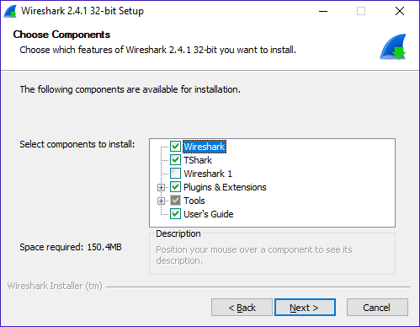
    - Choose your desired shortcut options and click Next.
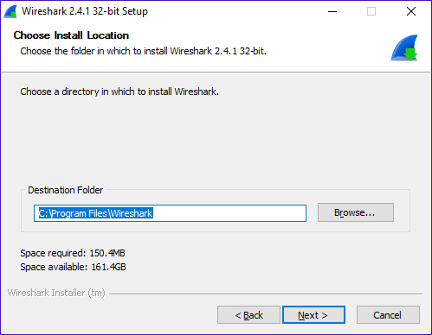
    - You can change the installation location of Wireshark, but unless you have limited disk space, it is recommended that you keep the default location.

    - To capture live network data, WinPcap must be installed on your PC. If WinPcap is already installed on your PC, the Install check box will be unchecked. If your installed version of WinPcap is older than the version that comes with Wireshark, it is recommended that you allow the newer version to be installed by clicking the Install WinPcap x.x.x (version number) check box.
    - Finish the WinPcap Setup Wizard if installing WinPcap.
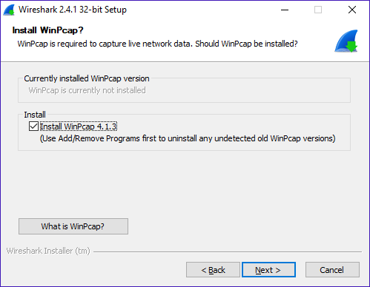
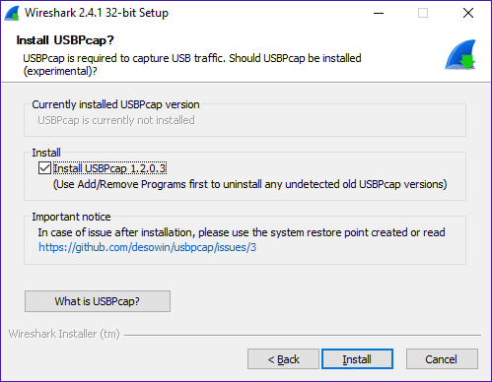
    - Wireshark starts installing its files and a separate window displays with the status of the installation. Click Next when the installation is complete.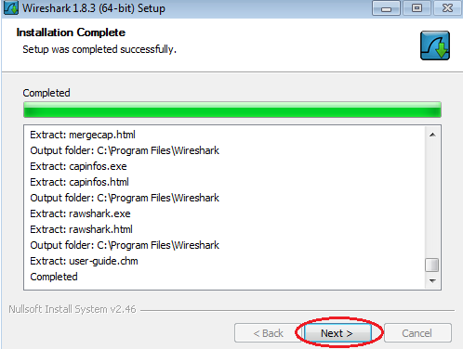
    - Click Finish to complete the Wireshark install process.
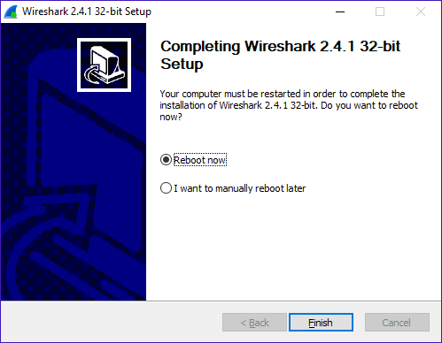

- Now open Wireshark and let’s start capturing files.
- First select your correct wireless interface or wired interface, you should see data after you press the start button on Wireshark top menu
- Next locate another computer on the same network and ping the Wireshark computer using the constant ping command e.g. ping 192.168.10.100 -t
- Next apply a filter to filter only icmp protocol packets (Print-screen this image)
- The filter is located directly under the main top menu
- Next click on one of the icmp packets from the PC or Laptop which you are pinging your Laptop and click on Ethernet II in one of the lower boxes.
- List the source MAC address and Designation MAC of both icmp reply and icmp request (Print-screen)
- Next from the top menu select, Statistics and then select Endpoint (Print screen output)
- Can you find the computer that is pinging your PC?
- Can you find any multicast addresses on the Endpoint output box?
- Next Let’s look incoming transmission, select Statistics and then Resolved Addresses

Lab #4 Deadline: Lab#4 is due before midnight on July 3, 2018.

Lab #4 is worth 15 pt.

Late Homework Assignment Penalty: Late homework assignments will not be accepted. I encourage you to start your assignments in advance. This helps produce a quality assignment. Using Blackboard’s Assignment Feature, submit homework assignment #1 before midnight on July 3, 2018.

Lab Assignment Submission: Homework assignment #1 must be submitted using Blackboard’s Assignment Feature. Homework assignments sent to my CSCC email account will not be accepted.

Academic Dishonesty: Academic dishonesty or plagiarism will result in a severe penalty such as course failure or other penalties. These penalties are outlined in your Student Handbook. Your work must be your work and not the work of others.

