**SSJ game**

**New Build**

The sprites movement is locked to the whole integer numbers of their **transform.position(x,y)**. I.e. they will always land on x=2,y=-8, never on x=2.45,y=-7.98. (They must start on whole integers in order to stay on the grid).



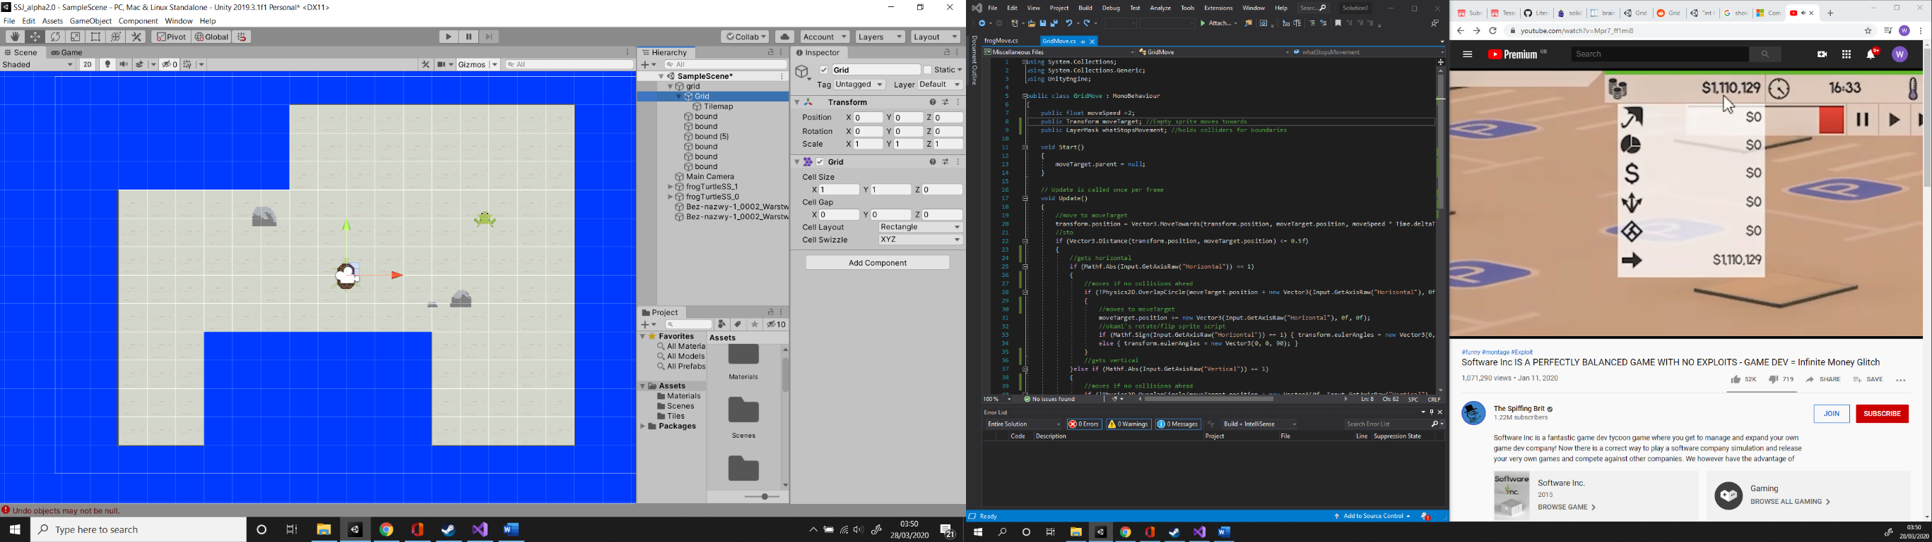

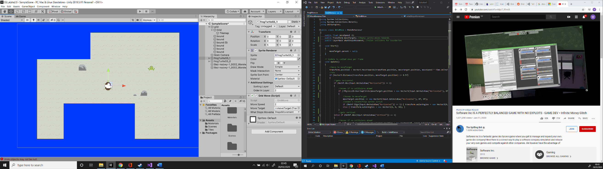

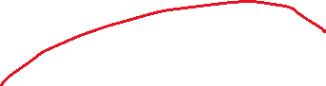



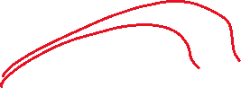

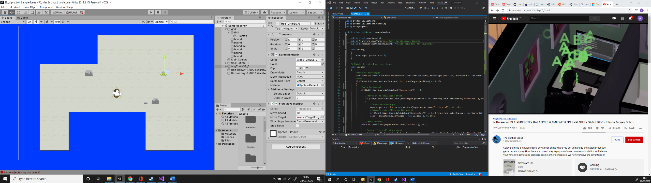



The sprites use an Empty ahead of them (**moveTarget**) to detect colliders (**bound/rocks**) and stop their movement if a collision is found (found from the layer **whatStopsMovement**).

**Turtle Movement**

Currently, when a movement key is held the turtle walks in that direct until the key is released. I would prefer if it only moved **+1** or **-1** per click and not move continuously. I couldn’t figure out how to implement this right away but I thought a single, short movement may be more appropriate for a turtle. I want it to be like when you quickly press the movement key once in build: **SSJ_alpha2.0**

**Frog Movement**

Frog moves as far in the direction of travel as possible. I would like for the turtle to only be able to move one space before the frog has completed its movement. That way each sprite makes one movement per input. (another character could be introduced that moves the like the frog but can jump over rocks).

**Win condition**

Still need a game controller that detects when the character meet on the same spot and ends the level.

**Fail condition**

Maybe sections that the character must avoid else having to restart the level. (like spikes in mario)

**Levels**

By moving the walls and rocks around and changing the starting positions of the characters I got a few different “*puzzle-y”* feeling maps. They mostly focus on the frogs movement but this can be expanded on.

**Movement code adapted from:** (watch if my notes don’t make sense, it’s late)

<https://www.youtube.com/watch?v=mbzXIOKZurA>