Kellen Haas

6/2/20

CPSC 2150 Project 2

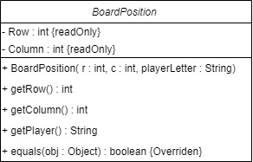

GameBoard Activity Diagrams:

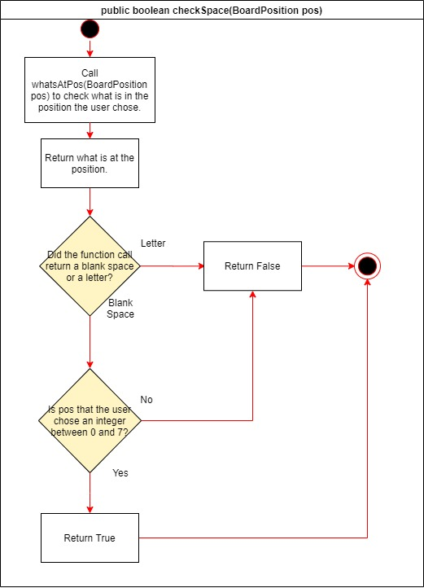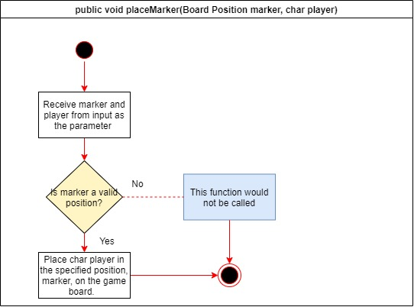

# GameScreen Activity Diagrams:

# Requirements Analysis