Kellen Haas

CPSC 2150

Project 4

11/17/2020

Requirements Analysis

# Functional Requirements

1. As a user, I can choose which row I want to place my marker in.
2. As a user, I can choose which column I want to place my marker in.
3. As a user, I can view the game board before my turn and after my turn with my updated marker that I just placed.
4. As a user, after the first user takes their turn, I can then choose my row.
5. As a user, after the first user takes their turn, I can choose my column.
6. As a user, I can expect that the system will notify me and my opponent if someone has won horizontally.
7. As a user, I can expect that the system will notify me and my opponent if someone has won vertically.
8. As a user, I can expect that the system will notify me and my opponent if someone has won diagonally.
9. As a user, I want to be notified by the system if there is a draw.
10. As a user, if I choose a position where a marker already has been placed, the system will tell me that I cannot place a marker there.
11. As a user, if I choose a position that is out of the bounds of the board, the system will tell me that it is not a valid position.
12. As a user, I want to be able to view both mine and my opponents placed markers after every turn.
13. As a user, I expect the top of the board to be the index 0, 0.
14. As a user, I want to be asked after the game has ended if I want to play again.
15. As a user, if I choose to play again, then the program should start over from the beginning and clear the game board.

# Non-Functional Requirements

1. The system must be coded in Java programming language.
2. The system must be able to run on Unix/Linux.
3. Program must be able to compile and run quickly and efficiently.
4. The system must be written in IntelliJ IDE for debugging purposes in the future.
5. The top left corner of the game board must be 0, 0.
6. The game board is currently 8x8.
7. Currently, player X goes first and then player O.

Design

# Activity Diagrams

GameScreen.java

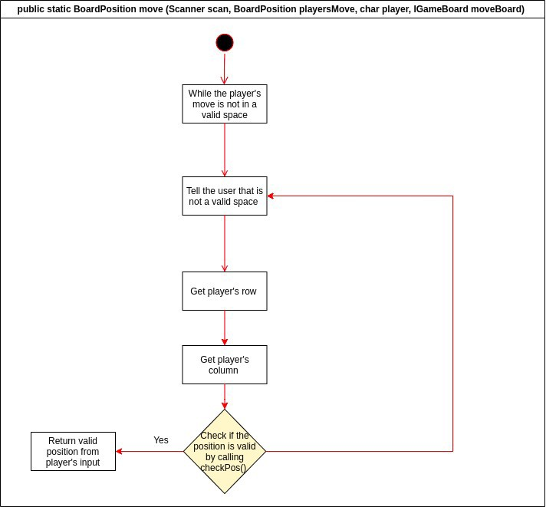

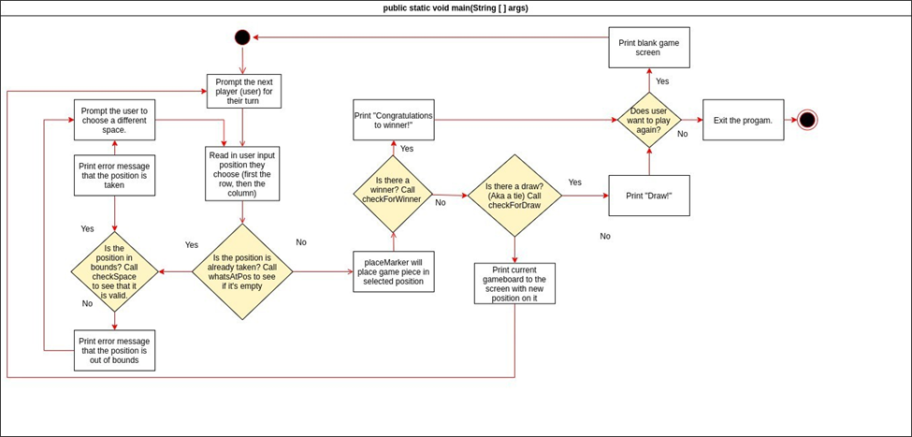

GameBoard.java

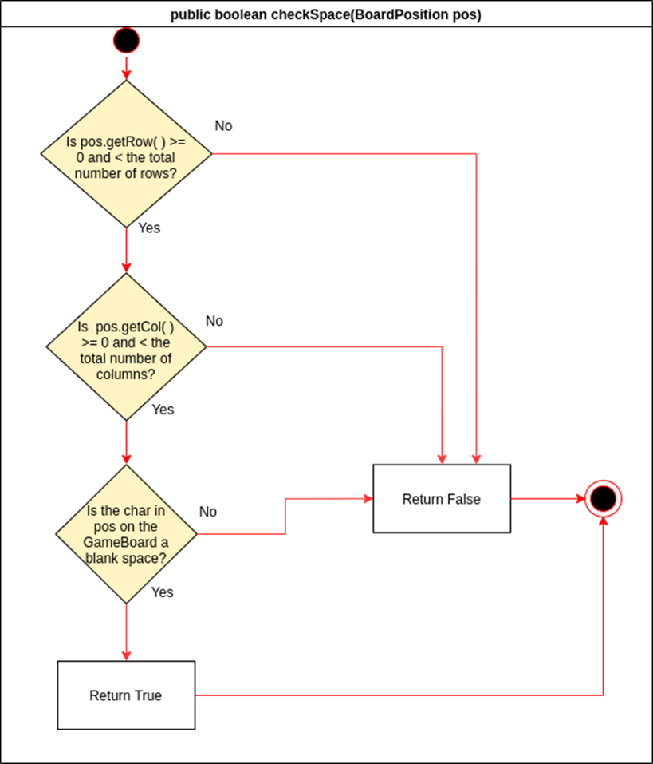

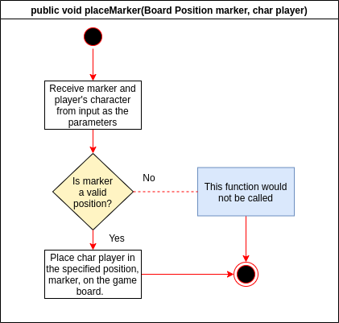

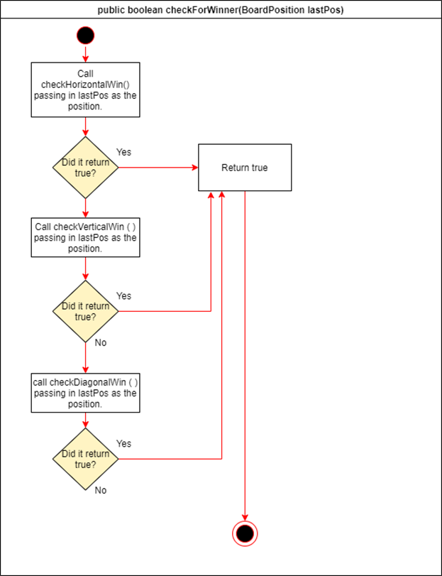

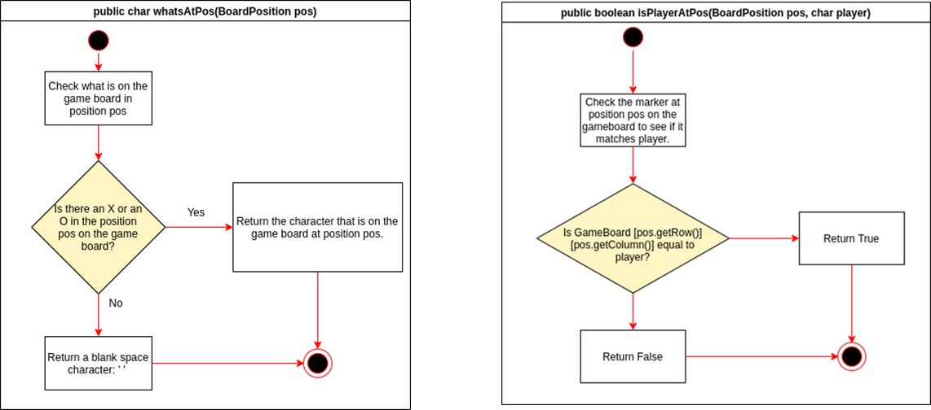

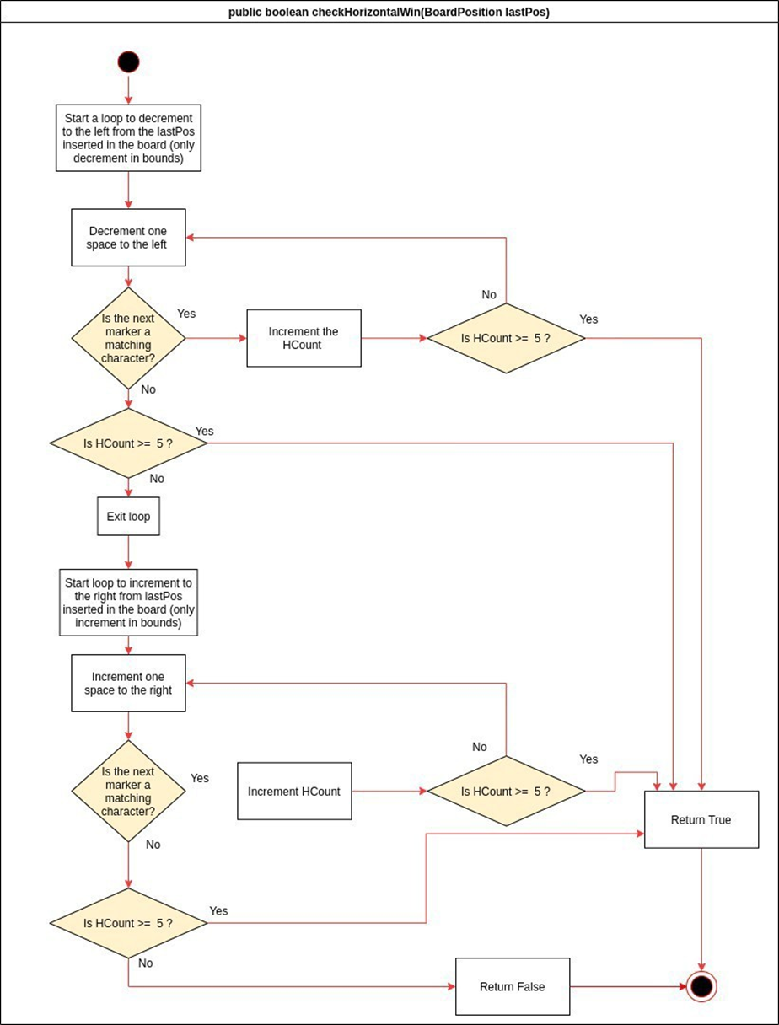

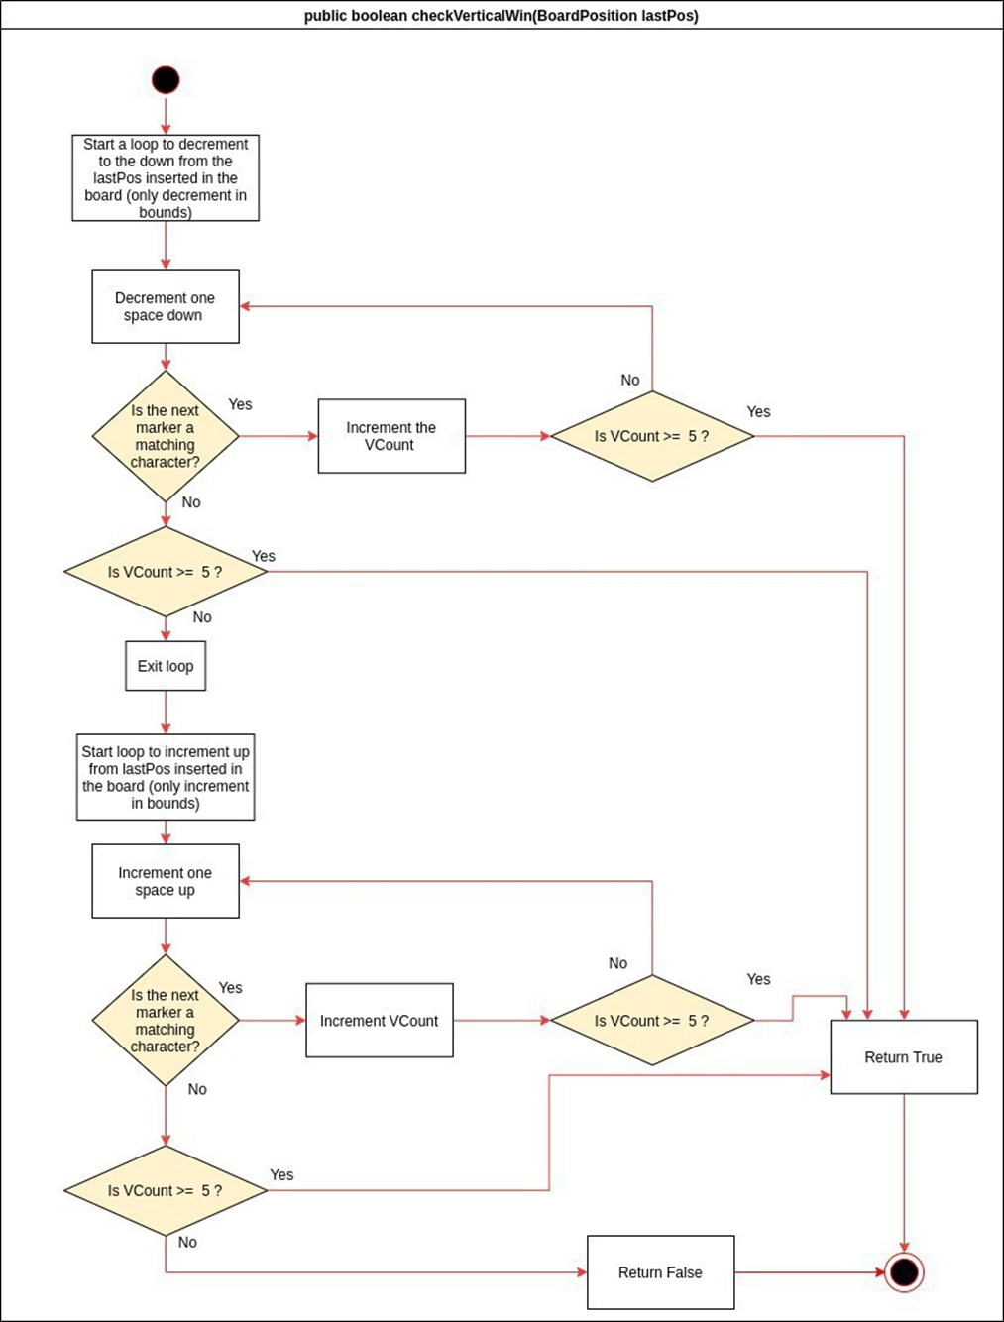

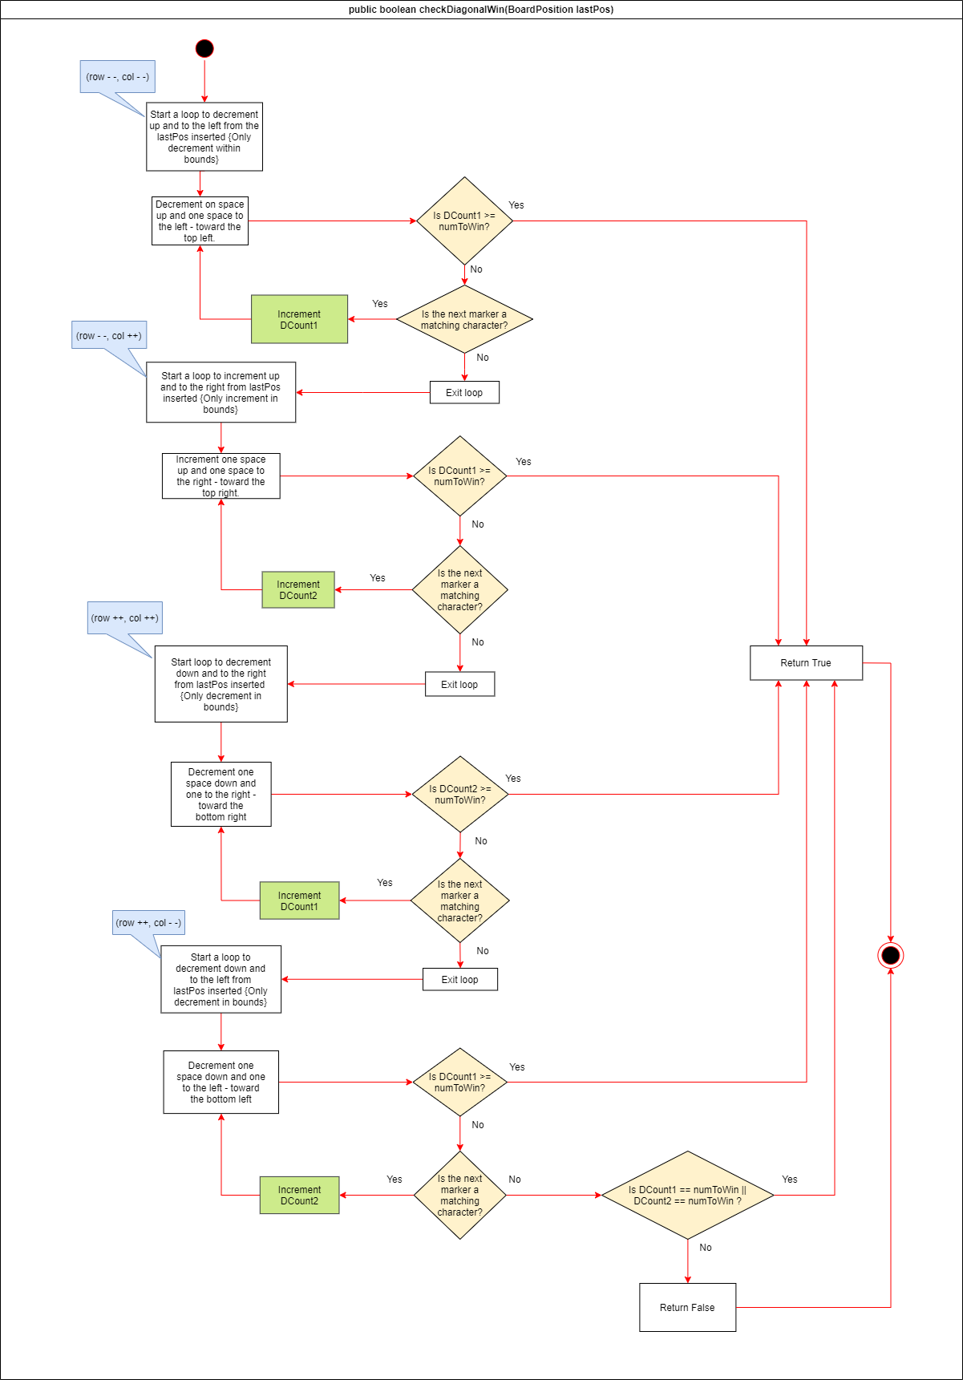

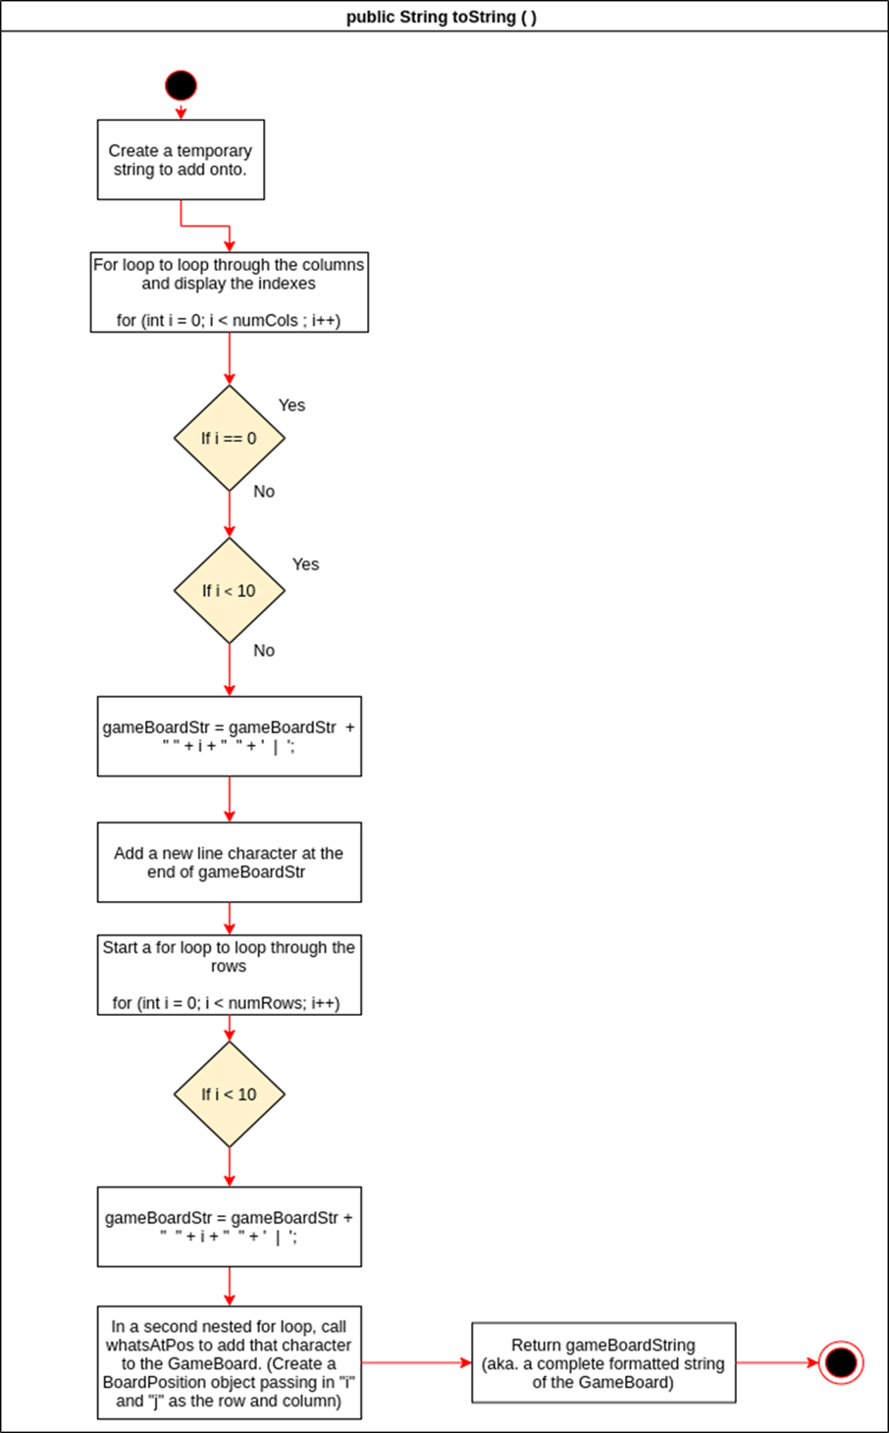

BoardPosition.java

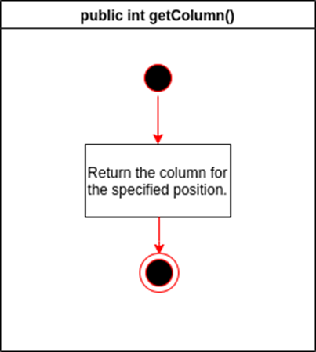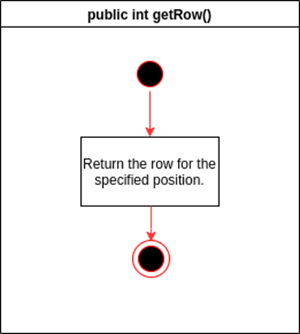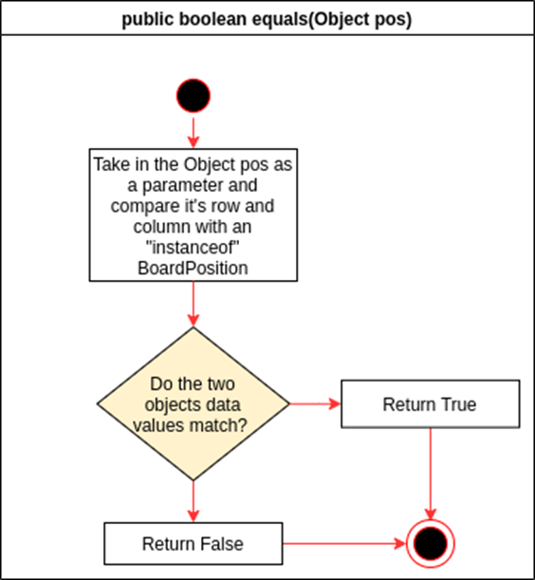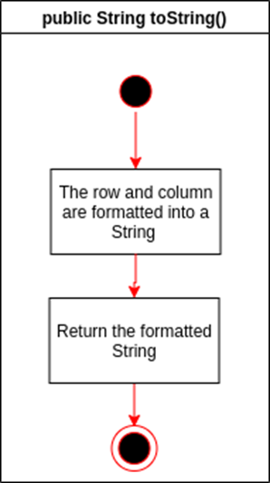

UML Class Diagrams

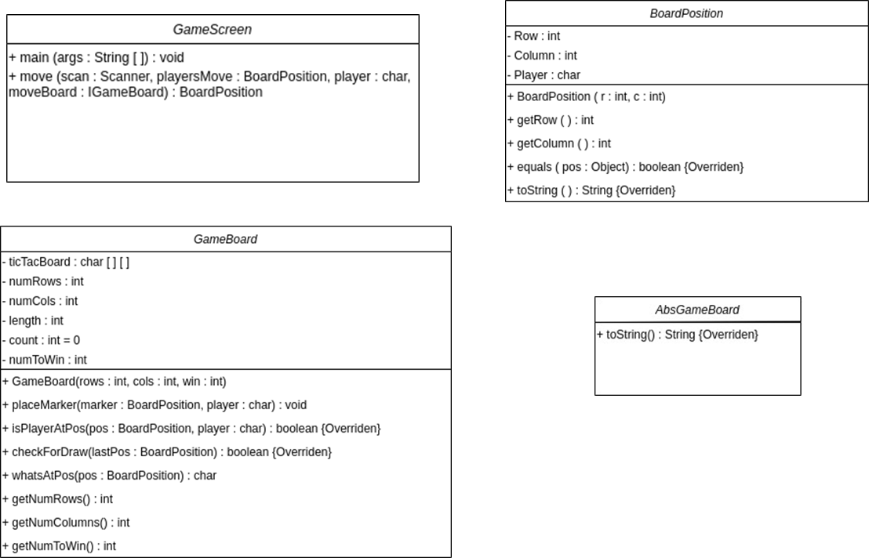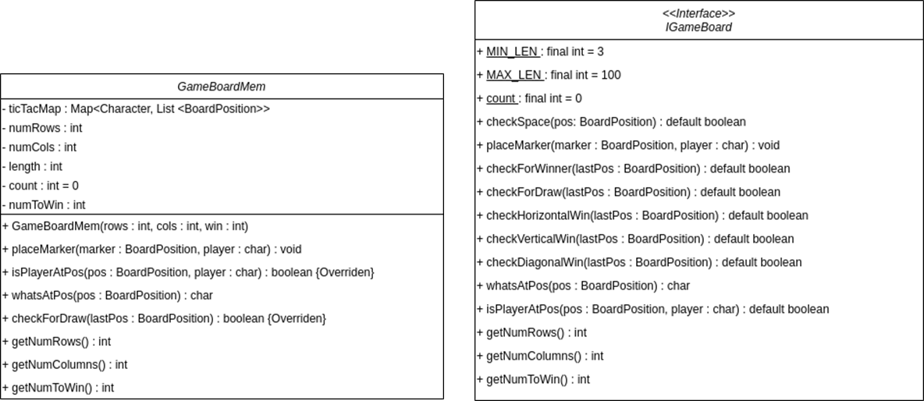

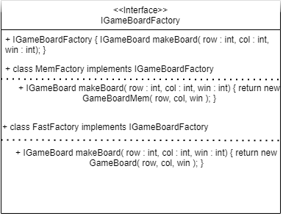

Testing

public void GameBoard()

|  |  |  |  |  |  |  |  |  |  |  |  |  |  |  |  |  |  |  |
| --- | --- | --- | --- | --- | --- | --- | --- | --- | --- | --- | --- | --- | --- | --- | --- | --- | --- | --- |
| **Input:**  State: (number to win = 3)   |  |  |  |  | | --- | --- | --- | --- | |  | 0 | 1 | 2 | | 0 |  |  |  | | 1 |  |  |  | | 2 |  |  |  |   IGameBoard gb = GameBoardFactory(3, 3, 3) | **Output:**  GameBoard constructor  getNumRows() = 3  getNumCols() = 3  getNumToWin() = 3  State: unchanged | **Reason:**  This test case is unique and distinct because it tests that the constructor successfully creates a game board using the minimum values for row, column, and number in a row to win.  **Function Name:**  TestGameBoard_Minimums |

public void GameBoard()

|  |  |  |  |  |  |  |  |  |  |  |  |  |  |  |  |  |  |  |
| --- | --- | --- | --- | --- | --- | --- | --- | --- | --- | --- | --- | --- | --- | --- | --- | --- | --- | --- |
| **Input:**  State: (number to win = 25)   |  |  |  |  | | --- | --- | --- | --- | |  | 0 | 1 | 2 | | 0 |  |  |  | | 1 |  |  |  | | 2 |  |  |  |   IGameBoard gb = GameBoardFactory(100, 100, 25) | **Output:**  GameBoard constructor  getNumRows() = 100  getNumCols() = 100  getNumToWin() = 25  State: unchanged | **Reason:**  This test case is unique and distinct because it tests that the constructor successfully creates a game board using the maximum values for row, column, and number in a row to win.  **Function Name:**  TestGameBoard_Maximums |

public void GameBoard()

|  |  |  |  |  |  |  |  |  |  |  |  |  |  |  |  |  |  |  |  |  |  |  |  |  |  |  |  |  |  |  |  |  |  |  |  |  |  |
| --- | --- | --- | --- | --- | --- | --- | --- | --- | --- | --- | --- | --- | --- | --- | --- | --- | --- | --- | --- | --- | --- | --- | --- | --- | --- | --- | --- | --- | --- | --- | --- | --- | --- | --- | --- | --- | --- |
| **Input:**  State: (number to win = 3)   |  |  |  |  |  |  |  | | --- | --- | --- | --- | --- | --- | --- | |  | 0 | 1 | 2 | 3 | 4 | 5 | | 0 |  |  |  |  |  |  | | 1 |  |  |  |  |  |  | | 2 |  |  |  |  |  |  | | 3 |  |  |  |  |  |  |   IGameBoard gb = GameBoardFactory(4, 6, 3) | **Output:**  GameBoard constructor  getNumRows() = 4  getNumCols() = 6  getNumToWin() = 3  State: unchanged | **Reason:**  This test case is unique and distinct because it tests that the constructor successfully creates a game board using different values for row and column.  **Function Name:**  TestGameBoard_Diff_RowsAndCols |

public void placeMarker(BoardPosition testPos, char player)

|  |  |  |  |  |  |  |  |  |  |  |  |  |  |  |  |  |  |  |  |  |  |  |  |  |  |  |  |  |  |  |  |  |  |  |
| --- | --- | --- | --- | --- | --- | --- | --- | --- | --- | --- | --- | --- | --- | --- | --- | --- | --- | --- | --- | --- | --- | --- | --- | --- | --- | --- | --- | --- | --- | --- | --- | --- | --- | --- |
| **Input:**  State: (number to win = 3)   |  |  |  |  | | --- | --- | --- | --- | |  | 0 | 1 | 2 | | 0 |  |  |  | | 1 |  |  |  | | 2 |  |  |  |   IGameBoard gb = GameBoardFactory(3, 3, 3)  player = ‘X’  testPos = new BoardPosition (2, 2)  gb.placeMarker (testPos, player) | **Output:**  getNumRows() = 3  getNumCols() = 3  getNumToWin() = 3  whatsAtPos(testPos) = ‘X’  State:   |  |  |  |  | | --- | --- | --- | --- | |  | 0 | 1 | 2 | | 0 |  |  |  | | 1 |  |  |  | | 2 |  |  | X | | **Reason:**  This test case is unique and distinct because it tests that the placeMarker function can successfully place a player’s character in the bottom right corner on the game board (2, 2).  **Function Name:**  Test_PlaceMarker_in_Bottom_Right_Corner() |

public void placeMarker(BoardPosition testPos, char player)

|  |  |  |  |  |  |  |  |  |  |  |  |  |  |  |  |  |  |  |  |  |  |  |  |  |  |  |  |  |  |  |  |  |  |  |
| --- | --- | --- | --- | --- | --- | --- | --- | --- | --- | --- | --- | --- | --- | --- | --- | --- | --- | --- | --- | --- | --- | --- | --- | --- | --- | --- | --- | --- | --- | --- | --- | --- | --- | --- |
| **Input:**  State: (number to win = 3)   |  |  |  |  | | --- | --- | --- | --- | |  | 0 | 1 | 2 | | 0 |  |  |  | | 1 |  |  |  | | 2 |  |  |  |   IGameBoard gb = GameBoardFactory(3, 3, 3)  player = ‘X’  testPos = new BoardPosition (0, 2)  gb.placeMarker (testPos, player) | **Output:**  getNumRows() = 3  getNumCols() = 3  getNumToWin() = 3  whatsAtPos(testPos) = ‘X’  State:   |  |  |  |  | | --- | --- | --- | --- | |  | 0 | 1 | 2 | | 0 |  |  | X | | 1 |  |  |  | | 2 |  |  |  | | **Reason:**  This test case is unique and distinct because it tests that the placeMarker function can successfully place a player’s character in top right corner on the game board (0, 2).  **Function Name:**  Test_PlaceMarker_in_Top_Right_Corner() |

public void placeMarker(BoardPosition testPos, char player)

|  |  |  |  |  |  |  |  |  |  |  |  |  |  |  |  |  |  |  |  |  |  |  |  |  |  |  |  |  |  |  |  |  |  |  |
| --- | --- | --- | --- | --- | --- | --- | --- | --- | --- | --- | --- | --- | --- | --- | --- | --- | --- | --- | --- | --- | --- | --- | --- | --- | --- | --- | --- | --- | --- | --- | --- | --- | --- | --- |
| **Input:**  State: (number to win = 3)   |  |  |  |  | | --- | --- | --- | --- | |  | 0 | 1 | 2 | | 0 |  |  |  | | 1 |  |  |  | | 2 |  |  |  |   IGameBoard gb = GameBoardFactory(3, 3, 3)  player = ‘X’  testPos = new BoardPosition (2, 0)  gb.placeMarker (testPos, player) | **Output:**  getNumRows() = 3  getNumCols() = 3  getNumToWin() = 3  whatsAtPos(testPos) = ‘X’  State:   |  |  |  |  | | --- | --- | --- | --- | |  | 0 | 1 | 2 | | 0 |  |  |  | | 1 |  |  |  | | 2 | X |  |  | | **Reason:**  This test case is unique and distinct because it tests that the placeMarker function can successfully place a player’s character in the bottom left corner on the game board (2, 0).  **Function Name:**  Test_PlaceMarker_in_Bottom_Left_Corner() |

public void placeMarker(BoardPosition testPos, char player)

|  |  |  |  |  |  |  |  |  |  |  |  |  |  |  |  |  |  |  |  |  |  |  |  |  |  |  |  |  |  |  |  |  |  |  |
| --- | --- | --- | --- | --- | --- | --- | --- | --- | --- | --- | --- | --- | --- | --- | --- | --- | --- | --- | --- | --- | --- | --- | --- | --- | --- | --- | --- | --- | --- | --- | --- | --- | --- | --- |
| **Input:**  State: (number to win = 3)   |  |  |  |  | | --- | --- | --- | --- | |  | 0 | 1 | 2 | | 0 |  |  |  | | 1 |  |  |  | | 2 |  |  |  |   IGameBoard gb = GameBoardFactory(3, 3, 3)  player = ‘X’  testPos = new BoardPosition (0, 0)  gb.placeMarker (testPos, player) | **Output:**  getNumRows() = 3  getNumCols() = 3  getNumToWin() = 3  whatsAtPos(testPos) = ‘X’  State:   |  |  |  |  | | --- | --- | --- | --- | |  | 0 | 1 | 2 | | 0 | X |  |  | | 1 |  |  |  | | 2 |  |  |  | | **Reason:**  This test case is unique and distinct because it tests that the placeMarker function can successfully place a player’s character in top left corner on the game board (0, 0).  **Function Name:**  Test_PlaceMarker_in_Top_Left_Corner() |

public void placeMarker(BoardPosition testPos, char player)

|  |  |  |  |  |  |  |  |  |  |  |  |  |  |  |  |  |  |  |  |  |  |  |  |  |  |  |  |  |  |  |  |  |  |  |
| --- | --- | --- | --- | --- | --- | --- | --- | --- | --- | --- | --- | --- | --- | --- | --- | --- | --- | --- | --- | --- | --- | --- | --- | --- | --- | --- | --- | --- | --- | --- | --- | --- | --- | --- |
| **Input:**  State: (number to win = 3)   |  |  |  |  | | --- | --- | --- | --- | |  | 0 | 1 | 2 | | 0 |  |  |  | | 1 |  |  |  | | 2 |  |  |  |   IGameBoard gb = GameBoardFactory(3, 3, 3)  player = ‘X’  testPos = new BoardPosition (1, 1)  gb.placeMarker (testPos, player) | **Output:**  getNumRows() = 3  getNumCols() = 3  getNumToWin() = 3  use whatsAtPos(testPos) for comparing the results of a cell in the board after a marker is placed.  State:   |  |  |  |  | | --- | --- | --- | --- | |  | 0 | 1 | 2 | | 0 | X | O | X | | 1 | O | X | O | | 2 | X | O | X | | **Reason:**  This test case is unique and distinct because it tests that the placeMarker function can successfully place a player’s character in the last available position on the game board (1, 1).  **Function Name:**  Test_PlaceMarker_Last_Marker_on_Board() |

public char whatsAtPos(BoardPosition testPos)

|  |  |  |  |  |  |  |  |  |  |  |  |  |  |  |  |  |  |  |  |  |  |  |  |  |  |  |  |  |  |  |  |  |  |  |
| --- | --- | --- | --- | --- | --- | --- | --- | --- | --- | --- | --- | --- | --- | --- | --- | --- | --- | --- | --- | --- | --- | --- | --- | --- | --- | --- | --- | --- | --- | --- | --- | --- | --- | --- |
| **Input:**  State: (number to win = 3)   |  |  |  |  | | --- | --- | --- | --- | |  | 0 | 1 | 2 | | 0 |  |  |  | | 1 |  |  |  | | 2 |  |  |  |   IGameBoard gb = GameBoardFactory(3, 3, 3)  player = ‘X’  testPos = new BoardPosition (2, 2) | **Output:**  getNumRows() = 3  getNumCols() = 3  getNumToWin() = 3  whatsAtPos(testPos) = ‘ ’  State:   |  |  |  |  | | --- | --- | --- | --- | |  | 0 | 1 | 2 | | 0 |  |  |  | | 1 |  |  |  | | 2 |  |  |  | | **Reason:**  This test case is unique and distinct because it tests that the whatsAtPos function can successfully determine and then return the character that is in the specified position.  **Function Name:**  Test_WhatsAtPos_Blank_Board() |

public char whatsAtPos(BoardPosition testPos)

|  |  |  |  |  |  |  |  |  |  |  |  |  |  |  |  |  |  |  |  |  |  |  |  |  |  |  |  |  |  |  |  |  |  |  |
| --- | --- | --- | --- | --- | --- | --- | --- | --- | --- | --- | --- | --- | --- | --- | --- | --- | --- | --- | --- | --- | --- | --- | --- | --- | --- | --- | --- | --- | --- | --- | --- | --- | --- | --- |
| **Input:**  State: (number to win = 3)   |  |  |  |  | | --- | --- | --- | --- | |  | 0 | 1 | 2 | | 0 |  |  |  | | 1 |  |  |  | | 2 |  |  |  |   IGameBoard gb = GameBoardFactory(3, 3, 3)  player = ‘X’  testPos = new BoardPosition (0, 0) | **Output:**  getNumRows() = 3  getNumCols() = 3  getNumToWin() = 3  whatsAtPos(testPos) = ‘X’  State:   |  |  |  |  | | --- | --- | --- | --- | |  | 0 | 1 | 2 | | 0 | X |  |  | | 1 |  |  |  | | 2 |  |  |  | | **Reason:**  This test case is unique and distinct because it tests that the whatsAtPos function can successfully determine and then return the character that is in the specified position even if it is the only marker on the board.  **Function Name:**  Test_WhatsAtPos_One_Marker_Placed() |

public char whatsAtPos(BoardPosition testPos)

|  |  |  |  |  |  |  |  |  |  |  |  |  |  |  |  |  |  |  |  |  |  |  |  |  |  |  |  |  |  |  |  |  |  |  |
| --- | --- | --- | --- | --- | --- | --- | --- | --- | --- | --- | --- | --- | --- | --- | --- | --- | --- | --- | --- | --- | --- | --- | --- | --- | --- | --- | --- | --- | --- | --- | --- | --- | --- | --- |
| **Input:**  State: (number to win = 3)   |  |  |  |  | | --- | --- | --- | --- | |  | 0 | 1 | 2 | | 0 |  |  |  | | 1 |  |  |  | | 2 |  |  |  |   IGameBoard gb = GameBoardFactory(3, 3, 3)  player = ‘X’  testPos = new BoardPosition (0, 0) | **Output:**  getNumRows() = 3  getNumCols() = 3  getNumToWin() = 3  whatsAtPos(testPos) = ‘X’  State:   |  |  |  |  | | --- | --- | --- | --- | |  | 0 | 1 | 2 | | 0 |  |  |  | | 1 |  |  |  | | 2 |  |  | X | | **Reason:**  This test case is unique and distinct because it tests that the whatsAtPos function can successfully determine and then return the character that is in the specified position even if it is the only marker on the board.  **Function Name:**  Test_WhatsAtPos_Bottom_Right_Corner() |