
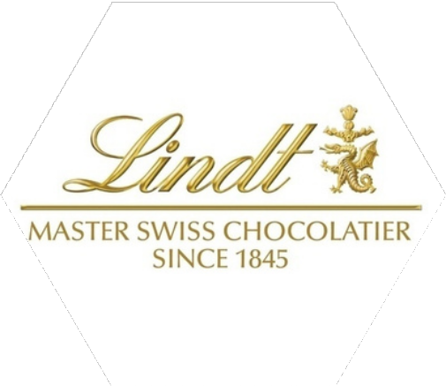
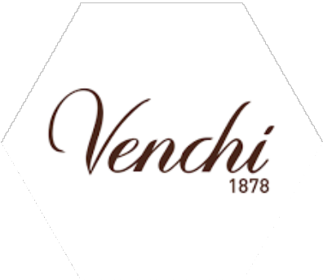


Financial Accounting Group 45

Cross-sectional
Financial Ratio Analysis

2023-2014

Prepared by
Ahmetcenaj Sindi | 151742 | Triki Wassim | 151107
Oz Ummuhan | 153246 | Moges Abel Ermias | 133068

BY AHMETCENAJ SINDI

Table Of Content

- Lindt and the Competitors
- Cross-sectional financial ratio analysis
  - Common-size ratios
  - Liquidity ratios
  - Profitability ratios
  - Solvency ratios
  - Operating performance ratios
  - Efficiency activity ratios
3. General comment

Lindt and the Competitors

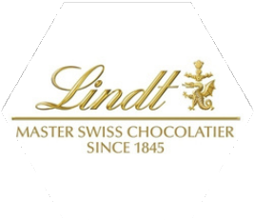
LINDT &SPRÜNGLI
Founded in 1845, Lindt & Sprüngli is a Swiss leader in premium chocolate. Lindt is recognized worldwide for its well-known iconic products, such as Lindor truffles and the Gold Bunny. In more than 120 countries, Lindt unites traditional Swiss craftsmanship with modern innovation. Its "Farming Program" contributes to responsible cocoa sourcing. Headquartered in Kilchberg, Switzerland, Lindt embodies quality and excellence in the international chocolate market.
AHMETCENAJ SINDI

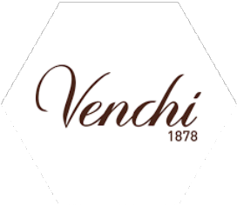
VENCHI
Founded in 1878, Venchi is an iconic Italian chocolatier known for its artisanal chocolates and gelato, including Gianduja bars and chocolate cigars. Present in over 70 countries, Venchi combines traditional Italian craftsmanship with innovation, using natural, high-quality ingredients. Headquartered in Castelletto Stura, Italy, Venchi represents the excellence of Italian confectionery.
OZ UMMUHAN


DOMORI
Domori S.p.A. is based in None, just outside Turin, where the production plant is located.
Since its birth in 1997, Domori has been a true revolution for the world of cocoa: it was the first chocolate company to use only fine cocoa, aiming for high quality.

TRIKI WASSIM


GUIDO GOBINO
Guido Gobino is a renowned Italian artisan chocolate company based in Turin, Italy. Established in 1964, it is celebrated for its high-quality ingredients, innovative techniques, and dedication to traditional Piedmontese chocolate-making. The company is especially famous for its Gianduja chocolates and signature Giandujotto pralines, crafted using local hazelnuts. Guido Gobino emphasizes sustainability, selecting the finest cocoa and supporting fair trade practices. Its exquisite products have gained international recognition, blending tradition with modern

flavors.
MOGES ABEL ERMIAS

Common-size and Liquidity ratios

COMMON SIZE
Net Income Comparison:

Lindt (3.20%): Lindt’s net income margin is substantially higher than the competitors’ average (0.33%). This suggests that Lindt operates with greater overall profitability, possibly due to economies of scale, efficient cost management, or stronger brand positioning in the global market.
  - Competitors (0.33%): The significantly lower net income margin for Guido Gobino, Domori, and Venchi indicates tighter profit margins. This could stem from their focus on artisanal production, higher operational costs, or smaller market reach compared to Lindt.
Gross profit Comparison:
- Lindt (47.98%): Lindt’s gross profit margin is healthy but considerably lower than the competitors’ average (71%). This implies that Lindt might have higher production or raw material costs relative to its revenue, or it operates in a broader price range with more affordable products targeting a wider audience.
  - Competitors (71%): A significantly higher gross profit margin suggests that Guido Gobino, Domori, and Venchi likely focus on premium, high-margin products. Their use of exceptional quality ingredients and artisanal techniques could drive up product pricing, enhancing gross profitability despite lower overall net income.

LIQUIDITY RATIO
Current Ratio:

Lindt (1.46): Indicates that Lindt has $1.46 in current assets for every dollar of current liabilities, suggesting adequate short-term financial health.
Competitors (2.67): A higher ratio implies these companies have a more substantial buffer to cover short-term obligations, potentially indicating a more conservative approach to liquidity management.
Quick Ratio:

Lindt (1.09): Excluding inventory, Lindt maintains $1.09 in liquid assets per dollar of current liabilities, reflecting sufficient immediate liquidity.
Competitors (2.55): A significantly higher quick ratio suggests these firms hold more liquid assets relative to their short-term liabilities, enhancing their ability to meet immediate financial demands.
Cash Ratio:
  - Lindt (0.01): A low cash ratio indicates minimal cash and cash equivalents on hand, which could imply reliance on other current assets or efficient cash utilization strategies.
  - Competitors (0.61): A higher cash ratio denotes a stronger cash position, providing greater flexibility to address short-term liabilities without liquidating other assets.

Profitability ratios
Lindt demonstrates stable gross margins, improving equity returns, and steady sales growth. However, it lags behind competitors in most profitability metrics, particularly operating profit margin, ROI, and ROA. Competitors’ consistent outperformance highlights their stronger operational efficiency, cost management, and investment strategies. Lindt should focus on improving operational profitability and capital

allocation to remain competitive.

Solvency ratios

BY OZ UMMUHAN

Lindt exhibits a conservative financial structure with lower leverage and no visible capitalization, suggesting a preference for equity financing. While competitors rely more heavily on debt, their interest coverage ratio shows better capacity to manage interest obligations. Lindt’s cautious approach reduces financial risk but may limit growth potential compared to competitors leveraging debt for expansion.
BY OZ UMMUHAN

Operating Performance ratios
Fixed Asset Turnover Ratio:
  - Lindt has a relatively stable Fixed Asset Turnover Ratio, averaging 4.10. This would suggest that Lindt efficiently uses its fixed assets to generate sales, though the ratio is lower compared to its competitors.
  - Competitors (Average) are higher in efficiency, averaging 7.29, meaning they generate more revenue per unit of fixed assets compared to Lindt.
- Among competitors, Domori has the highest average, 9.84, followed by Guido Gobino, 6.34, and Venchi, 5.7. This could mean that the company is more capable of exploiting its fixed assets.
Sales Revenues Per Employee:
- Lindt and Sprüngli has an average of $550,804.41 revenue per employee, way higher compared to its competitors, which averaged $143,336.65. It means that Lindt and Sprüngli has a more productive workforce, probably because of automation or higher-value products.
- Venchi and Domori have also done well in this measure but are way behind Lindt
General Observation:
- Lindt is good at workforce productivity (Sales Revenues Per Employee) but lags in Fixed Asset Turnover Ratio
- Competition, like Domori and Guido Gobino, is more asset efficient but not as productive per employee than Lindt.
Based on the above analysis, it seems that Lindt has a strategic opportunity by better utilization of its workforce and efficient use of fixed assets in order to reduce the gap with competitors. Competitors should study and find ways of enhancing

employees' productivity in order to catch up with Lindt in that area.

Efficiency ratios

BY AHMETCENAJ SINDI

Lindt demonstrates consistent efficiency in managing inventory and receivables but lags slightly behind competitors in inventory turnover and receivable collection periods. Competitors’ exceptionally high inventory turnover suggests potential discrepancies in measurement or operational differences. Lindt maintains steady operational efficiency but could improve on inventory management for faster cash

flow conversion.
BY TRIKI WASSIM

General comment

Cross-sectional financial ratio analysis presents sharp contrasts in performance for Lindt and its competition, emphasizing their areas of strength and their shortcoming positions. It would appear that Lindt has strong profitability with a high Net Income Margin, while there is outstanding workforce productivity reflected by its high Sales Revenues Per Employee. These suggest the focus of Lindt on efficiency in operations and the ability of the company to leverage its brand and workforce effectively.
However, in terms of asset utilization, as evidenced by its low Fixed Asset Turnover Ratio, Lindt lags behind, as also does liquidity, wherein the competition has stronger financial buffers. These gaps show chances for the optimization of the use of physical assets by Lindt and an increase in short- term financial flexibility.
Competitors are strong in asset efficiency, as evidenced by the higher Fixed Asset Turnover Ratios and better liquidity positions reflected by their higher Current and Cash Ratios. This is indicative of the focus of competitors on maximizing output from their resources and maintaining conservative liquidity strategies. However, it lags behind Lindt both in profitability and workforce productivity and thus can hardly compete with Lindt in some market segments.
This would also explain the difference in strategic priorities between them, as Lindt focuses on branding and operational productivity, whereas other companies emphasize asset efficiency. Generally, opportunities can be seen in improving some areas of their business- either in asset utilization or liquidity for Lindt, or workforce productivity and enhancement of profitability by its competitors. The case represents a cross-sectional analysis that has a huge scope for potential improvements toward competitiveness in the industry.

