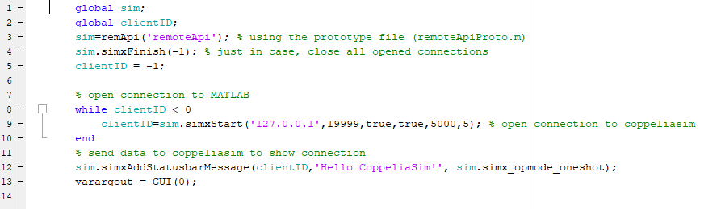

Lines 1 through to 13, is the code to create a connection to CoppeliaSim, this code is part of the remote API library that CoppeliaSim uses to open connections to external programs such as MATLAB. The line 14 is what calls and starts the GUI for robot control.

The following functions were created using the MATLAB guide functionality.

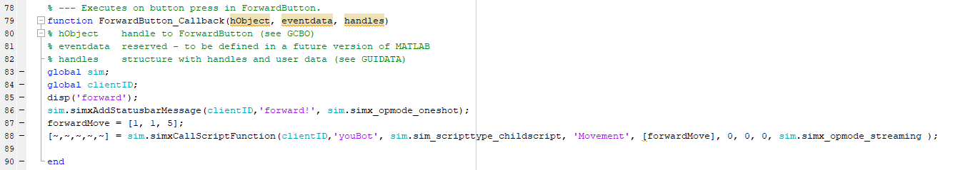

This function communicates to CoppeliaSim the intended direction and then also calls a MATLAB function called Movement and passes in the value forwardMove.

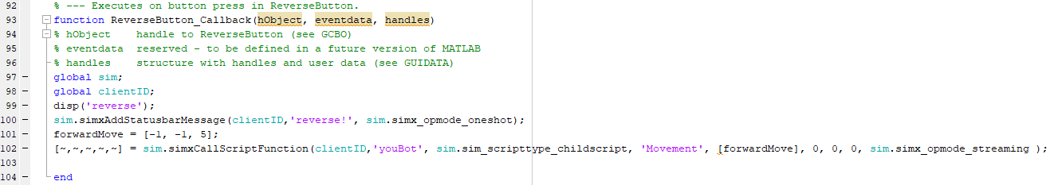

This function communicates to CoppeliaSim the intended direction and then also calls a MATLAB function called Movement and passes in the value forwardMove.

This is the function for the moving forwards and backwards of the youBot. The function accepts an input of direction to travel, pauses the simulation, enacts the change in velocities and then resumes to ensure all changes occur concurrently.

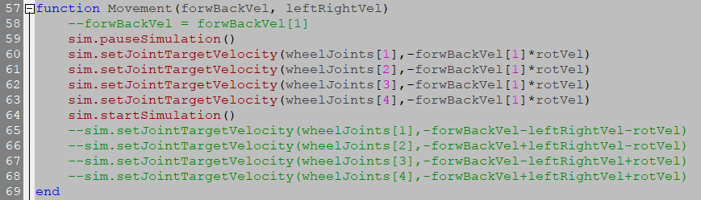

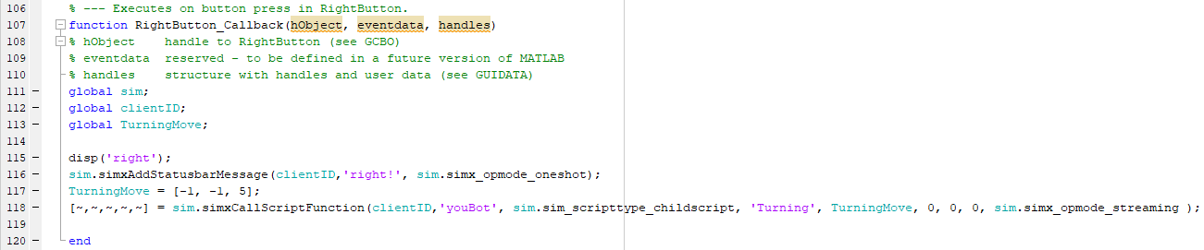

This function communicates to CoppeliaSim the intended direction and then also calls a MATLAB function called Turning and passes in the value TurningMove.

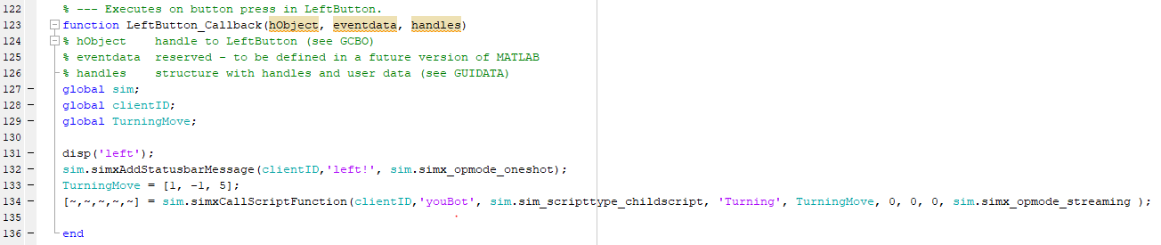

This function communicates to CoppeliaSim the intended direction and then also calls a MATLAB function called Turning and passes in the value TurningMove.

This is the function that is called when the youBot needs to move left and right. The function accepts the parameter of which direction it needs to move, pauses the simulation and changes all the wheel velocities before starting the simulation again to ensure the robot moves in the new direction as soon as the simulation resumes.

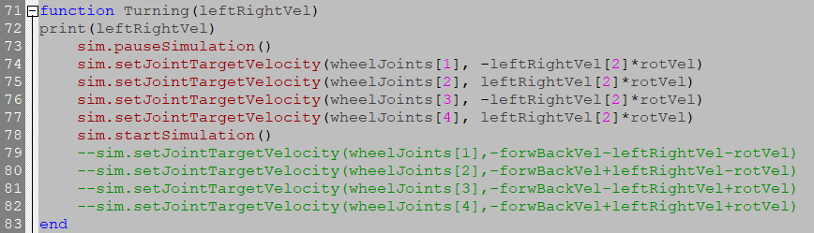

There are then several callbacks for the joint sliders.

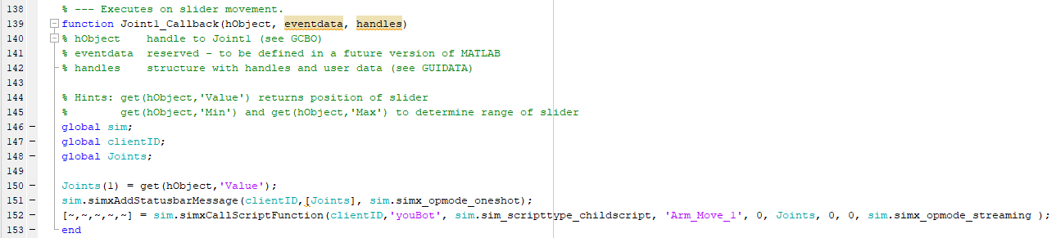

These read the value associated with the slider and send the value as a parameter to the called function in coppeliasim. This how it works for each joint angle.

The Coppeliasim functions called by the Joint slider callbacks are as follows

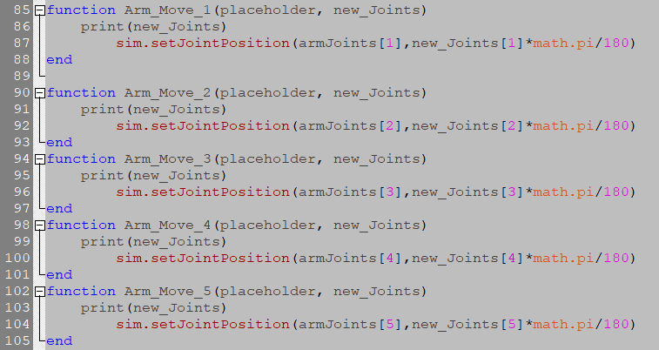

Each one accepts 2 parameters, one is a placeholder that is an irrelevant value, this is due to the way the remoteAPI works and the other is a table of joint values that are to be used to set the arm position. The print functions are to check that the numbers are being sent to CoppeliaSim properly.

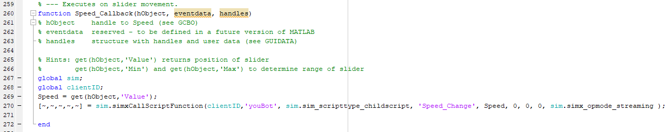

This is the callback from the speed slider. This works similarly to the joint sliders in the way that it reads the value associated with the position of the slider and passes the value as a parameter the key difference is that it calls a different function.

This is the function that changes the speed of the robot’s movement, not including the arm. A new speed value is passed in as a parameter and a global value is then changed for use across the rest of the program.

