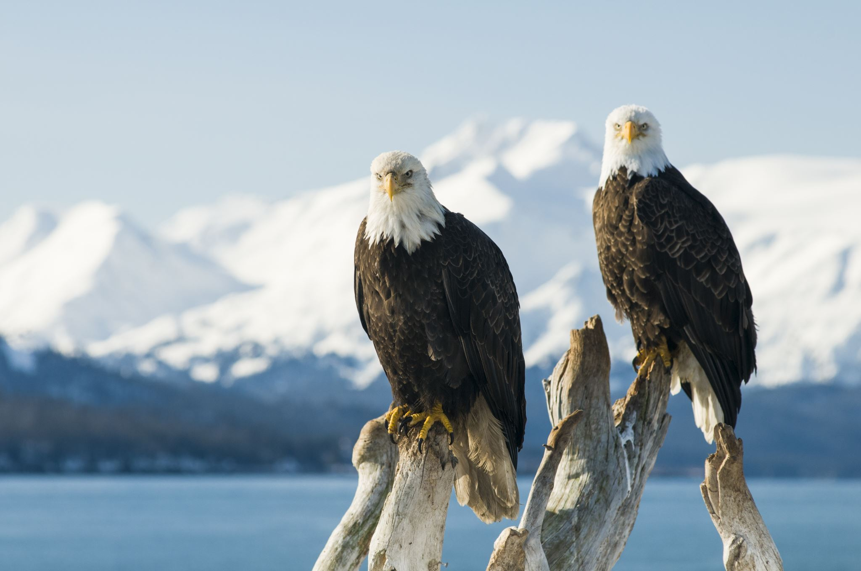

# EAGLES AND MOUNTAINS