CS_08

## Data Import and Plotting

# 加载所需库  
library(readr)  
library(ggplot2)  
library(knitr)  
library(kableExtra)  
  
# 下载并读取数据  
url <- "ftp://aftp.cmdl.noaa.gov/products/trends/co2/co2_annmean_mlo.txt"  
data <- read_table(url, skip = 57, col_names = c("year", "mean", "uncertainty"))

── Column specification ────────────────────────────────────────────────────────  
cols(  
 year = col_double(),  
 mean = col_double(),  
 uncertainty = col_double()  
)

# 绘制 CO2 随时间变化的折线图  
plot <- ggplot(data, aes(x = year, y = mean)) +  
 geom_line(color = "blue") +  
 labs(title = "Mauna Loa CO2 Annual Mean Levels",  
 x = "Year",  
 y = "Mean CO2 (ppm)") +  
 theme_minimal()  
print(plot)

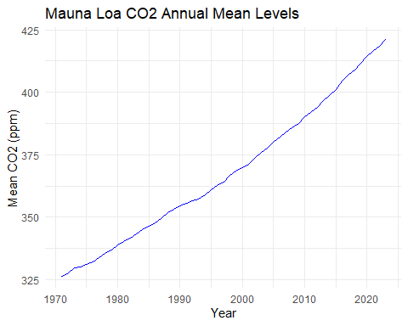

## Summary Table

# 生成表格并使用 kableExtra 美化  
summary_table <- data %>%  
 tail(5) %>%  
 kable() %>%  
 kable_styling(bootstrap_options = c("striped", "hover"), full_width = F)  
  
# 保存表格为 HTML  
save_kable(summary_table, file = "summary_table.html")  
  
# 使用 webshot2 将 HTML 文件保存为 PNG  
webshot2::webshot("summary_table.html", file = "table.png", zoom = 2)

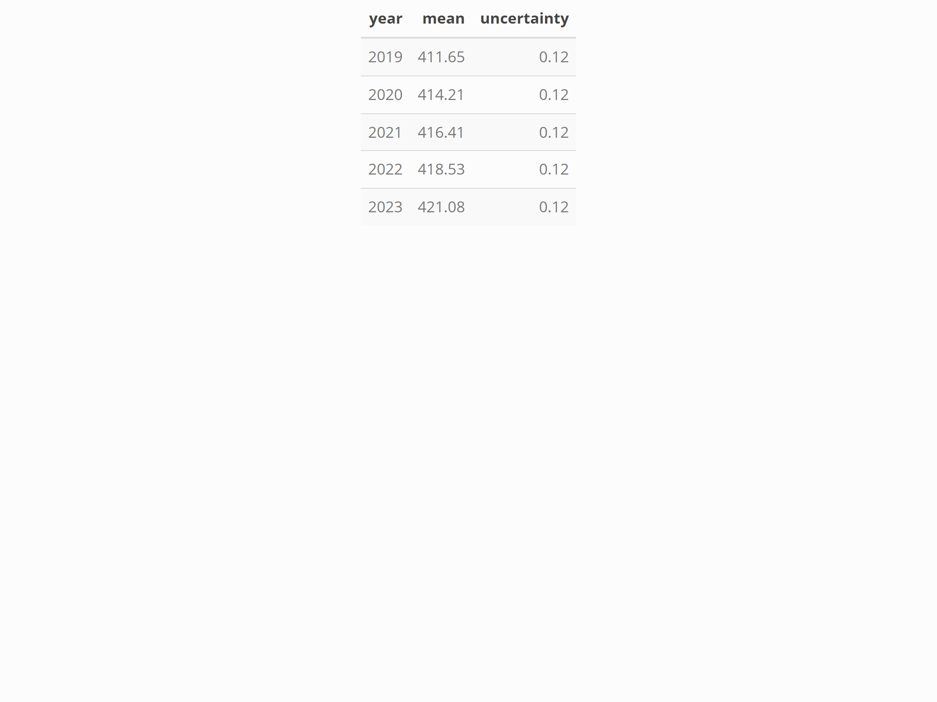

## Hidden Calculations Example