**A comparison between ml and dl model on Surgery based mortality prediction**

**Problem Statement :**

In the healthcare industry, there is a pressing need to accurately predict the survival outcomes of surgical procedures. To address this, a project has been initiated to create a machine learning (ML) and deep learning (DL) model that can effectively determine the likelihood of a patient surviving a surgery. The primary goal of this study is to compare the performance of both models and determine which one yields superior overall results.

To conduct this research, a comprehensive dataset comprising approximately 90,000 surgical cases from various hospitals has been acquired. This dataset encompasses a wide range of patient-specific information collected prior to the surgery, along with the corresponding outcomes indicating whether the patients survived the procedures or not. To ensure a robust evaluation of the models, the dataset will be divided into two distinct groups for training and assessment purposes.

**Background Information :**

Predicting surgical survival plays a vital role in the field of surgical and patient care, offering valuable insights for healthcare decision-making and improving patient outcomes. The process involves assessing the potential risks and outcomes associated with a surgical procedure, taking into account various factors such as patient characteristics, pre-existing medical conditions, surgical complexity, and overall health status. This prediction serves as a crucial component of surgical risk assessment, assisting medical professionals in identifying patients who may be at higher risk of complications leading to mortality.

One of the significant benefits of predicting surgical survival is its contribution to patient sorting. Accurately assessing the likelihood of survival allows healthcare practitioners to categorize patients based on their risk profiles. This sorting enables the allocation of appropriate resources, implementation of preventive measures, and the development of tailored treatment plans, ultimately optimizing patient outcomes.

Moreover, the prediction of surgical survival aids in surgical decision-making processes. Surgeons and healthcare teams can utilize this information to evaluate the necessity and feasibility of surgical interventions. By weighing the potential benefits against the associated risks, informed decisions can be made regarding the course of action.

The significance of predicting surgical survival also extends to perioperative planning. This involves comprehensive preparation before, during, and after the surgery, including decision-making regarding patient care and monitoring. By accurately predicting surgical survival, healthcare teams can devise strategies to minimize risks, optimize patient recovery, and enhance overall surgical outcomes.

In addition, the use of predictive models for surgical survival contributes to quality improvement initiatives within healthcare systems. Analyzing surgical outcomes allows for the identification of areas for improvement, implementation of evidence-based practices, and the development of protocols to enhance patient safety and reduce surgical complications. Predictive models serve as valuable tools for evaluating and monitoring the effectiveness of these initiatives, leading to better patient care and improved surgical outcomes over time.

Furthermore, the prediction of surgical survival is an active area of research and innovation in healthcare. Ongoing studies aim to identify novel predictive factors, refine existing models, and explore the integration of advanced technologies such as artificial intelligence (AI) and machine learning. The ultimate goal is to develop more accurate and reliable predictive models that assist healthcare providers in improving patient outcomes, advancing surgical techniques, and enhancing overall surgical care.

It is crucial to note that while predictive models offer valuable insights, they should always be used as decision support tools in conjunction with clinical expertise and judgment. The interpretation and application of predicted surgical survival should be done collaboratively with healthcare professionals, taking into account the unique characteristics and circumstances of individual patients.

**Problem Description:** The problem at hand is to develop a predictive model that can determine whether a person would survive a surgical procedure or not. Given a dataset containing information about patients who have undergone surgeries, the objective is to build a binary classification model that takes into account patient and surgical characteristics to predict the likelihood of survival. The model should be able to accurately classify patients into survival or non-survival categories based on a comprehensive set of features.

**Data Analysis:**

A comprehensive analysis of the dataset is vital to tackle the challenge of predicting surgical survival accurately. Several key steps are involved in this analysis:

Data Exploration: Thoroughly examine the dataset to understand the distribution of features, detect any missing values, and evaluate the overall data quality. Utilize descriptive statistics and visualizations to gain insights into the characteristics of patients who have undergone surgeries.

Feature Selection and Engineering: Apply techniques for feature selection to identify the most relevant and informative features that contribute significantly to predicting surgical survival. Collaborate with domain experts and medical professionals to determine the significance of specific features. Additionally, consider creating new features that capture essential patterns or interactions between variables.

Data Preprocessing: Preprocess the data by handling missing values appropriately, normalizing or standardizing numerical features, and encoding categorical variables. Address outliers and apply necessary data transformations to ensure data quality and suitability for modeling.

Model Selection and Evaluation: Explore various machine learning algorithms, including logistic regression, decision trees, random forests, support vector machines, or deep learning models. Train and evaluate these models using appropriate evaluation metrics such as accuracy, precision, recall, F1-score, and area under the ROC curve (AUC-ROC). Utilize cross-validation techniques to assess model generalization.

Model Interpretation: Analyze the predictive model to understand the impact of different features on the prediction of surgical survival. Use interpretability techniques such as feature importance, partial dependence plots, or SHAP values to gain insights into the decision-making process of the model.

**Applications :**

The prediction of surgical survival has diverse applications in healthcare settings. Here are several key applications:

Preoperative Risk Assessment: Accurately predicting surgical survival aids healthcare professionals in evaluating the potential risks and complications specific to an individual patient's surgical procedure. It helps determine the patient's overall health status, assess comorbidities, and anticipate any potential risks during surgery.

Treatment Planning and Decision-making: Precise predictions of surgical survival provide critical information for surgeons and healthcare teams when making decisions about the necessity and feasibility of surgical interventions. This facilitates shared decision-making with patients, enabling them to comprehend the potential outcomes and risks associated with the surgery, and helps in selecting appropriate treatment options.

Resource Allocation: Predictive models for surgical survival assist in optimizing resource allocation within healthcare systems. By identifying patients at a higher risk of surgical mortality, healthcare providers can allocate appropriate resources, such as specialized care units, monitoring equipment, and skilled personnel, to ensure optimal patient safety and outcomes.

Surgical Outcome Monitoring: The prediction of surgical survival enables healthcare organizations to monitor and evaluate the outcomes of surgical procedures. By comparing predicted survival rates with actual outcomes, healthcare providers can identify areas for improvement, implement quality improvement initiatives, and enhance surgical protocols to minimize complications and improve overall patient care.

Patient Counseling and Education: Accurate predictions of surgical survival facilitate informed patient counseling and education. Surgeons can utilize the predicted risk of surgical mortality to discuss potential outcomes, risks, and benefits with patients and their families. This information empowers patients to make well-informed decisions about their surgical treatment options.

Clinical Research and Trials: Predictive models for surgical survival have valuable applications in clinical research and trials. They assist in patient selection for research studies, enabling the inclusion of more homogeneous cohorts and improving study design. Additionally, predictive models can evaluate the effectiveness and safety of new surgical techniques or interventions by predicting their impact on surgical survival rates.

Quality Assurance and Benchmarking: Predictive models support quality assurance initiatives within healthcare organizations. They facilitate the monitoring of surgical outcomes, comparison of performance across different surgical units or hospitals, and establishment of benchmarks. This information drives quality improvement initiatives, identifies best practices, and ensures that surgical care meets or exceeds established standards.

Surgical Training and Education: Predicting surgical survival can be incorporated into surgical training and education programs to provide real-time feedback and guidance to surgical trainees. Integration of predictive models into surgical simulators or virtual reality platforms allows trainees to practice surgical procedures while receiving feedback on potential risks and complications, thus enhancing their learning experience.

These applications highlight the significance of predicting surgical survival in improving patient care, clinical decision-making, resource utilization, and quality assurance in surgical settings.

**Motivation for selection of project :**

The project of predicting surgical survival presents numerous compelling reasons for selection:

Enhanced Patient Safety and Outcome Improvement: Ensuring patient safety and improving surgical outcomes are critical objectives. Developing an accurate predictive model for surgical survival enables healthcare providers to identify high-risk patients and implement strategies to minimize complications, optimize surgical outcomes, and improve overall patient care.

Clinical Decision Support: Predictive models serve as valuable decision support tools for surgeons and healthcare teams. They provide objective and evidence-based information on the likelihood of surgical survival, enabling informed treatment planning, shared decision-making with patients, and optimization of surgical interventions based on individual patient characteristics and risks.

Quality Improvement Initiatives: Accurate prediction of surgical survival contributes to quality improvement initiatives within healthcare systems. By analyzing surgical outcomes, identifying factors influencing survival rates, and evaluating interventions, healthcare organizations can implement evidence-based practices, develop protocols, and monitor performance to enhance patient safety, minimize complications, and improve the overall quality of surgical care.

Resource Optimization: Predicting surgical survival assists in optimizing healthcare resources such as specialized care units, monitoring equipment, and skilled personnel. By identifying patients at higher risk of surgical mortality, healthcare providers can allocate resources efficiently, ensuring that the appropriate level of care is provided to each patient.

Personalized Medicine: Predictive models for surgical survival enable personalized medicine by considering individual patient characteristics, preoperative conditions, and surgical complexity. This allows for tailored treatment plans, optimized surgical approaches, and the implementation of interventions specific to each patient's needs, ultimately improving patient outcomes and satisfaction.

Technological Advancements and Data Analysis: With the availability of large and diverse healthcare datasets, along with advancements in machine learning and data analysis techniques, developing accurate predictive models for surgical survival becomes more feasible. Leveraging these technologies can lead to novel insights, improved model performance, and enhanced decision-making capabilities in surgical care.

Research and Innovation: Predicting surgical survival is an active area of research and innovation within the healthcare field. Engaging in this project allows researchers to contribute to the advancement of knowledge, identify novel predictive factors, refine existing models, and explore the integration of advanced technologies such as artificial intelligence and machine learning into surgical care.

In summary, the project of predicting surgical survival offers compelling reasons for selection, including enhanced patient safety, clinical decision support, quality improvement, resource optimization, personalized medicine, advancements in technology and data analysis, and opportunities for research and innovation.

**Dataset Description :**

**Source :** Mitisha Agarwal. (2021). <i>Patient Survival Prediction</i> [Data set]. Kaggle. https://doi.org/10.34740/KAGGLE/DSV/2972359

The project will leverage a large and diverse dataset comprising patient records that include information about individuals who have undergone various types of surgical procedures. The dataset will encompass an extensive set of features, including but not limited to the following:

Patient Demographics: Age, gender, race, ethnicity, and other relevant demographic information.

Pre-operative Conditions: Existing medical conditions such as cardiovascular diseases, respiratory diseases, diabetes, renal diseases, and other chronic conditions. Additional data might include vital signs such as blood pressure, heart rate, respiratory rate, and body temperature.

Laboratory Results: Pre-operative blood tests, including levels of hemoglobin, white blood cell count, platelet count, liver function tests, kidney function tests, and other relevant biomarkers.

Imaging Data: Radiological images such as X-rays, computed tomography (CT) scans, magnetic resonance imaging (MRI), or ultrasound images, providing insights into anatomical abnormalities or disease severity.

Surgical Details: Type of surgery (e.g., cardiac surgery, abdominal surgery, orthopedic surgery, etc.), surgical approach (open surgery, minimally invasive surgery), surgical complexity, duration of the procedure, and any documented intraoperative complications.

Medical History: Previous surgeries, medical interventions, medications, allergies, and known adverse reactions to anesthesia or specific medications.

**Current Benchmarks :**

**Proposed Plan :**

To address this complex problem, the following steps will be undertaken:

**Data Preprocessing:** The dataset will undergo comprehensive preprocessing steps, including cleaning, handling missing values, and standardization. Feature engineering techniques may be applied to extract meaningful information, such as creating new features from existing ones or aggregating data over specific time intervals.

**Feature Selection and Dimensionality Reduction:** Statistical techniques, domain knowledge, and feature importance analysis will be employed to select the most informative features that contribute significantly to predicting surgical survival. Dimensionality reduction techniques like principal component analysis (PCA) or feature embedding methods might be applied to handle high-dimensional data.

**Model Selection and Training:** A variety of machine learning algorithms will be explored and evaluated, including logistic regression, decision trees, random forests, gradient boosting methods (e.g., XGBoost, LightGBM), support vector machines (SVM), or deep learning models (e.g., neural networks). The dataset will be divided into training, validation, and testing sets for model training and evaluation. Hyperparameter tuning and model optimization will be performed to enhance performance.

**Model Evaluation and Validation:** The developed model's performance will be assessed using various evaluation metrics such as accuracy, precision, recall, F1-score, area under the ROC curve (AUC-ROC), and calibration curves. Cross-validation techniques (e.g., k-fold cross-validation) will be employed to evaluate the model's generalization capabilities and mitigate overfitting. External validation on an independent dataset, if available, will further validate the model's performance.

**Ethical Considerations and Privacy:** As this project involves sensitive medical data, strict adherence to ethical guidelines and privacy regulations is essential. Anonymization techniques will be employed to protect.

**Preliminary Exploratory Data Analysis :**

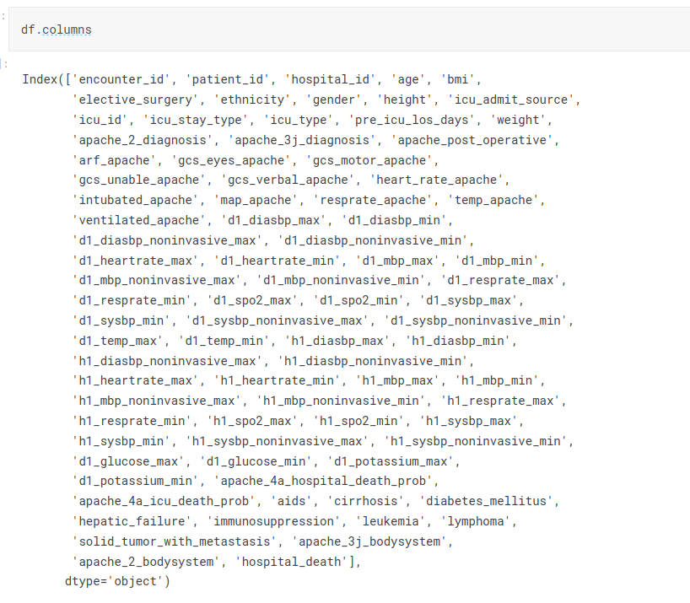

These are all the columns that are present in the dataset

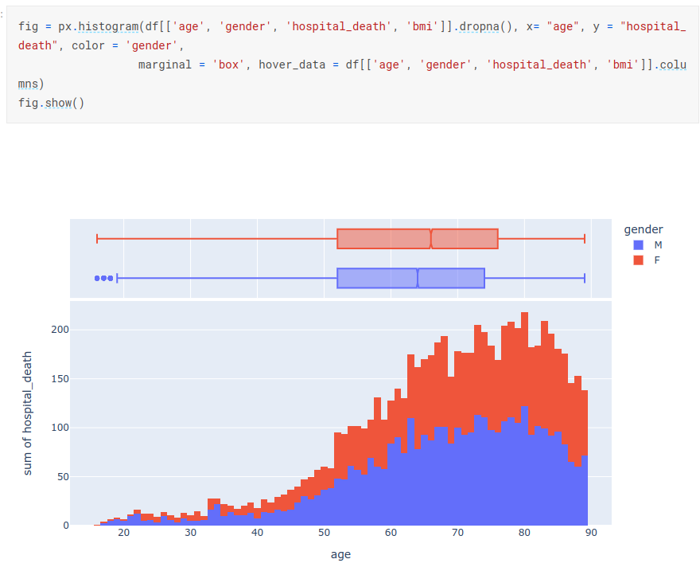

We can see that rate of death in females is much higher than that of males.

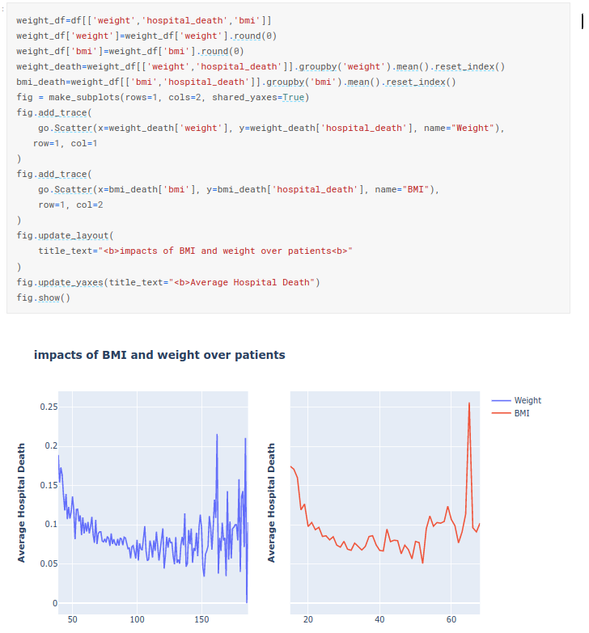

**Expected Outcomes :**

**Accurate Risk Assessment:** One of the primary expected outcomes is the development of predictive models that can accurately assess the risk associated with surgical interventions. These models should consider a comprehensive set of patient and surgical characteristics to provide reliable predictions of surgical survival. The expected outcome is a model with high accuracy, precision, recall, and AUC-ROC scores, allowing healthcare providers to effectively stratify patients based on their risk profiles.

**Improved Clinical Decision-making:** The prediction of surgical survival aims to enhance clinical decision-making by providing healthcare professionals with valuable information about the likelihood of survival for individual patients. The expected outcome is to empower surgeons and healthcare teams to make informed decisions, tailor treatment plans, and engage in shared decision-making with patients and their families, leading to improved patient care and outcomes.

**Enhanced Patient Safety:** Accurate prediction of surgical survival contributes to enhancing patient safety by identifying high-risk patients who may require additional monitoring, specialized care, or interventions. The expected outcome is the implementation of preventive measures and risk mitigation strategies that can minimize complications, optimize patient safety, and ultimately improve surgical outcomes.

**Resource Optimization:** Predictive models for surgical survival can aid in optimizing healthcare resources by identifying patients who are at a higher risk of surgical mortality. The expected outcome is the efficient allocation of resources, including specialized care units, equipment, and personnel, to ensure that the right level of care is provided to patients based on their predicted surgical survival.

**Quality Improvement:** Predicting surgical survival supports quality improvement initiatives within healthcare systems. The expected outcome is the identification of factors influencing surgical outcomes, the implementation of evidence-based practices, and the development of protocols to enhance patient safety and minimize complications. The models can serve as tools for monitoring and evaluating the effectiveness of these initiatives and driving continuous improvement in surgical care.

**Research Contributions:** The project on predicting surgical survival can contribute to the body of knowledge in healthcare research. The expected outcome is to provide valuable insights into the predictive factors, relationships, and patterns associated with surgical survival. This can lead to advancements in the field, identification of novel predictors, and further research in refining and expanding predictive models.

**Ethical Considerations and Fairness:** An important expected outcome is the integration of ethical considerations and fairness into the predictive models. Ensuring fairness in model predictions, addressing biases, and protecting patient privacy are crucial outcomes to be achieved. The models should strive for transparency, accountability, and ethical use of patient data to build trust and confidence in the healthcare system.

Overall, the expected outcomes for the topic of predicting surgical survival include accurate risk assessment, improved clinical decision-making, enhanced patient safety, optimized resource allocation, quality improvement in surgical care, research contributions, and adherence to ethical considerations. These outcomes collectively aim to improve patient outcomes, enhance healthcare decision-making, and drive continuous improvement in surgical care practices.

**Project Demonstration Stratergy :**