CSC 134 Fall 2018
Homework 4
Total: 100 points

This homework allows students to practice the development of a database using MySQL.

Section 1
Using SQL, create tables according to the given schema shown in Figure 1. The ER diagram is shown in Figure 2.

Doctor (dssn, dname, specialty)

Prescription( dssn, pre_no, pdate) foreign key (dssn) references to doctor(dssn)

Ph_company( pname, phone)

Drug (pname, trade_name, formula) foreign key (pname) references to Ph_company(pname)

Consist_of ( dssn, pre_no, pname, trade_name) foreign key (dssn, pre_no) references prescription(dssn, pre_no), foreign key (pname, trade_name) references drug(panme, trade_name)

Pharmacy (name, address, phone)

Sell (pharmacy_name, pname, trade_name, price) foreign key (pname, trade_name) references drug (pname, trade_name), foreign key (pharmacy_name) references pharmacy(name)

Figure 1 Schema

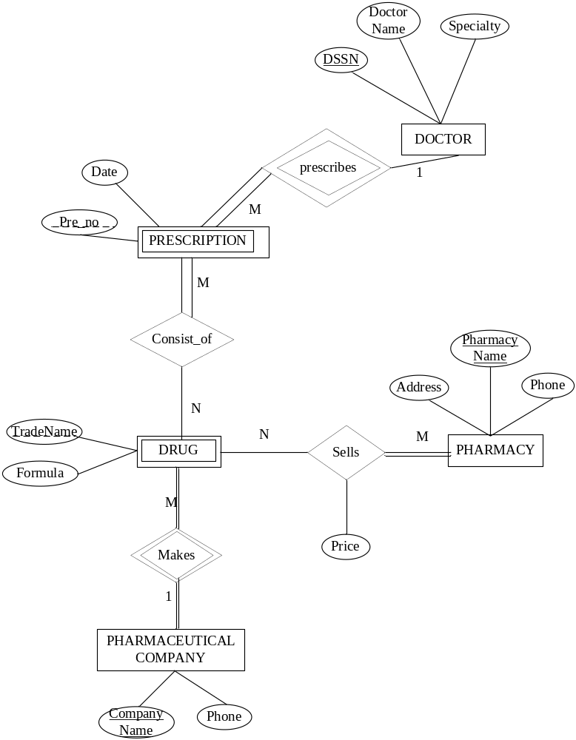
Figure 2 ER Diagram

Section 2
(1)Populate the database. Insert at least two tuples to the “Sell” table. For each of the other tables, insert at least one tuple.
(2) Execute one delete statement to the “Sell” table.
(3) Execute one update statement to the “Drug” table by changing the value of “formula”.

Section 3
Specify the statements to drop all the tables. Pay attention to the order of the drop statements in order to drop everything successfully.

Submission

Submit the following files to SacCT. Note: Submit through any other ways, such as email attachment, will not be graded. Do not zip them.
- Create table statements (file name must be: 1_create_table.txt)
- Insert statements to populate database, also include one update statement and one delete statement as required by Section 2 (file name must be : 2_populate_db.txt)
- Drop tables statements (file name must be: 3_drop.txt)

