FORENSIC EMAIL ANALYSIS REPORT
Authenticated phishing message sent as Dr. Tammy L. Murray
Worcester Public Schools
Analysis of original RFC 822 / EML evidence
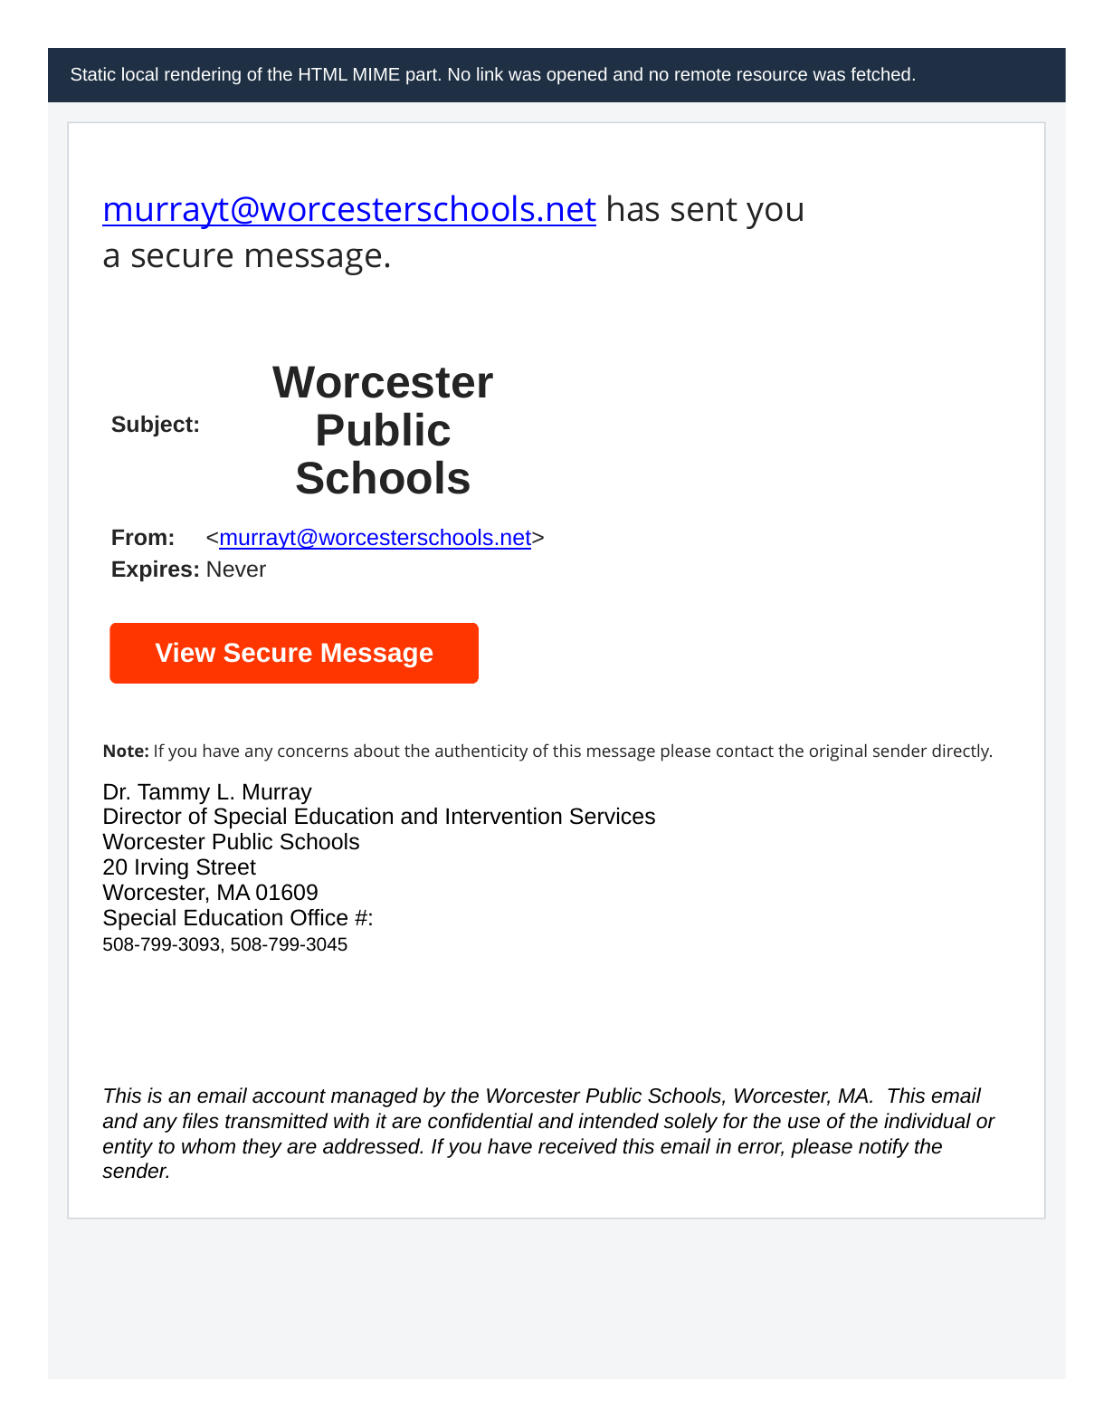
Static local rendering of the HTML MIME part. No hyperlink was followed.
Prepared for Parent Data Force
Preliminary external forensic analysis - not a substitute for Worcester internal logs or a legal opinion
Report date: July 30, 2026

1. Plain-English Explanation: What This Means
This email was not merely made to look like it came from Worcester Public Schools. The recipient’s Gmail system recorded that it passed Worcester Public Schools’ SPF, DKIM, and DMARC authentication checks. Most importantly, an independent recalculation of the DKIM body hash produced an exact match to the hash embedded in the Worcester-domain DKIM signature. That means the phishing body - including the Netlify link - was already present when the message was signed through a system authorized to send email for worcesterschools.net.
Bottom line
The evidence supports an authenticated abuse of a Worcester-authorized email-sending path. It is materially more serious than ordinary outside spoofing. It does not, by itself, identify the person who sent the message or prove that every Worcester Google Workspace service was compromised.

In everyday terms, the district must determine how someone was able to send a phishing email that Gmail treated as legitimate Worcester mail. Possible mechanisms include a stolen password, an active stolen session, a malicious or abused OAuth token, delegated mailbox access, an unauthorized “send as” configuration, an approved SMTP or API pathway, an insider, or another district-authorized sending mechanism. The original EML cannot choose among those possibilities; Worcester’s internal logs can.

1.1 Why this matters immediately
- Because the message authenticated as Worcester mail, ordinary anti-spoofing controls did not reject it. SPF, DKIM, and DMARC authenticate sending authorization and alignment; they do not guarantee that the human sender is trustworthy or that an authorized account has not been hijacked.
- The message directly blind-copied a parent address. The source of that address is unknown. It could have come from prior email, contacts, a group, a spreadsheet, a school information system, a special-education system, ParentSquare, or an external source.
- If the sending mechanism involved an active account session or broad OAuth access, the risk may extend beyond sending mail to reading messages, reviewing attachments, harvesting contacts, altering forwarding rules, or accessing other Google Workspace services within the account’s permissions.
- The EML does not establish that the whole Worcester domain or all Google Workspace services were compromised. It does establish that at least one district-authorized mail path was used to send a credential- or identity-harvesting lure.
- Until Worcester identifies the sending mechanism, revokes persistence, traces all recipients, and reviews related account and Workspace activity, the scope and current containment status remain unresolved.

1.2 Consequences and implications
Area | What may be exposed | Current evidence | Assessment
Family safety | Credentials, identity data, contact information, or documents entered at the phishing site | The email directs recipients to an external Netlify site reportedly requesting sensitive information. The site itself was not accessed during this examination. | Elevated
Gmail account | Mailbox contents, sent mail, drafts, attachments, contacts, filters, forwarding, delegated access | Authenticated sending is confirmed; read access is not established and depends on the method used. | Potential
Recipient lists | Family and staff email addresses, groups, exported contact data | One parent address is confirmed as a direct Bcc recipient; the source and total list are unknown. | Elevated
Google Drive | Files accessible to the account, including shared documents and attachments saved in Drive | Possible only if the compromise had Drive-capable access or the user session had ordinary Workspace access. No Drive access is proven. | Unknown
Calendar / Contacts / Groups | Events, contact data, memberships, distribution lists | Possible depending on account permissions and token scopes. No access is proven. | Unknown
Admin console | Domain-wide settings, user accounts, security controls | Only possible if the affected identity had administrative privileges or a separate admin identity was compromised. No such evidence appears in the EML. | Not established
Regulatory / privacy review | Assessment of personal information and education-record exposure, notification, preservation, and disclosure obligations | The EML supports a serious incident assessment but does not prove that protected records were acquired. | Potential

2. Executive Findings
Confidence | Finding
Confirmed | The supplied EML is 14,356 bytes and has SHA-256 4ee90ccb567ae2fedd22eb87b726c51e940f9ba6556e3500bb1bb7019d4f15b9.
Confirmed | The visible From address and Return-Path are murrayt@worcesterschools.net.
Confirmed | The message was delivered through Google mail infrastructure from 209.85.220.41.
Confirmed | Gmail recorded SPF=pass, DKIM=pass for worcesterschools.net, and DMARC=pass.
Confirmed | The DKIM signature uses d=worcesterschools.net, selector s=google, and relaxed/relaxed canonicalization.
Confirmed | The independently recomputed relaxed DKIM body hash exactly matches the bh= value in the Worcester-domain DKIM signature.
Confirmed | The signed MIME body contains the phishing destination https://murraytammy.netlify.app/.
Confirmed | The original recipient copy lists bgleason2109@gmail.com in Bcc and “undisclosed-recipients” in To.
Confirmed | The message is multipart/alternative with text/plain and text/html parts and no attachment.
Strongly supported | The message was created or transmitted through Gmail / Google Workspace or an authenticated Google-connected sending mechanism.
Strongly supported | The sender used or modified a secure-message template; the actual link points to Netlify while the HTML title metadata contains a long MailAnyOne redirect URL.
Unresolved | The identity of the sender, the access mechanism, the full recipient count, the address source, the current persistence status, and any access to mail, Drive, contacts, student data, or other systems.

2.1 Security-status conclusion
Current status cannot be called safely contained from this evidence alone
The EML proves successful authenticated delivery. It does not show whether the relevant account, token, session, delegation, relay, or API access was disabled. A conclusion that the event was merely “spam” or has been fully resolved requires supporting identity, Gmail, OAuth, device, rules, Drive, and incident-response records.

3. Evidence Received and Integrity
Evidence file | Worcester Public Schools.eml
File type | RFC 822 / EML email message
File size | 14,356 bytes
MD5 | 513ea64a8c3e0fd52d56fca8a7b413ee
SHA-1 | 8ca0ed23aeb65df6b6d3a58de7b0b1aeafcc52de
SHA-256 | 4ee90ccb567ae2fedd22eb87b726c51e940f9ba6556e3500bb1bb7019d4f15b9
SHA-512 | 3c43bfc05c1af6d2f7e7b3bddeeac4787243e389d500fed894889b244ca63b3c3a133a8910147e631bb686572301a4e97a8f36a51e57a071c11d775f3dbf08a8

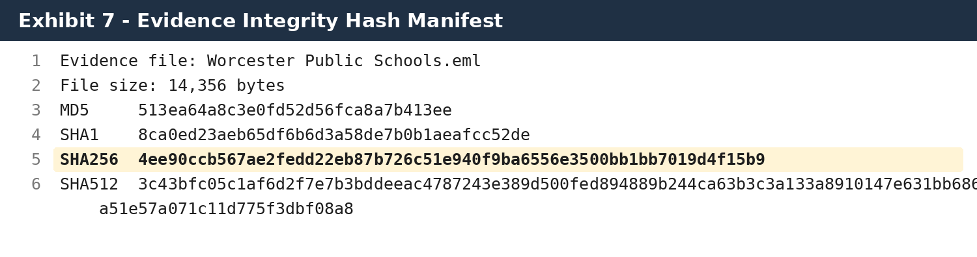
Exhibit 7. Hash manifest calculated from the supplied raw EML.

3.1 Comparison evidence
Three known-good messages from the same Worcester Public Schools mailbox were examined as control samples: two automatic replies sent July 21 and July 27, 2026, and one manually authored reply sent June 5, 2026. The comparison was limited to messages available in the connected Gmail mailbox. The sample is useful for identifying recurring account and Google Workspace artifacts, but it is not a complete export of Dr. Murray’s mailbox or Worcester’s server logs.
Control A - automatic reply | Date: Mon, 27 Jul 2026 12:40:26 -0700 | Message-ID: <CADiU6eQ0twTD_jvcPZkR0eXTkitO8U+65wuingLtzfBRN4cCkA@mail.gmail.com>
Control B - automatic reply | Date: Tue, 21 Jul 2026 09:28:21 -0700 | Message-ID: <CADiU6eQ77PeJ653mNiQaB6j25bzcHDNB_vf1O7LdEdSZRJQ9ZA@mail.gmail.com>
Control C - manual reply | Date: Fri, 5 Jun 2026 16:55:00 -0400 | Message-ID: <CADiU6eSQkp1KYVLdnBZFi4t0NO=NopNhgmY6xzWz8LYuiBEF-Q@mail.gmail.com>

4. Methodology
The examination was performed as a non-destructive static analysis. The suspicious URL was not opened, the Netlify site was not queried, no attachment was executed, and no remote resource was intentionally fetched. The supplied EML was read in binary form and preserved unchanged for hashing.

4.1 Steps performed
- Read the EML as raw bytes and recorded byte size plus MD5, SHA-1, SHA-256, and SHA-512 digests for integrity and future deduplication.
- Parsed the message using Python’s standards-based email parser under the default modern policy to identify RFC 5322 headers, MIME structure, transfer encodings, and decoded text/plain and text/html parts.
- Extracted the Received chain, Return-Path, Authentication-Results, ARC results, DKIM-Signature, From, Date, Message-ID, Subject, To, Bcc, MIME-Version, and Content-Type fields.
- Decoded quoted-printable MIME bodies without changing the original EML and calculated separate SHA-256 hashes for the decoded plain-text and HTML parts.
- Extracted URLs and compared the visible button destination with the anchor title metadata. No reputation or attribution conclusion was drawn from the site name alone.
- Recomputed the DKIM body hash under the “relaxed” body canonicalization specified by RFC 6376: normalize to CRLF, remove trailing horizontal whitespace, compress internal whitespace sequences, remove trailing empty lines, append the final CRLF, calculate SHA-256, and Base64-encode the result.
- Compared the computed Base64 body hash against the bh= value in the Worcester-domain DKIM-Signature.
- Converted relevant timestamps to Coordinated Universal Time and Worcester local time while preserving each original Date and Received offset. No physical-location conclusion was drawn from a timezone offset.
- Compared the suspicious message with the three available known-good messages from the same mailbox, examining Date offsets, Message-ID form, Return-Path, Google sending host, SPF/DKIM/DMARC results, MIME type, auto-reply markers, and signature/footer artifacts.
- Compared the technical findings against current official Google Workspace, Netlify, IETF, Massachusetts, and U.S. Department of Education documentation listed in the Sources section.
- Created static screenshot-style exhibits from exact header and MIME values and a local rendering of the HTML part. The rendering did not navigate to the link.

4.2 Validation limits
- The full DKIM cryptographic signature was not independently revalidated against a separately preserved DNS public key. Instead, this report relies on the receiving Gmail Authentication-Results showing DKIM=pass, the preserved ARC authentication results, and an independent exact match of the signed body hash.
- The examination has no direct access to Worcester Public Schools’ Google Admin console, endpoint logs, Google Vault, security investigation tool, OAuth logs, user sign-in logs, Drive logs, Contacts logs, Groups logs, or third-party gateway telemetry.
- The linked Netlify site was not accessed. Therefore, this report does not independently document the fields requested by the website, site contents, deployment history, operator, access logs, or collected submissions.
- The EML proves direct delivery to the identified Bcc recipient but does not reveal all Bcc recipients or the campaign’s total distribution.
- The three control messages are a small convenience sample from the connected Gmail mailbox. They are sufficient to test whether specific header patterns recur, but not to establish every normal configuration or sending method used by the account.
- Technical authentication proves use of an authorized domain-sending path; it does not identify the human actor or establish that Dr. Murray personally sent the message.

4.3 Reproducibility and classification rules
Each major conclusion was classified according to the Appendix B confidence framework. A fact was marked Confirmed only when it was directly present in the preserved EML, reproduced by a deterministic calculation, or present verbatim in a control message. Strongly supported findings require multiple consistent artifacts but still depend on Worcester’s internal logs for mechanism or attribution. Potential consequences are described conditionally and are not treated as proven access.
The screenshots in this report are evidentiary facsimiles produced from verbatim raw-header or decoded MIME text. They are not photographs of Worcester’s Admin console. The locally rendered message body was generated from the HTML MIME part with external navigation disabled; it was not produced by visiting the Netlify site.

5. Technical Analysis

5.1 Authentication and delivery path
The receiving Gmail system recorded that the message passed SPF, DKIM, and DMARC. SPF identified 209.85.220.41 as an authorized sending host for the envelope sender murrayt@worcesterschools.net. DKIM verified a signature using d=worcesterschools.net and selector s=google. DMARC passed because the authenticated domain aligned with the visible From domain.
Interpretation
These results make ordinary unauthenticated display-name spoofing an inadequate explanation. The message was accepted as authorized Worcester-domain mail. Authentication does not prove that the authorized path was used legitimately.

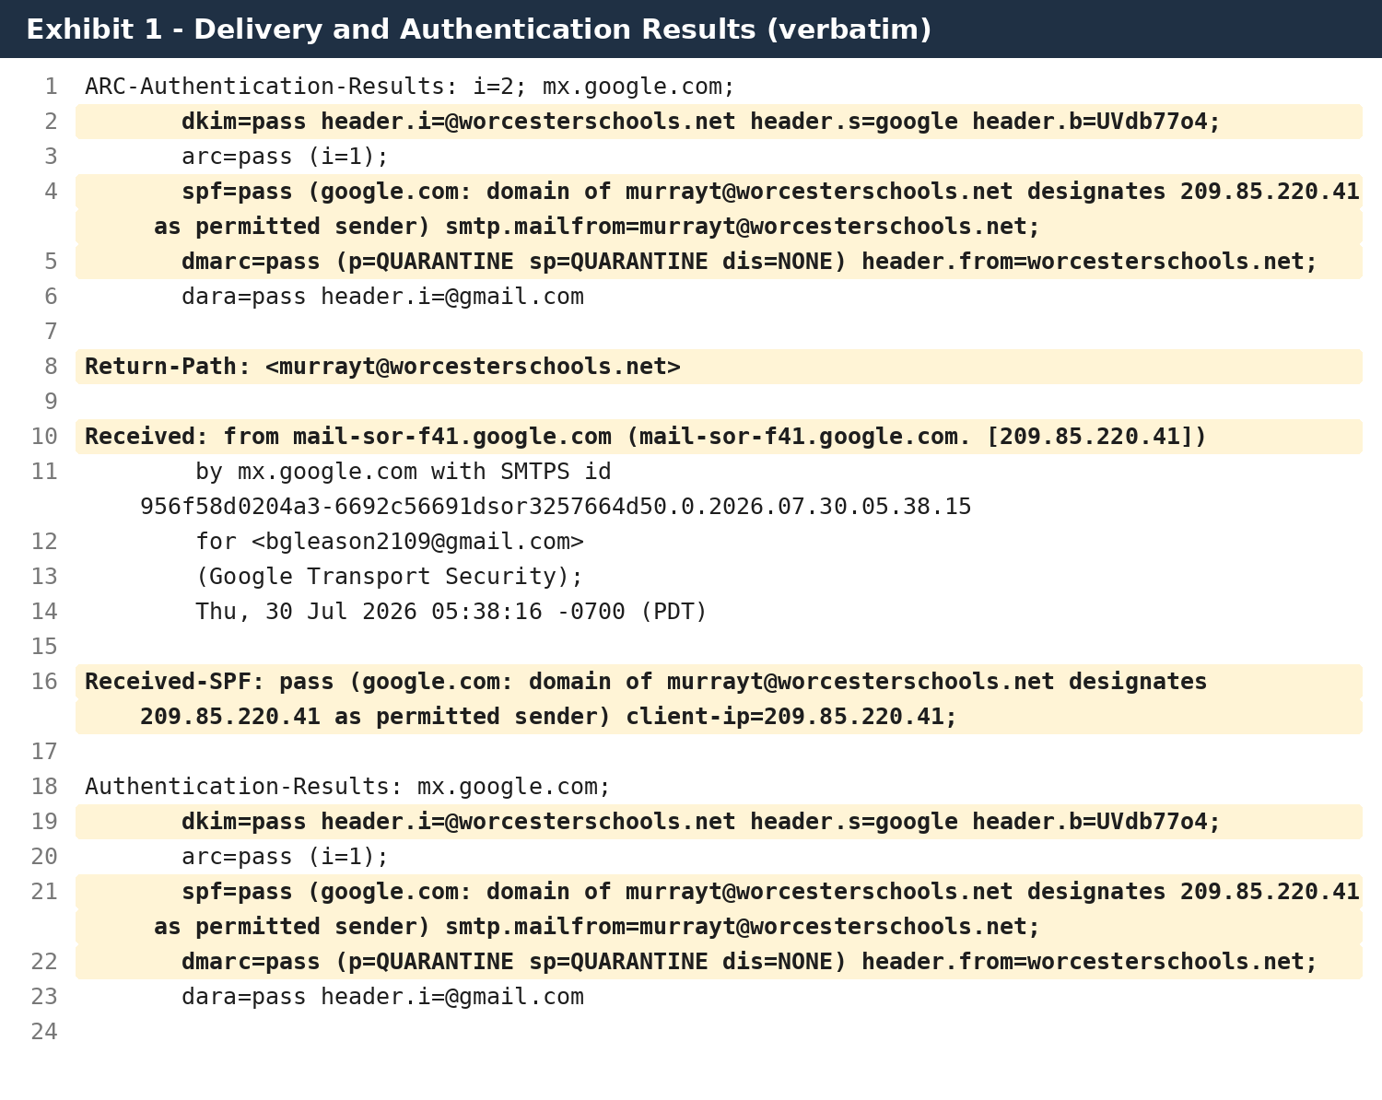
Exhibit 1. Verbatim delivery and authentication fields from the original EML.

5.2 Worcester-domain DKIM signature and signed fields
The DKIM signature specifies relaxed/relaxed canonicalization and identifies worcesterschools.net as the signing domain. The h= list covers content-type, to, subject, message-id, date, from, and MIME-version, among other repeated identity fields. The bh= parameter contains the Base64-encoded SHA-256 hash of the canonicalized message body.
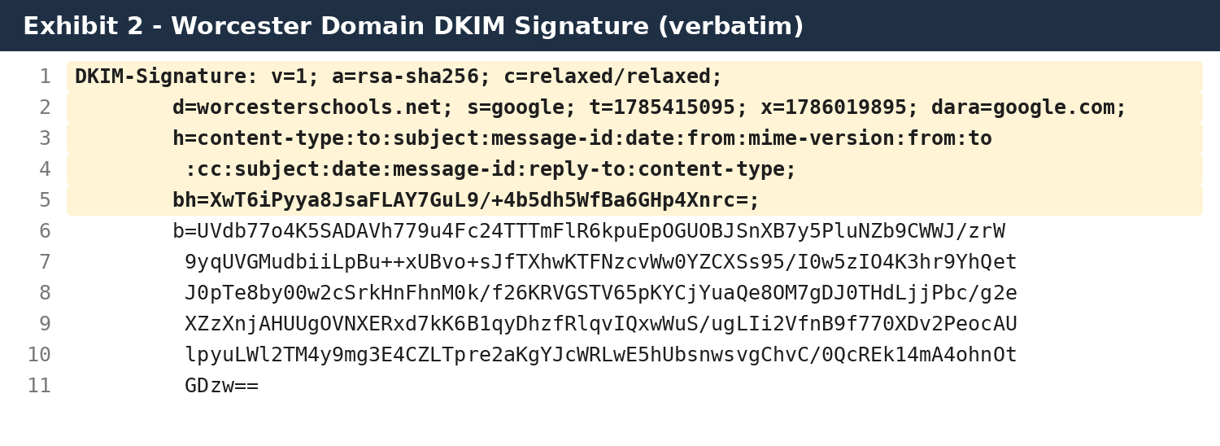
Exhibit 2. Verbatim Worcester-domain DKIM-Signature.

5.3 Independent DKIM body-hash verification
The calculated relaxed-body SHA-256 digest was 5f04fa88fcb26bc26c6852c063b1ae2fdffee1be5d87959f05ae861e9e179eb7. Base64 encoding produced XwT6iPyya8JsaFLAY7GuL9/+4b5dh5WfBa6GHp4Xnrc=, exactly matching the bh= value in the DKIM signature.
Forensic significance
The supplied MIME body matches the body hash applied under the Worcester-domain signature. The malicious Netlify destination was therefore present in the signed body, not inserted later by the recipient or by the subsequent forwarding chain.

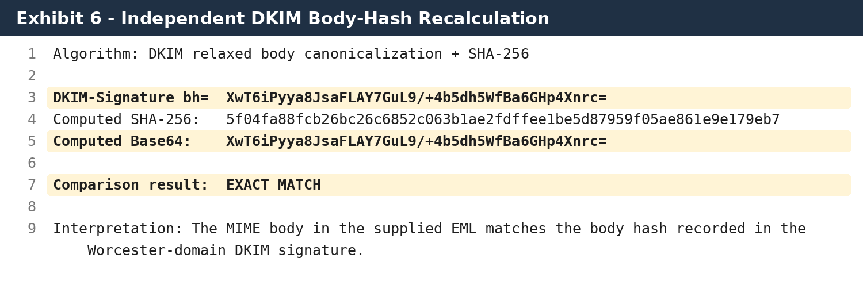
Exhibit 6. Independent DKIM relaxed-body hash reproduction and exact comparison.

5.4 Message identity, direct targeting, and timestamps
The message identifies “Murray, Tammy” at murrayt@worcesterschools.net as the From address, uses the same domain address in Return-Path, and includes a Gmail-format Message-ID. The recipient copy contains “To: undisclosed-recipients:;” and directly lists bgleason2109@gmail.com in Bcc. The Date header is 5:37:38 a.m. at -0700, equivalent to 8:37:38 a.m. EDT. Google’s transport headers record receipt at approximately 8:38:15-8:38:16 a.m. EDT.
The approximately 37-38 second interval is ordinary message transit timing. The -0700 Date offset is not unique to the suspicious message: both July automatic replies from the same mailbox also use -0700, while the June manually authored reply uses the expected -0400 Eastern Daylight Time offset. The offset therefore cannot be used as evidence that the actor was physically located in the Pacific time zone. It may reflect the generating service, vacation-response infrastructure, account configuration, client configuration, API behavior, or another Workspace setting.
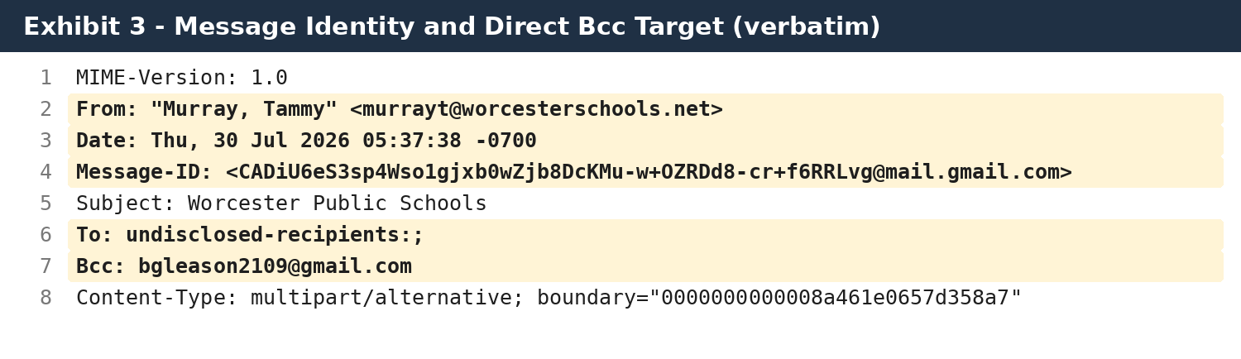
Exhibit 3. Verbatim message identity fields and direct Bcc recipient.

5.5 MIME structure and message content
The message is multipart/alternative and contains one text/plain part and one text/html part. It has no file attachment and no embedded image payload. The phishing action is therefore external-link based. The plain-text part states that a “secure message” never expires and directs the recipient to the Netlify URL.
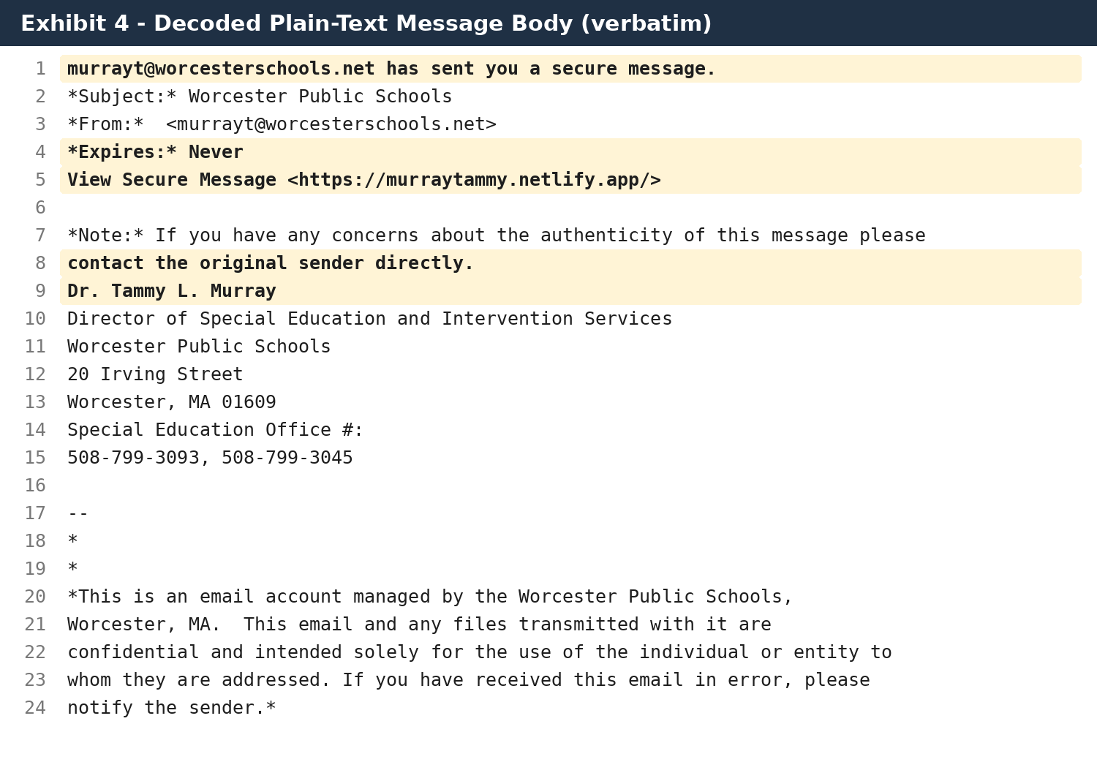
Exhibit 4. Decoded plain-text MIME body, verbatim.

5.6 HTML lure and link mismatch
The HTML button’s actual href value is https://murraytammy.netlify.app/. Netlify documents that each deployed project receives a default [site-name].netlify.app address. The site name “murraytammy” therefore corresponds to the chosen Netlify project subdomain, not a Worcester Public Schools domain.
The same anchor contains a title attribute beginning with a long encrypt-na.mailanyone.net redirect. This mismatch is consistent with a legitimate secure-message template being copied or modified so that the visible button points to a different destination while old metadata remains. That is a reasoned inference, not proof of the precise creation method.
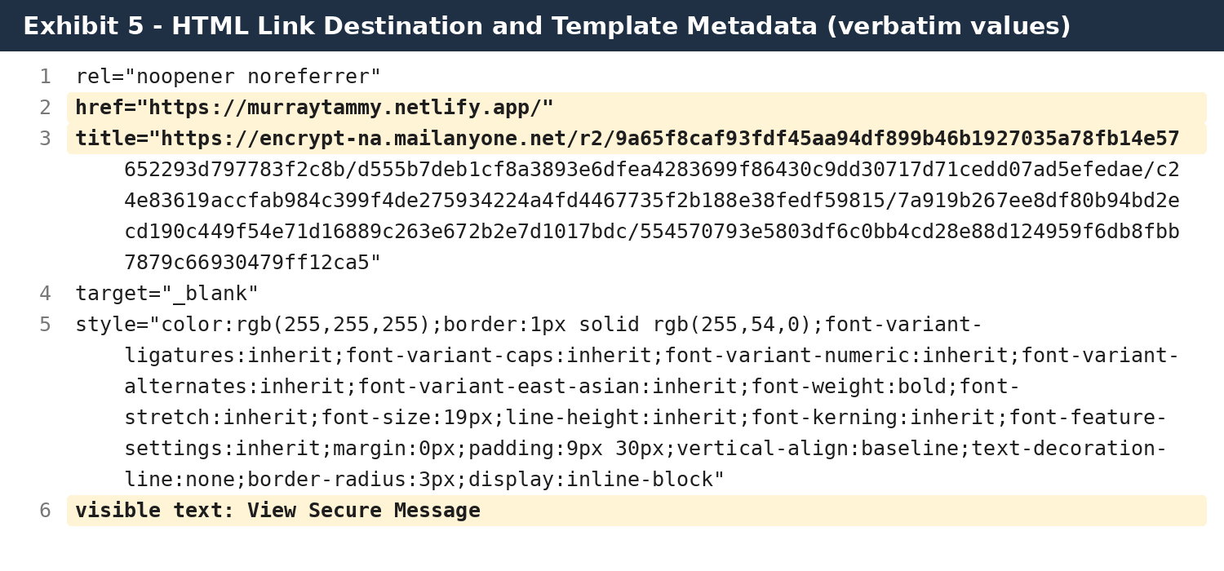
Exhibit 5. Verbatim link destination and MailAnyOne title metadata.

Exhibit 8. Static local rendering of the HTML MIME part; no link was opened.

5.7 Indicators of Google Workspace / Gmail generation
- The Message-ID ends in mail.gmail.com.
- The sending and receiving path uses Google mail servers and Google-specific transport fields.
- The domain DKIM selector is “google.”
- The HTML includes gmail_signature and data-smartmail="gmail_signature" artifacts.
- The MIME boundary and message composition are consistent with Gmail-generated mail.
Together, these facts strongly support a Gmail or Google-connected sending mechanism. They do not distinguish Gmail webmail, a mobile or desktop client, delegated access, Gmail API use, an OAuth-authorized application, or another authenticated Google Workspace pathway.

5.8 Comparison against known-good messages from the same account
The control samples materially refine the interpretation. All four messages - the suspicious message, two automatic replies, and the June manual reply - share the same visible sender identity, Worcester Return-Path, Google sending host family, 209.85.220.41 sending IP in the preserved recipient copies, SPF/DKIM/DMARC pass results, the Google DKIM selector, and Gmail-format Message-IDs beginning with CADiU6e and ending in @mail.gmail.com. These similarities confirm that the suspicious message follows the same authenticated Google Workspace transport pattern as legitimate mail from the account.
The suspicious message differs from the two vacation replies in important ways. The vacation replies are text/plain and contain Precedence: bulk, X-Autoreply: yes, and Auto-Submitted: auto-replied. The suspicious message lacks those automatic-reply markers and is multipart/alternative with a purpose-built HTML lure. It therefore was not generated by the ordinary vacation responder represented by those controls.
Sample | Raw Date header | Worcester time | Message type / markers | Interpretation
Suspicious | 30 Jul 2026 05:37:38 -0700 | 08:37:38 EDT | multipart/alternative; no auto-reply markers | Authenticated phishing lure
Control A | 27 Jul 2026 12:40:26 -0700 | 15:40:26 EDT | text/plain; X-Autoreply=yes; Auto-Submitted=auto-replied | Legitimate vacation reply
Control B | 21 Jul 2026 09:28:21 -0700 | 12:28:21 EDT | text/plain; X-Autoreply=yes; Auto-Submitted=auto-replied | Legitimate vacation reply
Control C | 5 Jun 2026 16:55:00 -0400 | 16:55:00 EDT | manual reply; References/In-Reply-To present | Legitimate manual reply
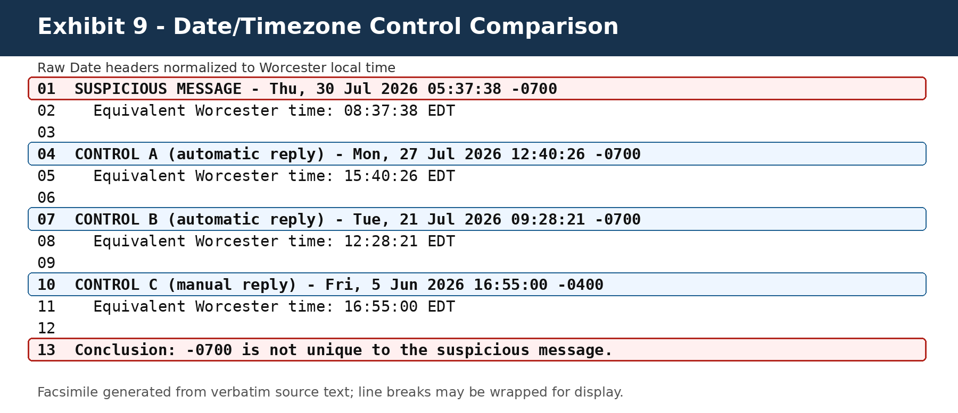
Exhibit 9. Verbatim Date-header comparison and normalization to Worcester local time.
Timezone conclusion
The -0700 offset is a recurring header characteristic in the July control mail and is not a reliable indicator of attacker location. The stronger evidence is the authenticated sending path, exact DKIM body-hash match, direct Bcc targeting, and non-automatic phishing content.

6. What May Be Compromised - and What Is Not Yet Proven

6.1 Gmail and mailbox access
Authenticated sending could result from full account takeover, but it can also result from a narrower mechanism that permits sending only. If the attacker possessed a password, stolen browser session, app password, or broad OAuth token, the attacker may have been able to read mail, search historical family communications, open attachments, view drafts, and create persistence through filters, forwarding, delegates, or send-as settings. None of those actions is proven by this EML; they require account and Gmail audit evidence.

6.2 Contacts, family addresses, and distribution data
The direct Bcc establishes that the sending process had Brent Gleason’s email address. The EML does not reveal whether it came from the mailbox’s prior correspondence, Google Contacts, a Google Group, an exported list, a student information system, a special-education platform, ParentSquare, or another source. If multiple families received the same message, the source of the list becomes a central scope question.

6.3 Drive and other Google Workspace services
A Google Workspace user account commonly provides access to multiple services, but access depends on account permissions, administrator configuration, and OAuth scopes. A stolen interactive user session could potentially reach Gmail, Drive, Calendar, Contacts, and files shared with that account. A send-only API token might permit sending without Drive access. An administrator compromise could create domain-wide consequences, but there is no evidence in this EML that the affected account held administrator privileges or that the Admin console was accessed.
Required restraint
The correct conclusion is not “all of Worcester Google Workspace is compromised.” The defensible conclusion is that an authorized Worcester email path was abused and the broader Workspace scope remains unknown until the relevant logs are examined.

6.4 Continuing persistence risk
Changing a password alone may be insufficient if the attacker retained an OAuth token, app password, delegated access, forwarding rule, active session cookie, compromised endpoint, or approved third-party app. Google’s own compromised-account guidance directs administrators to suspend the account, investigate user and mail activity, review OAuth, Groups, Drive, Calendar and forwarding settings, revoke tokens, and reset sign-in cookies.

7. Consequences for WPS and Affected Families

Higher-success phishing
Because the message authenticated and used the real director’s signature block, recipients had substantially more reason to trust it than an ordinary spoofed email.

Identity theft and fraud exposure
If the external site collected names, dates of birth, Social Security numbers, identification documents, account credentials, or financial information, affected individuals could face account takeover, identity theft, fraud, extortion, and long-term monitoring burdens.

Student privacy exposure
If unauthorized access reached education records or systems maintaining student information, the incident could implicate student privacy and FERPA-related duties. The U.S. Department of Education notes that education-data breaches can lead to identity theft, fraud, extortion, and possible FERPA violations.

Massachusetts breach assessment
Massachusetts law requires notification when a covered person or agency knows or has reason to know of a security breach or unauthorized acquisition or use of defined personal information. This report does not determine whether the statutory threshold was met; it identifies evidence requiring a prompt documented assessment.

Operational and evidentiary consequences
WPS should preserve short-retention email, identity, endpoint, security, and cloud logs. Delay can cause the loss of the exact records needed to determine actor, recipients, click activity, persistence, and data access.

Trust and communication consequences
Families may reasonably question whether future email from district officials is genuine. Clear notification, verified alternate contact methods, and a documented containment explanation may be necessary to restore trust.

8. Required Incident-Response and Audit Work
The following steps are necessary to determine whether the incident is contained and whether other Google Workspace information was accessed. Some capabilities depend on WPS’s Google Workspace edition and administrative privileges.
1. Preserve the original message, all recipient copies, message trace data, security alerts, support tickets, Google Vault material, endpoint telemetry, third-party gateway logs, and incident communications under a documented legal and records hold.
2. Temporarily suspend or otherwise contain the affected account as appropriate; revoke sign-in cookies, OAuth tokens, app passwords, delegated access, and suspicious sessions; reset credentials; and verify multi-factor authentication and recovery settings.
3. Run Email Log Search using the exact Message-ID and sender account to determine all recipients, statuses, routing, delivery events, and message timestamps.
4. Use Gmail log events and Gmail message investigations, where available, to identify the send event, client context, session, originating IP, API or SMTP method, and post-delivery remediation.
5. Review User log events for successful and failed sign-ins, suspicious sign-in warnings, device/session changes, password events, and authentication challenges.
6. Review OAuth log events and third-party application access for new or unusual grants, scopes, API calls, service accounts, and token use.
7. Review Gmail settings for forwarding, filters, delegates, send-as aliases, POP/IMAP, routing, compliance rules, app passwords, and mailbox delegation.
8. Review Contacts and Groups activity, directory exports, Google Takeout, and any list-management system that could explain the family recipients.
9. Review Drive logs for search, view, download, copy, external sharing, item-content access, and sync activity by the affected identity during the relevant period.
10. Review Calendar, device, Chrome, Admin, Vault, and other available log sources for related activity and persistence.
11. Identify the source of the Netlify site, submit and preserve abuse/takedown correspondence, and request preservation of deployment, access, form-submission, and account records through appropriate lawful channels.
12. Determine which recipients clicked, what data was submitted, what notices were issued, and what individual remediation is required.
13. Document the incident timeline, containment decisions, risk assessment, notification analysis, and final root cause rather than relying on an informal description that it was “spam.”

9. Specific Audit Queries and Indicators
Message-ID | <CADiU6eS3sp4Wso1gjxb0wZjb8DcKMu-w+OZRDd8-cr+f6RRLvg@mail.gmail.com>
From / envelope | murrayt@worcesterschools.net
Subject | Worcester Public Schools
Recipient indicator | bgleason2109@gmail.com
Actual URL | https://murraytammy.netlify.app/
Domain | murraytammy.netlify.app
Template URL indicator | encrypt-na.mailanyone.net/r2/…
Send time | July 30, 2026, 8:37:38 a.m. EDT (Date header originally -0700)
Google receipt | Approximately July 30, 2026, 8:38:15-8:38:16 a.m. EDT
Raw EML SHA-256 | 4ee90ccb567ae2fedd22eb87b726c51e940f9ba6556e3500bb1bb7019d4f15b9
DKIM body SHA-256 | 5f04fa88fcb26bc26c6852c063b1ae2fdffee1be5d87959f05ae861e9e179eb7
DKIM bh Base64 | XwT6iPyya8JsaFLAY7GuL9/+4b5dh5WfBa6GHp4Xnrc=
Decoded plain SHA-256 | ef2b4bc24d0ec7727c3d1f8d12f432e6dfa971d9f7380f11476b484f9d2aa90f
Decoded HTML SHA-256 | d23b5ac28f35e0bb8bdc106feb1fa8c0637c36171b6037a52ef381fb39a11ed1

10. Conclusion
The original EML materially changes the factual assessment. The message was not simply an outside email displaying Dr. Murray’s name. Gmail recorded successful SPF, DKIM, and DMARC authentication for Worcester Public Schools, and the message was signed with the worcesterschools.net DKIM domain. The independently recalculated DKIM body hash exactly matches the signed bh= value, confirming that the phishing body and Netlify link were present in the body authenticated under the Worcester-domain signature.
The evidence therefore supports misuse of an authorized Worcester email-sending pathway. Comparison with legitimate messages from the same account confirms that the suspicious message shares the account’s authenticated Google transport pattern, while lacking the automatic-reply markers present in the July vacation responses. The -0700 Date offset is not unique to the phishing message and does not establish attacker location. The most important unresolved questions are how sending authorization was obtained, whether it remains active, where the recipient list originated, how many families were targeted, whether recipients submitted information, and whether the actor accessed Gmail content, contacts, Drive, student systems, or other Workspace services.
Final assessment
This should be handled as an authenticated account or authorized-sending-path security incident requiring documented containment, scope analysis, recipient tracing, data-access review, preservation, and notification assessment - not merely as generic unsolicited spam.

Appendix A - Verbatim Core Header Extracts
The following values are reproduced from the supplied EML. Line folding and whitespace are preserved in the screenshot exhibits; selected core values are transcribed below for accessibility and searchability.

Authentication-Results
dkim=pass header.i=@worcesterschools.net header.s=google header.b=UVdb77o4;
spf=pass (google.com: domain of murrayt@worcesterschools.net designates 209.85.220.41 as permitted sender) smtp.mailfrom=murrayt@worcesterschools.net;
dmarc=pass (p=QUARANTINE sp=QUARANTINE dis=NONE) header.from=worcesterschools.net;

Identity fields
From: "Murray, Tammy" <murrayt@worcesterschools.net>
Date: Thu, 30 Jul 2026 05:37:38 -0700
Message-ID: <CADiU6eS3sp4Wso1gjxb0wZjb8DcKMu-w+OZRDd8-cr+f6RRLvg@mail.gmail.com>
Subject: Worcester Public Schools
To: undisclosed-recipients:;
Bcc: bgleason2109@gmail.com

DKIM core tags
c=relaxed/relaxed;
d=worcesterschools.net; s=google;
bh=XwT6iPyya8JsaFLAY7GuL9/+4b5dh5WfBa6GHp4Xnrc=;

Plain-text lure
murrayt@worcesterschools.net has sent you a secure message.
*Subject:* Worcester Public Schools
*Expires:* Never
View Secure Message <https://murraytammy.netlify.app/>

Appendix B - Confidence Framework
Confirmed | Directly demonstrated by the supplied EML, deterministic calculation, or exact header/body value.
Strongly supported | Multiple independent artifacts support the conclusion, but internal WPS logs are needed to identify the precise mechanism.
Potential / plausible | A technically possible consequence of certain compromise paths, but not demonstrated by the EML.
Not established | The report found no evidence sufficient to support the conclusion.

Appendix C - Control-Sample Header Extracts
The following control fields were obtained from known-good messages received from the same account. They are reproduced to show the basis for the timezone and transport comparison.

Control A - automatic reply, July 27, 2026
From: "Murray, Tammy" <murrayt@worcesterschools.net>
Date: Mon, 27 Jul 2026 12:40:26 -0700
Message-ID: <CADiU6eQ0twTD_jvcPZkR0eXTkitO8U+65wuingLtzfBRN4cCkA@mail.gmail.com>
X-Autoreply: yes
Auto-Submitted: auto-replied
dkim=pass; spf=pass; dmarc=pass
Received from mail-sor-f41.google.com [209.85.220.41]

Control B - automatic reply, July 21, 2026
From: "Murray, Tammy" <murrayt@worcesterschools.net>
Date: Tue, 21 Jul 2026 09:28:21 -0700
Message-ID: <CADiU6eQ77PeJ653mNiQaB6j25bzcHDNB_vf1O7LdEdSZRJQ9ZA@mail.gmail.com>
X-Autoreply: yes
Auto-Submitted: auto-replied
dkim=pass; spf=pass; dmarc=pass
Received from mail-sor-f41.google.com [209.85.220.41]

Control C - manual reply, June 5, 2026
From: "Murray, Tammy" <murrayt@worcesterschools.net>
Date: Fri, 5 Jun 2026 16:55:00 -0400
Message-ID: <CADiU6eSQkp1KYVLdnBZFi4t0NO=NopNhgmY6xzWz8LYuiBEF-Q@mail.gmail.com>
References and In-Reply-To fields present
dkim=pass; spf=pass; dmarc=pass
Received from mail-sor-f41.google.com [209.85.220.41]

Appendix D - Technical and Official Sources
[1] RFC 6376 - DomainKeys Identified Mail (DKIM) Signatures (official source)
[2] RFC 7208 - Sender Policy Framework (SPF) (official source)
[3] RFC 7489 - Domain-based Message Authentication, Reporting, and Conformance (DMARC) (official source)
[4] Google Workspace Admin Help - Set up DKIM (official source)
[5] Google Workspace Admin Help - Identify and secure compromised accounts (official source)
[6] Google Workspace Admin Help - Troubleshoot message delivery with Email Log Search (official source)
[7] Google Workspace Admin Help - Data sources for the security investigation tool (official source)
[8] Google Workspace Admin Help - About the security center (official source)
[9] Google Workspace Admin Help - Drive log events (official source)
[10] Google Workspace Admin Help - Control which apps access Google Workspace data (official source)
[11] Netlify Docs - Understand domains and default Netlify subdomains (official source)
[12] Mass.gov - Report a data breach (official source)
[13] U.S. Department of Education - Data Security: K-12 and Higher Education (official source)
[14] U.S. Department of Education - Data Breach Response Checklist (official source)
END OF REPORT

