WORCESTER PUBLIC SCHOOLS

Phishing Landing Page and Public-Risk Analysis
Separate Technical Report | July 30, 2026

Target URL | https://murraytammy.netlify.app/
Source email | Original RFC 822 / EML file
Current site status | Not reachable; hostname did not resolve during testing
Raw EML SHA-256 | 4ee90ccb567ae2fedd22eb87b726c51e940f9ba6556e3500bb1bb7019d4f15b9
Report scope | Landing-page indicators, deception pattern, and public risk

Preliminary external analysis. No Worcester Public Schools, Netlify, Google Workspace, or law-enforcement backend logs were available.

1. Plain-English explanation
What this means: The email tried to make families believe that Dr. Tammy Murray and Worcester Public Schools had sent them a protected school message. The button did not take recipients to a Worcester Public Schools, Google, Microsoft, or recognized secure-message domain. It took them to a custom site named after Tammy Murray on Netlify, a general-purpose website-hosting platform.
Why that is dangerous: A recipient who trusted the sender identity and clicked the button could have been shown a fake login, a request to enter an email address or password, a document-download prompt, or another form designed to collect information. Because the site is now unavailable, this report cannot honestly state which exact fields appeared. The deceptive email and destination nevertheless created a credible risk of credential theft, personal-information collection, account takeover, and follow-on targeting of families.
Why the school context makes the risk worse: Families regularly receive confidential special-education records, evaluation materials, meeting notices, placement documents, and secure links. A message appearing to come from the district’s Director of Special Education is therefore unusually likely to be trusted and opened. The campaign exploited that trust relationship.
Bottom line: the message used an authenticated district sender identity to direct families to an unrelated, personalized website. Even without proof of the exact landing-page form, that combination is consistent with a targeted phishing attempt and posed a serious public risk.

2. Scope and methodology
- Source preservation: Examined the original EML as raw bytes and preserved its SHA-256 hash. The analysis did not rely solely on a screenshot or forwarded text.
- URL extraction: Extracted the clickable destination from both the plain-text and HTML MIME parts and confirmed that the destination was the same Netlify URL.
- Deception analysis: Compared the claimed identity, subject, secure-message language, signature, destination domain, button label, and hidden HTML metadata.
- Live retrieval: Attempted to retrieve the target URL directly and through an independent web-fetching environment. The hostname did not resolve and no live page content was returned.
- Archive/reputation search: Searched for indexed references and publicly discoverable archived scans. No page copy sufficient to reconstruct the landing page was located.
- Risk analysis: Assessed reasonably foreseeable harms from the proven lure and destination, while avoiding claims about unobserved fields, scripts, or data submissions.
- Confidence labeling: Separated direct evidence, strong inference, plausible risk, and unknown facts requiring provider or district logs.

3. Current status of the destination
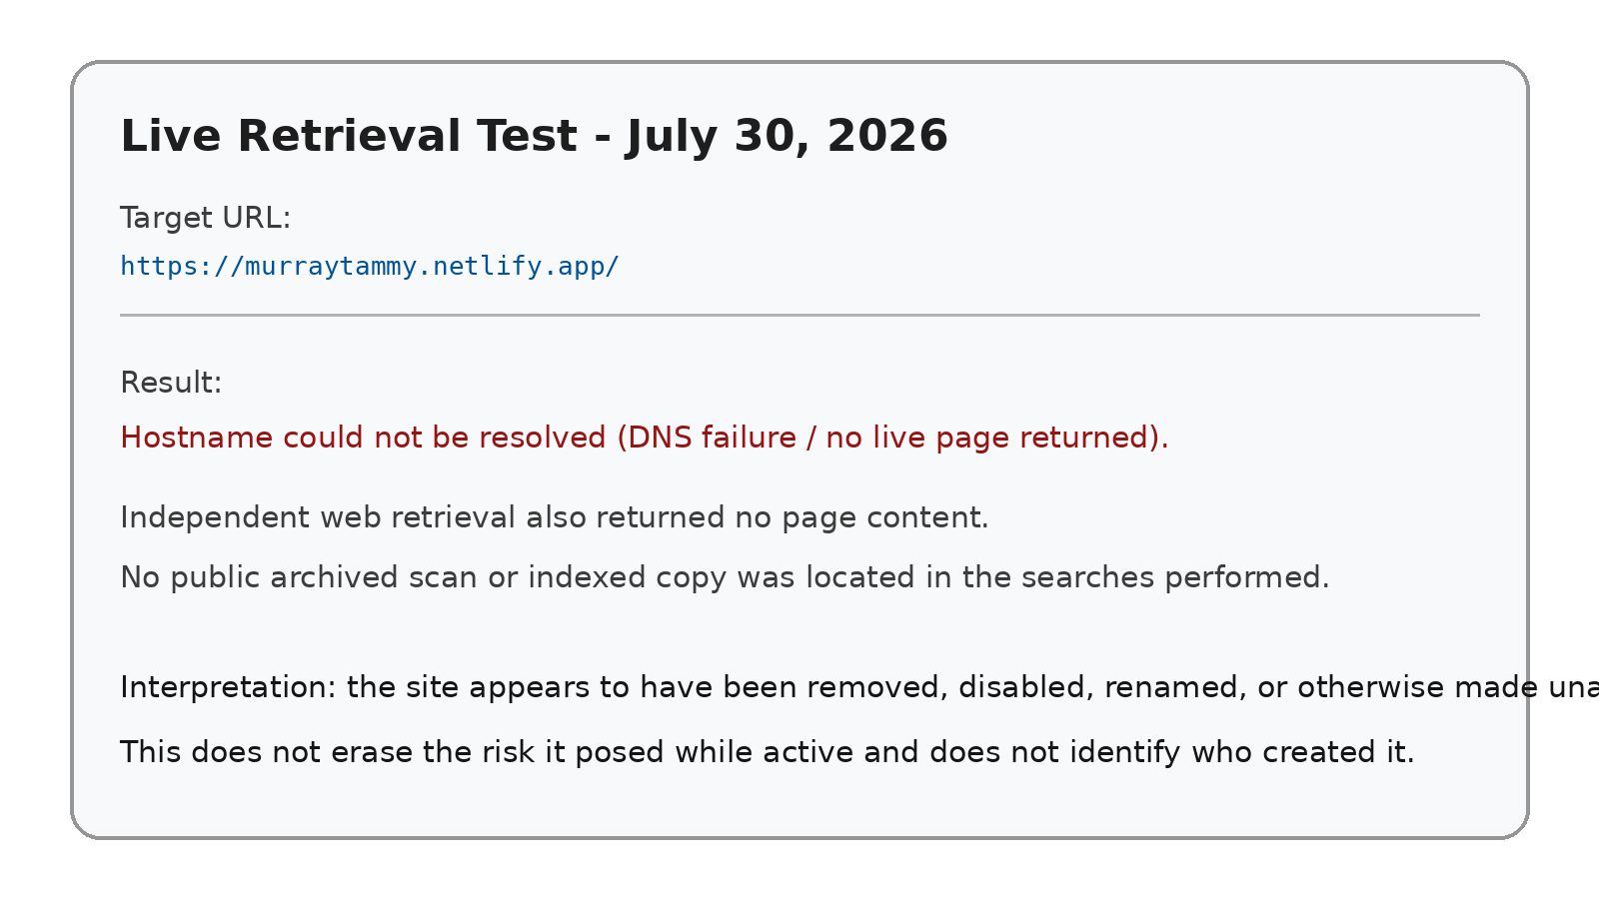
Exhibit 1. Documented retrieval result. The site was not reachable during this analysis.
Finding: The target hostname currently does not resolve. This is consistent with removal, suspension, deletion, renaming, or expiration of the Netlify site. It does not establish who removed it or when it became unavailable.
Evidentiary consequence: The exact landing-page appearance, fields, JavaScript, network requests, data-storage destination, and submitted-data history cannot be reconstructed from the live site at this time. Those facts may still exist in Netlify account records, deployment files, DNS history, abuse reports, browser histories, endpoint-security logs, or law-enforcement preservation returns.

4. Indicators that the campaign was phishing
Indicator | Why it matters | Evidence level
False security framing | The message announced a “secure message,” but the link went to a generic Netlify subdomain rather than an identifiable district secure-message service. | Direct evidence
Personalized impersonation domain | The hostname “murraytammy” used the official’s name to increase trust while remaining outside worcesterschools.net. | Direct evidence
Authority exploitation | The sender identity and signature invoked the Director of Special Education and Intervention Services. | Direct evidence
Bulk but concealed distribution | The message used “undisclosed-recipients” and Bcc, reducing recipients’ ability to see campaign scope. | Direct evidence
Indefinite urgency/access cue | The message claimed the protected content “Expires: Never,” encouraging access without a normal document description or case context. | Direct evidence
Generic subject | “Worcester Public Schools” supplied no student name, document type, meeting, case, or ordinary operational context. | Direct evidence
Template mismatch | The actual href was the Netlify site while hidden title metadata referenced a long MailAnyOne encryption URL, suggesting template copying or substitution. | Strong inference
Authenticated trust channel | The email passed district-domain authentication, making ordinary user skepticism less likely and increasing the lure’s effectiveness. | Direct evidence
No legitimate destination disclosure | The message did not explain why a public website-hosting domain was being used or identify Netlify as an authorized district processor. | Direct evidence
Post-incident disappearance | The destination is now unavailable. Short-lived infrastructure is common in phishing, although disappearance alone is not proof. | Corroborating circumstance

Exhibit 2
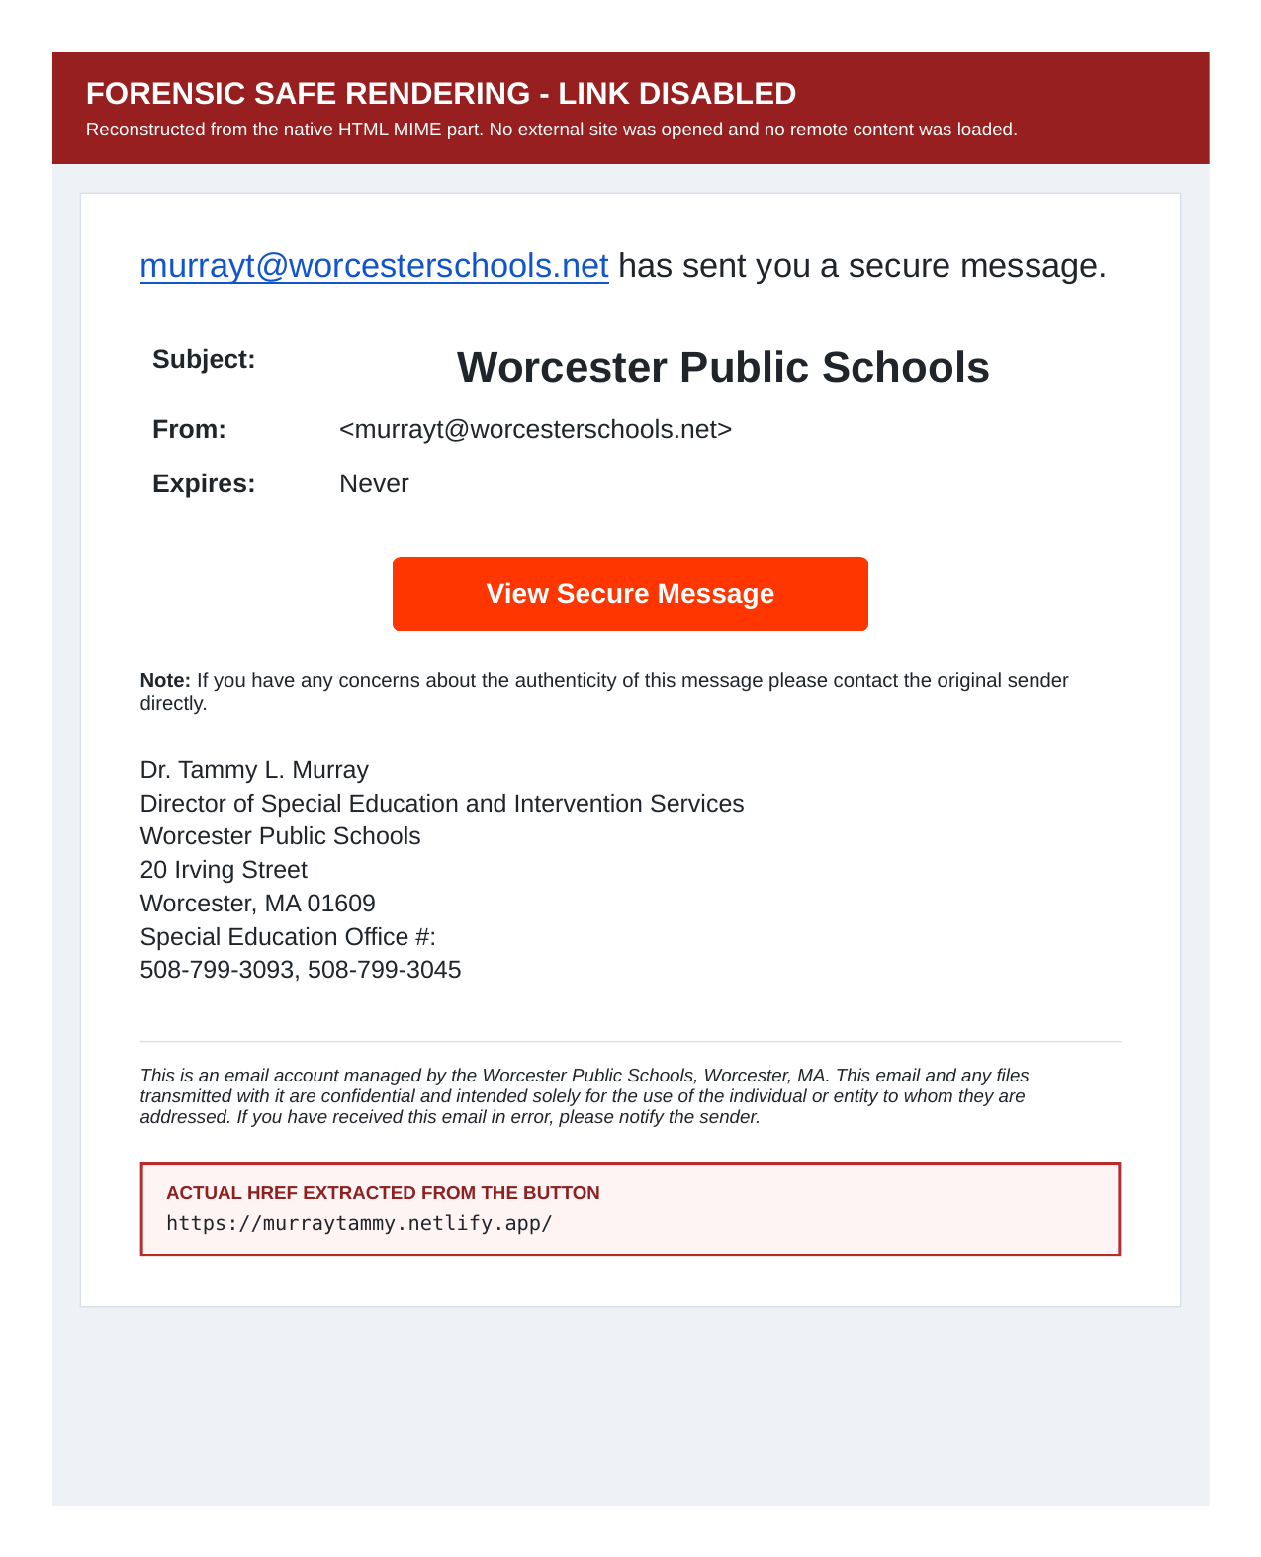
Exhibit 2. Safely rendered email showing the secure-message lure and official signature.

Exhibit 3
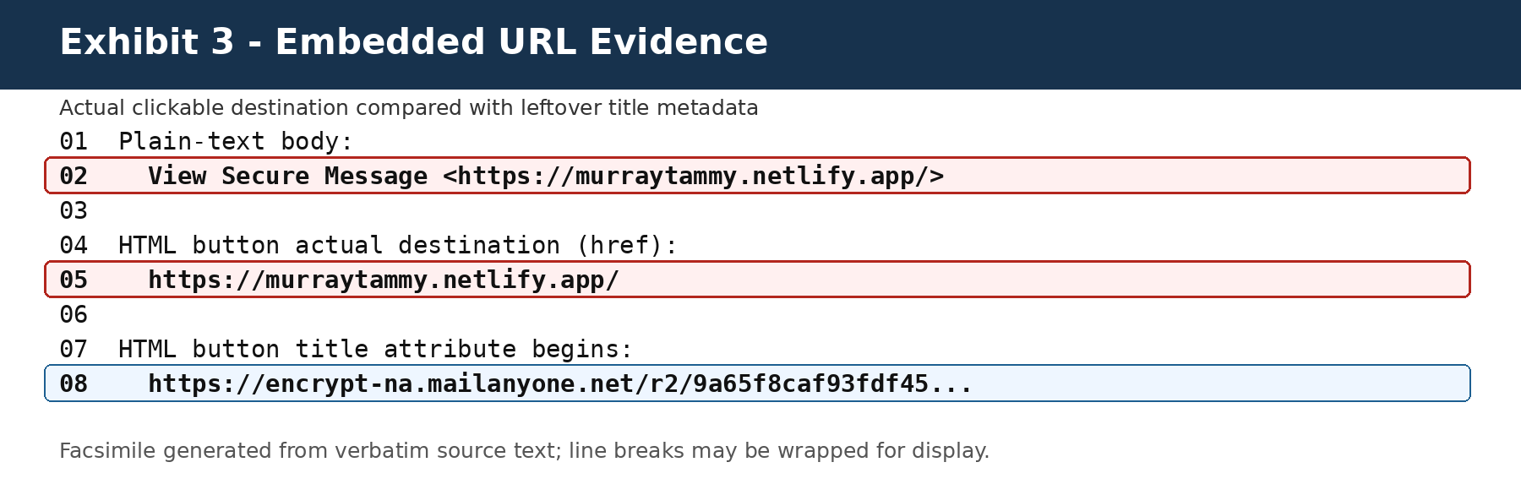
Exhibit 3. HTML evidence showing the Netlify href and mismatched MailAnyOne title metadata.

Exhibit 4
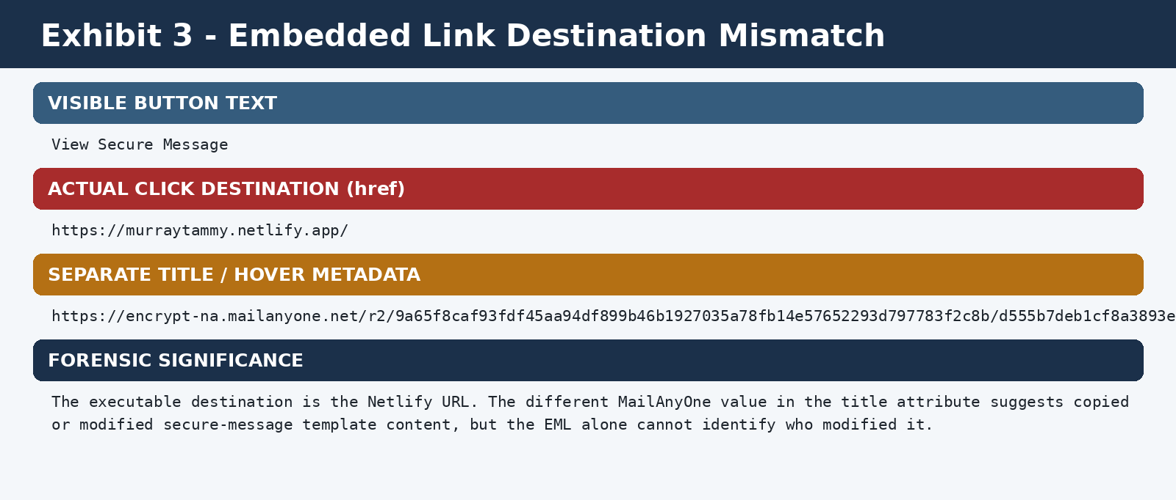
Exhibit 4. Extracted malicious destination and related link evidence.

5. Risk posed to families and the public
- Credential theft: A fake Microsoft, Google, Gmail, or district login could capture passwords and, where reused, expose additional services.
- Mailbox takeover: Stolen credentials could allow reading, forwarding, deleting, or impersonating family communications, including special-education records.
- Collection of student-linked information: The lure’s school context could prompt recipients to provide student names, dates of birth, disability-related information, addresses, phone numbers, or case details.
- Follow-on social engineering: Knowing that a recipient is connected to WPS special education could support highly tailored phone calls, invoices, document requests, or placement-related scams.
- Account recovery abuse: Email addresses, phone numbers, security answers, or session tokens could be used to reset other accounts.
- Malware or unwanted downloads: A landing page could direct users to a file or browser prompt. No such download is proven here because the page is unavailable.
- Loss of trust in legitimate notices: Families may ignore later genuine secure messages, IEP notices, meeting links, or emergency communications.
- Disproportionate impact: Families of students with disabilities may have more frequent contact with district personnel and may be more likely to expect sensitive documents, making this lure particularly credible.
- Institutional exposure: If the campaign used compromised Workspace access, the risk could extend beyond one outbound message to contacts, prior mail, Drive links, delegated access, OAuth tokens, or mailing lists. The available evidence does not establish the scope.

6. Consequences for Worcester Public Schools
- The incident requires more than blocking one URL. The District must determine how an authenticated district identity was used, what recipient source was accessed, and whether any account, token, delegation, or application remained active.
- If multiple families received the same message, the District must determine whether the recipient list itself came from a protected school system, contact export, group, mailbox history, or external source.
- Because the site is unavailable, delay increases the risk that provider logs, deployment artifacts, and network records will be lost under ordinary retention schedules.
- Family notification decisions should be based on the verified scope and potential exposure, not merely on whether the link was later disabled.
- The response should include password/session controls, OAuth review, delegated-access review, forwarding/filter review, Google Workspace audit review, and preservation requests to Netlify and Google.

7. What is proven, inferred, and unknown
Category | Conclusion
Proven | The signed email directed recipients to the Netlify URL; the lure represented itself as a secure WPS message; the destination is outside the district domain; the site is currently unavailable.
Strongly supported | The message was designed to induce trust and a click through impersonation of a school official and secure-message presentation.
Plausible but unconfirmed | The landing page may have sought credentials, personal information, downloads, or redirects.
Not established | The exact landing-page fields, scripts, data recipient, number of visitors, number of submissions, creator identity, or scope of any Workspace compromise.

8. Records needed to reconstruct the landing page
- Netlify site/account identifier, owner account, creation time, deployment history, deploy ZIPs, source repository linkage, access logs, form-submission records, function logs, environment variables, and abuse/takedown records.
- DNS and certificate history for murraytammy.netlify.app, including first-seen and last-seen information.
- Google Workspace click-protection, Safe Browsing, email-log, investigation-tool, and security-center records for the URL.
- Endpoint/browser history from affected recipients, including screenshots, downloads, cached files, HAR/network logs, and saved-page data.
- Any family reports describing what appeared after clicking and whether information was entered.
- WPS IT tickets, incident timeline, indicators of compromise, remediation records, and provider preservation requests.
- Public-records response identifying aggregate recipient counts and the source of the distribution list.

9. Recommended immediate actions
- Issue a plain-language notice to potentially affected families describing the sender, subject, URL, date, and safe next steps.
- Advise anyone who entered credentials to change the password from a clean device, revoke sessions, review MFA methods, and check forwarding rules.
- Preserve Google Workspace and Netlify records before retention periods expire.
- Block the URL and related indicators across district email, web filtering, and endpoint tools.
- Review Dr. Murray’s account, delegated users, OAuth applications, send-as settings, filters, forwarding, login history, session history, and administrative changes.
- Determine whether any WPS contact list or student-related system was queried, exported, or accessed.
- Maintain a documented incident chronology and explain the basis for any decision not to notify families.

10. Sources and limitations
- Original EML: Worcester Public Schools.eml, received July 30, 2026.
- Google Chrome Help, “Manage warnings about unsafe sites” (phishing and social-engineering risk descriptions).
- Google Safe Browsing documentation and Transparency Report materials.
- Netlify documentation explaining default netlify.app project addresses.
- urlscan.io documentation describing archived sandbox scans and collected page artifacts.
Limitation statement: The live site could not be reached and no archived copy sufficient to inspect its DOM, forms, scripts, or network calls was located. Accordingly, this report does not claim that a specific login field, malware payload, or data-exfiltration endpoint was observed. It analyzes the proven phishing lure and the risks reasonably created by directing recipients to the unauthorized destination.

