The two core problems we’re focused on solving at Immune Check are difficulty in tracking a person’s vaccination record, and a lack of good technology that alerts people what vaccinations have expired, or what additional vaccinations are required before travelling to any foreign country based on any real-time disease outbreak. We have witnessed many people don’t remember which vaccinations are nearing their date of expiration, and which ones are already past their date of expiration, including ourselves. This is a big problem, because disease outbreaks happen very often all around the world. It can happen at any place and time. If people living in an affected area are not properly immunized, it can lead to serious health concerns, including death. Additionally, people travelling to a foreign country might need new vaccinations before entering the destination country. As a result, considerable amount of time and resources is lost in determining what additional vaccinations are required for each traveller, based on each of their vaccination records. Anyone who takes a job in healthcare, or is a student in medical field, has to prove that they have all their immunizations up to date. If they can’t prove it, they have to get re-immunized. Again, this is a waste of time and resources. Realizing all these problems, we are building a platform where a user can easily keep track of all their vaccinations, is alerted immediately whenever a disease outbreak happens near them, and get to know what vaccinations are required before travelling to any country in the world, all in one mobile application.

Our main focus while building Immune Check is data authenticity, efficiency and ease of use. We want Immune Check to be a reliable tool for every demographic of consumers, from the tech-savvy to the non-tech savvy. No existing application allows a user to keep track of their vaccinations, alert them if an outbreak occurs near them, and provide worldwide vaccination requirement information, all in one place. Immune Check is a one-of-a-kind mobile application that allows a user to do just that. The main features of the application are, mutable list of vaccinations taken by the user including each of their respective information such as date received and date of expiration, disease outbreak alert in the nearby area, and a real-time global disease outbreak alert.

To use Immune Check, the user has to first sign up to the application and then login. While signing up, the user is prompted to enter all the vaccinations that they have received so far along with the date received. The user also has the option to add their family members and enter each of their vaccination records too. After logging in, the user is shown a list of all the family members and they can tap anyone to check their record. If any of the family member has an expired vaccination in their record, their name is shown in a red background.

After tapping the desired family member, the user can navigate to any of the following screens; My Records, Travel and Map. The “My Records” screen has a list of colour coded names of all vaccinations taken by the user which are listed based on how close their date of expiration is. This means, all the expired vaccinations are at the top and are marked by red, followed by near expiring vaccinations which are marked by orange and lastly, the vaccinations that are okay or don’t need attention which are marked by green. The user can easily add any new vaccination that they receive later on. Another important feature of Immune Check is its “Travel” section. Whenever the user decides to visit a foreign country, they can go to this screen and enter the destination country name in the search bar on the top. The application then displays all the vaccinations that are needed to travel there based on any recent disease outbreak. While displaying the search result, Immune Check automatically filters out the vaccinations the user has already taken and is not nearing their date of expiration. This way, the user saves a lot of time and resources to determine exactly which vaccinations they need. Lastly, the “Maps” section shows all outbreaks happening in all countries in real time, marked in a world map. Immune Check has a live notification system that notifies the user immediately if any outbreak happens near their area.

The team:

We have a very hardworking team of people from diverse backgrounds. Our team was initially formed during the Hacking Health hackathon in which we placed second. Xiaodong is the guy behind the idea for Immune Check.

Jeremy is the epistemologist and developer at Immune Check. He picked up software development while implementing scientific computing for the research that his team published in the academic medical literature. He is constantly learning about functional reactive programming patterns to make pretty websites. Currently, he is also a lead software developer for C-Core's LookNorth team, where he helps develop web and mobile platforms that translate their engineering scientists' research in satellite remote sensing and ice engineering into apps that benefit industries, communities, and the public at large.

Prasanga is the lead full stack developer at Immune Check. He is an undergraduate student at MUN doing a major in computer science and a minor in mathematics. He has experience working with multiple programming languages such as Java, Javascript, Python, PHP, HTML, CSS and MySQL. He also has knowledge on a variety of libraries and frameworks such as ReactJS, Materialize CSS, Bootstrap etc.

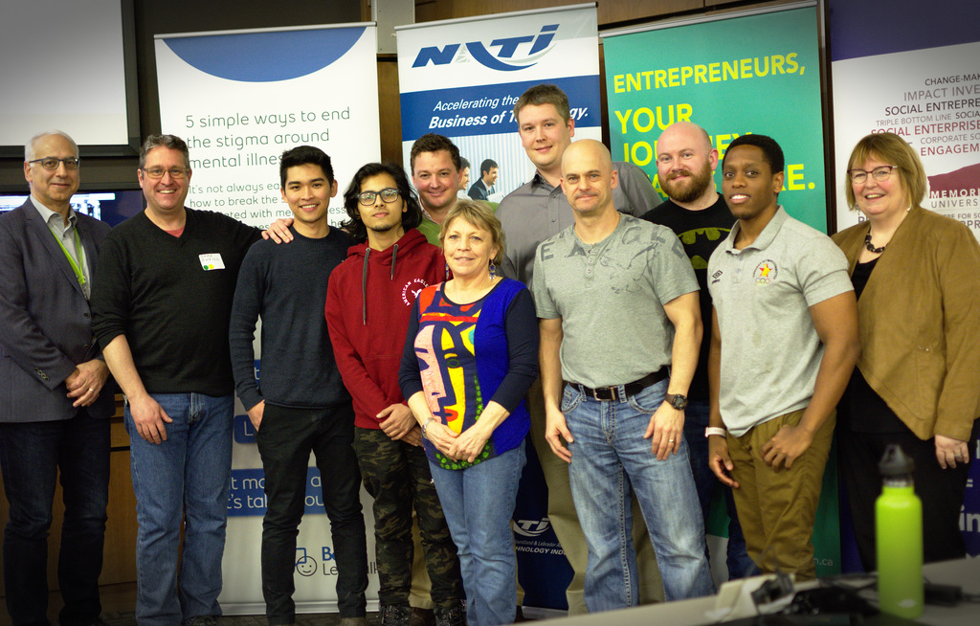

(Photo (l-r): Dr. Larry Alteen (judge), Immune-Check team members Sean O'Neill, Xiaodong Yan, Prasanga Dhakal, Jeremy Hetzel, Mollie Butler, Dean Klemola, Ken March, Chad Lawlor and Munya Mazambani, and Dr. Margaret Steele (judge))